|  |  |  |  |
| --- | --- | --- | --- |
|  | United Nations | ECE/TRANS/WP.29/GRE/2019/21 | |
| Description: _unlogo | **Economic and Social Council** | | Distr.: General  7 August 2019  Original: English |

**Economic Commission for Europe**

Inland Transport Committee

**World Forum for Harmonization of Vehicle Regulations**

**Working Party on Lighting and Light-Signalling**

**Eighty-second session**

Geneva, 22-25 October 2019

Item 5 of the provisional agenda

**UN Regulations Nos. 37 (Filament lamps), 99 (Gas discharge light sources), 128 (Light emitting diodes light sources) and the Consolidated Resolution on the common specification of light source categories**

Proposal for amendment to the Consolidated Resolution on the common specification of light source categories

Submitted by the Task Force on Substitutes and Retrofits[[1]](#footnote-2)\*

The text reproduced below was prepared by the Task Force on Substitutes and Retrofits (TF SR) with the aim to introduce a new light emitting diode (LED) substitute light source category H11/LED for road illumination applications. The technical provisions are based on the equivalence criteria (informal document GRE-80-02), as amended for light sources used in road illuminaton applications (informal document GRE-82-03). The modifications to the existing text of the Resolution are marked in bold for new or strikethrough for deleted characters.

I. Proposal

*The Status table*, insert a new row at the bottom to read:

|  |  |  |  |  |
| --- | --- | --- | --- | --- |
| **[8]** | **[2019-xx-xx]** | **[17x]** | **[ECE/TRANS/WP.29/2020/xx]** | **Introduction of a new LED substitute light source category H11/LED** |

”

*Paragraph 3.3., insert a new entry into Group 4,* to read:

“

|  |  |  |  |  |
| --- | --- | --- | --- | --- |
| ***Group 4*** | | | | |
| ***LED substitute light source categories1 only for use in lamps approved with filament light source(s) of its counterpart light source category*** | | | | |
|  | ***Category*** |  | ***Counterpart filament light source category*** | ***Sheet number(s)*** |
|  | C5W/LEDK | 2 | C5W | C5W/LED/1 to 4 |
|  | **H11/LED** |  | **H11** | **H11/LED/1 to 7** |
|  | PY21W/LED |  | PY21W | PY21W/LED/1 to 4 |
|  | R5W/LED |  | R5W | R5W/LED/1 to 4 |
|  | W5W/LEDK | 2 | W5W | W5W/LED/1 to 4 |
|  | WY5W/LED |  | WY5W | W5W/LED/1 to 4 |

*Annex 3,*

*List of sheets for LED light sources and their sequence,* amend to read:

“

|  | *Sheet number(s)* |  |
| --- | --- | --- |
|  | C5W/LED/1 to 4  **H11/LED/1 to 7**  L1/1 to 5 |  |
|  | LR1/1 to 5 |  |
|  | LW2/1 to 5 |  |
|  | Lx3/1 to 6 |  |
|  | LR4/1 to 5 |  |
|  | Lx5/1 to 6 |  |
|  | PY21W/LED/1 to 4  R5W/LED/1 to 4  W5W/LED/1 to 4 |  |

”

*After sheet C5W/LED/4*, insert new sheets H11/LED/1 to 7, to read:

(see following pages; one page per sheet)

**Category H11/LED Sheet H11/LED/1**

The drawings are intended only to illustrate the essential dimensions (in mm) of the LED light source.

# 

Reference plane 1/

Reference axis 2/

A

B

e

f

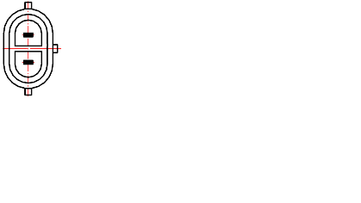

V+

Ground

View C

View A

**Figure 1: Main drawing**

35

**∅**15.0

25.0

4

44.0

**∅**19.0

**∅**25.0

**∅** 50

50°

Reference plane

Reference axis

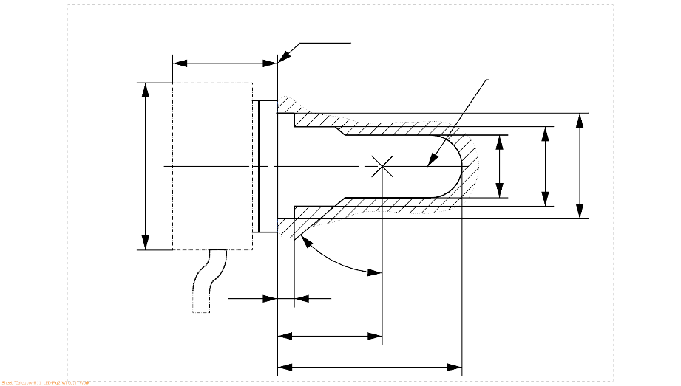

**Figure 2: Maximum LED light source outline 3/**

1/ The reference plane is the plane formed by the underside of the bevelled lead-in flange of the cap.

2/ The reference axis is perpendicular to the reference plane and passing through the centre of the 19 mm cap diameter.

3/ The LED light source shall not exceed the envelope as indicated in Figure 2.

**Category H11/LED Sheet H11/LED/2**

Table 1

**Essential electrical and photometrical characteristics of the LED light source**

| *Dimensions in mm* | | | *LED light sources of normal production* | | *Standard LED light sources* |
| --- | --- | --- | --- | --- | --- |
| *12V* | *24V* |
| e 2/ | | | 25.0 nom. | | |
| f 2/ | | | 4.5 nom | | |
| Contrast 6/ | | | 100 min. | | |
| Cap: [PGJX19-2] in accordance with IEC Publication 60061 (sheet 7004-[110A-1]) | | | | | |
| *Electrical and photometric characteristics* | | | *4/* | *5/* | *4/* |
| Rated values | | Volts | 12 | 24 | 12 |
| Watts | 18 | 18 | 18 |
| Test voltage | | Volts (DC) | 13.2 | 28.0 | 13.2 |
| Objective values | Power | Watts | 21 max. | 21 max. | 21 max. |
| Electrical current | mA | 350 min.  1750 max.  (at 9-16 V DC) | 175 min.  875 max.  (at 16-32 V DC) | 350 min.  1750 max.  (at 9-16 V DC) |
| Luminous flux 1/ 3/  (at test voltage) | lm | 1,350 ± 10% | 1,350 ± 10% | 1,350 ± 10 % |
| Luminous flux 1/ | lm | 270 min.  (at 9 V DC) | 150 min.  (at 16 V DC) | 270 min.  (at 9 V DC) |

1/ The light emitted shall be white without a correlated colour temperature restriction.

2/ To be checked by means of a “box system”, sheet H11/LED/3

3/ The value measured at elevated ambient air temperature of 60°C shall be at least 70% of this value

4/ In case of a failure of any of the light emitting elements (open circuit failure), the LED light source shall either still comply to the requirements concerning luminous flux and luminous intensity distribution or stop emitting light whereby, in the latter case, the electrical current draw, when operated between 12 V and 14 V, shall be less than 100 mA

5/ In case of a failure of any of the light emitting elements (open circuit failure), the LED light source shall either still comply to the requirements concerning luminous flux and luminous intensity distribution or stop emitting light whereby, in the latter case, the electrical current draw, when operated between 24 V and 28 V, shall be less than 50 mA

6/ The contrast is the proportion of luminous flux originating from two different areas, see details in sheet H11/LED/3

**Category H11/LED Sheet H11/LED/3**

Screen projection requirements

The following test is intended to define the requirements for the apparent light emitting area of the LED light source and to determine whether the light emitting area is correctly positioned relative to the reference axis and reference plane in order to check compliance with the requirements.

The position of the light emitting area is checked by a box system defined in Figure 4 when operated at test voltage, which shows the projections when viewing from B (see sheet H11/LED/1, Figure 1) and from A and –A (see sheet H11/LED/1, Figure 1), i.e. along the C-planes C0, C90 and C270 (as defined in Figure 6).

The proportion of the total luminous flux emitted into these viewing directions from the area(s) as defined in Figure 4:

• Total box area: (A+B+C) / E shall be not less than 90%  
(for standard light sources a minimum of 95% applies)

• Area A: A / (A+B+C) shall be not more than 10%

• Areas B1, B2 and B3: B1/B, B2/B, B3/B shall each be not less than 15%

• Area B: B / (A+B+C) shall be not less than 72 %  
(for standard light sources a minimum of 75% and a maximum of 85% applies)

• Area C: C / (A+B+C) shall be not more than 22%

c1

x1

x2

c2

b1

b2

y1

y1

e

a1/2

a2

**E**

**B1**

**B2**

**B3**

**C**

**B**

**A**

Reference axis

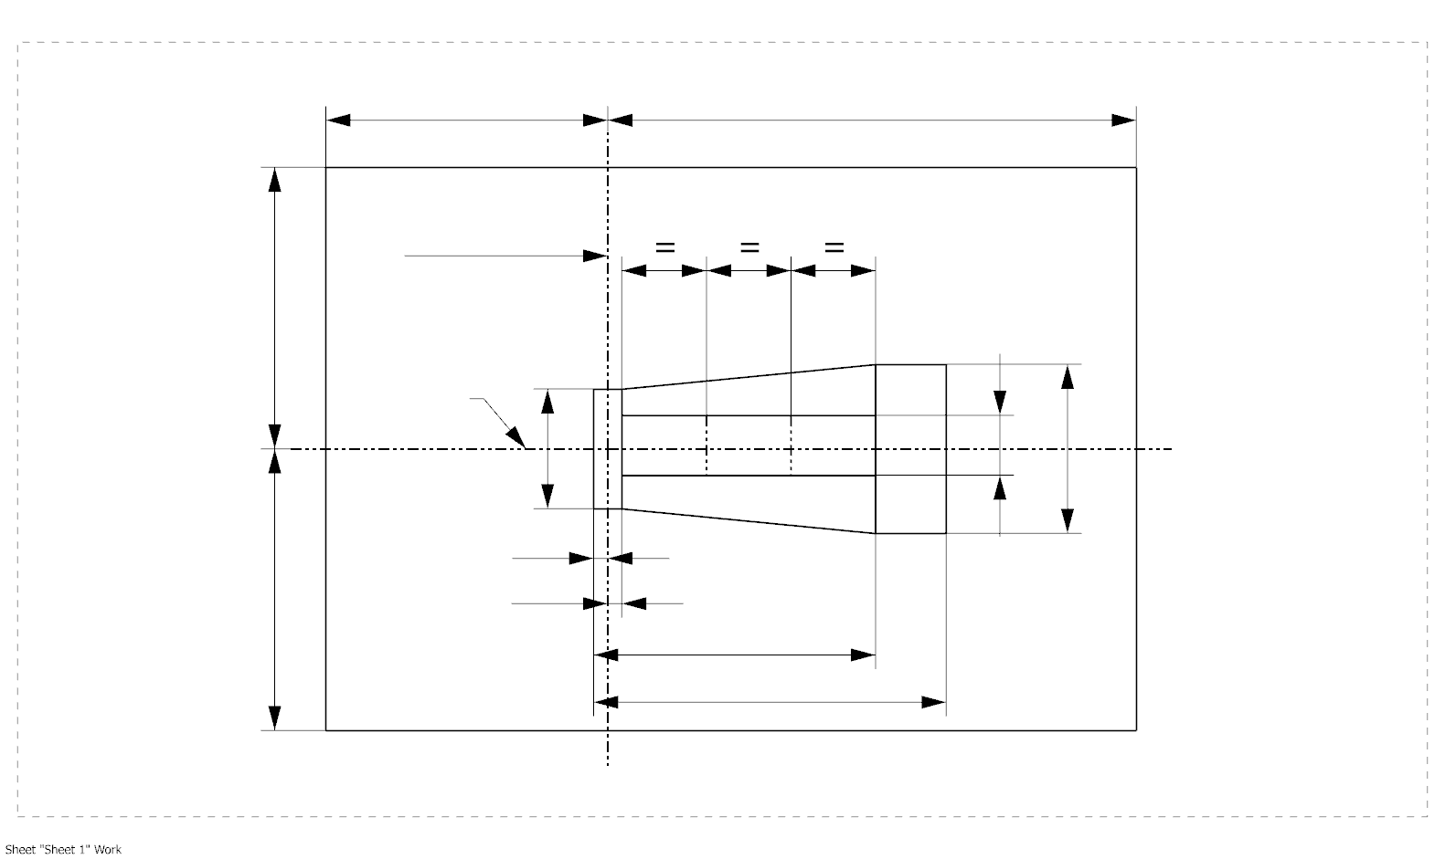

a1

**Figure 4: Box definition of the light emitting area (dimensions given in Table 2)**

The contrast is checked by a box system defined in Figure 5 when operated at test voltage, which shows the projections when viewing from A and –A (see sheet H11/LED/1, Figure 1), i.e. along the C-planes C90 and C270 (as defined in Figure 6).

The contrast is the proportion of the total luminous flux values emitted into these viewing directions from the corresponding areas (A+B+C) and D. The value of the contrast (A+B+C) / D shall be within the limits given in Table 1 (see Figure 5 for the definition of the area D).

**Category H11/LED Sheet H11/LED/4**

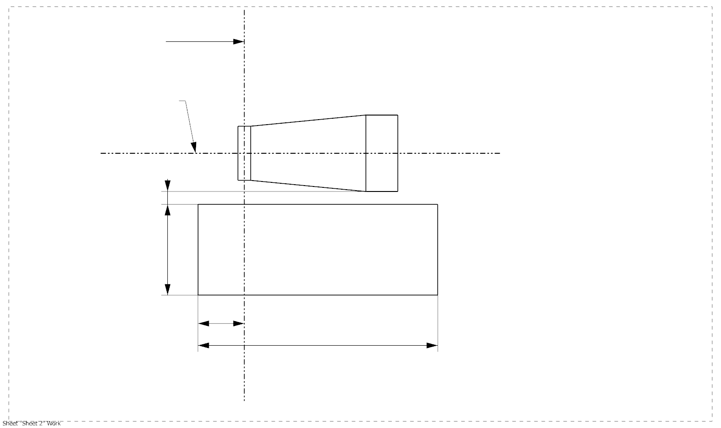

g2

g3

d

g1

**A**

**D**

**C**

**B**

e

Reference axis

**Figure 5: Box definition of the area D (dimensions given in Table 2)**

Table 2

**Dimensions of the box definitions in Figure 4 and Figure 5**

|  |  |  |  |
| --- | --- | --- | --- |
| All views  (as specified above) | *Dimensions in mm* | All views  (as specified above) | *Dimensions in mm* |
| a1 | 1.7 | x1 | 25 |
| a2 | 1.9 | x2 | 19 |
| b1 | 0.2 | y1 | 12.5 |
| b2 | 0.2 | g1 | 2.85 |
| c1 | 5.0 | g2 | 7.5 |
| c2 | 4.0 | g3 | 1.45 |
| d | 0.4 |  | |

**Category H11/LED Sheet H11/LED/5**

Normalized luminous intensity distribution

The following test is intended to determine the normalized luminous intensity distribution of the light source in the C-planes as described in Figure 6 when operated at test voltage. The intersection of the reference axis and the plane parallel to the reference plane at distance e = 25.0 mm is used as the coordinate system origin.

The light source is mounted on a flat plate with the corresponding holder features. The plate is fixed to the goniometer table by a bracket, so that the reference axis of the light source lines up with one of the rotating axis of the goniometer. The corresponding measurement set-up is described in Figure 6.

Luminous intensity data is recorded with a standard photo-goniometer. The measurement distance should be chosen appropriately in order to make sure that the detector is located in the far field of the light distribution.

The measurements shall be performed in C-planes for which the line of intersection coincides with the reference axis of the light source. The test points for each plane and polar angles γ are specified in Table 3.

The measured luminous intensity values, normalised to the measured luminous flux of the individual light source under test, shall be converted to normalised luminous intensity values of a 1000 lm light source. These data shall comply with the limits as defined in Table 3.

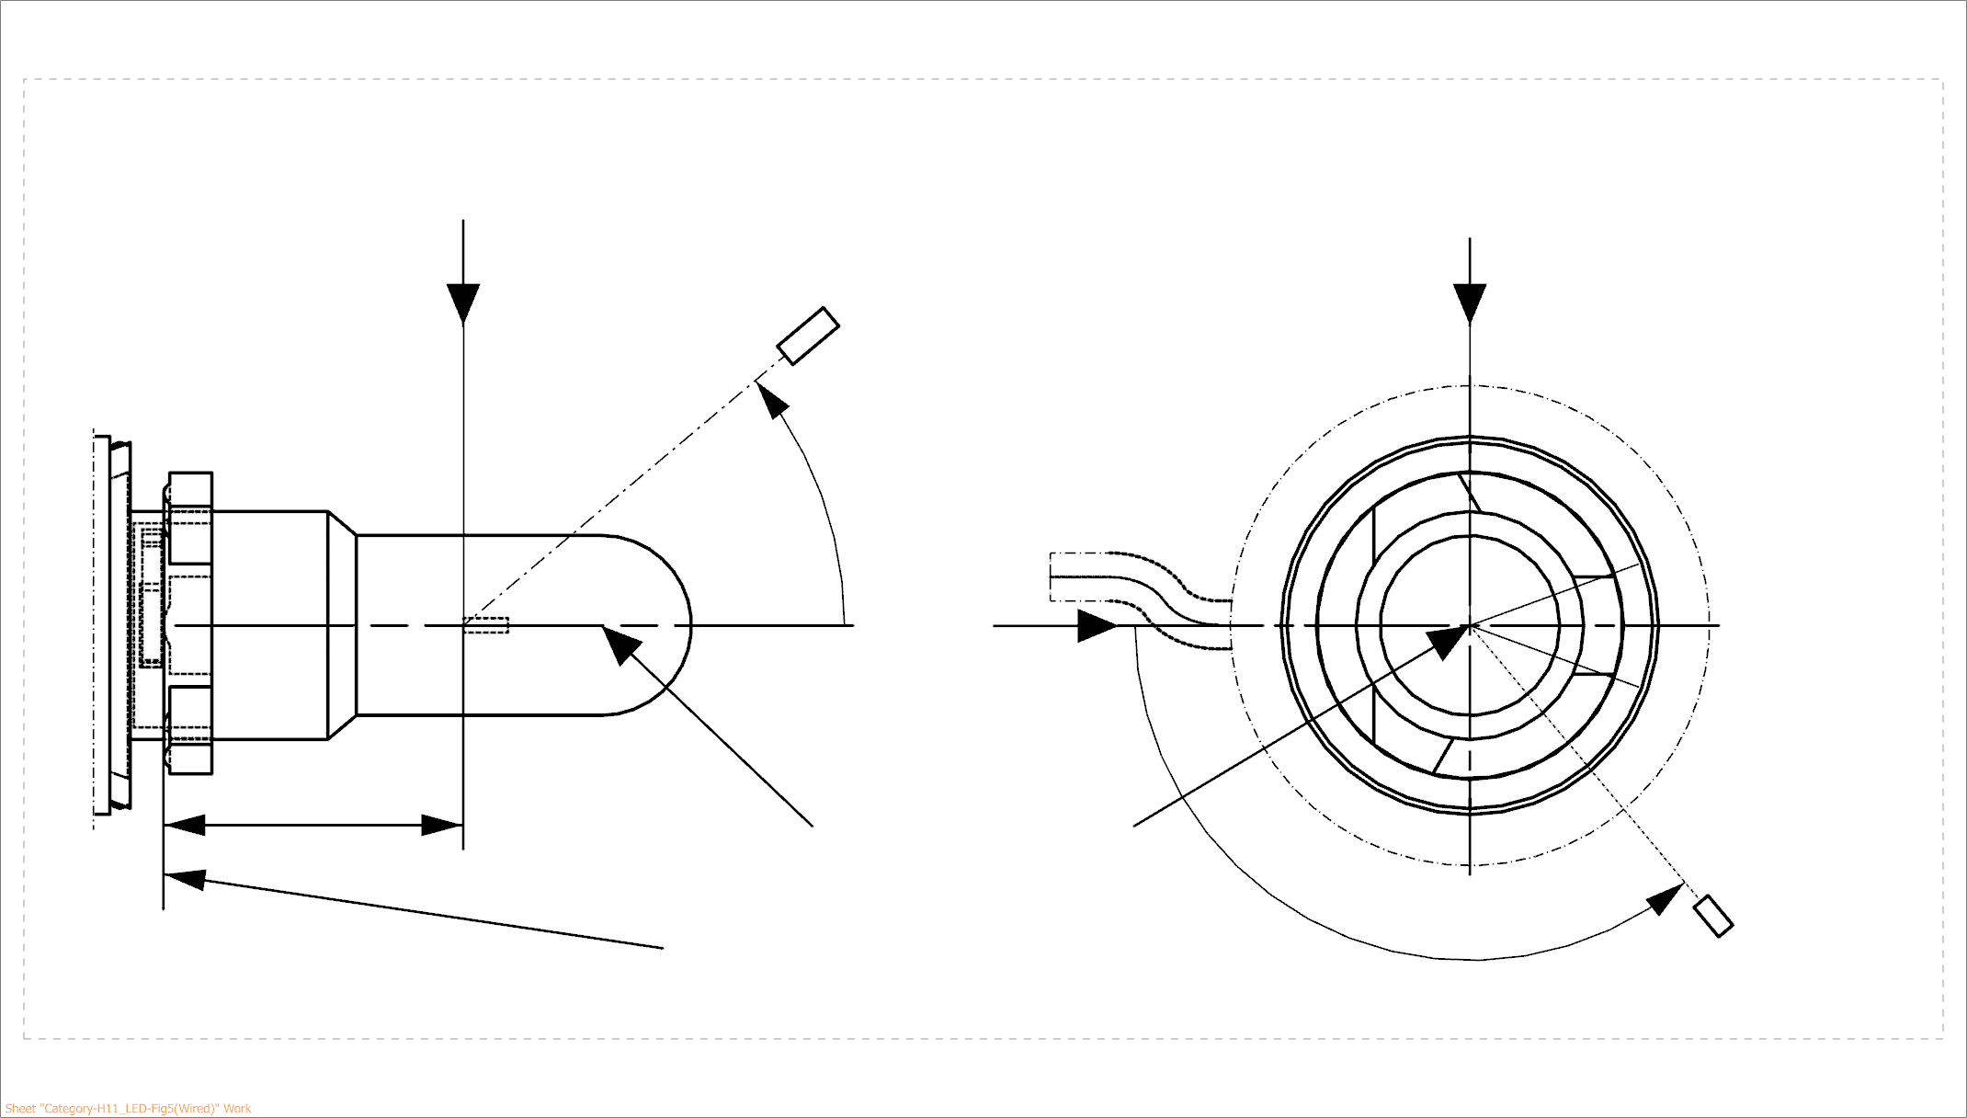

25,0

***View from B***

***View from C***

Reference plane

Reference axis

**B**

**A**

C = 270°

C = 90°

C = 180°

**C**

C = 0°

****

**A**

Photo-Detector of Goniometer

**Figure 6 - Setup to measure the luminous intensity distribution and the definition of C-Planes and angle **

C-planes: see CIE publication 70-1987, "The measurement of absolute intensity distributions".

**Category H11/LED Sheet H11/LED/6**

Table 3 – Part 1

**Test point values of normalized intensity (Black top area)**

|  |  |  |
| --- | --- | --- |
| LED light source of normal production and standard LED light source | | |
|  | Minimum intensity (cd/klm) | Maximum intensity (cd/klm) |
|  | C0, C90, C180, C270 | C0, C90, C180, C270 |
| 0° | n/a | 10 |
| 10° | n/a | 10 |
| 20° | n/a | 10 |
| 30° | n/a | 10 |

The light pattern as described in Table 3 – part 1 shall be substantially uniform, i.e. in between two adjacent grid points the relative luminous intensity requirement is calculated by linear interpolation using the two adjacent grid points. In case of doubt this may be checked in addition to verification of the grid points given in Table 3 – part 1.

*Note: The angular range in Table 3 – Part 1 is equivalent to the black top of its counterpart H11 filament light source specified by 3 in sheet H11/3.*

Table 3 – Part 2

**Test point values of normalized intensity (Distortion free area)**

|  |  |  |
| --- | --- | --- |
|  | LED light source of normal production and standard LED light source | |
|  | Minimum intensity (cd/klm) | Maximum intensity (cd/klm) |
|  | C0, C90, C270 | C0, C90, C270 |
| 50° | 80 | 130 |
| 60° | 80 | 130 |
| 70° | 80 | 130 |
| 80° | 80 | 130 |
| 90° | 80 | 130 |
| 100° | 80 | 130 |
| 110° | 80 | 130 |
| 120° | 80 | 130 |
| 130° | 80 | 130 |
| 140° | 80 | 130 |

The light pattern as described in Table 3 – part 2 (excluding the section between C90 and C270) shall be substantially uniform, i.e. in between two adjacent grid points the relative luminous intensity requirement is calculated by linear interpolation using the two adjacent grid points. In case of doubt this may be checked in addition to verification of the grid points given in Table 3 – part 2.

*Note:* *The angular range in Table 3 – Part 2 is equivalent to the distortion free area of its counterpart H11 filament light source specified by* 2 *and* 1 *in sheet H11/3.*

**Category H11/LED Sheet H11/LED/7**

Table 3 – Part 3

**Test point values of normalized intensity (Shading area of the lead-in wire of the counterpart filament light source)**

|  |  |  |
| --- | --- | --- |
|  | LED light source of normal production and standard LED light source | |
|  | Minimum intensity (cd/klm) | Maximum intensity (cd/klm) |
| C-plane |  = 90° |  = 90° |
| C0 | 80 | 130 |
| C30 | 80 | 130 |
| C60 | 80 | 130 |
| C90 | 80 | 130 |
| C120 | 80 | 130 |
| C150 | 80 | 130 |
| C180 | n/a | n/a |
| C210 | 80 | 130 |
| C240 | 80 | 130 |
| C270 | 80 | 130 |
| C330 | 80 | 130 |
| C330 | 80 | 130 |
| C360 (= C0) | 80 | 130 |

The light pattern as described in Table 3 – part 3 (excluding the section between C150 and C210) shall be substantially uniform, i.e. in between two adjacent grid points the relative luminous intensity requirement is calculated by linear interpolation using the two adjacent grid points. In case of doubt this may be checked in addition to verification of the grid points given in Table 3 – part 3.

*Note: Due to the shading area created by the lead-in wire of its counterpart H11 filament light source (opposite to the metal-free zone; see Figure 4 on sheet H11/2) there is no requirement in the C180-plane.*

II. Justification

1. This proposal specifies a LED substitute category H11/LED which is equipped with a different connector than the connector of its counterpart filament light source category, to prevent misuse.

2. This category was developed taking into account informal document GRE-82-03 on the equivalence criteria including those that are specific to road illumination applications: dedicated near-field photometry including homogeneity contrast, dedicated far-field photometry including distrortion free zones and block-top region. See also the equivalence reports.

1. \* In accordance with the programme of work of the Inland Transport Committee for 2018–2019 (ECE/TRANS/274, para. 123 and ECE/TRANS/2018/21 and Add.1, Cluster 3), the World Forum will develop, harmonize and update Regulations in order to enhance the performance of vehicles. The present document is submitted in conformity with that mandate. [↑](#footnote-ref-2)