Proposal to amend UN Regulations Nos. 48,
07 series and 08 series of Amendments

The proposed modifications to the existing text of the UN Regulations are marked in bold for new or strikethrough for deleted characters.
- Proposal to amend TPs to UN R48.07
At the end of paragraph 12., add a new paragraph 12.6. and its sub-paragraphs to read:

"12.6. Transitional provisions applicable to 07 series of amendments.
12.6.1. As from the official date of entry into force of the 07 series of amendments, no Contracting Party applying this UN Regulation shall refuse to grant or refuse to accept UN type approvals under this UN Regulation as amended by the 07 series of amendments.
12.6.2. As of 1 May 2022 Contracting Parties applying this UN Regulation shall not be obliged to accept UN type approvals to the preceding series of amendments, first issued after 1 May 2022.
12.6.3. Until 01. May 2024, Contracting Parties applying this Regulation shall accept type-approvals to the preceding series of amendments without emergency stop signal installed, first issued before 1. May 2022.
12.6.4. As from 1. May 2024, Contracting Parties applying this Regulation shall not be obliged to accept type-approvals issued to the preceding series of amendments to this Regulation without emergency stop signal installed.
12.6.5. Notwithstanding the transitional provisions above, Contracting Parties who start to apply this UN Regulation after the date of entry into force of the most recent series of amendments are not obliged to accept UN type-approvals which were granted in accordance with any of the preceding series of amendments to this UN Regulation.
12.6.6. Notwithstanding paragraph 12.6.4., Contracting Parties applying this UN Regulation shall continue to accept UN type-approvals to the preceding series of amendments to this UN Regulation, for the vehicle types which are not affected by the changes introduced by the 07 series of amendments.
12.6.7. Contracting Parties applying this UN Regulation shall not refuse to grant type-approvals according to any preceding series of amendments to this UN Regulation or extensions thereof."

- Proposal to amend TPs to UN R48.08
At the end of paragraph 12., add a new paragraph 12.7. and its sub-paragraphs to read:

"12.7. Transitional provisions applicable to 08 series of amendments.
12.7.1. As from the official date of entry into force of the 08 series of amendments, no Contracting Party applying this UN Regulation shall refuse to grant or refuse to accept UN type approvals under this UN Regulation as amended by the 08 series of amendments.
12.7.2. As of 1 May 2024 Contracting Parties applying this UN Regulation shall not be obliged to accept UN type approvals to the preceding series of amendments, first issued after 1 May 2024.
12.7.3. Until 1 September 2027, Contracting Parties applying this UN Regulation shall accept UN type-approvals to the preceding series of amendments, first issued before 1 May 2024
12.7.4. As from 1 September 2027, Contracting Parties applying this UN Regulation shall not be obliged to accept type-approvals issued to the preceding series of amendments to this UN Regulation.
12.7.5. Notwithstanding the transitional provisions above, Contracting Parties who start to apply this UN Regulation after the date of entry into force of the most recent series of amendments are not obliged to accept UN type-approvals which were granted in accordance with any of the preceding series of amendments to this UN Regulation.
12.7.6. Notwithstanding paragraph 12.7.4. Contracting Parties applying this UN Regulation shall continue to accept UN type-approvals to the preceding series of amendments to this UN Regulation, for the vehicle types which are not affected by the changes introduced by the 08 series of amendments.
12.7.7. Contracting Parties applying this UN Regulation shall not refuse to grant UN type-approvals according to any preceding series of amendments to this UN Regulation or extensions thereof."

- Justification:

- To propose “1. May” instead of “1. September” as enforcement date.

Document ECE/TRANS/WP.29/1044/Rev.2 “General Guidelines for United Nations regulatory procedures and transitional provisions in UN Regulations” states the following:

“Dates (b) and (c) shall be set at September 1st of a year whenever feasible.” in the general guideline. This means the dates do not have to be set at September 1st, if not feasible.
Date (b) and (c) are defined as follows:
- The date as from which Contracting Parties are no longer obliged to accept UN type approvals to the previous version which were first issued after this date;
- The date as from which Contracting Parties shall not be obliged to accept UN type approvals issued pursuant to the preceding version(s) of the amended UN Regulation, regardless of the date of issue;

As the 07 series transfers the requirements of the European General Safety Regulation (GSR) into ECE legislation the enforcement dates have to aligned. Therefore OICA proposes 01. May 2022 and 01. May 2024.

- Adding paragraphs 12.6.3 and 12.6.4 to the TPs of the 07 series
In document ECE/TRANS/WP.29/1044/Rev.2 the following diagram with a footnote is been incorporated:

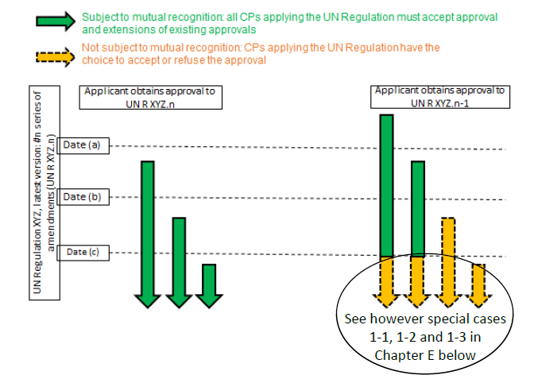

Note: Existing approvals remain valid, but Contracting Parties are not obliged to accept them as from date (c). If date (c) is not specified in the transitional provisions and if the text of special cases 1-1, 1-2, and/or 1-3 (see paragraphs 40-42 below) is not used, this date (c) is regarded as identical to date (b).
Date (c) defines the date from which onwards contracting parties are not obliged to accept old approvals. Without such a “(c) date” the “New Type date (b)” would be regarded as such. This would mean that all UN R48 approvals have to be updated to the 07 series after 01. May 2022. With the 04 series, 05 series and 06 series parallel in force leads to situations where vehicles cannot been updated because technical not feasible. Therefore paragraphs 12.6.3. and 12.64. been introduced.
C) Amending paragraphs 12.7.2 and 12.7.3 of the TPs to the 08 series
The “New Type date” of the 08 series should be aligned with the TPs of the 07 series. Therefore 1. September 2023 is been replaced by 01. May 2024 in paragraphs 12.7.2 and 12.7.3.

