submitted by the Russian Federation | Informal document GRPE-79-07  79th GRPE session, 21-24 May 2019  Agenda item 7

On Emission of Particulate Matters Less Than 10 Microns to Air Environment of Large Cities and Megalopolises During Operation of Vehicles

Creation and development of vehicles in order to support human life and activities is followed not only by improvement of living and transport conditions for the population but also by negative effects connected with rather significant contamination of the air environment in large cities to the levels dangerous for the health of the population.
According to the World Health Organization (WHO) specialists' estimations, at the end of the last century, air pollution in the human living environment caused three million early deaths of people all over the world annually. Over the last 40 years, lung cancer rate has significantly increased in the developed and developing countries all over the world. The maximum morbidity rates were recorded in Europe and USA and the minimum ones were recorded in Eastern countries.
The WHO concern is quite clear, however, the decision that only diesel engine vehicles cause smog formation is premature and unfounded. It appears that senior officials of WHO still have memories of smoking and fuming exhaust gases of vehicles in the 1970-1980. It should be emphasized that in the last 30 years the international legislation and vehicle manufacturers have performed a huge scope of works on the reduction of vehicles hazardous substances (HS) and particulate matters (PM) emissions. Figure 1 shows the results of works on change (reduction) of vehicle hazardous substances emissions: CO, CH, NO_{x} and PM with vehicle EG by the example of the vehicle fleet growth in the Russian Federation (RF).
As seen from the total hazardous substances emissions balance (Fig. 1), timely equipping vehicles with antitoxic systems and especially engine exhaust gases after treatment systems, as per EURO-0 to EURO-5, might be an effective measure and reduce emissions of hazardous substances by the Russian Federation vehicle fleet by five times (yellow curve) by 2019, but since the fleet renewal takes from 10 to 15 years (dash curves), in fact, emissions of hazardous substances reduced no more than twice.

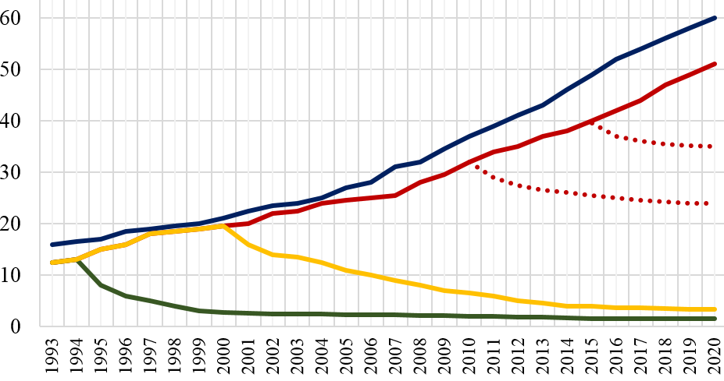
Fig. 1. Fleet growth and change of HS emissions by the RF vehicle fleet

- Russian Federation vehicle fleet growth, million pcs
- actual (until 2000) and forecasted emissions of hazardous substances by the Russian Federation vehicles complying only with Euro-0 standards, million t
- emissions by new vehicles, which might be in the Russian Federation since introduction of UN standards from Euro-0 to Euro-6 since starting from 1994, million t
- current emissions by new vehicles in the Russian Federation in case of introduction of Euro-0 to Euro-5 standards back in 2000.
- actual emissions of the hazardous substances by all vehicles taking into account the vehicle fleet renewal duration from 10 to 15 years, million t

Based on the researches made in the Russian Federation, in 2014, the Russian Federation presented a paper on the 162nd session of the World Forum (WP.29) on the development of the international UN Regulations (Requirements for Vehicle Design), in which attention of the world society has been drawn to comparison of emissions of particulate matters (PM) in exhaust gases and of those caused by vehicle tyres and brake mechanisms wear.
However, when reviewing paper WP.29-162-39 "On Real Emission of Particulate Matters by Automobile Transport" of the Russian Federation, the European Tyre & Rubber Manufacturers Association (ETRMA) presented its document, in which based on the researches made in 2010, dimensions of matters generated as a result of a wear on the asphalt pavement were within 4-350 microns range.
That is why ETRMA states that average size of TRWP is approximately 80-100 microns. Matters (particles) of this size are residual by their nature and that is why they will mainly be left on the road or alongside it.
In additional response to this document, research of PM emissions less than 10 microns carried out in the Russian Federation showed that there is always a background of PM less than 10 microns above the roadway. It should be noted that most PMs are matters with the size of 0.3 to 5 microns (Fig. 2).
Figure 2 shows results of definition of dispersion and amount of PM emissions less than 10 microns in case of the vehicle driving through the Moscow Central Circle asphalt road at the constant speed.

micron
50 km/h
40 km/h
30 km/h
Background
Amount of particles in 1 m³ sampling, million pcs

Fig. 2. Dispersion and amounts of PM emissions at the constant vehicle driving speed

Researches have shown that PM emissions at the constant vehicle driving speed significantly (2 to 10 times) exceed background values and increase along with the speed increase, while main PM emission (> 97%) is represented by 0.3 to 5.0 microns’ matters.
Thus, the most important current period problem is the reduction of PM emissions in exhaust gases, from tyre and asphalt roadway wear during the vehicle operation in the heavily-populated urban areas.
Special emphasis should be put on quite interesting and important data of the made researches of chemical results of the PM analysis for the content of polycyclic aromatic hydrocarbons (PAH), containing carcinogenic substances which cause cancer (Table 1) in the study referred to by ETRMA.
This list is not an exhaustive PAH list but it contains PAHs most widely spread in the environment as well as PAHs considered as carcinogenic and able to provoke cancerous diseases at people according to the International Agency for Research on Cancer (IARC).

Table 1
Analysis of polycyclic aromatic hydrocarbons (PAH) content in the matters.
(The values are expressed in parts per million (ppm) in the matters mix)

Chemical substances | Road particles (RP) | Tyre wear particles  (TWP) | Tyre particles (TP)
Acenaphthene | 4.08 | 0.04 | 0.13
Naphthalene | 6.1 | 0.2 | 1.18
Phenantrene | 53.4 | 1.66 | 1.21
Pyrene | 54.84 | 4.77 | 0.06
Acenaphthylene | 0.14 | 0.15 | 1.24
Anthracene | 7.36 | 0.1 | 0.11
Benzanthracene | 38.65 | 0.18 | 2.87
Benzo[a]pyrene | 12.51 | 0.28 | -
Benzo(b)fluoranthene | 7.4 | 0.37 | 0.92
Benzo(g,h,i)perylene | 4.04 | 3.22 | 1.77
Benzo(k)fluoranthene | 7.4 | 0.02 | 0.92
Chrysene | 17.72 | 0.36 | 2.95
Dibenz(a,h)anthracene | 2.56 | 0.1 | 0.87
Fluoranthene | 82.13 | 0.98 | 1.62
Fluorene | 1.76 | 0.07 | 0.25
Indeno-1,2,3(c,d)pyrene | 5.36 | 0.21 | -

Due to the different approaches to evaluation of amounts of PM emissions in exhaust gases, those from tyre wear and lack of attention to the roadway wear mentioned above, there has risen a global ecological conflict between the transport and environment, which by the current time period has become critical both by its level and violent growth. With intense search (or sometimes its imitation) for the transport ecological problem solution by means of electric vehicles (EV) and alternative fuels in the background, attention to the enormous growth of PM emissions from tyre and roadway wear has been weakened.
In November 2018, at the 48th meeting of the special international group on the Particles Measurement Program and during the 78th GRPE session, documents from the United Kingdom (Great Britain) and Japan were presented.
UK's report, reflecting the point of view of the Department for Transport, states a number of negative influences of the air contamination on the population health.
Based on the results of such medical researches, the UK Government called for forbiddance of sales of both gasoline and diesel vehicles starting from 2032, and the Parliament members want more support for the manufacturers of the electric vehicles.
Table 2 shows the percentage distribution of PM_{2.5} by emission sources in the UK, where only 12% PM emissions are registered from road transport.
Table 2
Percentage distribution of PM _{2.5} by emission sources in the UK

 | Sources | Emission share, %
1. | Coal and wood burning in households | 38 %
2. | Industrial burning | 16 %
3. | Road transport | 12 %
4. | Use of solvents and industrial processes | 13 %

Special emphasis is placed on 2.5 microns’ matters, which can infiltrate the lungs and blood in the form of smoke, soot or dust, and then move through the body and remain in the human organs thus reducing lifetime.
Figure 3 shows the results of researches of the actual amounts of 2.5 microns PM emissions from different road transport system in the UK.

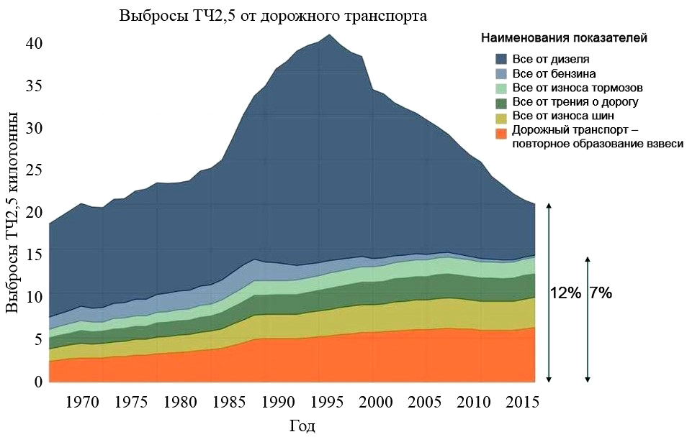
Parameter denominations
PM2.5 emission from the road transport
All from diesel
All from gasoline
All from brake wear
All from friction on the road
All from tyre wear
Road transport – repeated formation of suspended matter
PM2.5 emission, kt

Fig. 3. Change of actual 2.5 microns PM emissions from different vehicle sources in the UK

It is necessary to pay attention to quite representative materials of the UK Department for Transport concerning amounts of PM emissions from tyre, roadway and even brake systems wear, as in principle they are similar in size, which is being denied by the ETRMA position!
Materials submitted from Japan side by the Global Automotive Standards Internationalization Center (GASIC) at the 48th meeting on the PM measurement show tyre wear measurement values which are registered within the range of from 0.15-0.2 g/km up to 1.2-1.4 g/km, which is well corresponded to the Russian Federation data submitted earlier in 2013-2014 on the Global Forum (WP-29).
However, for some reason, Japanese researchers again propose a conclusion that share of 2.5 microns tyre wear matters in the air environment amounts to approximately 3% of the total PM emission and "that is why tyre wear dust almost completely remains on the road".
Figure 4 shows the results of summarized researches of PM emissions from different sources when operating the vehicle fleet in Moscow from 2002 to the present time along with the forecast of their emissions up to 2030.
Tons a year
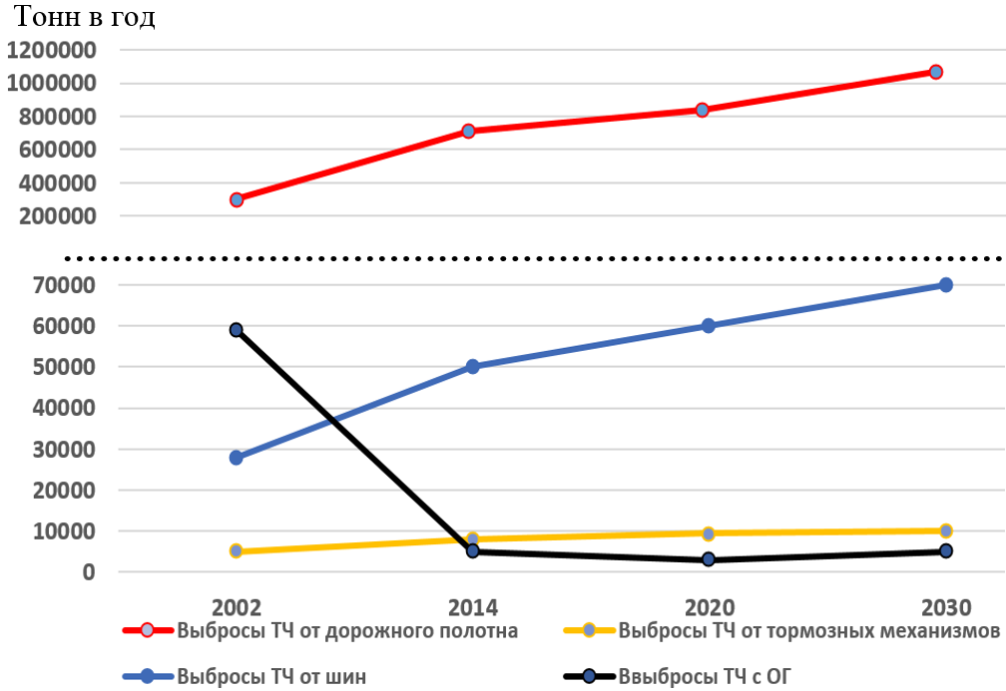
PM emission from the roadway
PM emission in the exhaust gas
PM emission from the brakes
PM emission from the tyres

Fig. 4. Dynamic and forecast for annual PM emissions in exhaust gases and caused by wear of tyres, brakes and roadway in Moscow

Comparing 22 million tons of only 2.5-micron PM emissions from 37 million vehicles in the UK in 2015 and approximately 0.8 million tons of 10-micron PM emissions from 5 million vehicles only in Moscow as well as 8 million tons of 10-micron PM emissions from the Russian Federation vehicle fleet amounted to 50 million vehicles, we face a question: how to evaluate these discrepancies? The result of this comparison tells us that there is an urgent need in a unified international procedure for evaluation of the PM emissions which currently should be actively discussed in both IWG on PM and GRPE within the World Forum (WP.29).
So, based on the abovementioned, we face a question: what shall we do? How can we reduce PM emission and content of carcinogenic substances both in exhaust gases and, first of all, according to Fig. 4, in tyre and roadway wear products?
Tyre manufacturers actively search for new materials in order to replace oil products with renewable raw materials.
Thus, within the last 30-40 years, tyre manufacturers have been performed active work on tyre life increase, some serious results have been achieved: average tyre run was increased almost twice from 30-40 thousand km to 60-90 thousand km that resulted, in our opinion, in sharp increase of PM emissions less than 10 microns.
For significant (basic) reduction of dangerous carcinogenic PM emissions from asphalt roadway wear, it shall be reasonable and necessary to use a simple concrete roadway with no heavy oil fuel in the cities. This activity will allow sharp reduction of basic PM emissions in the city atmosphere no less than by 80%.

