Proposal for the 03 series of amendments to UN Regulation
No. 67 (LPG vehicles)
The text was prepared by the expert from Turkey. It proposes amendment to UN Regulation No. 67 on LPG vehicles to insert new provisions on the location on the vehicle of the filling unit.

- Proposal
Insert a new paragraph 6.15.10.8., to read:
"6.15.10.8. For vehicles of category M1, the filling unit shall not be located below the body of the vehicle and shall respect the height provisions of paragraph 17.4.5.
The filling unit shall not be located under the chassis of the vehicle or within the rear surface of the external energy absorbing elements (e.g. bumper) of the vehicle. The centre of outlet of filling unit shall be above 350 mm from the ground surface when the vehicle is in its reference mass in running order. In the case the outlet of filling unit is located between 350 mm to 1,200 mm above the ground and directed downwards, in vertical plane the angle between horizontal road surface and outlet plane of the filling unit shall be equal to or greater than 60 degrees."

Insert new paragraphs 22.14. to 22.17., to read:
"22.14. As from the official date of entry into force of the 03 series of amendments, no Contracting Party applying this Regulation shall refuse to grant or refuse to accept type approvals under this Regulation as amended by the 03 series of amendments.
22.15. As from 1 September 2021, Contracting Parties applying this Regulation shall not be obliged to accept type approvals to the preceding series of amendments, first issued after 1 September 2021.
22.16. Until 1 September 2022, Contracting Parties applying this Regulation shall accept type approvals to the preceding series of amendments, first issued before 1 September 2021.
22.17. As from 1 September 2022, Contracting Parties applying this Regulation shall not be obliged to accept type approvals issued to the preceding series of amendments to this Regulation.
22.18. Notwithstanding paragraph 22.15., Contracting Parties applying the UN Regulation shall continue to accept UN type-approvals issued according to the preceding series of amendments to the UN Regulation, for the vehicles / vehicle systems / vehicle components which are not affected by the changes introduced by the 03 series of amendments."
Secretariat to insert amendments to marking provisions.

- Justification
- In the current text of UN Regulation No. 67, there are no provisions on the location of the filling unit of the LPG container outside the vehicle. The filling unit located under the vehicle causes problems including:
(a) Difficulties with filling the LPG container;
(b) Risks involved on occupational health and safety of LPG container filling operators;
(c) When filling the container, obliges operators to kneel down/lie down on the ground;
(d) When the vehicle is in laden position, the filler pistol maybe unable to fit the space between ground and filling unit and prevents the filling of the container.

Problems during filling with various application under the vehicle:
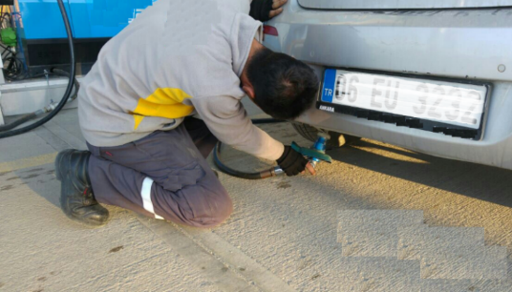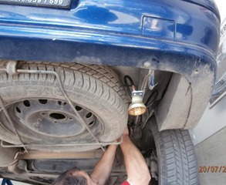

Alternative solutions:
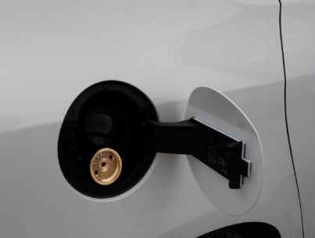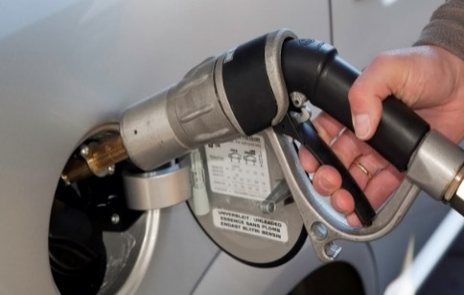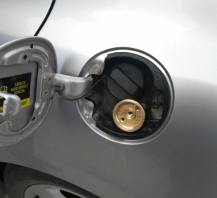

Number of road motor vehicles by kind of fuel used in Turkey
Year | Total | LPG
2013 | 17 939 447 | 3 934 753
2014 | 18 828 721 | 4 161 003
2015 | 19 994 472 | 4 358 751
2016 | 21 090 424 | 4 527 674
2017 | 22 218 945 | 4 705 599
Source: TurkStat, Road Motor Vehicle Statistics

- Paragraph 30 of ECE/TRANS/WP.29/GRSG/92 (Report of 113th GRSG), related to new provisions for the location on the vehicle of the filling unit: “The expert from Turkey introduced ECE/TRANS/WP.29/GRSG/2017/22 proposing to insert new provisions on the location on the vehicle of the filling unit and a limitation of the service life of LPG containers. The expert from OICA introduced a counter proposal for transitional provisions (GRSG-113-19)."

However, paragraph 9(a) of ECE/TRANS/WP.29/GRSG/2019/1/Add.1 (Agenda of 116th GRSG); “GRSG agreed to further consider a proposal by Turkey on new provisions for the location on the vehicle of the filling unit and a limitation of the service life of LPG containers (ECE/TRANS/WP.29/GRSG/2017/22).”

- Following the discussions, we prepared a revised document which related to new provisions for the location on the vehicle of the filling unit, taking into account the comments received.

Contact:
Fatih ÖZÇINAR (fatih.ozcinar@sanayi.gov.tr)
Ministry of Industry and Technology / TURKEY
_________________

