Seat back according to un regulation No. 80
Finnish Safety Investigation Authority has given a recommendation to introduce a change UN Regulation No 80 regarding the structure of the back part of seats for the purpose of making them safer, by adding padding and removing hard protrusions located right in the front of passengers.
Accident analysis shows that 10 passengers were injured in their face. According to analysis, these injuries happened when passengers hit their face to a rigid handle shown in a picture below.
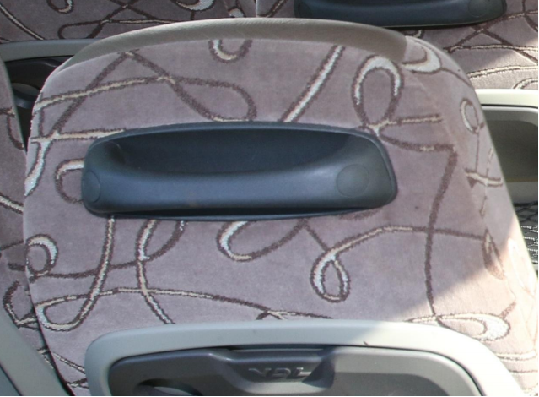
UN Regulation No 80 in force requires dynamic test according to Appendix 1 Test 2 or Appendix 6 pendulum test to show a conformity of back of a seat. In the Appendix 6, which is linked to UN Regulation No 21, point of impact of the pendulum is not clearly defined. That may cause a situation in which the safety of the handle similar to the one shown in picture is not assessed.
Should the point of impact be defined more clearly?
Should the allowed impulse caused by acceleration be reconsidered?
___________________

