Submitted by the expert from IMMA | Informal document GRBP-71-09  (71st GRBP, 28 - 31 January 2020,  agenda item 2)

Proposal for amendments to the 04 series of amendments
to UN Regulation No.41 (Noise of L3 category of vehicles)

The text reproduced below was prepared by the expert from the International Motorcycle Manufacturers Association (IMMA) to amend UN Regulation No. 41-04 (up to Supplement 7), in order to clarify the implications of footnote one on the requirements specified in Annex 4. The modifications to Regulation No. 41 are marked in bold for new or strikethrough for deleted characters.
I. Proposal
Annex 4, footnote 1., amend to read:
“Specifications for the test site
The specifications surface and dimensions for the test site reproduced in this Annex are valid until the end of the period indicated in paragraph 12.9.
II. Justification
The proposed new wording of the footnote 1 clarifies that, not all specifications, but only those for the surface and dimensions for the test site reproduced in Annex 4 will have a limited validity until the end of the period indicated in paragraph 12.9.

After that period – meaning as of 20th January 2021, which is 60 months after the entry into force of Supplement 3 to the 04 series of amendments (see paragraph 2.9. of regulation R41) – the specifications for the surface and dimensions for the test site reproduced in this Annex will no longer be valid but will be substituted by the reference to ISO18844:2014.

However, Annex 4 will not be entirely substituted by the reference to ISO10844:2014. Such proposal clarifies that only those paragraphs of the Annex 4 will be substituted, which are covered by the ISO10844:2014. All other paragraphs of Annex 4 will remain valid and applicable also after 20th January 2021.

Further clarification on the specifications keeping their validity also after 20th January 2021.
The following paragraphs of UNECE R41.04 cannot be substituted by means of a reference to ISO10844:2014, since this ISO standard does not include entirely or partially equivalent elements in its’ normative content:

2.1. Residual voids content
The residual voids content, V_{C}, of the test track paving mixture shall not exceed 8 percent. For the measurement procedure, see paragraph 4.1.
Remark: ISO10844:2014 does not include an equivalent element to Annex 4, 2.1. in its’ normative section, but only in its’ informative section. The substitution of elements of Annex 4 by means of informative elements of an ISO standards is inappropriate.

3.1. Area
When designing the test track layout it is important to ensure that, as a minimum requirement, the area traversed by the vehicles running through the test strip is covered with the specified test material with suitable margins for safe and practical driving. This will require that the width of the track is at least 3 m and the length of the track extends beyond lines AA and BB by at least 10 m at either end. Figure 1 shows a plan of a suitable test site and indicates the minimum area which shall be machine laid and machine compacted with the specified test surface material. According to paragraph 1.3.1. of Annex 3 measurements have to be made on each side of the vehicle. This can be made either by measuring with two microphone locations (one on each side of the track) and driving in one direction, or measuring with a microphone only on one side of the track but driving the vehicle in two directions. If the latter method is used, then there are no surface requirements on that side of the track where there is no microphone.
Remark: ISO10844:2014 does not include an equivalent content to the part of Annex 4, 3.1. as indicated in italic letters.

Figure 1
Minimum requirements for test surface area. The shaded part is called "Test Area"
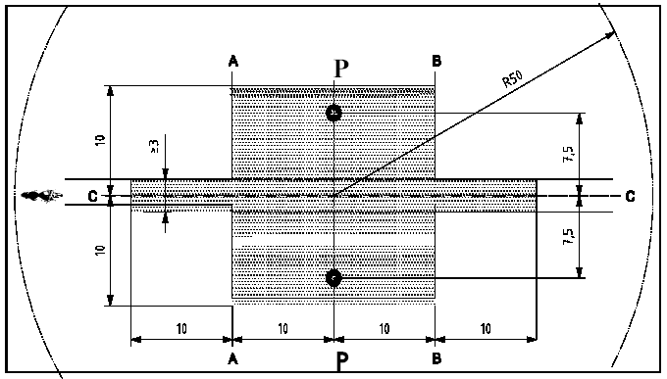
A'
B'
P'
C'

Remark: ISO10844:2014 does not include an equivalent to Annex 4, Figure 1 or a description of the test area which includes the microphone position(s) and the width of the driving lane.

3.2.2. Design guidelines
As a guide to the surface constructor, an aggregate grading curve which will give desired characteristics is shown in Figure 2. In addition, Table 1 gives some guidelines in order to obtain the desired texture and durability. The grading curve fits the following formula:
P (percent passing) = 100 * (d / d_{max})^{1/2}
Where:
d = square mesh sieve size, in mm
d_{max} = 8 mm for the mean curve
d_{max} = 10 mm for the lower tolerance curve
d_{max} = 6.3 mm for the upper tolerance curve

Figure 2
Grading curve of the aggregate in the asphaltic mix with tolerances
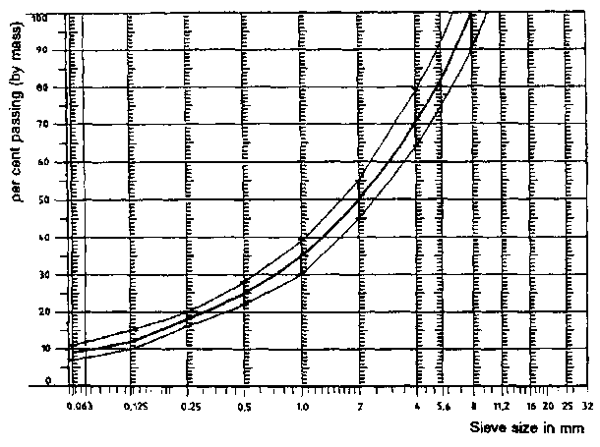
In addition to the above, the following recommendations are given:
(a) The sand fraction (0.063 mm < square mesh sieve size < 2 mm) shall include no more than 55 percent natural sand and at least 45 percent crushed sand;
(b) The base and sub-base shall ensure a good stability and evenness, according to best road construction practice;
(c) The chippings shall be crushed (100 percent crushed faces) and of a material with a high resistance to crushing;
(d) The chippings used in the mix shall be washed;
(e) No extra chippings shall be added onto the surface;
(f) The binder hardness expressed as PEN value shall be 40 – 60, 60 - 80 or even 80 - 100 depending on the climatic conditions of the country. The rule is that as hard a binder as possible shall be used, provided this is consistent with common practice;
(g) The temperature of the mix before rolling shall be chosen so as to achieve by subsequent rolling the required voids content. In order to increase the probability of satisfying the specifications of paragraphs 2.1. to 2.4. above, the compactness shall be studied not only by an appropriate choice of mixing temperature, but also by an appropriate number of passing and by the choice of compacting vehicle.

Table 1
Design guidelines
Quantity | Target values |  | Tolerances
 | by total mass of mix | by mass of the aggregate
Mass of stones, square mesh sieve (SM) > 2 mm | 47.6 % | 50.5 % | ±5
Mass of sand 0.063 < SM < 2 mm | 38.0 % | 40.2 % | ±5
Mass of filler SM < 0.063 mm | 8.8 % | 9.3 % | ±2
Mass of binder (bitumen) | 5.8 % | N.A. | ±0.5
Max. chipping size | 8 mm |  | 6.3 – 10
Binder hardness | (see para. 3.2.2. (f)) |  | –
Polished stone value (PSV) | >50 |  | –
Compactness, relative to Marshall compactness | 98 % |  | –
Remark: ISO10844:2014 does not include equivalent elements to Annex 4, 3.2.2. in its’ normative section, but only in its’ informative section. The substitution of elements of Annex 4 by means of informative elements of an ISO standards is inappropriate.

6.1.3. Method of compaction (e.g. type of roller, roller mass, number of passes).
6.1.4. Temperature of the mix, temperature of the ambient air and wind speed during laying of the surface.
Remark: ISO10844:2014 does not include equivalent elements to Annex 4, 6.1.3. and 6.1.4.

6.1.6.7. Date of the test(s) and date when the cores were taken from the test track.
6.2. Documentation of vehicle noise tests conducted on the surface
In the document describing the vehicle noise test(s) it shall be stated whether all the requirements of this standard were fulfilled or not. Reference shall be given to a document according to paragraph 6.1. describing the results which verify this.
Remark: ISO10844:2014 does not include equivalent elements to Annex 4, 6.1.6.7. and 6.2.

_________________________

