EEVC MDB Face Specification Validation Test Programme

Progress Report
May 2001

R Lowne for EEVC WG13

Introduction.

Problems have been experienced by some automobile manufacturers in testing to the ECE Regulation 95 (Side Impact) or the equivalent Directive, due to the differing behaviour of different side impact MDB faces. Different designs that claim to meet the dynamic performance required by the Directive and Regulation can result in different behaviour of cars when tested in the full scale test.

To resolve these difficulties, EEVC recommended moving to a single specified design of MDB face to improve consistency, repeatability and reproducibility. EEVC WG13 recommended a design based on the principles of the AFL progress barrier face and produced a draft Specification which was presented to GRSP in December 2000. EEVC believed that it would be advisable to validate the proposed design standard before it could be recommended for adoption in ECE Regulation 95.

A small validation programme was developed to assess whether MDB faces produced by several MDB face manufacturers to the same design specification would behave in the same way and show improved repeatability and reproducibility. A total of 28 MDB to wall tests and 4 full scale car impact tests have been performed. This test programme has now been completed although some of the results are still to be analysed. Nevertheless, some of the results are now available and a number of initial conclusions can be drawn.

Test Programme

The test programme was designed to assess the behaviour of the MDB faces both under the flat load cell wall Certification test procedure and under more realistic test conditions, including two of the special test conditions, developed by EEVC under the MDB evaluation test programme, and full scale car impacts.

- Flat rigid load cell wall test.

The test conditions followed those specified for the Dynamic Certification test (Figure 1). These tests provide some information on repeatability and reproducibility under limited test conditions. Table 1 shows the tests performed.
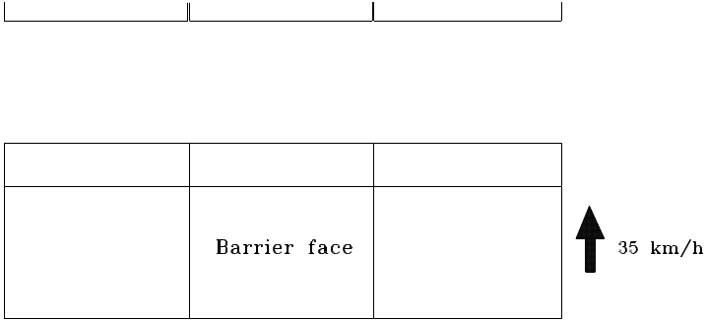

Figure 1 Flat Rigid Load Cell Wall Test Condition (Certification Test Procedure)

Table 1 Test Matrix for Flat Loadcell Wall tests

Test Institute | MDB
UTAC | AFL | CELLBOND | SHOWA | PLASCORE | AFL | AFL
TNO | AFL | CELLBOND | SHOWA | PLASCORE | CELLBOND | CELLBOND
TRL | AFL | CELLBOND | SHOWA | PLASCORE
BASt | AFL | CELLBOND | SHOWA | PLASCORE

- Rigid Sill Loading Test (RSLT)
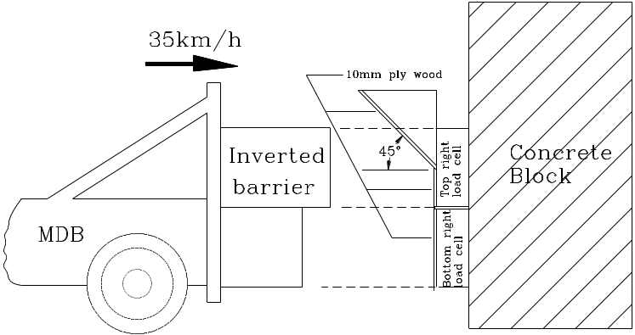
Figure 2. Rigid Sill Loading Test Conditions

The Rigid Sill Loading test, illustrated in Figure 2, simulates an impact into a rigid vehicle sill. It uses the load cell wall with the load cells modified by the addition of rigid wedge shaped blocks mounted on the top three load cells. The surface of the wall is wood faced to minimise slip. The barrier is inverted on the mobile trolley so that the bumper section of the barrier face impacts the simulated sill and is prevented from riding over the sill during the impact. The test was found to be most discriminating in determining the effects of non-axial loading to the honeycomb blocks. The performance of the MDB faces can be determined both by the forces measured on the load cells and by observing the behaviour of the individual blocks from high speed film records of the tests. This provides a good measure of reproducibility under more realistic impact conditions. (The MDB faces tested are given in Table 2)

- Offset Pole Impact test

This test condition was shown to be particularly effective at determining the effect of shear forces applied to the front surface of the MDB face and simulated the effect of tests against a very strong B-pillar. The performance of the MDB faces is determined both by the forces measured on the load cells and by observing the behaviour of the individual blocks from high speed film records of the tests. This provides a good measure of reproducibility under concentrated loading impact conditions, with particular reference to shear behaviour at the front plate interface. The MDB faces tested are given in Table 2.
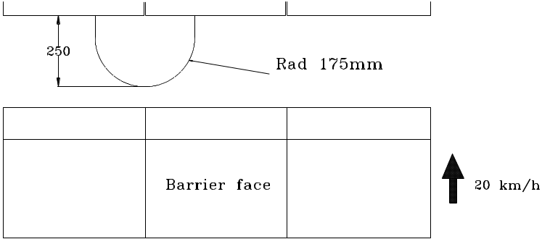
Figure 3 Offset Pole Impact Test Conditions

Table 2. Rigid Sill Loading Test and Pole Test Matrix

Test | Test Institute |  | MDB Face
*RSLT |  | TRL |  | AFL | CELLBOND | SHOWA | PLASCORE
*Offset Pole |  | BASt |  | AFL | CELLBOND | SHOWA | PLASCORE

- Full Scale Car Impact Test

The test conditions followed those of the R95 Full Scale Test, although supplementary data have been collected (e.g. door intrusion velocities, final static deformation profiles). The test programme is shown in Table 3.

Table 3 Full Scale Car Impact Test programme

Test Institute | Vehicle | MDB Face
UTAC | V1 |  |  |  | AFL
TNO | V2 |  |  | CELLBOND
Fiat | V3 | AFL | CELLBOND

Provisional Results

Flat Loadcell Wall Tests

The results of the loadcell wall tests in the previous MDB Face Evaluation programme, for all of the MDB faces available at that time, are shown in Figure 4. This shows the total force vrs barrier face deformation for all of the different designs of barrier face tested at all test institutes.

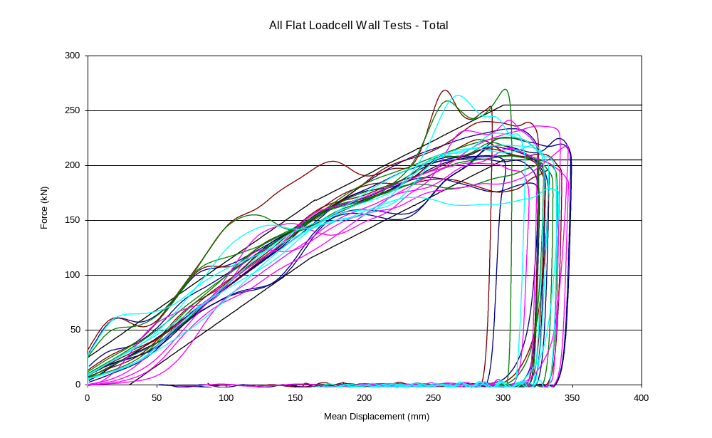
Figure 4. Total Force vrs barrier displacement – Evaluation Test Programme,
7 MDB faces, 4 test institutes (28 test results)
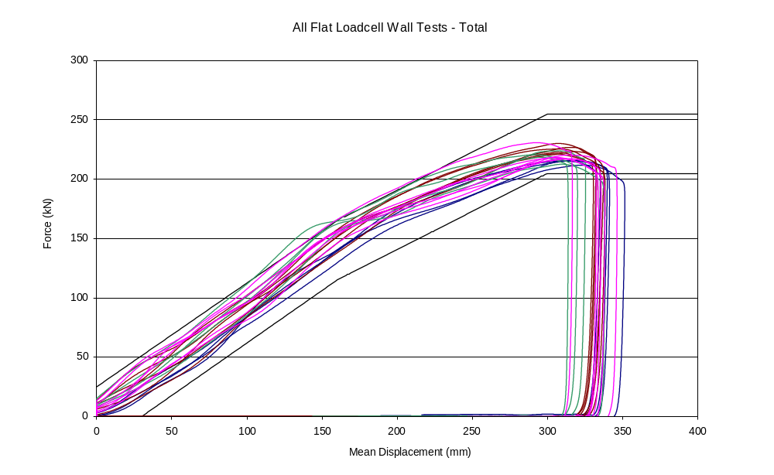
The equivalent results from the current validation test programme, with the MDB Faces to the new design specification are shown in figure 5
Figure 5. Total Force vrs barrier displacement – Validation Test Programme,
4 MDB faces, 4 test institutes (20 test results, including repeat tests)

As can clearly be seen, the variability of the new barrier faces is considerably better than it was with the old barrier faces. In addition, the shape of the force-deflection curves is a much better match to the shape of the corridor with the new barrier faces. This is encouraging, especially bearing in mind that not all of the faces built, in prototype form, completely followed the full design specification requirements.

This improvement can also be illustrated by comparing reproducibility of MDB faces from all manufacturers and reproducibility at different test institutes.

Figure 6 shows the total force results for all four MDB manufacturers at one test institute (BASt), showing very good reproducibility between manufacturers.
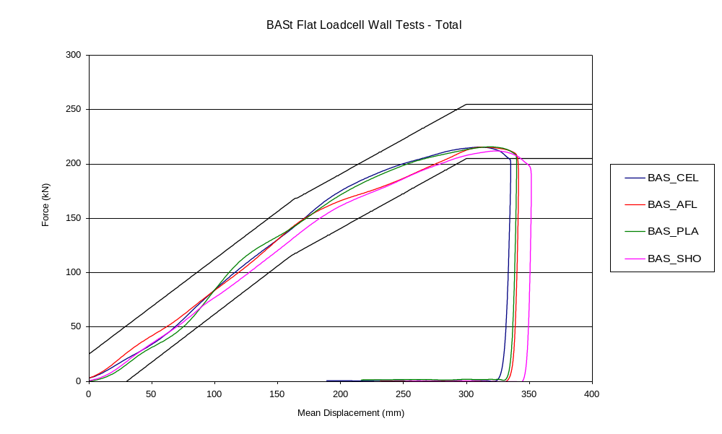
Figure 6. Total force vrs deformation for 4 different manufacturers
at one test institute (BASt)
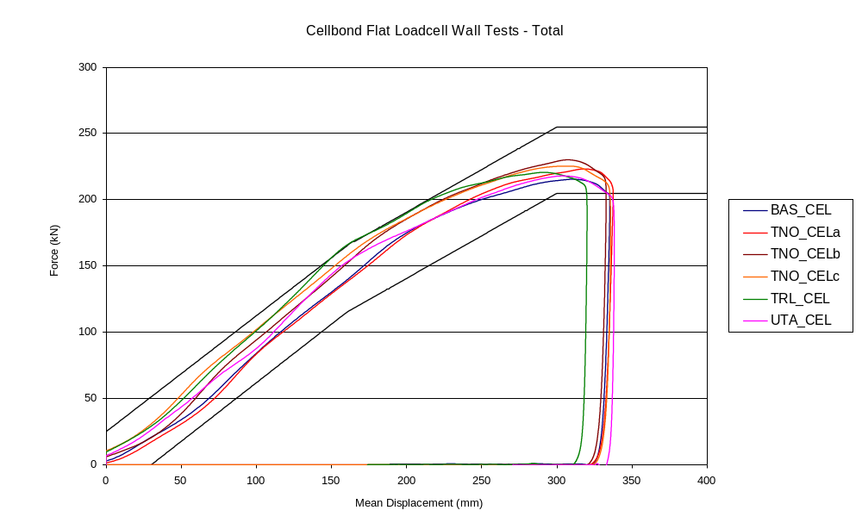
Figure 7 shows the results for one MDB face manufacturer at all of the test institutes, including three repeat tests at one institute. This shows that very similar results are obtained at all of these test institutes. This compares favourably with the results from the previous study where there was a marked test institute variation with some MDB face designs.
Figure 7. Total force vrs deformation for 1 manufacturer (Cellbond)
at all test institutes

Rigid Sill Loading Test

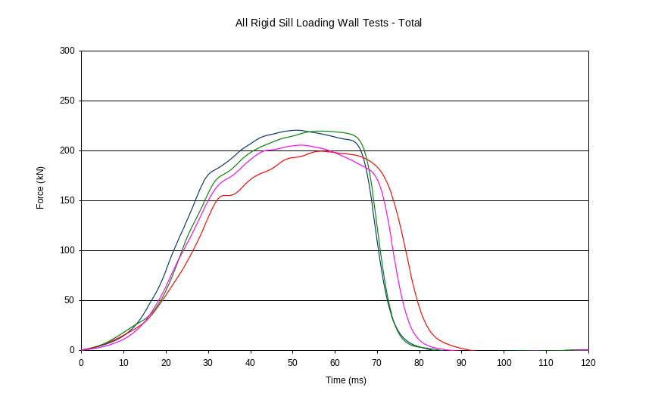
Figure 8 shows the total force – time history for the rigid sill loading test
Figure 8 Force-time history for the 4 MDB face manufacturers
in the Validation study Rigid Sill Loading Tests

The repeatability of the overall performance of the barrier faces is good. However, the variability of the individual blocks was much greater, with the AFL barrier faces showing a much lower force for blocks 1 to 3 and a much higher force for blocks 4 to 6 than the barrier faces from the other three manufacturers. This was because the top row of blocks (numbers 1 to 3 in the rigid sill loading test) partially de-bonded from the backing plate.

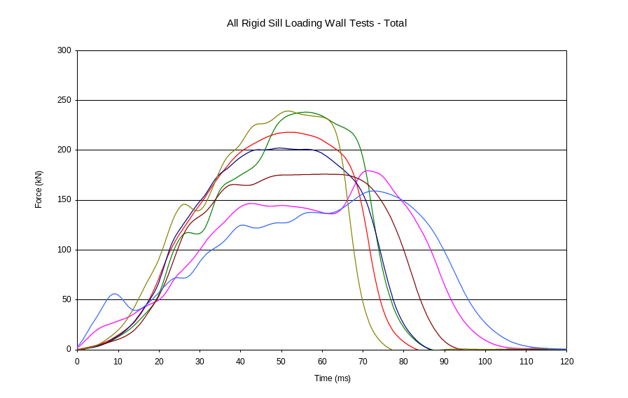
However, this is a significant improvement over the results with the original MDB faces in the previous test programme (Figure 9)
Figure 9 Force-time history for the 7 MDB face designs
in the MDB Evaluation study Rigid Sill Loading Tests

Offset Pole Test

Figure 10 shows the total force – deformation results for the offset pole test seen in the earlier programme with the original MDB faces. The variation between MDB face designs is clear. Figure 11 shows the results in this test with the new design of MDB face for 4 manufacturers. The improved reproducibility is obvious from these results.
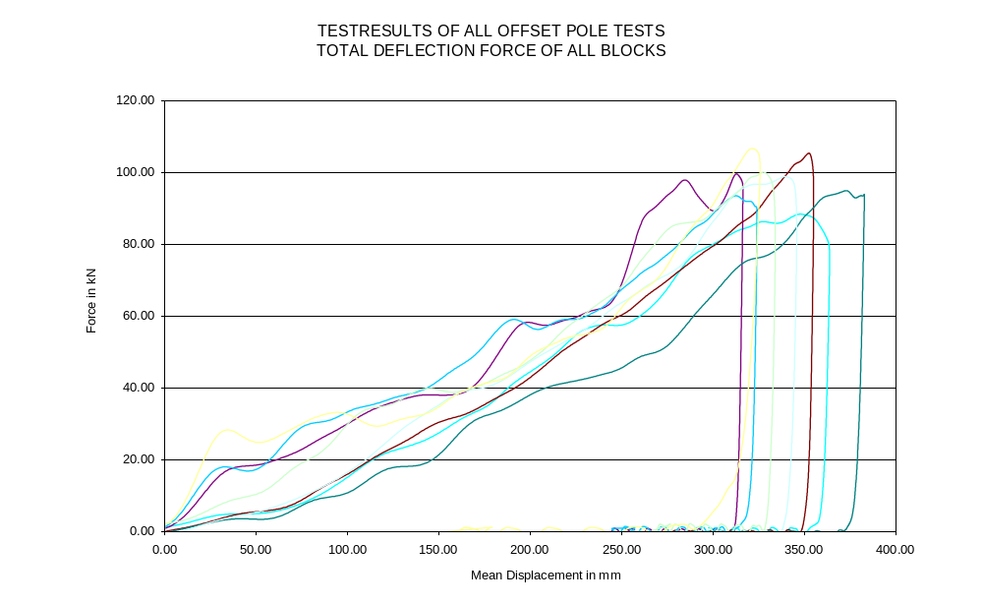
Figure 10. Offset Pole Test results in the Evaluation test programme
with the original MDB faces
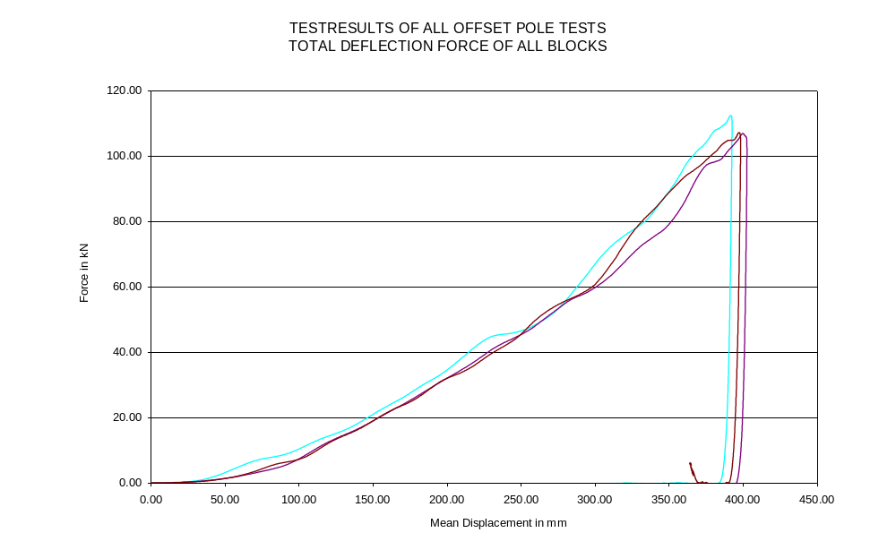
Figure 11. Offset Pole Test results in the Validation test programme
with MDB faces built to the revised DesignSpecification

Full Scale Car Tests

The results of the full scale car tests have not yet been fully analysed. However, apart from the detachment of the blocks from the rear plate with one barrier face, there have been no observed problems with these new barrier faces. The block detachment is believed to have been an adhesive strength problem and, as it occurred after the main impact loading, is not thought to have affected the test result.

Interim conclusions.

- The MDB Faces produced appear to show improved repeatability and reproducibility in comparison with the range of MDB faces produced under the previous performance specification, based on the total force results.
- The individual block forces showed more variation than the total sum force results, which was reflected in the quasi-static test results. This may be a result of differing manufacturing experience with the material types used for each block.
- The relationship between the static force-deformation and the dynamic force-deformation needs further analysis.
- The results with the new MDB faces in the Rigid Sill Loading Test and the Offset Pole impact test show a marked improvement in reproducibility over the previous designs.
- No problems were observed during the full scale tests but these have yet to be fully analysed.
- Further analysis of all test results is required before the details of the design specification can be confirmed
- It is not possible to make any recommendations at this stage – but the results so far are encouraging.
- A full report and recommendations will be presented at the next GRSP meeting.

