E/ECE/324/Rev.1/Add.47/Rev.12/Amend.8−E/ECE/TRANS/505/Rev.1/Add.47/Rev.12/Amend.8
8 November 2019
Agreement
Concerning the Adoption of Harmonized Technical United Nations Regulations for Wheeled Vehicles, Equipment and Parts which can be Fitted and/or be Used on Wheeled Vehicles and the Conditions for Reciprocal Recognition of Approvals Granted on the Basis of these United Nations Regulations*
(Revision 3, including the amendments which entered into force on 14 September 2017)
_________
Addendum 47 – UN Regulation No. 48
Revision 12 - Amendment 8
Supplement 12 to 06 series of amendments – Date of entry into force: 15 October 2019
Installation of lighting and light-signalling devices
This document is meant purely as documentation tool. The authentic and legal binding text is: ECE/TRANS/WP.29/2018/99/Rev.2.
_________
UNITED NATIONS
Supplement 12 to the 06 series of amendments to UN Regulation No. 48 (Installation of lighting and light-signalling devices)
Paragraph 2. and its subparagraphs, amend to read:
"2. Definitions
2.1. General
2.1.1. The definitions given in this Regulation and its series of amendments in force at the time of application for type approval shall apply to the Light-Signalling Devices (LSD), Road Illumination Devices (RID) and Retro-Reflective Devices (RRD) Regulations.
2.1.2. References to standard (étalon) light source(s) shall refer to Regulations Nos. 37, 99 and 128 respectively, and to their series of amendments in force at the time of application for type approval.
2.1.3. "Approval of a vehicle" means the approval of a vehicle type with regard to the number and mode of installation of the lighting and light-signalling devices.
2.1.4. "Device" means an element or an assembly of elements used to perform one or more functions.
2.1.4.1. "Lighting function" means the light emitted by a device to illuminate the road and objects in the direction of vehicle movement.
2.1.4.2. "Light-signalling function" means the light emitted or reflected by a device to give to other road users visual information on the presence, identification and/or the change of movement of the vehicle.
2.1.5. "Lamp" means a device designed to illuminate the road or to emit a light signal to other road users. Rear registration plate lamps and retro-reflectors are likewise to be regarded as lamps. For the purpose of this Regulation, light-emitting rear registration plates and the service-door-lighting system according to the provisions of UN Regulation No. 107 on vehicles of categories M₂ and M₃ are not considered as lamps.
2.1.6. "Change index" means a sequential number, starting from 0, specific to each lamp (function) covered by UN Regulations [LSD], [RID] and [RRD]. It indicates the number of times that the new series of amendments to the pertinent UN Regulation ([LSD], [RID] and [RRD]) have introduced higher stringency requirements for this lamp (function)."
2.2. Type definitions
2.2.1. "Vehicle type with regard to the installation of lighting and light-signalling devices" means vehicles which do not differ in the essential respects mentioned in paragraphs 2.2.1.1. to 2.2.1.4.
The following are likewise considered not to be "vehicles of a different type": vehicles which differ within the meaning of paragraphs 2.2.1.1. to 2.2.1.4., but not in such a way as to entail a change in the kind, number, positioning and geometric visibility of the lamps and the inclination of the dipped-beam prescribed for the vehicle type in question, and vehicles on which optional lamps are fitted or are absent:
2.2.1.1. The dimension and the external shape of the vehicle;
2.2.1.2. The number and positioning of the devices;
2.2.1.3. The headlamp-levelling system;
2.2.1.4. The suspension system.
2.3. Vehicle
2.3.1. "Unladen vehicle" means a vehicle without driver, crew, passengers and load, but with a full supply of fuel, spare wheel and the tools normally carried.
2.3.2. "Laden vehicle" means a vehicle loaded to its technically permissible maximum mass, as stated by the manufacturer, who shall also fix the distribution of this mass between the axles in accordance with the method described in Annex 5.
2.3.3. "Extreme outer edge" on either side of the vehicle, means the plane parallel to the median longitudinal plane of the vehicle and touching its lateral outer edge, disregarding the projection:
2.3.3.1. Of tyres near their point of contact with the ground, and of connections for tyre-pressure gauges;
2.3.3.2. Of any anti-skid devices mounted on the wheels;
2.3.3.3. Of devices for indirect vision;
2.3.3.4. Of side direction-indicator lamps, end-outline marker lamps, front and rear position lamps, parking lamps, retro-reflectors and side-marker lamps.
2.3.3.5. Of customs seals affixed to the vehicle, and of devices for securing and protecting such seals.
2.3.3.6. Of service-door lighting systems on vehicles of categories M₂ and M₃ as specified in paragraph 2.1.5.
2.3.4. "Overall dimensions" means the distance between the two vertical planes defined in paragraph 2.3.3. above.
2.3.4.1. "Overall width" means the distance between the two vertical planes defined in paragraph 2.3.3. above.
2.3.4.2. "Overall length" means the distance between the two vertical planes perpendicular to the median longitudinal plane of the vehicle and touching its front and rear outer edge, disregarding the projection:
(a) Of devices for indirect vision;
(b) Of end-outline marker lamps;
(c) Of coupling devices, in the case of motor vehicles.
For trailers in the "overall length" and in any measurement in length the drawbar shall be included, except when specifically excluded.
2.3.5. "Operating tell-tale" means a visual or auditory signal (or any equivalent signal) indicating that a device has been switched on and is operating correctly or not.
2.3.6. "Closed-circuit tell-tale" means a visual (or any equivalent signal) indicating that a device has been switched on, but not indicating whether it is operating correctly or not.
2.3.7. "Ground" means the surface on which the vehicle stands which should be substantially horizontal.
2.3.8. "Movable components" of the vehicle mean those body panels or other vehicle parts the position(s) of which can be changed by tilting, rotating or sliding without the use of tools. They do not include tiltable driver cabs of trucks.
2.3.9. "Normal position of use of a movable component" means the position(s) of a movable component specified by the vehicle manufacturer for the normal condition of use and the park condition of the vehicle.
2.3.10. "Normal condition of use of a vehicle" means:
2.3.10.1. For a motor vehicle, when the vehicle is ready to move with its propulsion engine running and its movable components in the normal position(s) as defined in paragraph 2.3.9.;
2.3.10.2. And for a trailer, when the trailer is connected to a drawing motor vehicle in the conditions as prescribed in paragraph 2.3.10.1. and its movable components are in the normal position(s) as defined in paragraph 2.3.9..
2.3.11. "Park condition of a vehicle" means:
2.3.11.1. For a motor vehicle, when the vehicle is at standstill and its propulsion engine is not running and its movable components are in the normal position(s) as defined in paragraph 2.3.9.;
2.3.11.2. And for a trailer, when the trailer is connected to a drawing motor vehicle in the condition as described in paragraph 2.3.11.1. and its movable components are in the normal position(s) as defined in paragraph 2.3.9.
2.4. Lamps generalities
2.4.1. "Equivalent lamps" means lamps having the same function and authorized in the country in which the vehicle is registered; such lamps may have different characteristics from those installed on the vehicle when it is approved on condition that they satisfy the requirements of this Regulation.
2.4.2. "Independent lamps" means devices having separate apparent surfaces in the direction of the reference axis, separate light sources and separate lamp bodies.
2.4.3. "Grouped lamps" means devices having separate apparent surfaces in the direction of the reference axis² and separate light sources, but a common lamp body.
2.4.4. "Combined lamps" means devices having separate apparent surfaces in the direction of the reference axis², but a common light source and a common lamp body.
2.4.5. "Reciprocally incorporated lamps" means devices having separate light sources or a single light source operating under different conditions (for example, optical, mechanical, electrical differences), totally or partially common apparent surfaces in the direction of the reference axis² and a common lamp body.
2.4.6. "Single-function lamp" means a part of a device which performs a single lighting or light-signalling function.
2.4.7. "Concealable lamp" means a lamp capable of being partly or completely hidden when not in use. This result may be achieved by means of a movable cover, by displacement of the lamp or by any other suitable means. The term "retractable" is used more particularly to describe a concealable lamp the displacement of which enables it to be inserted within the bodywork.
2.4.8. "Distance between two lamps" which face in the same direction means the shortest distance between the two apparent surfaces in the direction of the reference axis. Where the distance between the lamps clearly meets the requirements of the Regulation, the exact edges of apparent surfaces need not be determined.
2.4.9. "Optional lamp" means a lamp, the installation of which is left to the discretion of the manufacturer.
2.4.10. "Pair" means the set of lamps of the same function on the left- and right-hand side of the vehicle.
2.4.10.1. "Matched pair" means the set of lamps of the same function on the left- and right-hand side of the vehicle, which, as a pair, complies with the photometric requirements.
2.4.11. "Single and multiple lamps"
2.4.11.1. "A single lamp" means:
(a) A device or part of a device having one lighting or light-signalling function, one or more light source(s) and one apparent surface in the direction of the reference axis, which may be a continuous surface or composed of two or more distinct parts; or
(b) Any assembly of two lamps marked "D", whether identical or not, having the same function; or
(c) Any assembly of two independent retro-reflectors, whether identical or not, that have been approved separately; or
(d) Any interdependent lamp system composed of two or three interdependent lamps marked "Y" approved together and providing the same function.
2.4.11.2. "Two lamps" or "an even number of lamps" in the shape of a band or strip, means two lamps with a single light emitting surface, providing such a band or strip is placed symmetrically in relation to the median longitudinal plane of the vehicle.
2.4.12. "Interdependent lamp system" means an assembly of two or three interdependent lamps providing the same function.
2.4.12.1. "Interdependent lamp marked "Y"" means a device operating as part of an interdependent lamp system. Interdependent lamps operate together when activated, have separate apparent surfaces in the direction of the reference axis and separate lamp bodies, and may have separate light source(s).
2.4.13. "Lamps marked "D"" means independent lamps, approved as separate devices in such a way that they are allowed to be used either independently or in an assembly of two lamps to be considered as a "single lamp".
2.4.14. Headlamps of different "Classes" mean headlamps identified by particular photometric provisions.
2.4.15. Definitions with regard to Headlamps emitting a driving-beam and/or a symmetrical passing-beam for vehicles of categories L and T:
2.4.15.1. "Additional lighting unit" means the part of a headlamp system that provides the bend lighting. It is independent from the device that provides the principal passing beam, may consist of optical, mechanical and electrical components, and it may be grouped and/or reciprocally incorporated with other lighting or light-signalling devices.
2.4.16. Definitions with regard to retro-reflectors:
2.4.16.1. "Retro-reflection" means the reflection in which radiation is returned in directions close to the direction from which it came, this property being maintained even over wide variations of the direction of the incident radiation:
2.4.16.2. "Retro-reflective device" means an assembly ready for use and comprising one or more retro-reflective optical units; Retro-reflective devices are divided into classes according to their photometric characteristics: Class IA or IB, Class IIIA or IIIB, and Class IVA. Retro-reflective devices of Classes IB and IIIB are devices combined with other signal lamps which are not watertight and which are integrated into the body of a vehicle.
2.4.17. Definition with regard to Retro-reflective marking:
2.4.17.1. "Retro-reflective marking material" means a surface or a device from which, when directionally illuminated, a relatively large portion of the incident radiation is retro-reflected.
2.4.17.2. "Rear marking plate" means a plate faced with retro-reflective and fluorescent material or devices intended to increase the visibility and permit easy identification of heavy and long vehicles.
2.4.17.3. "Slow moving vehicle (SMV) rear marking plate" means a triangular plate with truncated corners with a characteristic pattern faced with retro-reflectors or retro-reflective materials and retro-reflective or fluorescent material.
2.4.17.4. "Sample unit" means a complete retro-reflective device ready to be mounted on a vehicle and representative of current production.
2.4.17.5. "Fluorescence" means when certain substances are brought near to a source of ultraviolet or blue radiations, they emit radiations which are nearly always of longer wave-length than those producing the effect. This phenomenon is called fluorescence. By day and in twilight, fluorescent colours are brighter than normal colours because they reflect part of the light falling upon them, and in addition they emit light. At night they are not brighter than ordinary colours.
2.5. Lamps
2.5.1. "Driving-beam (main-beam) headlamp" means the lamp used to illuminate the road over a long distance ahead of the vehicle.
2.5.2. "Passing-beam (dipped-beam) headlamp" means the lamp used to illuminate the road ahead of the vehicle without causing undue dazzle or discomfort to oncoming drivers and other road-users.
2.5.2.1. "Principal passing-beam (principal dipped-beam)" means the dipped-beam produced without the contribution of infrared (IR) emitter and/or additional light sources for bend lighting.
2.5.3. "Direction-indicator lamp" means the lamp used to indicate to other road-users that the driver intends to change direction to the right or to the left. A direction-indicator lamp or lamps may also be used according to the provisions of UN Regulation No. 97 or No. 116.
2.5.4. "Stop lamp" means a lamp used to indicate to other road users to the rear of the vehicle that the longitudinal movement of the vehicle is intentionally retarded.
2.5.5. "Rear-registration plate illuminating device" means the device used to illuminate the space reserved for the rear registration plate; such a device may consist of several optical components.
2.5.6. "Front position lamp" means the lamp used to indicate the presence and the width of the vehicle when viewed from the front.
2.5.7. "Rear position lamp" means the lamp used to indicate the presence and width of the vehicle when viewed from the rear.
2.5.8. "Retro-reflector" means a device used to indicate the presence of a vehicle by the reflection of light emanating from a light source not connected to the vehicle, the observer being situated near the source.
For the purposes of this Regulation the following are not considered as
retro-reflectors:
2.5.8.1. Retro-reflecting number plates;
2.5.8.2. The retro-reflecting signals mentioned in the ADR (European Agreement concerning the international carriage of dangerous goods by road);
2.5.8.3. Other retro-reflective plates and signals which shall be used to comply with national requirements for use as regards certain categories of vehicles or certain methods of operation;
2.5.8.4. Retro-reflecting materials approved as Class D or E or F according to UN Regulations Nos. 104 or [RRD] and used for other purposes in compliance with national requirements.".
2.5.9. "Conspicuity marking" means a device intended to increase the conspicuity of a vehicle, when viewed from the side or rear (or in the case of trailers, additionally from the front), by the reflection of light emanating from a light source not connected to the vehicle, the observer being situated near the source.
2.5.9.1. "Contour marking" means a conspicuity marking intended to indicate the horizontal and vertical dimensions (length, width and height) of a vehicle.
2.5.9.1.1. "Full contour marking" means a contour marking that indicates the outline of the vehicle by a continuous line.
2.5.9.1.2. "Partial contour marking" means a contour marking that indicates the horizontal dimension of the vehicle by a continuous line, and the vertical dimension by marking the upper corners.
2.5.9.2. "Line marking" means a conspicuity marking intended to indicate the horizontal dimensions (length and width) of a vehicle by a continuous line.
2.5.10. "Front fog lamp" means a lamp used to improve the illumination of the road ahead of the vehicle in case of fog or any similar condition of reduced visibility.
2.5.11. "Rear fog lamp" means a lamp used to make the vehicle more easily visible from the rear in dense fog.
2.5.12. "Reversing lamp" means the lamp used to illuminate the road to the rear of the vehicle and to warn other road-users that the vehicle is reversing or about to reverse.
2.5.13. "Parking lamp" means a lamp which is used to draw attention to the presence of a stationary vehicle in a built-up area. In such circumstances it replaces the front and rear position lamps.
2.5.14. "End-outline marker lamp" means the lamp fitted near to the extreme outer edge and as close as possible to the top of the vehicle and intended to indicate clearly the vehicle's overall width. This lamp is intended, for certain vehicles and trailers, to complement the vehicle's front and rear position lamps by drawing particular attention to its bulk.
2.5.15. "Side marker lamp" means a lamp used to indicate the presence of the vehicle when viewed from the side.
2.5.16. "Daytime running lamp" means a lamp facing in a forward direction used to make the vehicle more easily visible when driving during daytime.
2.5.17. "Cornering lamp" means a lamp used to provide supplementary illumination of that part of the road which is located near the forward corner of the vehicle at the side towards which the vehicle is going to turn.
2.5.18. "Exterior courtesy lamp" means a lamp used to provide supplementary illumination to assist the entry and exit of the vehicle driver and passenger or in loading operations;
2.5.19. "Manoeuvring lamp" means a lamp used to provide supplementary illumination to the side of the vehicle to assist during slow manoeuvres.
2.6. Signal
2.6.1. "Hazard warning signal" means the simultaneous operation of all of a vehicle's direction-indicator lamps to show that the vehicle temporarily constitutes a special danger to other road users.
2.6.2. "Emergency stop signal" means a signal to indicate to other road users to the rear of the vehicle that a high retardation force has been applied to the vehicle relative to the prevailing road conditions.
2.6.3. "Rear-end collision alert signal (RECAS)" means an automatic signal given by the leading vehicle to the following vehicle. It warns that the following vehicle needs to take emergency action to avoid a collision.
2.7. System
2.7.1. "Aiming" means the positioning of the beam or part thereof on an aiming screen according to the relevant criteria;
2.7.2. "Adjustment" means the use of the means provided by the system for vertical and/or horizontal aiming of the beam;
2.7.3. "Bend lighting" means a lighting function to provide enhanced illumination in bends.
2.7.4. "Adaptive front lighting system" (or "AFS") means a lighting device type-approved according to UN Regulations Nos. 123 or [RID], providing beams with differing characteristics for automatic adaptation to varying conditions of use of the dipped-beam (passing-beam) and, if it applies, the main-beam (driving-beam).
2.7.4.1. "Lighting unit" means a light-emitting component designed to provide or contribute to one or more front lighting function(s) provided by the AFS.
2.7.4.2. "Installation unit" means an indivisible housing (lamp body) which contains one or more lighting unit(s).
2.7.4.3. "Lighting mode" or "Mode" of a front-lighting function provided by an AFS means a beam within the provisions either for one of the passing beam classes or for the main beam, designed and specified by the manufacturer for adaptation to dedicated vehicle and ambient conditions;
2.7.4.4. "System control" means that part(s) of the AFS receiving the AFS control signals from the vehicle and controlling the operation of the lighting units automatically.
2.7.4.5. "AFS control signal" (V, E, W, T) means the input to the AFS in accordance with the paragraph 6.22.7.4. of this Regulation.
2.7.4.6. "Neutral state" means the state of the AFS when a defined mode of the class C passing-beam ("basic passing-beam") or of the main beam in the maximum condition of activation, if any, is produced, and no AFS control signal applies.
2.7.4.7. "Adaptive main-beam" means a main-beam of the AFS that adapts its beam pattern to the presence of oncoming and preceding vehicles in order to improve the long-range visibility for the driver without causing discomfort, distraction or glare to other road users.
2.7.5. Definitions with regard to AFS:
2.7.5.1. "Class" of a passing beam (C, V, E or W) means the designation of a passing beam, identified by particular provisions according to UN Regulation No. 48 (For explanation only. The provisions of the passing-beam classes are dedicated to conditions as follows: C for the basic passing-beam, V for use in lit areas such as towns, E for use on roads such as motorways, W for use in adverse conditions such as wet road);
2.7.5.2. "Bending mode" means the designation of a mode of a front-lighting function with its illumination being laterally moved or modified (to obtain an equivalent effect), designed for bends, curves or intersections of the road, and, identified by particular photometric provisions;
(a) "Category 1 bending mode" means a bending mode with horizontal movement of the kink of the cut-off;
(b) "Category 2 bending mode" means a bending mode without horizontal movement of the kink of the cut-off;
2.7.5.3. "Right side" respectively "left side" means the combined total of the lighting units intended to be installed to that side of the longitudinal median plane of the vehicle, relative to its forward motion;
2.7.5.4. "Signal" means any AFS control signal or any additional control input to the system or a control output from the system to the vehicle;
2.7.5.5. "Signal generator" means a device, reproducing one or more of the signals for system tests;
2.7.5.6. "Supply and operating device" means one or more components of a system providing power to one or more parts of the system, including such as power and/or voltage control(s) for one or more light sources as e.g. electronic light source control gears;
2.7.5.7. "System reference axis" for an AFS means the intersection line of the vehicle's longitudinal median plane with the horizontal plane through the centre of reference of one lighting unit specified in the drawings accompanying the application for approval of the device;
2.7.5.8. "Traffic-change function" means any front-lighting function or a mode thereof, or part(s) thereof only, or any combination of these, intended to avoid glare and provide sufficient illumination in case where a vehicle being equipped with a system designed for one traffic direction only is temporarily used in a country with the opposite direction of traffic.
2.7.5.9. "Substitute function" means any specified front-lighting and/or front light-signalling, be it a front-lighting and/or a front light-signalling function, or a mode thereof, or part(s) thereof only, or any combination of it, intended to replace a front-lighting function/ mode in case of failure.
2.7.5.10. "Functional unit" means a part of a lighting unit providing a specific light distribution which may be used for different modes or classes. If used for the bending mode its light distribution may vary as a function of the T-signal (turn-radius); however, the light distribution shall be identical for a given T-signal (turn-radius) in all modes or classes.
2.7.6. "Sequential activation" means an electrical connection where the individual light sources of a lamp are wired such that they are activated in a predetermined sequence.
2.7.7. "Retro-reflecting optical unit" means a combination of optical components producing retro-reflection.
2.8. Lens
2.8.1. "Lens" means the outermost component of the lamp (unit) which transmits light through the illuminating surface;
2.8.2. "Coating" means any product or products applied in one or more layers to the outer face of a lens;
2.8.3. "Textured outer lens" or "Textured outer lens area" means all or part of an outer lens, designed to modify or influence the propagation of light from the light source(s), such that the light rays are significantly diverted from their original direction.
2.9. Light sources
2.9.1. "Light source" means one or more elements for visible radiation, with a base for mechanical and electrical connection, possibly assembled with one or more components to control the elements for visible radiation.
2.9.1.1. "Replaceable light source" means a light source which is designed to be inserted in and removed from the holder of its device without tool.
2.9.1.2. "Non-replaceable light source" means a light source which can only be replaced by replacement of the device to which this light source is fixed.
(a) In case of a light source module: a light source which can only be replaced by replacement of the light source module to which this light source is fixed;
(b) In case of AFS: a light source which can only be replaced by replacement of the lighting unit to which this light source is fixed.
2.9.1.3. "Light source module" means an optical part of a device which is specific to that device. It contains one or more non-replaceable light sources and it may optionally contain one or more holders for approved replaceable light sources.
2.9.1.4. "Filament light source" (filament lamp) means a light source where the only element for visible radiation is one or more filaments producing thermal radiation.
2.9.1.5. "Gas-discharge light source" means a light source where the only element for visible radiation is a discharge arc producing electroluminescence.
2.9.1.6. "Light-emitting diode (LED) light source" means a light source where the only element for visible radiation is one or more solid state junctions producing electroluminescence possibly completed with one or more elements for fluorescence-based conversion.
2.9.1.7. "LED module" means a light source module containing as light sources only LEDs. However it may optionally contain one or more holders for approved replaceable light sources.
2.9.2. "Electronic light source control gear" means one or more components between supply and light source, whether or not integrated with the light source or the applied lamp, to control voltage and/ or electrical current of the light source.
2.9.2.1. "Ballast" means one or more components, either between supply and light source or integrated with the light source, to control the electrical current of a gas-discharge light source.
2.9.2.2. "Ignitor" means an electronic light source control gear to start the arc of a gas-discharge light source.
2.9.3. "Variable intensity control" means the device which automatically controls rear light signalling devices producing variable luminous intensities to assure the unvarying perception of their signals. The variable intensity control is part of the lamp, or part of the vehicle, or split between the said lamp and the vehicle.
2.10. Photometry
2.10.1. "Objective luminous flux" means:
(a) In the case of a light source:
The value of the objective luminous flux, not including any tolerances, as indicated in the relevant data sheet of the applicable light source Regulation according to which the light source is approved;
(b) In the case of an LED module:
The value of the objective luminous flux as indicated in the technical specification submitted with the LED module for approval of the lamp of which the LED module is a part;
2.10.2. "Light emitting surface" of a "lighting device", "light-signalling device" or a retro-reflector means the surface as declared in the request for approval by the manufacturer of the device on the drawing, see Annex 3 (see e.g. Parts 1, and 4).
This shall be declared according to one of the following conditions:
(a) In the case where the outer lens is textured, the declared light emitting surface shall be all or part of the exterior surface of the outer lens;
(b) In the case where the outer lens is non-textured the outer lens may be disregarded and the light emitting surface shall be as declared on the drawing, see Annex 3 (see e.g. Part 5).
2.10.3. "Illuminating surface" (see Annex 3).
2.10.3.1. "Illuminating surface of a lighting device" (paragraphs 2.5.1., 2.5.2., 2.5.10., 2.5.12. and 2.5.17.) means the orthogonal projection of the full aperture of the reflector, or in the case of headlamps with an ellipsoidal reflector of the "projection lens", on a transverse plane. If the lighting device has no reflector, the definition of paragraph 2.10.3.2. shall be applied. If the light emitting surface of the lamp extends over part only of the full aperture of the reflector, then the projection of that part only is taken into account.
In the case of a dipped-beam headlamp, the illuminating surface is limited by the apparent trace of the cut-off on to the lens. If the reflector and lens are adjustable relative to one another, the mean adjustment should be used.
In the case of AFS being installed: where a lighting function is produced by two or more simultaneously operated lighting units on a given side of the vehicle, the individual illuminating surfaces, taken together, constitute the illuminating surface to be considered (for example, in the figure of paragraph 6.22.4. below, the individual illuminating surfaces of the lighting units 8, 9 and 11, regarded together and taking into account their respective location, constitute the illuminating surface to be considered for the right hand side of the vehicle).
2.10.3.2. "Illuminating surface of a light-signalling device other than a retro-reflector" (paragraphs 2.5.3. to 2.5.7., 2.6.1., 2.5.11. and 2.5.13. to 2.5.16.) means the orthogonal projection of the lamp in a plane perpendicular to its axis of reference and in contact with the exterior light-emitting surface of the lamp, this projection being bounded by the edges of screens situated in this plane, each allowing only 98 per cent of the total luminous intensity of the light to persist in the direction of the axis of reference.
To determine the lower, upper and lateral limits of the illuminating surface only screens with horizontal or vertical edges shall be used to verify the distance to the extreme edges of the vehicle and the height above the ground.
For other applications of the illuminating surface, e.g. distance between two lamps or functions, the shape of the periphery of this illuminating surface shall be used. The screens shall remain parallel, but other orientations are allowed to be used.
In the case of a light-signalling device whose illuminating surface encloses either totally or partially the illuminating surface of another function or encloses a non-lighted surface, the illuminating surface may be considered to be the light emitting surface itself (see e.g. Annex 3, Parts 2, 3, 5 and 6).
2.10.3.3. "Illuminating surface of a retro-reflector" (paragraph 2.5.8.) means, as declared by the applicant during the component approval procedure for the retro-reflectors, the orthogonal projection of a retro-reflector in a plane perpendicular to its axis of reference and delimited by planes contiguous to the declared outermost parts of the retro-reflectors' optical system and parallel to that axis. For the purposes of determining the lower, upper and lateral edges of the device, only horizontal and vertical planes shall be considered.
2.10.4. The "apparent surface" for a defined direction of observation means, at the request of the manufacturer or his duly accredited representative, the orthogonal projection of:
Either the boundary of the illuminating surface projected on the exterior surface of the lens;
Or the light-emitting surface;
Only in the case of a light-signalling device producing variable luminous intensities, its apparent surface that may be variable as specified in paragraph 2.9.3. shall be considered under all conditions permitted by the variable intensity control, if applicable.
In a plane perpendicular to the direction of observation and tangential to the most exterior point of the lens. Different examples of the application of apparent surface can be found in Annex 3 to this Regulation.
2.10.5. "Axis of reference" (or "reference axis") means the characteristic axis of the lamp determined by the manufacturer (of the lamp) for use as the direction of reference (H = 0°, V = 0°) for angles of field for photometric measurements and for installing the lamp on the vehicle.
2.10.6. "Centre of reference" means:
(a) The intersection of the axis of reference with the exterior light-emitting surface or
(b) A point on or near a retro-reflective area
which is designated to be the centre of the device for the purpose of specifying its performance; it is specified by the manufacturer of the lamp.
2.10.7. "Angles of geometric visibility" means the angles which determine the field of the minimum solid angle in which the apparent surface of the lamp is visible. That field of the solid angle is determined by the segments of the sphere of which the centre coincides with the centre of reference of the lamp and the equator is parallel with the ground. These segments are determined in relation to the axis of reference. The horizontal angles ß correspond to the longitude and the vertical angles α to the latitude.
2.10.8. "Photometric stability has occurred" means the variation of the luminous intensity for the specified test point is less than 3 per cent within any 15 minute period.
2.10.9. "Gonio(photo)meter system (if not otherwise specified in a particular Regulation)" means a system used for the photometric measurements specified by the angular coordinates in degrees on a sphere with a vertical polar axis according to CIE publication No. 70, Vienna 1987, i.e. corresponding to a gonio(photo)meter system with a horizontal ("elevation") axis fixed to the ground and a second, moveable ("rotation") axis perpendicular to the fixed horizontal axis (see Annex 14 to this Regulation). Note: The above mentioned CIE publication specifies a procedure to correct the angular coordinates in the case where an alternative gonio(photo)meter system is used.
2.10.10. "H plane" means the horizontal plane containing the centre of reference of the lamp.
2.10.11. "Transverse plane" means a vertical plane perpendicular to the median longitudinal plane of the vehicle.
2.10.12. ''Angle of divergence" means the angle between the straight lines connecting the centre of reference to the centre of the receiver and to the centre of the source of illumination.
2.10.13. ''Illumination angle" means the angle between the axis of reference and the straight line connecting the centre of reference to the centre of the source of illumination.
2.10.14. "Angle of rotation" means the angle through which the retro-reflective device is rotated about its axis of reference starting from one given position.
2.10.15. "Angular diameter of the retro-reflective device" means the angle subtended by the greatest dimension of the visible area of the illuminating surface, either at the centre of the source of illumination or at the centre of the receiver.
2.10.16. "Illumination of the retro-reflective device" is the abbreviated expression used conventionally to designate the illumination measured in a plane perpendicular to the incident rays and passing through the centre of reference.
2.10.17. "Coefficient of luminous intensity (CIL)" means the quotient of the luminous intensity reflected in the direction considered, divided by the illumination of the retro-reflective device for given angles of illumination, divergence and rotation.
2.11. Colour
2.11.1. Colour of the light emitted from a device
2.11.1.1. "White" means the chromaticity coordinates (x,y) of the light emitted that lie inside the chromaticity areas defined by the boundaries:
W₁₂ | green boundary | y = 0.150 + 0.640 x
W₂₃ | yellowish green boundary | y = 0.440
W₃₄ | yellow boundary | x = 0.500
W₄₅ | reddish purple boundary | y = 0.382
W₅₆ | purple boundary | y = 0.050 + 0.750 x
W₆₁ | blue boundary | x = 0.310
With intersection points:
 | x | y
W₁ | 0.310 | 0.348
W₂ | 0.453 | 0.440
W₃ | 0.500 | 0.440
W₄ | 0.500 | 0.382
W₅ | 0.443 | 0.382
W₆ | 0.310 | 0.283
2.11.1.2. "Selective-yellow" means the chromaticity coordinates (x,y)⁴ of the light emitted that lie inside the chromaticity areas defined by the boundaries:
SY₁₂ | green boundary | y = 1.290 x - 0.100
SY₂₃ | the spectral locus
SY₃₄ | red boundary | y = 0.138 + 0.580 x
SY₄₅ | yellowish white boundary | y = 0.440
SY₅₁ | white boundary | y = 0.940 - x
With intersection points:
 | x | y
SY₁ | 0.454 | 0.486
SY₂ | 0.480 | 0.519
SY₃ | 0.545 | 0.454
SY₄ | 0.521 | 0.440
SY₅ | 0.500 | 0.440
2.11.1.3. "Amber" means the chromaticity coordinates (x,y)⁴ of the light emitted that lie inside the chromaticity areas defined by the boundaries:
A₁₂ | green boundary | y = x - 0.120
A₂₃ | the spectral locus
A₃₄ | red boundary | y = 0.390
A₄₁ | white boundary | y = 0.790 - 0.670 x
With intersection points:
 | x | y
A₁ | 0.545 | 0.425
A₂ | 0.560 | 0.440
A₃ | 0.609 | 0.390
A₄ | 0.597 | 0.390
2.11.1.4. "Red" means the chromaticity coordinates (x,y)⁴ of the light emitted that lie inside the chromaticity areas defined by the boundaries:
R₁₂ | yellow boundary | y = 0.335
R₂₃ | the spectral locus
R₃₄ | the purple line | (its linear extension across the purple range of colours between the red and the blue extremities of the spectral locus).
R₄₁ | purple boundary: | y = 0.980 – x
With intersection points:
 | x | y
R₁ | 0.645 | 0.335
R₂ | 0.665 | 0.335
R₃ | 0.735 | 0.265
R₄ | 0.721 | 0.259
2.11.2. Night-time colour of the light retro-reflected from a device excluding retro-reflective tires according to UN Regulation No. 88
2.11.2.1. "White" means the chromaticity coordinates (x,y)⁴ of the light reflected that lie inside the chromaticity areas defined by the boundaries:
W₁₂ | blue boundary: | y = 0.843 - 1.182 x
W₂₃ | violet boundary | y = 0.489 x + 0.146
W₃₄ | yellow boundary | y = 0.968 - 1.010 x
W₄₁ | green boundary | y = 1.442 x - 0.136
With intersection points:
 | x | y
W₁ | 0.373 | 0.402
W₂ | 0.417 | 0.350
W₃ | 0.548 | 0.414
W₄ | 0.450 | 0.513
2.11.2.2. "Yellow" means the chromaticity coordinates (x,y)⁴ of the light reflected that lie inside the chromaticity areas defined by the boundaries:
Y₁₂ | green boundary | y = x - 0.040
Y₂₃ | the spectral locus
Y₃₄ | red boundary | y = 0.200 x + 0.268
Y₄₁ | white boundary | y = 0.970 - x
With intersection points:
 | x | y
Y₁ | 0.505 | 0.465
Y₂ | 0.520 | 0.480
Y₃ | 0.610 | 0.390
Y₄ | 0.585 | 0.385
2.11.2.3. "Amber" means the chromaticity coordinates (x,y)⁴ of the light reflected that lie inside the chromaticity areas defined by the boundaries:
A₁₂ | green boundary | y = 1.417 x - 0.347
A₂₃ | the spectral locus
A₃₄ | red boundary | y = 0.390
A₄₁ | white boundary | y = 0.790 - 0.670 x
With intersection points:
 | x | y
A₁ | 0.545 | 0.425
A₂ | 0.557 | 0.442
A₃ | 0.609 | 0.390
A₄ | 0.597 | 0.390
2.11.2.4. "Red" means the chromaticity coordinates (x,y)⁴ of the light reflected that lie inside the chromaticity areas defined by the boundaries:
R₁₂ | yellow boundary | y = 0.335
R₂₃ | the spectral locus
R₃₄ | the purple line
R₄₁ | purple boundary | y = 0.978 - x
With intersection points:
 | x | y
R₁ | 0.643 | 0.335
R₂ | 0.665 | 0.335
R₃ | 0.735 | 0.265
R₄ | 0.720 | 0.258
2.11.3. Day-time Colour of the light reflected from a device
2.11.3.1. "White" means the chromaticity coordinates (x,y)⁴ of the light reflected that lie inside the chromaticity areas defined by the boundaries:
W₁₂ | violet boundary | y = x - 0.030
W₂₃ | yellow boundary | y = 0.740 – x
W₃₄ | green boundary | y = x + 0,050
W₄₁ | blue boundary | y = 0.570 – x
With intersection points:
 | x | y
W₁ | 0.300 | 0.270
W₂ | 0.385 | 0.355
W₃ | 0.345 | 0.395
W₄ | 0.260 | 0.310"
2.11.3.2. "Yellow" means the chromaticity coordinates (x,y)⁴ of the light reflected that lie inside the chromaticity areas defined by the boundaries:
Y₁₂ | red boundary | y = 0.534 x + 0.163
Y₂₃ | white boundary | y = 0.910 - x
Y₃₄ | green boundary | y =1.342 x - 0.090
Y₄₁ | the spectral locus
With intersection points:
 | x | y
Y₁ | 0.545 | 0.454
Y₂ | 0.487 | 0.423
Y₃ | 0.427 | 0.483
Y₄ | 0.465 | 0.534
2.11.3.3. "Red" means the chromaticity coordinates (x,y)⁴ of the light reflected that lie inside the chromaticity areas defined by the boundaries:
R₁₂ | red boundary | y = 0.346 – 0.053 x
R₂₃ | purple boundary | y = 0.910 – x
R₃₄ | yellow boundary | y = 0.350
R₄₁ | the spectral locus
With intersection points:
 | x | y
R₁ | 0.690 | 0.310
R₂ | 0.595 | 0.315
R₃ | 0.560 | 0.350
R₄ | 0.650 | 0.350"
2.11.4. Day-time colour of the fluorescent a device
2.11.4.1. "Red" means the chromaticity coordinates (x,y)⁴ of the light reflected that lie inside the chromaticity areas defined by the boundaries:
FR₁₂ | red boundary | y = 0.346 – 0.053 x
FR₂₃ | purple boundary | y = 0.910 – x
FR₃₄ | yellow boundary | y = 0.315 + 0.047 x
FR₄₁ | the spectral locus
With intersection points:
 | x | y
FR₁ | 0,690 | 0,310
FR₂ | 0,595 | 0,315
FR₃ | 0,569 | 0,341
FR₄ | 0,655 | 0,345
"
Paragraph 3.2.1., amend to read:
"3.2.1. A description of the vehicle type with regard to the items mentioned in paragraphs 2.2.1.1. to 2.2.1.4. above, together with the restrictions on loading, particularly the maximum permissible load in the boot;"
Paragraph 3.2.4., amend to read:
"3.2.4. If necessary, in order to verify the conformity to the prescriptions of the present Regulation, layout drawing(s) for each individual lamp showing the illuminating surface as defined in paragraph 2.10.3., the light-emitting surface as defined in paragraph 2.10.2., the axis of reference as defined in paragraph 2.10.5. and the centre of reference as defined in paragraph 2.12. 2.10.6. This information is not necessary in the case of the rear registration plate lamp (paragraph 2.5.5.);"
Paragraph 3.2.5., amend to read:
"3.2.5. The application shall include a statement of the method used for the definition of the apparent surface (see paragraph 2.10.4.)."
Paragraph 3.2.6.2., amend to read:
"3.2.6.2. The related AFS control signals and their technical characteristics as defined according to Annex 10 to UN Regulation No. 123 or Annex 14 to UN Regulation No. [RID]."
Paragraph 3.2.7., amend to read:
"3.2.7. For vehicles of M and N categories a description of the electric power supply conditions for the devices indicated in paragraphs 2.5.1., 2.5.2., 2.5.4., 2.5.6. and 2.5.7. above, including, if applicable, information on a special power supply/electronic light source control gear, or variable intensity control."
Paragraph 5.1., amend to read:
"5.1. The lighting and light-signalling devices shall be so fitted that under normal conditions of use as defined in paragraphs 2.3.10., 2.3.10.1. and 2.3.10.2. and notwithstanding any vibrations to which they may be subjected, they retain the characteristics prescribed by this Regulation and enable the vehicle to comply with the requirements of this Regulation. In particular, it shall not be possible for the lamps to be inadvertently maladjusted."
Paragraph 5.2., amend to read:
"5.2. The illuminating lamps described in paragraphs 2.5.1., 2.5.2. and 2.5.10. shall be so installed that correct adjustment of their orientation can easily be carried out."
Paragraph 5.4., amend to read:
"5.4. In the absence of specific instructions, the height and orientation of the lamps shall be verified with the vehicle unladen and placed on a flat, horizontal surface, in the condition defined in paragraphs 2.3.10., 2.3.10.1. and 2.3.10.2. and, in the case where an AFS is installed, with the system in its neutral state."
Paragraph 5.5.1., amend to read:
"5.5.1. Be fitted to the vehicle symmetrically in relation to the median longitudinal plane (this estimate to be based on the exterior geometrical form of the lamp and not on the edge of its illuminating surface referred to in paragraph 2.10.3.);"
Paragraph 5.7.2.1., amend to read:
"5.7.2.1. Single lamps as defined in paragraph 2.4.11.1., subparagraph (a), composed of two or more distinct parts, shall be installed in such a way that:
…"
Paragraph 5.7.2.2., amend to read:
"5.7.2.2. Single lamps as defined in paragraph 2.4.11.1., subparagraph (b) or (c), composed of two lamps marked "D" or two independent retro reflectors, shall be installed in such a way that:
…"
Paragraph 5.7.2.3., amend to read:
"5.7.2.3. Single lamps as defined in paragraph 2.4.11.1., subparagraph (d) shall fulfil the requirements of paragraph 5.7.2.1.
Where two or more lamps and/or two or more separate apparent surfaces are included into the same lamp body and/or have a common outer lens these shall not be considered as an interdependent lamp system.
However, a lamp in the shape of a band or strip may be part of an interdependent lamp system."
Paragraph 5.9.3., amend to read:
"5.9.3. The photometric characteristics of a direction indicator lamp of categories 1, 1a, 1b, 2a or 2b may be varied during a flash by sequential activation of light sources as specified in paragraph 5.6. of UN Regulation No. 6. or paragraph 5.6.11. of UN Regulation No. [LSD].
This provision shall not apply when direction indicator lamps of categories 2a and 2b are operated as emergency stop signal according to paragraph 6.23.1. of this Regulation."
Paragraph 5.10., amend to read:
"5.10. No red light which could give rise to confusion shall be emitted from a lamp as defined in paragraph 2.1.5. in a forward direction and no white light which could give rise to confusion, shall be emitted from a lamp as defined in paragraph 2.1.5. in a rearward direction. No account shall be taken of lighting devices fitted for the interior lighting of the vehicle. In case of doubt, this requirement shall be verified as follows:"
Paragraph 5.18.2., amend to read:
"5.18.2. In the case where the functions referred to in paragraph 5.18. are obtained by an assembly of two lamps marked "D" (see paragraph 2.4.11.1.), only one of the lamps needs to meet the position, geometric visibility and photometric requirements for those lamps at all fixed positions of the movable components."
Paragraph 5.23., amend to read:
"5.23. Lamps approved with light source(s) according to UN Regulation No. 37, except when such light sources are used as non-replaceable light source(s) as defined in paragraph 2.9.1.2., shall be fitted in a vehicle in such a way that the light source can be correctly replaced without the need for expert assistance and without the need for special tools, other than those provided with the vehicle by the manufacturer. The vehicle manufacturer shall provide with the vehicle a detailed description of the procedure for replacement."
Paragraph 5.24., amend to read:
"5.24. Any temporary fail-safe replacement of the light-signalling function of a rear position lamp is allowed, provided that the replacement function in case of a failure is similar in colour, main intensity and position to the function that has ceased to operate and provided that the replacement device remains operational in its original safety function. During replacement, a tell-tale on the dashboard (paragraph 2.3.5. of this Regulation) shall indicate occurrence of a temporary replacement and need for repair."
Paragraph 5.27., amend to read:
"5.27. For vehicles of M and N categories the applicant shall demonstrate to the Technical Service responsible for type approval testing that the electric power supply conditions for the devices indicated in 2.5.1., 2.5.2., 2.5.4., 2.5.6. and 2.5.7. above comply, when the electrical system of the vehicle is in a constant voltage operating condition, representative for the relevant category of powered vehicle as specified by the applicant, with the following provisions:
…"
Insert a new paragraph 5.32., to read:
"5.32. A device type approved according to any preceding series of amendments to UN Regulations Nos. [LSD] and/or [RID] and/or [RRD] is deemed equivalent to one approved according to the latest series of amendments to the pertinent UN Regulations Nos. [LSD] and/or [RID] and/or [RRD], when the change indexes (defined in paragraph 2.1.6.) related to each individual lamp (function) do not differ. In this case such a device may be fitted on the vehicle to be type approved without any update of the device type approval documents and device markings."
Paragraph 6.1., amend to read:
"6.1. Main-beam headlamp (UN Regulations Nos. 98, 112 and [RID])"
Paragraph 6.1.2., amend to read:
"6.1.2. Number
Two or four, type approved according to
(a) UN Regulation No. 98 or 112, excluding Class A headlamp
or
(b) UN Regulation [RID], Classes B and D headlamps only
For vehicles of the category N₃: Two extra main-beam headlamps may be installed.
Where a vehicle is fitted with four concealable headlamps the installation of two additional headlamps shall only be authorized for the purpose of light-signalling, consisting of intermittent illumination, at short intervals (see paragraph 5.12. above) in daylight."
Paragraph 6.2., amend to read:
"6.2. Dipped-beam headlamp (UN Regulations Nos. 98, 112 and [RID])"
Paragraph 6.2.2., amend to read:
"6.2.2. Number
Two, type approved according to
(a) UN Regulation No. 98 or 112, excluding Class A headlamp,
or
(b) UN Regulation [RID], Classes B and D headlamps only."
Paragraph 6.2.5., amend to read:
"6.2.5. Geometric visibility
Defined by angles α and ß as specified in paragraph 2.10.7.:
α = 15° upwards and 10° downwards,
ß = 45° outwards and 10° inwards.
The presence of partitions or other items of equipment near the headlamp shall not give rise to secondary effects causing discomfort to other road users."
Paragraph 6.2.7.3., amend to read:
"6.2.7.3. In the case of dipped-beam headlamps according to UN Regulation No. 98 or [RID], the gas-discharge light sources shall remain switched on during the main-beam operation."
Paragraph 6.2.9., amend to read:
"6.2.9. …
Only dipped-beam headlamps according to UN Regulation No. 98 or 112 or [RID] may be used to produce bend lighting.
…"
Paragraph 6.3., amend to read:
"6.3. Front fog lamp (UN Regulation No. 19 or [RID])"
Paragraph 6.3.2., amend to read:
"6.3.2. Number
Two, complying with either the requirements of the 03 and subsequent series of amendments to UN Regulation No. 19 or the requirements of UN Regulation No. [RID]."
Paragraph 6.3.5., amend to read:
"6.3.5. Geometric visibility
Defined by angles α and ß as specified in paragraph 2.10.7.:
α = 5° upwards and downwards,
ß = 45° outwards and 10° inwards.
The presence of partitions or other items of equipment near the front fog lamp shall not give rise to secondary effects causing discomfort to other road users.¹³"
Paragraph 6.3.7., amend to read:
"6.3.7. …
(b) The front fog lamps cannot be simultaneously lit with any other lamps with which they are reciprocally incorporated as indicated by the relevant symbol ("/") according to paragraph 10.1. of Annex 1 of UN Regulation No. 19. or item 9.5.1. of Annex 1 of UN Regulation No. [RID]."
Paragraph 6.3.9., amend to read:
"6.3.9. Other requirements
In the case where there is a positive indication in the communication form in Annex 1 of UN Regulation No. 19 or in Annex 1 of UN Regulation No. [RID] the alignment and the luminous intensities of the Class "F3" front fog beam may be automatically adapted ... "
Paragraph 6.4., amend to read:
"6.4. Reversing lamp (UN Regulation No. 23 or [LSD])"
Paragraph 6.4.5.1., amend to read:
"6.4.5.1. Devices installed at the rear of the vehicle:
Defined by angles α and β, as specified in paragraph 2.10.7.:
α = 15° upwards and 5° downwards,
β = 45° to right and to left if there is only one device,
45° outwards and 30° inwards if there are two. "
Paragraph 6.5., amend to read:
"6.5. Direction-indicator lamp (UN Regulation No. 6 or [LSD])"
Paragraph 6.5.8., amend to read:
"6.5.8. …
It shall be activated by the signal produced according to paragraph 6.2.2. of UN Regulation No. 6 or according to paragraph 5.6.3. of UN Regulation No. [LSD] or another suitable way.¹³
…"
Paragraph 6.7., amend to read:
"6.7. Stop lamp (UN Regulation No.7 or [LSD])"
Paragraph 6.8., amend to read:
"6.8. Rear registration plate lamp (UN Regulation No. 4 or [LSD])"
Paragraph 6.9., amend to read:
"6.9. Front position lamp (UN Regulation No. 7 or [LSD])"
Paragraph 6.10., amend to read:
"6.10. Rear position lamp (UN Regulation No. 7 or [LSD])"
Paragraph 6.11., amend to read:
"6.11. Rear fog lamp (UN Regulation No. 38 or [LSD])"
Paragraph 6.11.5., amend to read:
"6.11.5. Geometric visibility
Defined by angles α and ß as specified in paragraph 2.10.7.:
α = 5° upwards and 5° downwards;
ß = 25° to right and to left. "
Paragraph 6.12., amend to read:
"6.12. Parking lamp (UN Regulation No. 77 or 7 or [LSD])"
Paragraph 6.13., amend to read:
"6.13. End-outline marker lamp (UN Regulation No. 7 or [LSD])"
Paragraph 6.14., amend to read:
"6.14. Rear retro-reflector, non-triangular (UN Regulation No. 3 or [RRD])"
Paragraph 6.14.2., amend to read:
"6.14.2. Number
Two, the performances of which shall conform to the requirements concerning Class IA or IB retro-reflectors in UN Regulation No. 3 or [RRD]. Additional retro-reflecting devices and materials (including two retro-reflectors not complying with paragraph 6.14.4. below), are permitted provided they do not impair the effectiveness of the mandatory lighting and light-signalling devices."
Paragraph 6.15., amend to read:
"6.15. Rear retro-reflector, triangular (UN Regulation No. 3 or [RRD])"
Paragraph 6.15.2., amend to read:
"6.15.2. Number
Two, the performances of which shall conform to the requirements concerning Class IIIA or Class IIIB retro-reflectors in UN Regulation No. 3 or [RRD]. Additional retro-reflecting devices and materials (including two retro-reflectors not complying with paragraph 6.15.4. below), are permitted provided they do not impair the effectiveness of the mandatory lighting and light-signalling devices."
Paragraph 6.16., amend to read:
"6.16. Front retro-reflector, non-triangular (UN Regulation No. 3 or [RRD])"
Paragraph 6.16.2., amend to read:
"6.16.2. Number
Two, the performances of which shall conform to the requirements concerning Class IA or IB retro-reflectors in UN Regulation No. 3 or [RRD]. Additional retro-reflecting devices and materials (including two retro-reflectors not complying with paragraph 6.16.4. below), are permitted provided they do not impair the effectiveness of the mandatory lighting and light-signalling devices."
Paragraph 6.17., amend to read:
"6.17. Side retro-reflector, non-triangular (UN Regulation No. 3 or [RRD])"
Paragraph 6.17.2., amend to read:
"6.17.2. Number
Such that the requirements for longitudinal positioning are complied with. The performances of these devices shall conform to the requirements concerning Class IA or IB retro-reflectors in UN Regulation No. 3 or [RRD]. Additional retro-reflecting devices and materials (including two retro-reflectors not complying with paragraph 6.17.4. below), are permitted provided they do not impair the effectiveness of the mandatory lighting and light-signalling devices."
Paragraph 6.18., amend to read:
"6.18. Side-marker lamps (UN Regulation No. 91 or [LSD])"
Paragraph 6.19., amend to read:
"6.19. Day-time running lamp (UN Regulation No. 87 or [LSD])"
Paragraph 6.20., amend to read:
"6.20. Cornering lamp (UN Regulation No. 119 or [RID])"
Paragraph 6.20.5., amend to read:
"6.20.5. Geometric visibility
Defined by angles α and β as specified in paragraph 2.10.7.:
α = 10° upwards and downwards,
β = 30° to 60° outwards. "
Paragraph 6.21., amend to read:
"6.21. Conspicuity markings (UN Regulation No. 104 or [RRD])"
Paragraph 6.21.1.2.5., amend to read:
"6.21.1.2.5. In cases where the manufacturer, after verification by the Technical Service, can prove to the satisfaction of the Type Approval Authority that it is impossible, due to the operational requirements which may require special shape, structure or design of the vehicle, to comply with the requirements contained in paragraphs 6.21.2. to 6.21.7.5. below, then partial fulfilment of some of these requirements is acceptable. This is conditional upon a portion of the requirements being met where possible, and the application of conspicuity markings that partially meet requirements maximised on the vehicle structure. This may include fitting of additional brackets or plates containing material compliant with UN Regulation No. 104 or [RRD] where structure is available to ensure clear and uniform signalling compatible with the objective of conspicuity.
Where partial fulfilment is deemed acceptable, retro-reflective devices like retro-reflectors of class IVA of UN Regulation No. 3 or [RRD] or brackets containing retro-reflecting material compliant with photometric requirements of Class C of UN Regulation No. 104 or [RRD] may substitute part of the required conspicuity markings. In this case, at least one of these retro-reflective devices shall be installed per 1,500 mm.
The necessary information shall be indicated in the communication form."
Paragraph 6.21.4.2.1.1., amend to read:
"6.21.4.2.1.1. For motor vehicles, each end of the vehicle, or in the case of tractors for semi-trailers each end of the cab;
However, an alternative marking mode within 2,400 mm from the front end of the motor vehicle is allowed where a series of retro-reflectors of Class IVA of UN Regulation No. 3 or [RRD] or Class C of UN Regulation No. 104 or [RRD] are mounted followed by the required conspicuity marking as follows:
(a) Retro-reflector size minimum 25 cm²;
(b) One retro-reflector mounted not more than 600 mm from the front end of the vehicle;
(c) Additional retro-reflectors spaced not more than 600 mm apart;
(d) The distance between the last retro-reflector and the start of the conspicuity marking shall not exceed 600 mm."
Paragraph 6.21.7.4., amend to read:
"6.21.7.4. Where rear marking plates conforming either to the 01 series of amendments to UN Regulation No. 70 or to UN Regulation No. [RRD] are installed these may be considered, at the discretion of the manufacturer, as part of the conspicuity marking to the rear, for the purposes of calculating the length of the conspicuity marking and its proximity to the side of the vehicle."
Paragraph 6.22., amend to read:
"6.22. Adaptive front lighting system (AFS) (UN Regulation No. 123 or [RID])
Where not otherwise specified below, the requirements for main-beam headlamps (paragraph 6.1.) and for dipped-beam headlamps (paragraph 6.2.) of this Regulation apply to the relevant part of the AFS."
Paragraph 6.22.6.1.2.1., amend to read:
"6.22.6.1.2.1. In case the passing-beam is generated by several beams from different lighting units, the provisions according to paragraph 6.22.6.1.2. above apply to each said beam's "cut-off" (if any), which is designed to project into the angular zone, as indicated under item 9.3. of the communication form conforming to the model in Annex 1 to UN Regulation No. 123 or item 9.3.3. in Annex 1 to UN Regulation No. [RID]."
Paragraph 6.22.6.3., amend to read:
"6.22.6.3. Horizontal orientation:
For each lighting unit the kink of the elbow of the cut-off line, if any, when projected on the screen, shall coincide with the vertical line through the reference axis of said lighting unit. A tolerance of 0.5 degree to that side which is the side of the traffic direction shall be allowed. Other lighting units shall be adjusted according to the applicant's specification, as defined according to Annex 10 of UN Regulation No. 123 or Annex 14 of UN Regulation No. [RID]."
Paragraph 6.22.7.4.3., amend to read:
"6.22.7.4.3. …
(b) In case of a class E mode of the passing-beam which, according to the system's approval documents / communication sheet, complies with a "data set" of UN Regulation No. 123, Annex 3, Table 6, or of UN Regulation No. [RID], Table 14 only.
Data set E1: The vehicle's speed exceeds 100 km/h (E1-signal applies);
Data set E2: The vehicle's speed exceeds 90 km/h (E2-signal applies);
Data set E3: The vehicle's speed exceeds 80 km/h (E3-signal applies)."
Paragraph 6.22.8.2., amend to read:
"6.22.8.2. A visual failure tell-tale for AFS is mandatory. It shall be non-flashing. It shall be activated whenever a failure is detected with respect to the AFS control signals or when a failure signal is received in accordance with paragraph 5.9. of UN Regulation No. 123 or paragraph 4.13. of UN Regulation No. [RID]. It shall remain activated while the failure is present. It may be cancelled temporarily, but shall be repeated whenever the device which starts and stops the engine is switched on and off."
Paragraph 6.22.8.4., amend to read:
"6.22.8.4. A tell-tale to indicate that the driver has set the system into a state according to paragraph 5.8. of UN Regulation No. 123 or paragraph 4.12. of UN Regulation No. [RID] is optional."
Paragraph 6.22.9.1., amend to read:
"6.22.9.1. An AFS shall be permitted only in conjunction with the installation of headlamp cleaning device(s) according to UN Regulation No. 45¹⁸ for at least those lighting units, which are indicated under item 9.2.3. of the communication form conforming to the model in Annex 1 to UN Regulation No. 123 or under item 9.3.2.3. in Annex 1 to UN Regulation No. [RID], if the total objective luminous flux of the light sources of these units exceeds 2,000 lm per side, and which contribute to the Class C (basic) passing-beam."
Paragraph 6.22.9.5., amend to read:
"6.22.9.5. The means according to the provisions of paragraph 5.8. of UN Regulation No 123 or paragraph 4.12 of UN Regulation No. [RID], which allow the vehicle to be used temporarily in a territory with the opposite direction of driving than that for which approval is sought, shall be explained in detail in the owner’s manual."
Paragraph 6.26., amend to read:
"6.26. Manoeuvring lamps (UN Regulation No. 23 or [LSD])"
Paragraph 6.26.9.2., amend to read:
"6.26.9.2. At the request of the applicant and with the consent of the Technical Service the requirement of 6.26.9.1 may be verified by a drawing or simulation or deemed be satisfied if the installation conditions comply with paragraph 6.2.2. of UN Regulation No. 23 or paragraph 5.10.2. of UN Regulation No. [LSD], as noticed in the communication document in Annex 1, paragraph 9."
Annex 3,
Introductory part, amend to read:
"Annex 3
Examples of lamp surfaces, axes, centres of reference, and angles of geometric visibility
These examples show some arrangements to aid the understanding of the provisions and are not intended to be design restrictive.
KEY for all examples in this Annex:

1. Illuminating surface  2. Axis of reference  3. Centre of reference  4. Angle of geometric visibility  5. Light-emitting surface  6. Apparent surface based on the illuminating surface  7a. Apparent surface based on the light-emitting surface according to paragraph 2.10.2. (a) (with outer lens)  7b. Apparent surface based on the light-emitting surface according to paragraph 2.10.2. (b) (without outer lens)  8. Direction of visibility | IO Inner optical part  LG Light guide  L Outer lens  R Reflector  S Light source  X Not part of this function  F1 Function one  F2 Function two
…"
Part 5, amend to read:
"Part 5 – Example of illuminating surface in comparison with light-emitting surface in the case of a "single function lamp" (see paragraphs 2.10.2. to 2.10.3. of this Regulation)
…"
Part 5, Examples 7 to 9, amend to read:
"Example 7
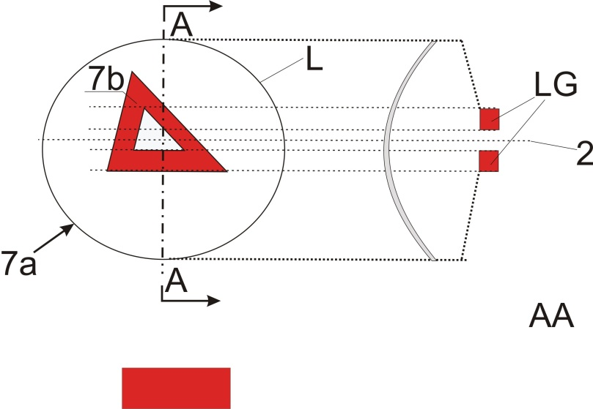
Section
In the case where the non-textured outer lens is excluded, "7b" is the apparent surface according to paragraph 2.10.2. (b).
Example of a light guide optic or a reflector optic behind an outer lens:
Example 8
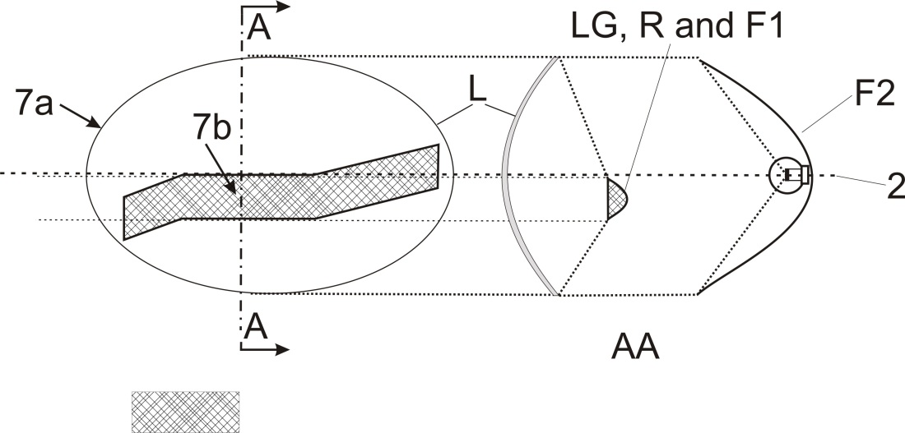
Sectionn
Section
In the case where the non textured outer lens is excluded, "7b" is the apparent surface according to paragraph 2.10.2. (b), and F1 shall not transparent to F2

Example of a light source with a reflector optic in combination with an area which is not part of this function, behind an outer lens:
Example 9
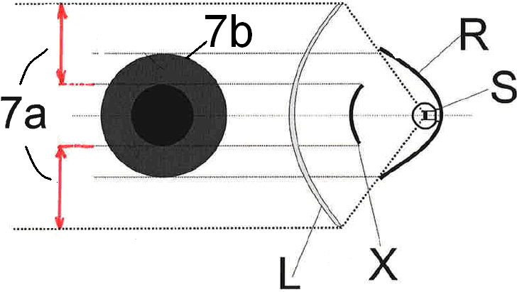
In the case where the non textured outer lens is excluded, "7b" is the apparent surface according to paragraph 2.10.2. (b).

…"
Part 6, amend to read:
"Part 6 – Examples showing the determination of the light-emitting surface in comparison with illuminating surface (See paragraphs 2.10.2. and 2.10.3. of this Regulation)
Note: Reflected light could / may contribute to the determination of the light emitting surface

Example A
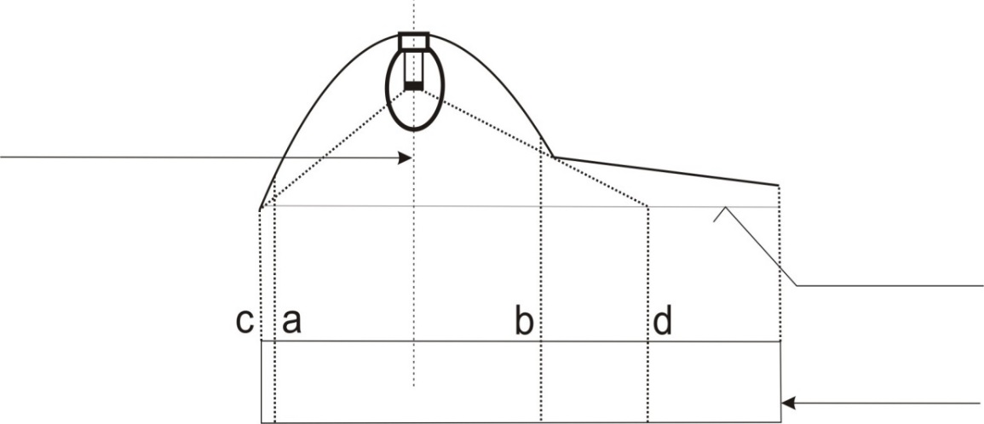
Surface of the lens
shown flat for convenience
PROJECTED VIEW
DECLARED
AXIS OF REFERENCE
 | Illuminating surface | Declared light-emitting surface according to 2.10.2. (a)
Edges are | a and b | c and d

Example B
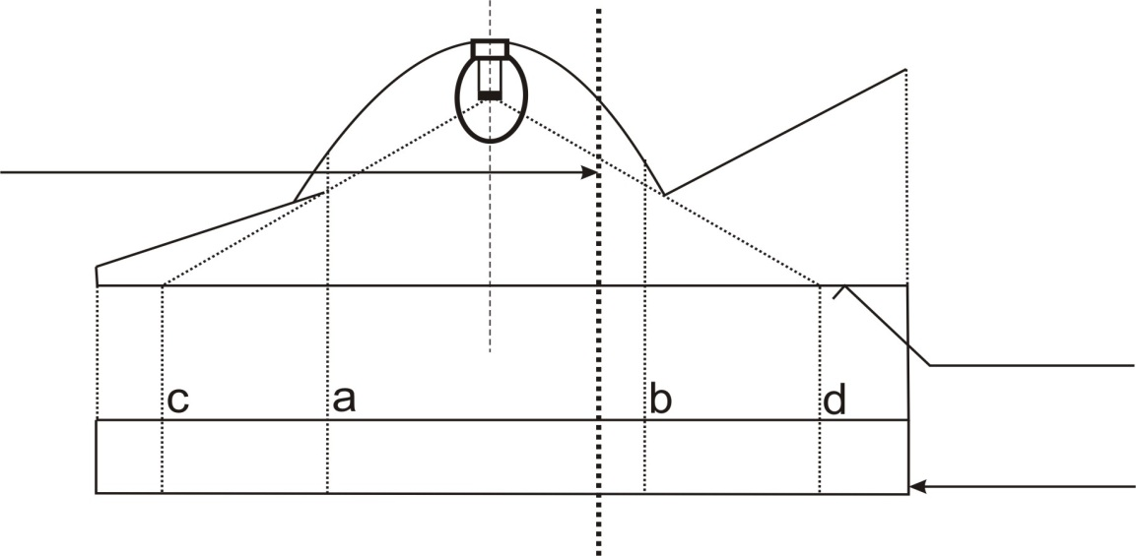
PROJECTED VIEW
Surface of the lens
shown flat for convenience
DECLARED
AXIS OF REFERENCE
 | Illuminating surface | Declared light-emitting surface according to 2.10.2. (a)
Edges are | a and b | c and d

…

Example D
Example to determine a light emitting surface according to 2.10.2. (a) in combination with an area which is not part of the function:
DECLARED
AXIS OF REFERENCE
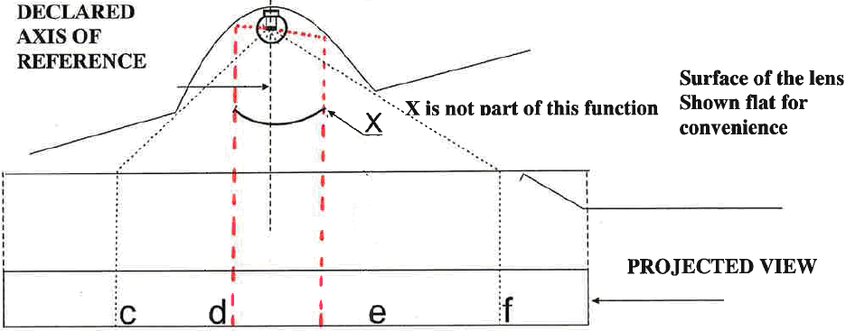
Surface of the lens Shown flat for convenience
X is not part of this function
PROJECTED VIEW

 | Declared Light-emitting surface according to 2.10.2. (a)
Edges are | c-d and e-f
Example E
Example to determine the apparent surface in combination with an area which is not part of the function and a non-textured outer lens (according to 2.10.2. (b)):
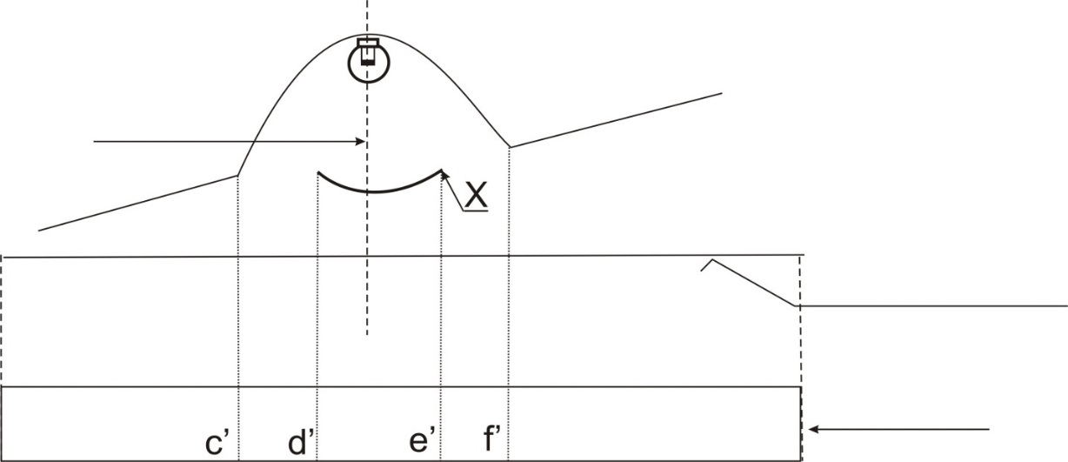
PROJECTED VIEW
Surface of the lens Shown flat for convenience
X is not part of this function
DECLARED
AXIS OF REFERENCE

 | Declared Light emitting surface according to 2.10.2. (b) for example
Edges are | c’-d’ and e’-f’

"

Part 7, amend to read:
"…
In the case where the non-textured outer lens is excluded, "7b" is the apparent surface according to paragraph 2.10.2. and F1 shall not be transparent to F2:
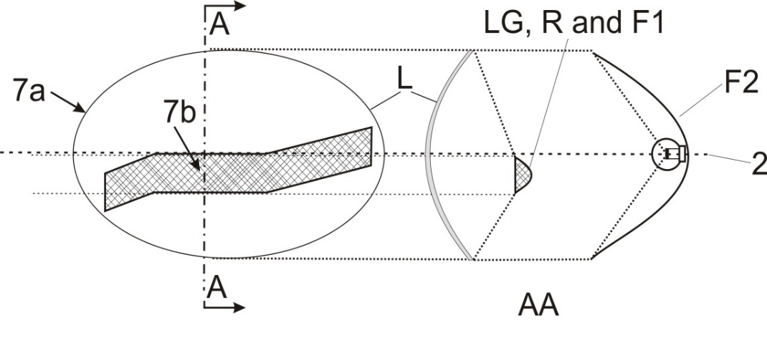
F1 is not reciprocally incorporated with F2
…"

Annex 9,
Paragraph 1.1. amend to read:
"1.1. Position of lamps
The position of lamps, as defined in paragraph 2.1.6. of this Regulation, in width, in height and in length shall be checked in accordance with the general requirements set out in paragraphs 2.10.2., 2.10.3., 2.10.4., 2.3.3. and 5.4. of this Regulation.
The values measured for the distances shall be such that the individual specifications applicable to each lamp are fulfilled. "
Paragraph 1.2.1. amend to read:
"1.2.1. The angles of geometric visibility shall be checked in accordance with paragraph 2.10.7. of this Regulation.
…"
Annex 15, amend to read:
"Annex 15
Gonio(photo)meter system used for the photometric measurements as defined in paragraph 2.10.9. of this Regulation
Photometer
v
h
"

* Former titles of the Agreement: Agreement concerning the Adoption of Uniform Conditions of Approval and Reciprocal Recognition of Approval for Motor Vehicle Equipment and Parts, done at Geneva on 20 March 1958 (original version); Agreement concerning the Adoption of Uniform Technical Prescriptions for Wheeled Vehicles, Equipment and Parts which can be Fitted and/or be Used on Wheeled Vehicles and the Conditions for Reciprocal Recognition of Approvals Granted on the Basis of these Prescriptions, done at Geneva on 5 October 1995 (Revision 2).
In the case of lighting devices for the rear registration plate and direction-indicators of categories 5 and 6, the "light-emitting surface" shall be used.
Examples to enable a decision regarding reciprocal incorporation of lamps can be found in Annex 3, Part 7.
CIE Publication 15.2, 1986, Colorimetry, the CIE 1931 standard colorimetric observer.

