E/ECE/324/Rev.1/Add.40/Rev.2/Amend.9−E/ECE/TRANS/505/Rev.1/Add.40/Rev.2/Amend.9
30November 2021
Agreement
Concerning the Adoption of Harmonized Technical United Nations Regulations for Wheeled Vehicles, Equipment and Parts which can be Fitted and/or be Used on Wheeled Vehicles and the Conditions for Reciprocal Recognition of Approvals Granted on the Basis of these United Nations Regulations*
(Revision 3, including the amendments which entered into force on 14 September 2017)
_________
Addendum 40 – UN Regulation No. 41
Revision 2 - Amendment 9
Supplement 9 to the 04 series of amendments – Date of entry into force: 30 September 2021
Uniform provisions concerning the approval of motor cycles with regard to noise
This document is meant purely as documentation tool. The authentic and legal binding text is: ECE/TRANS/WP.29/2021/4.
_________
UNITED NATIONS
Table of Contents, Annexes, 4, amend to read:
"4 Test track layout"
Paragraph 12.3., amend to read:
"12.3. Contracting Parties applying this Regulation may grant type approvals according to any preceding series of amendments to this Regulation. However, the specification of the test track may conform to ISO10844:2014."
Insert a new paragraph 12.4. to read:
"12.4. Contracting Parties applying this Regulation shall continue to grant extensions of existing approvals to any preceding series of amendments to this Regulation.¹ However, the specification of the test track may conform to ISO10844:2014."
Paragraphs 12.4. (former) to 12.9., renumber as 12.5. to 12.10., respectively.
Annex 3
Paragraph 1.2.1., third indent, delete "to the requirements of Annex 4 or".
Annex 4
Title, delete footnote 1 and amend to read:
"Test track layout"

Paragraphs 1. (including footnote 2), 2., and 2.1. to 2.5., delete.

Paragraph 2.2., footnote 3, delete.

Paragraphs 3., 3.1., 3.2., 3.2.1., 3.2.1.1. to 3.2.1.4., and 3.2.2., delete.

Figure 1, amend to read:

"Figure 1
Test track layout with dimensions in meters
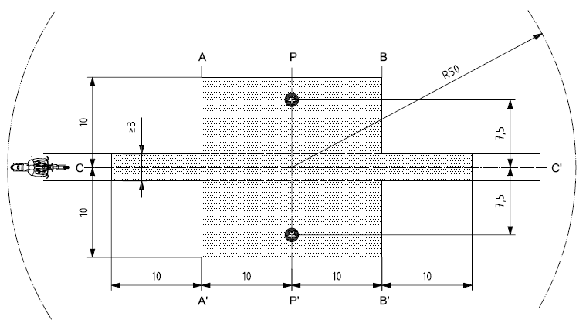

Key

Minimum area covered with test road surface, i.e. test area

Microphone positions (height 1,2m)

"

Figure 2 and Table 1, delete.

Paragraphs 4., 4.1. to 4.3., 5. and 5.1. to 5.3., delete.

Paragraphs 6., 6.1., 6.1.1. to 6.1.6., 6.1.6.1. to 6.1.6.7. and 6.2., delete.

* Former titles of the Agreement: Agreement concerning the Adoption of Uniform Conditions of Approval and Reciprocal Recognition of Approval for Motor Vehicle Equipment and Parts, done at Geneva on 20 March 1958 (original version); Agreement concerning the Adoption of Uniform Technical Prescriptions for Wheeled Vehicles, Equipment and Parts which can be Fitted and/or be Used on Wheeled Vehicles and the Conditions for Reciprocal Recognition of Approvals Granted on the Basis of these Prescriptions, done at Geneva on 5 October 1995 (Revision 2).
Note by the secretariat: the wording was adjusted in line with the decision of WP.29 at its November 2020 session (ECE/TRANS/WP.29/1155, paras. 92 and 93, and informal document WP.29-182-11).

