E/ECE/324/Rev.1/Add.29/Rev.3/Amend.10−E/ECE/TRANS/505/Rev.1/Add.29/Rev.3/Amend.10
21 February 2022
Agreement
Concerning the Adoption of Harmonized Technical United Nations Regulations for Wheeled Vehicles, Equipment and Parts which can be Fitted and/or be Used on Wheeled Vehicles and the Conditions for Reciprocal Recognition of Approvals Granted on the Basis of these United Nations Regulations*
(Revision 3, including the amendments which entered into force on 14 September 2017)
_________
Addendum 29 – UN Regulation No. 30
Revision 3 - Amendment 10
Supplement 24 to the 02 series of amendments – Date of entry into force: 7 January 2022
Uniform provisions concerning the approval of pneumatic tyres for motor vehicles and their trailers
This document is meant purely as documentation tool. The authentic and legal binding text is: ECE/TRANS/WP.29/2021/75.
_________
UNITED NATIONS
Paragraph 3.1.14., symbol, replace to read:
"
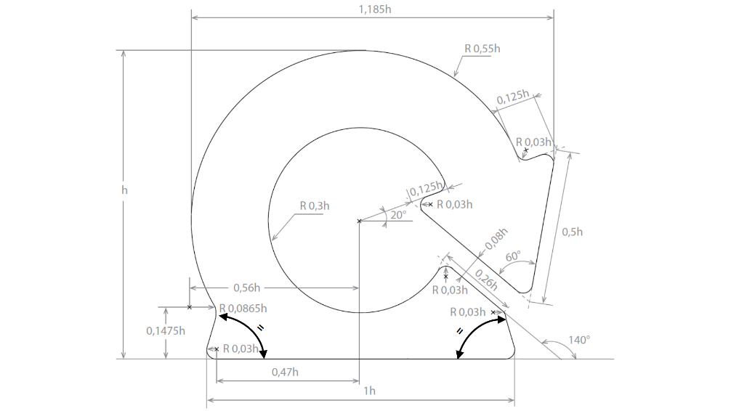"
Annex 7
Paragraph 3.2., amend to read:
"3.2. Inflate the tyre to an inflation pressure of 2.5 bar and condition the tyre-and-wheel assembly at a test room temperature of 38 ºC ± 3 ºC for not less than three hours."
Paragraph 3.7., amend to read:
"3.7. During the test the temperature of the test room must be maintained at 38°C ± 3°C.
The temperature sensor shall be at a distance not less than 0.15 m and not more than 1.00 m from the tyre sidewall."
Paragraph 4.2., amend to read:
"4.2. Inflate it to an inflation pressure of 2.5 bar and condition the tyre-and-wheel assembly at a test room temperature of 25 ºC ± 3 ºC for not less than three hours."
Paragraph 4.7., amend to read:
"4.7. During the test the temperature of the test room must be maintained at 25°C ± 3°C.
The temperature sensor shall be at a distance not less than 0.15 m and not more than 1.00 m from the tyre sidewall."

* Former titles of the Agreement: Agreement concerning the Adoption of Uniform Conditions of Approval and Reciprocal Recognition of Approval for Motor Vehicle Equipment and Parts, done at Geneva on 20 March 1958 (original version); Agreement concerning the Adoption of Uniform Technical Prescriptions for Wheeled Vehicles, Equipment and Parts which can be Fitted and/or be Used on Wheeled Vehicles and the Conditions for Reciprocal Recognition of Approvals Granted on the Basis of these Prescriptions, done at Geneva on 5 October 1995 (Revision 2).

