|  |
| --- |
| **INF.5** |
| |  |  | | --- | --- | | **Economic Commission for Europe**  Inland Transport Committee  **Working Party on the Transport of Perishable Foodstuffs**  **Seventy-ninth session**  Geneva, 25-28 October 2022  Item 3 (b) of the provisional agenda  **Activities of other international organizations dealing  with issues of interest to the Working Party:**  **Transfrigoroute International** | 19 October 2022  English | |

Report of year 2022

Transmitted by Transfrigoroute International

|  |
| --- |
| *Summary* |
| **Executive summary**: Report of year 2022 from Transfrigoroute International  **Action to be taken:** Information & support for discussion  **Related documents**: NA |
|  |

A. Crisis situation

1. After 2 years of severe impact by the consequences of COVID-19 and the successive blanket lockdown which occurred throughout the world, our sector benefitted from a strong recovery started in 2021.

2. Nevertheless, the repercussions of the COVID-19 crisis were still responsible for perturbation both in sea transport and component shortage in 2022 (i.e. several lockdown in Asia in 2022).

3. Starting February 2022, a new crisis has started with conflict Ukraine-Russia.

4. Transportation and logistics, including all suppliers from this business sector (OEM, equipment manufacturer…) are being particularly hard hit by the conflict. Our sector is not only suffering from the rise in raw material and energy prices, but also suffer from shortage of components, sometimes paralyzing entire production lines.

B. Context and challenges

5. Despite previously mentioned crisis, political agenda, and strong ambition from EU regarding climate change are still ongoing.

6. Transfrigoroute International is at the crossroad of two revolutions: decarbonizing all transport segments to contribute to the global, European, and national emissions reduction targets, but also transforming the refrigerant used by for our operations to render them more sustainable.

7. Regarding transport decarbonization, development of alternative power train vehicle and alternative power source for thermal appliances is accelerating but there are still no clear rules in ATP which currently does not considers the multiplicity of solutions to power thermal appliances.

8. This topic has been discussed intensively within different forum (Transfrigoroute International, IIR CERTE and WP11 IWG) but remain problematic as there are different views on the interpretation of the scope of the ATP.

9. In order to clarify this, a face-to-face meeting has been held in Brussels on 7 September, 2022 with 10 experts from different organization (TI-CCT, TÜV Süd, CRT, Cemafroid Competent authority) and you can find minutes of this meeting here after.

C. Scope of ATP

10. In the run-up to the next meeting of WP11 (25-28 October 2022), around 10 experts representing different organization (TI-CCT, TÜV Süd, CRT, Cemafroid Competent authority) met in Brussels to discuss outstanding issues on the ATP.

11. Overall, there was agreement that progress on the ATP has been very slow and that contentious issues remain even after years of discussion.

12. The discussion initially centered on the scope that the ATP should cover, but also raised few other topics.

Open point mention during discussion

* ATP = international and international is associated to long haul but in reality, cross border region could also be covered by ATP with regional transport and even distribution activities.
* A limited number of countries apply ATP as national legislation while the majority apply ATP only to equipment used for international transport.
* The question of harmonizing the practice and having all countries applying ATP for national transport (in order to guarantee food safety and also transport equipment energy efficiency) was debated
* However it was admitted that:
* as no short-term changes should be expected vs. current situation, any modification or addition in ATP rules will impact either all national or only international refrigerated transport’s activities, depending on the country
* this does not impact directly the scope of the discussions which needs to happen about the implementation of future technologies.
* There is not much quality performance indicator for ATP regulation.

13. This lack of factual metrics does not help a proper evaluation of amendment proposals. (i.e. when proposals are made, they should quantify an improvement in some metric)

* Definition of equipment is not clear and different interpretation are suggested
* Interpretation 1- Equipment = complete vehicle, including vehicle powertrain and associated energy storage + supportive structure (chassis) + insulated box + thermal appliance
* Interpretation 2- Equipment = supportive structure (chassis) + insulated box + thermal appliance
* Differences in interpretation lead to difference of application of ATP rules between contracting parties. This could lead to distortion of competitions.
* There are divergences between the French and English languages when it comes to definitions (i.e. Autonomous vs Independent).

Requirement for minimum run time

* A clear question has been debated whether a requirement on a minimum duration of operations should be included in the ATP.
* This was considered by most to be a non-ATP requirement.
* The majority do not believe a minimum duration requirement is necessary in the ATP for the following reasons:

1. This is not the case today (i.e. no requirement on minimum fuel tank size).
2. This notion is covered by Article 4 – “The equipment shall be so selected and used that the temperature conditions prescribed in the said annexes can be complied with throughout carriage. Furthermore, all appropriate measures shall be taken, more particularly as regards the temperature of the foodstuffs at the time of loading and as regards icing or re-icing during the journey or other necessary operations.”
3. Transformation of power train (vehicle & thermal appliance) will lead to logistics adjustment and logistics scheme will adapt to new technical constraint (and not the reverse).

* In consequence of this point of view, some definitions (Annex 1) should be modified
* Definitions of “Refrigerated equipment” and “Mechanically refrigerated equipment” does not mention any requirement for a minimum duration of operation.
* Definitions of “Heated equipment” and “Mechanically refrigerated and heated equipment” does mention a requirement for a minimum duration of operation (“not less than 12 hours without renewal of supply at a practically constant value”)
* This is not coherent and should be corrected as it creates confusion
* ATP text should clearly distinguished requirement for testing and requirement for normal operation.
* Another consequence is that participants did not agree on the need to include a definition of autonomy (as a duration of operation).

Scope of certification

* It was reiterated that the purpose of the ATP is to set the rules for equipment and does not include certification of fuels.
* Cemafroid Competent authority believes that energy and power source should be part of the certification – everyone except Cemafroid Competent authority disagreed with this.
* The issue of batteries was also raised because with the new laws pushing for electric vehicles (AFIR in the EU), battery life and dependence on them will play a role in deliveries and therefore food safety. Not everyone agrees that this falls within the scope of the ATP.
* A long debate occurs on energy source and power source be part of ATP certification (in the mechanical system only)?

14. This debate ends up with a diagram representing different option of scope (see below).

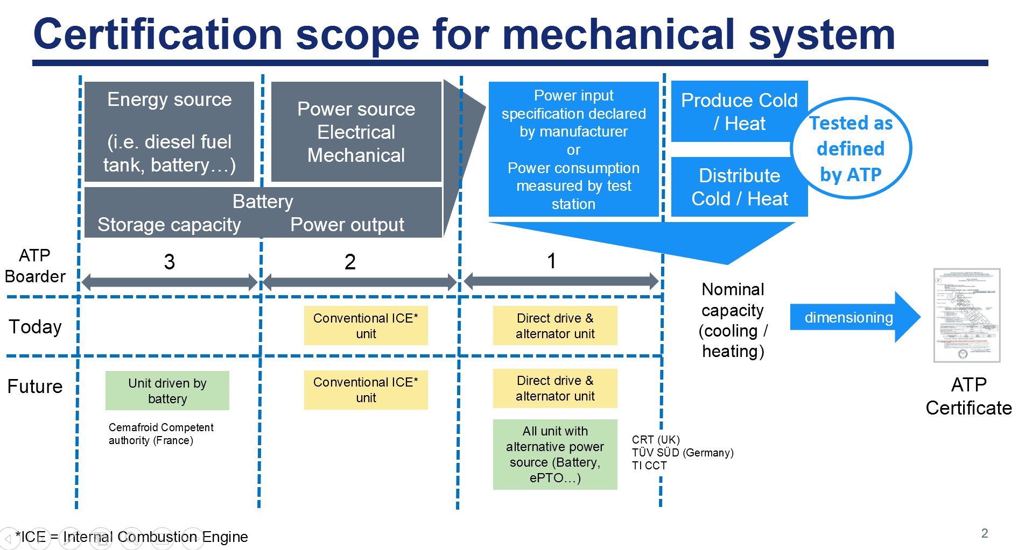

* In addition to the diagram, find below clarification on the 3 listed scopes

Scope 1 Power input specification for the refrigeration system is declared by TRU (Transport Refrigeration Unit) manufacturer or measured by ATP Test Station.

The source of this power input is not validated nor tested by ATP test station (vehicle ICE, vehicle alternator…).

This is the case today for all direct drive & alternator driven TRU

Scope 2 Power source (ICE) is embedded within the TRU

The full TRU, including ICE is tested and validated by ATP test station

This is the case today for conventional ICE powered TRU

Scope 3 this scope does include the test and/or validation of storage capacity by ATP test station

This never apply today with existing TRU technologies.

* A remark is made that scope 1, 2 and 3 describe the minimum amount of testing, meaning which tests should be mandatory for ATP, but we should also consider that some checks – not necessarily lab tests in an ATP test station - might be needed for these systems as well.
* Below is the summary of different recommendation

