E/ECE/324/Rev.1/Add.89/Rev.3/Amend.8−E/ECE/TRANS/505/Rev.1/Add.89/Rev.3/Amend.8
23 November 2022
Agreement
Concerning the Adoption of Harmonized Technical United Nations Regulations for Wheeled Vehicles, Equipment and Parts which can be Fitted and/or be Used on Wheeled Vehicles and the Conditions for Reciprocal Recognition of Approvals Granted on the Basis of these United Nations Regulations*
(Revision 3, including the amendments which entered into force on 14 September 2017)
_________
Addendum 89 – UN Regulation No. 90
Revision 3 - Amendment 8
Supplement 8 to the 02 series of amendments – Date of entry into force: 8 October 2022.
Uniform provisions concerning the approval of replacement brake lining assemblies, drum-brake linings and discs and drums for power-driven vehicles and their trailers
This document is meant purely as documentation tool. The authentic and legal binding text is: ECE/TRANS/WP.29/2022/17.
_________
UNITED NATIONS

Annex 14,
Table A14/2.2.5, amend to read:
"
Disc Diameter  [mm] | Disc Thickness  [mm] | Tangential force F  [kN] min
≥ 150 < 250 | ≤ 3 | ≥ 8
 | >3 ≤ 4 | ≥ 10
 | > 4 | ≥ 12
≥ 250 < 350 | ≤ 4 | ≥ 8
 | > 4 ≤ 5 | ≥ 11
 | > 5 | ≥ 14
”
Annex 15,
Insert a new paragraph 1.5., to read:
“1.5. Definition of bell mounting face
“Bell mounting face” means the surface of a brake disc that goes in contact with wheel hub.
The mounting surface is calculated between the disc inner diameter T(i) and a diameter T(o) defined as the max diameter of area subjected to flatness restrictions as indicated on disc drawing (see figure 1).
In case indications on the drawing are missing, T(o) is defined as follows:
T(o) = T(k) + B + 10mm
Figure 1
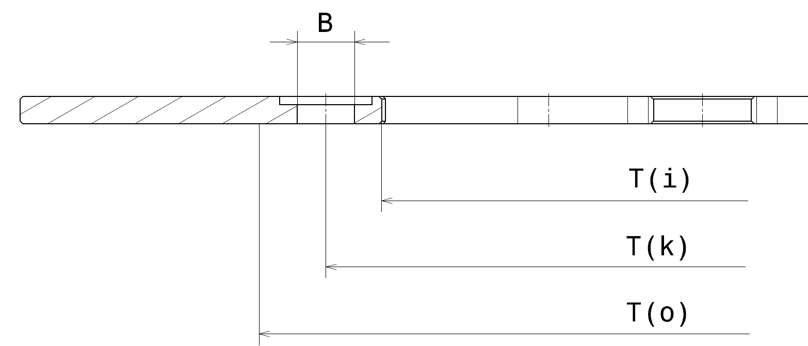
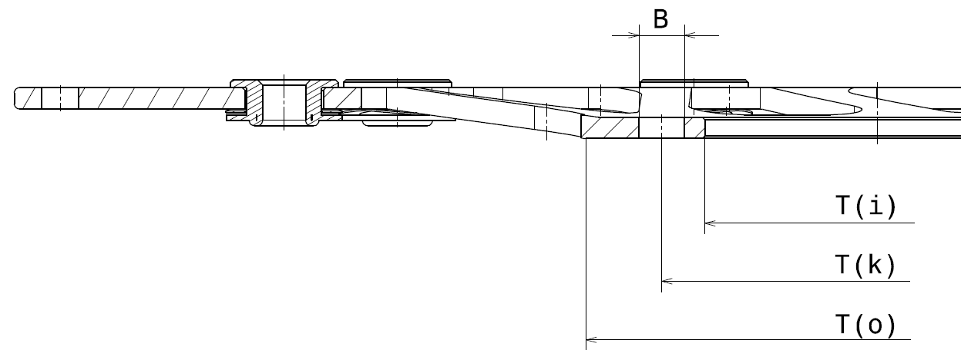
"
Insert a new paragraph 1.6., to read:
"1.6. Definition of reference disc
Within each discs group, the reference disc is the one which has the highest ratio of kinetic energy (considering all the replacement applications foreseen) and its mass, as described in paragraph 5.3.6."
Paragraph 2.3., amend to read:
"2.3. Braking surface lightening: any solution is allowed (holes, slots, wave, etc.) provided that the ratio between the vehicle kinetic energy to the mass of the disc braking surface, must be same or higher than the reference disc (with tolerance of – 20 per cent maximum).
Example:
Outer diameter 300 mm,
radial width of the braking surface 36.5 mm ≥ total area A = 302 cm²
Lightening on the braking surface: 64 holes diameter 7 mm ≥ total area
B = 24.6 cm2
δ = Braking surface material specific weigh
Braking Surface Mass (BSM)= (A-B) * Th * δ
Vehicle kinetic energy K.E.= ½ m V² (as defined in para. 5.3.6)
Braking Surface Lightening (BSL) 𝑟𝑎𝑡𝑖𝑜 = 𝐾.𝐸. / 𝐵SM "
Paragraph 2.6., amend to read:
"2.6. Spokes of the bell with full/empty ratio – measured on the average circumference between end of the mounting face and max. diameter of the bell same or higher than the reference disc (with a tolerance of -20 per cent max.), thickness same or higher than the reference disc (with a tolerance of -15 per cent max) and same mechanical properties, as specified in the international standard for materials, with respect to the reference disc."
Paragraph 2.9., amend to read:
"2.9. Outer diameter included in the range of 100 mm, according to Table 2.9.:
Range  [mm] | One piece | Composite fixed | Floating discs
≥ 150 < 250 | X | X | X
≥ 250 < 350 | X | X | X
"

* Former titles of the Agreement: Agreement concerning the Adoption of Uniform Conditions of Approval and Reciprocal Recognition of Approval for Motor Vehicle Equipment and Parts, done at Geneva on 20 March 1958 (original version); Agreement concerning the Adoption of Uniform Technical Prescriptions for Wheeled Vehicles, Equipment and Parts which can be Fitted and/or be Used on Wheeled Vehicles and the Conditions for Reciprocal Recognition of Approvals Granted on the Basis of these Prescriptions, done at Geneva on 5 October 1995 (Revision 2).

