E/ECE/324/Rev.1/Add.89/Rev.3/Amend.9−E/ECE/TRANS/505/Rev.1/Add.89/Rev.3/Amend.9
17 February 2023
Agreement
Concerning the Adoption of Harmonized Technical United Nations Regulations for Wheeled Vehicles, Equipment and Parts which can be Fitted and/or be Used on Wheeled Vehicles and the Conditions for Reciprocal Recognition of Approvals Granted on the Basis of these United Nations Regulations*
(Revision 3, including the amendments which entered into force on 14 September 2017)
_________
Addendum 89 – UN Regulation No. 90
Revision 3 - Amendment 9
Supplement 9 to the 02 series of amendments – Date of entry into force: 4 January 2023.
Uniform provisions concerning the approval of replacement brake lining assemblies, drum-brake linings and discs and drums for power-driven vehicles and their trailers
This document is meant purely as documentation tool. The authentic and legal binding text is: ECE/TRANS/WP.29/2022/82.
_________
UNITED NATIONS
Paragraph 1. in Annex 7a, amend to read:
"1. Grouping criteria
The grouping is made according to the following approach:
(a) According to the individual friction material of the brake lining;
(b) Depending on the area of the friction material area of the brake lining assembly operated by the piston/pistons of only one side of the brake calliper or, in case of drum brakes, of only one brake shoe.
Friction material area means all the area enclosed within the perimeter of the brake lining (see the red cross-hatched area, Figure 1, Figure 2), thus excluding the presence of any grooves and/or chamfers:
Figure 1
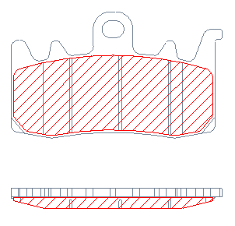
Figure 2
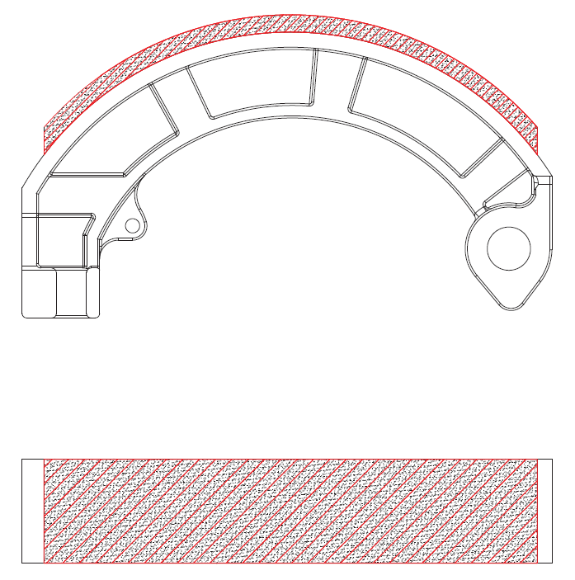

3 area groups are foreseen, as in Table 1 (for brake pads) and in Table 2 (for brake shoes):
…

Table 2
Group | Brake lining area  [cm²]
A | ≤21
B | > 21 ≤ 54
C | > 54
"

* Former titles of the Agreement: Agreement concerning the Adoption of Uniform Conditions of Approval and Reciprocal Recognition of Approval for Motor Vehicle Equipment and Parts, done at Geneva on 20 March 1958 (original version); Agreement concerning the Adoption of Uniform Technical Prescriptions for Wheeled Vehicles, Equipment and Parts which can be Fitted and/or be Used on Wheeled Vehicles and the Conditions for Reciprocal Recognition of Approvals Granted on the Basis of these Prescriptions, done at Geneva on 5 October 1995 (Revision 2).

