|  |  |  |  |
| --- | --- | --- | --- |
|  | United Nations | ECE/TRANS/WP.11/2023/2 | |
| United Nations logo | **Economic and Social Council** | | Distr.: General  2 August 2023  English  Original: French |

**Economic Commission for Europe**

Inland Transport Committee

**Working Party on the Transport of Perishable Foodstuffs**

**Eightieth session**

Geneva, 24–27 October 2023

Item 4 (e) of the provisional agenda

**Status and implementation of the Agreement on the International  
Carriage of Perishable Foodstuffs and on the Special Equipment  
to be Used for such Carriage (ATP):**

**Exchange of good practices for better implementation of ATP**

Guide to good practices for the installation of recessed and/or deflector-mounted thermal devices and under-frame or offset thermal devices.

Transmitted by the Government of France

Introduction

1. Some refrigeration units may be installed in spaces reserved for them in the body or integrated into aerodynamic deflectors, or may have condensers mounted in the engine compartment or under the vehicle chassis.

2. These configurations may differ from the conditions under which prototypes are tested in official test stations.

3. Such installations may result in a reduction of expected refrigeration performance owing to impeded airflow at the condenser inlet.

Cases concerned

General provisions applicable for the fitting of thermal appliances

(cases Nos. 1 to 6)

4. The provisions below are intended to provide clarification for the installation of recessed units, units with deflectors, under-frame units or units that can be offset.

Equipment concerned

5. Case No. 1: Standard production vans with integrated insulation and unit partially recessed in the roof:



6. Case No. 2: Standard production vans with integrated insulation and unit partially recessed in the roof, with a roof air deflector:



7. Case No. 3: Chassis cabs with front-mounted units and a deflector over the cab:

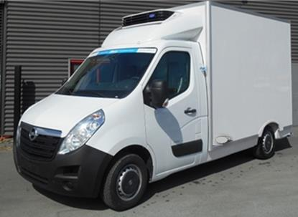

8. Case No. 4 : Standard production vans with integrated insulation and the unit installed under the chassis or in the engine compartment:



9. Case No. 5 : Standard production trucks and trailers with the unit installed under the chassis:

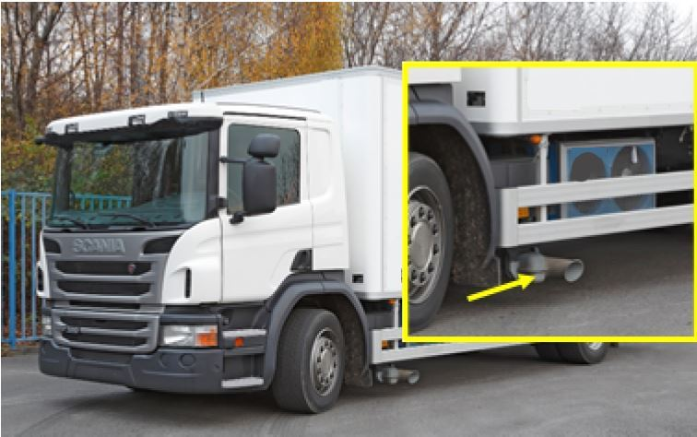

10. Case No. 6: Semi-trailers with deflectors:



Provisions applicable by manufacturers of thermal appliances

11. The manufacturer may specify:

• All the precautions to be taken during manufacture by the body manufacturer to ensure performance equivalent to that of the type test report

• The minimum distances for the elements of the body to be respected to ensure performance equivalent to that of the type test report

12. The competent authority may assess the steps taken by the manufacturer to ensure that all the scenarios and their impacts have been taken into account in order to ensure performance equivalent to that of the type test report.

Provisions applicable by manufacturers of insulated bodies

13. The body manufacturer should respect the recommendations made by the manufacturer of the thermal appliance. The installation of the unit may, where appropriate, be subject to formal validation by the thermal appliance manufacturer if at least one of the requirements defined by the thermal appliance manufacturer calls into question the performance of the unit.

14. Mandatory safety features shall not serve as grounds for dispensation from the specifications established by the thermal appliance manufacturer.

Provisions applicable by fitters of thermal appliances

15. The fitter of the thermal appliance should comply with the fitting instructions established by the manufacturer of the thermal appliance, which may be amended by the body manufacturer, in accordance with the provisions of the preceding paragraph.

16. Any other modifications should be formally validated by the thermal appliance manufacturer.

Specific provisions applicable for fitting recessed thermal appliances (*cases Nos. 1 to 3*)

Case No. 1

17. The installation instructions should specify that:

• A minimum distance should be maintained between the walls of the recessed drip basin and the air inlet of the condenser

• A maximum depth of the drip basin should be ensured. The drip basin must not be deeper than the maximum height of the unit’s condenser

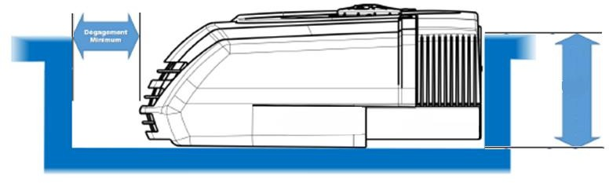

Case No. 2

18. The installation instructions may specify that:

• In addition to the conditions required for case No. 1, and in cases where a deflector has been added, a minimum free area should be ensured for the air flow at the inlet and outlet of the condenser. It should be specified that the unit and the cover should be installed so that they are flush.

Case No. 3

19. The installation instructions must specify that:

• The deflector may, if necessary, be cut to allow for the circulation of an air flow to and from the condenser. The minimum free area should be ensured to allow for the air flow in and out of the condenser.

