|  |  |  |  |
| --- | --- | --- | --- |
|  | United Nations | ECE/TRANS/WP.11/2023/5 | |
| United Nations logo | **Economic and Social Council** | | Distr.: General  3 August 2023  English  Original: French |

**Economic Commission for Europe**

Inland Transport Committee

**Working Party on the Transport of Perishable Foodstuffs**

**Eightieth session**

Geneva, 24–27 October 2023

Item 5 (a) of the provisional agenda

## **Proposals for amendments to ATP:**

**Pending proposals**

Proposed amendments to annex 1, appendix 2, paragraph 7.3.7

Transmitted by the Government of France

|  |
| --- |
| *Summary* |
| **Executive summary**: Proposal to supplement annex 1, appendix 2, paragraph 7.3.7, with acceptance criteria for the coating of internal dividing walls |
| **Action to be taken**: Supplement annex 1, appendix 2, paragraph 7.3.7 |
| **Related documents**: None |
|  |

Introduction

1. The means of transport used for perishable foodstuffs should not, as a result of their layout, state of repair or loading, constitute a risk of contamination, deterioration or soiling of the foodstuffs.

2. European Regulation 852/2014 contains relevant provisions that apply to these means of transport:

(a) Chapter IV of annex II of European Regulation 852/2004 states that “Conveyances and/or containers used for transporting foodstuffs are to be kept clean and maintained in good repair and condition to protect foodstuffs from contamination and are, where necessary, to be designed and constructed to permit adequate cleaning and/or disinfection.”;

(b) Chapter V of annex II of European Regulation 852/2004 states that “All articles, fittings and equipment with which food comes into contact are to [...] be so constructed, be of such materials and be kept in such good order, repair and condition as to minimise any risk of contamination”.

3. The materials used in the design of dividing walls are likely to come into contact with the foodstuffs transported. These materials must not cause spoilage of the foodstuffs or impart harmful properties. However, dividing walls whose outer coating is not bonded to the central insulating panel of the dividing walls present a design-related risk of accumulation of dirt between the outer coating and the central insulation. This risk may be exacerbated by the fact that these partitions can be stored outside the equipment, exposing them to all kinds of dirt.

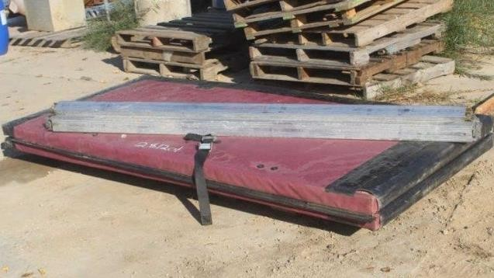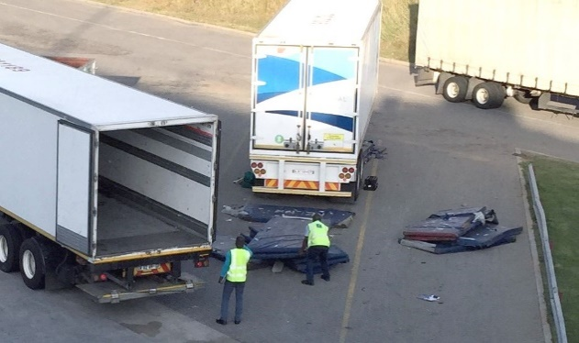

4. Annex 1, appendix 2, paragraph 7, refers to thermal losses through internal dividing walls of which only two types are represented, by the terms “longitudinal” and “transversal”. As a result, the acceptance criteria for these dividing walls in ATP are not clear enough to rule out technological solutions that would not meet the objective of certification, or to prevent differences in interpretation between competent authorities, which could lead to multi-temperature equipment being accepted for certification in one country and but rejected in another.

5. The purpose of this proposal is to supplement the proposals on internal dividing walls by introducing, in annex 1, appendix 2, paragraph 7.3.7:

* Acceptance criteria for coating of internal dividing walls

Proposal

6. Add at the end of 7.3.7. Internal dividing walls:

“The internal dividing wall(s) shall consist of an insulated panel and a coating joined together with the panel.”

7. It is proposed to translate the French term “*solidaire*” by “joined together” in the English version.

Impact

| Cost: | No impact. |
| --- | --- |
| Environment: | Improved hygiene conditions within equipment by avoiding external storage of removable dividing walls. |
| Feasibility: | The proposed amendment can easily be introduced into ATP. A transitional period of one year is proposed. |
| Enforceability: | No problems are expected. |