|  |  |  |  |
| --- | --- | --- | --- |
|  | United Nations | ECE/TRANS/WP.11/2023/6[1]* | |
| United Nations logo | **Economic and Social Council** | | Distr.: General  3 August 2023  English  Original: French |

**Economic Commission for Europe**

Inland Transport Committee

**Working Party on the Transport of Perishable Foodstuffs**

**Eightieth session**

Geneva, 24–27 October 2023

Item 4 (e) of the provisional agenda

**Status and implementation of the Agreement on   
the International Carriage of Perishable Foodstuffs and on   
the Special Equipment to be Used for such Carriage (ATP):**

**Exchange of good practices for better implementation of ATP**

Guide for issuing the declaration of conformity (annex 1, appendix 2, paragraph 7.3.6) and for dimensioning multi‑temperature, multi-compartment (MTMC)   
equipment – Handling of application cases specific to the multi‑temperature equipment dimensioning tool

Transmitted by the Government of France

Introduction

1. Under the new provisions in the 6 July 2020 version of ATP, which are included in the 1 June 2022 version, all applications for ATP certificates for multi-temperature equipment manufactured after 1 October 2020 must include a declaration of conformity attached to the certificate.

2. Equipment manufacturers use an automated multi-temperature equipment dimensioning tool to prove the correct dimensioning of equipment. This tool covers the vast majority of cases, but some specific cases require the use of an appropriate dimensioning method.

3. The purpose of this document is to specify the operating procedures for specific cases.

Dimensioning

Case of multi-compartment equipment with a variable number of compartments

4. All configurations must be calculated to verify the correct dimensioning of the equipment. However, only the least favourable configuration should be presented in the annex to the certificate. The sketch showing the configuration corresponding to the configuration on the application for certification must be attached. Prior to applying for certification, the manufacturer or fitter shall verify the correct dimensioning for the least favourable case. The least favourable case corresponds to the configuration with the positions of the bulkheads and the number of compartments that require the greatest refrigeration capacity. The different configurations calculated shall be retained by the applicant.

Example : case of a “J” configuration (the size of the compartments is defined by the position of the stops or markings on the body walls)

5. The annex to the certificate shows all configurations:

Image. 1

Front

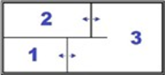

Rear

6. The dimensioning is verified for the least favourable case:

Image. 2

Front

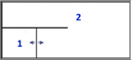

Rear

Front



Rear

7. The compartments are numbered starting from the front left compartment. In the above example, according to this rule, the compartment numbers differ depending on whether the longitudinal bulkhead is connected to the front or the rear of the equipment. However, the dimensioning method does not change.

Case of equipment with a mono-temperature unit and a multi‑temperature unit

8. The dimensioning tools developed are intended to measure the impact of the position of bulkheads on the dimensioning of multi-temperature multi-compartment equipment. Some configurations require specific adaptations to avoid distorting the calculation results.

9. For example, in the case below, the height and width of the compartment must be set and the length adjusted in the tool so that the resulting area is equal to the area of the insulated surface of the body.

10. The equipment must be dimensioned in two stages. In the case below, compartment 2 (C2) and compartment 3 (C3) are equipped with a multi-temperature thermal appliance sharing the same refrigeration unit. There must therefore be a dimensioning calculation and supporting documentation for the appliance.

11. Compartment 1 (C1), with a mono-temperature thermal appliance, must be considered separately, to ensure that the refrigeration unit can cover the volume of the compartment.

Image. 3

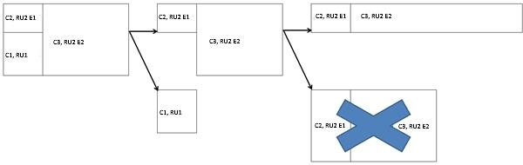

*C: Compartment

*RU: Refrigeration unit

*E: Evaporator

12. The resulting surface area is calculated to the area of an equivalent parallelepiped.

Case of equipment with integrated insulation (non-parallelepipedic insulation forms) or case of equipment with an integrated box

13. The width of the compartment must be set and the height and length adjusted in the tool so that the resulting surface area is equal to the insulated surface area of the body. The resulting area is calculated to the area of an equivalent parallelepiped.

Image. 4

View from above:

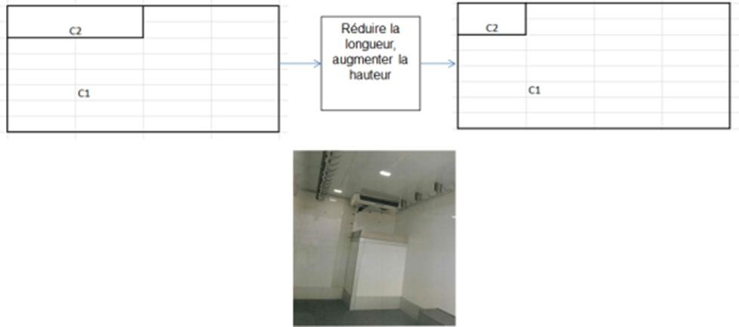

Reduce the length, increase the height.

View from the side:

Reduce the length, increase the height.



Non-independent equipment

14. In the case of non-independent equipment, the same dimensioning method should be used as for independent equipment.

15. The class shown on the declaration of conformity without the “X” extension (e.g. FRC) will be different from the class shown on the certificate (e.g. FRCX), but this difference does not call the dimensioning of the equipment into question.

Case of mono-temperature multi-compartment equipment equipped with non-removable fixed bulkheads (e.g. FRC-IR, FRC-IR-IR)

16. The unit should be dimensioned only according to the internal surface area and insulating capacity of the temperature-controlled compartment in which the evaporator is installed. In this case, the insulation coefficient of the compartment is composed of the insulating capacity of the panels and of the bulkhead that form the compartment.

*Note:* *Not applicable if a multi-temperature unit is used only with a single evaporator.*

1. * Reissued for technical reasons on 25 August 2023.