E/ECE/324/Rev.1/Add.49/Rev.4−E/ECE/TRANS/505/Rev.1/Add.49/Rev.4
15 September 2023

Agreement
Concerning the Adoption of Harmonized Technical United Nations Regulations for Wheeled Vehicles, Equipment and Parts which can be Fitted and/or be Used on Wheeled Vehicles and the Conditions for Reciprocal Recognition of Approvals Granted on the Basis of these United Nations Regulations *
(Revision 3, including the amendments which entered into force on 14 September 2017)
_________
Addendum 49: UN Regulation No. 50
Revision 4
Incorporating all valid text up to:
Supplement 17 to the original version of the Regulation – Date of entry into force: 8 October 2015
Supplement 18 to the original version of the Regulation – Date of entry into force: 8 October 2016
Supplement 19 to the original version of the Regulation – Date of entry into force: 10 October 2017
Supplement 20 to the original version of the Regulation – Date of entry into force: 10 February 2018
01 series of amendments – Date of entry into force: 15 October 2019
Uniform provisions concerning the approval of front position lamps, rear position lamps, stop lamps, direction indicators and rear-registration-plate illuminating devices for vehicles of category L
_________
UNITED NATIONS

This document is meant purely as documentation tool. The authentic and legal binding texts are:
- ECE/TRANS/WP.29/2015/24 as amended by para. 61 of the report
- ECE/TRANS/WP.29/2016/21
- ECE/TRANS/WP.29/2017/28
- ECE/TRANS/WP.29/2017/80
- ECE/TRANS/WP.29/2017/81 as amended by para. 76 of the report
- ECE/TRANS/WP.29/2018/103/Rev.1
UN Regulation No. 50
Uniform provisions concerning the approval of front position lamps, rear position lamps, stop lamps, direction indicators and rear-registration-plate illuminating devices for vehicles of category L
Contents
Page
Regulation
1. Scope 4
2. Definitions 4
3. Application for approval 4
4. Markings 6
5. Approval 6
6. General specifications 8
7. Intensity of light emitted 10
8. Test procedure 11
9. Colour of light emitted 12
10. Conformity of production 12
11. Penalties for non-conformity of production 12
12. Production definitively discontinued 13
13. Names and addresses of Technical Services responsible for conducting approval tests, and of
Type Approval Authorities 13
14. Transitional provisions 13
Annexes
1 Minimum horizontal (H) and minimum vertical (V) angles for spatial light distribution 14
2 Communication 17
3 Examples of arrangements of the approval marks 19
4 Photometric measurements 21
5 Photometric measurements for the rear-registration-plate illuminating device 23

1. Scope
This Regulation applies to front position lamps, rear position lamps, stop lamps, direction indicators, and rear-registration-plate illuminating devices for vehicles of category L.
2. Definitions
2.1. Definitions of terms
The definitions given in UN Regulations Nos. 53 or 74 and the series of amendments in force at the time of application for type approval shall apply to this Regulation.
2.2. "Front position lamps, rear position lamps, stop lamps, direction indicator lamps and rear-registration-plate illuminating devices of different types" means lamps which differ in such essential respects as:
(a) The trade name or mark:
(i) Lamps bearing the same trade name or mark but produced by different manufacturers shall be considered as being of different types;
(ii) Lamps produced by the same manufacturer differing only by the trade name or mark shall be considered as being of the same type;
(b) The characteristics of the optical system, (levels of intensity, light distribution angles, category of light source, light source module, etc.);
(c) The sequential activation of light sources, if any.
A change of the colour of the light source or the colour of any filter does not constitute a change of type.
2.3. The definitions of the colour of the light emitted, given in UN Regulation No. 48 and its series of amendments in force at the time of application for type approval shall apply to this Regulation.
2.4. References made in this Regulation to standard (étalon) filament light source(s) and to UN Regulation No. 37 shall refer to UN Regulation No. 37 and its series of amendments in force at the time of application for type approval.
References made in this Regulation to standard (étalon) LED light source(s) and to UN Regulation No. 128 shall refer to UN Regulation No. 128 and its series of amendments in force at the time of application for type approval.
3. Application for approval
3.1. The application for approval shall be submitted by the holder of the trade name or mark or by his duly accredited representative. It shall specify:
3.1.1. The purpose or purposes for which the device submitted for approval is intended;
3.1.2. In the case of a front position lamp an indication whether it is intended to emit white or amber light;
3.1.3. In the case of a direction indicator, the category;
3.1.4. At the choice of the applicant, that the device may be installed on the vehicle with different inclinations of the reference axis in respect to the vehicle reference planes and to the ground or rotate around its reference axis or, in the case of a rear registration plate lamp, that the device may be fitted in more than one or a field of positions in relation to the space to be occupied by the registration plate; these different conditions of installation (or different positions) shall be indicated in the communication form.
3.2. For each type of device, the application shall be accompanied by:
3.2.1. Drawings, in triplicate, in sufficient detail to permit identification of the type of the device and showing the following:
(a) In what geometrical position(s) the device may be mounted on the vehicle; the axis of observation to be taken is the axis of reference in the tests (horizontal angle H = 0°, vertical angle V = 0°); and the point to be taken as the centre of reference in the said tests;
(b) The geometrical conditions of installation of the device(s) that meet(s) the requirements of paragraph 7.;
(c) In the case of an interdependent lamp system, the interdependent lamp or the combination of interdependent lamps that fulfil the requirements of paragraphs 6.8., 7.1. and of Annex 4 to this Regulation;
(d) The position intended for the approval number and the additional symbols in relation to the circle of the approval mark.
3.2.2. A brief technical description stating, in particular, with the exception of lamps with non-replaceable light sources:
(a) The category or categories of filament light source(s) prescribed; this filament light source category shall be one of those contained in UN Regulation No. 37 and its series of amendments in force at the time of application for type approval; and/or
(b) The category or categories of LED light source(s) prescribed; this LED light source category shall be one of those contained in UN Regulation No. 128 and its series of amendments in force at the time of application for type approval; and/or
(c) The light source module specific identification code.
3.2.3. Two devices.
3.2.4. In the case of a type of lamp differing only by the trade name or mark from a type that has already been approved it shall be sufficient to submit:
3.2.4.1. A declaration by the lamp manufacturer that the type submitted is identical (except in the trade name or mark) with and has been produced by the same manufacturer as, the type already approved, the latter being identified by its approval code;
3.2.4.2. Two samples bearing the new trade name or mark or equivalent documentation."
3.2.5. In the case of a non-replaceable filament light source(s) or light source module(s) equipped with non-replaceable filament light source(s): the documents according to paragraph 6.6. of this Regulation.
4. Markings
4.1. Devices submitted for approval shall in a clearly legible and indelible way bear the following markings:
4.1.1. The trade name or market of the applicant;
4.1.2. With the exception of lamps with non-replaceable light sources, a clearly legible and indelible marking indicating:
(a) The category or categories of light source(s) prescribed; and/or
(b) The light source module specific identification code.
4.2. They shall comprise furthermore a space of sufficient size for the approval mark (see paragraph 3.2.1.).
4.3. Lamps with non-replaceable light sources or light source module(s) shall bear the marking of the rated voltage or range of voltage.
4.4. In the case of light source module(s) the light source module(s) shall bear:
4.4.1. The trade name or mark of the applicant; this marking must be clearly legible and indelible;
4.4.2. The specific identification code of the module; this marking must be clearly legible and indelible. This specific identification code shall comprise the starting letters "MD" for "MODULE" followed by the approval marking without the circle as prescribed in paragraph 5.5.1. below and in the case several non-identical light source modules are used, followed by additional symbols or characters; this specific identification code shall be shown in the drawings mentioned in paragraph 3.2.1. above.
The approval marking does not have to be the same as the one on the lamp in which the module is used, but both markings shall be from the same applicant.
4.4.3. The marking of the rated voltage or range of voltage.
5. Approval
5.1. If the two devices of a type of device which are submitted in pursuance of paragraph 3. above meet the requirements of this Regulation, approval shall be granted. All the devices of an interdependent lamp system shall be submitted for type approval by the same applicant.
5.2. When two or more lamps are part of the same device, approval is only granted, if each of these lamps satisfies the provisions of this Regulation or of another Regulation. Lamps not satisfying any one of those Regulations shall not be part of such device.
5.3. An approval number shall be assigned to each type approved. Its first two digits (at present 00 for the Regulation in its original form) shall indicate the series of amendments incorporating the most recent major technical amendments to the Regulation at the time of issue of the approval. The same Contracting Party may not assign the same number to another type of device covered by this Regulation.
5.4. Notice of approval or of refusal of approval of a type of device pursuant to this Regulation shall be communicated to the Parties to the Agreement applying this Regulation, by means of a form conforming to the model shown in Annex 2 to this Regulation and of an attached drawing supplied by the applicant for approval, in a format not exceeding A4 (210 x 297 mm) and, if possible, on a scale of 1:1.
5.5. Each device conforming to a type approved under this Regulation shall bear, in the space referred to in paragraph 4.2. above, in addition to the markings referred to in paragraphs 4.1. and 4.3. an international approval mark consisting of:
5.5.1. A circle enclosing the letter "E" followed by the distinguishing number of the country which was granted the approval, and
5.5.2. The number of this Regulation followed by the letter "R", a dash and the approval number;
5.5.3. In the general case of a direction indicator: a number indicating the category 11, 11a, 11b, 11c or 12 close to the circle according to paragraph 5.5.1. and on the opposite side to the approval number;
5.5.4 In the case of a direction indicator, which does on one side not attain the minimum luminous intensity prescribed up to an angle of H = 80° according to paragraph 7.7.1.: a horizontal arrow, the tip of which is oriented to the side where the minimum luminous intensity according to paragraph 7.7.1. is complied with up to an angle of at least 80°;
5.5.5. On front or rear position lamps of which the visibility angles are asymmetrical with regard to the reference axis in a horizontal direction, an arrow pointing towards the side on which the photometric specifications are met up to an angle of 80° H.
5.5.6. On devices with reduced light distribution in conformity to paragraph 2.3. in Annex 4 to this Regulation a vertical arrow starting from a horizontal segment and directed downwards."
5.5.7. On interdependent lamps, which may be used as part of an interdependent lamp system, the additional symbol shall be marked as follows:
(a) For a front position lamp "MAY";
(b) For a rear position lamp "MRY";
(c) For a stop lamp "MSY".
5.6. Where a device has been found to comply with the requirements of several Regulations, a single approval mark may be applied comprising a circle according to paragraph 5.5.1., the approval numbers and the additional symbols appropriate to each Regulation under which approval has been granted. The size of the components of this single approval mark shall not be less than the minimum size required for the smallest of the individual marks under a Regulation, under which approval has been granted.
5.7. The approval mark referred to in paragraph 5.5. above shall be clearly legible and be indelible. It may be placed on an inner or outer part (transparent or not) of the device emitting the light. In any case the marking shall be visible when the device is fitted on the vehicle or when a movable part such as the set or a compartment cover is opened.
5.8. Annex 3 gives an example of arrangement of the approval mark.
6. General specifications
The requirements contained in sections 5. "General specifications" and 6. "Individual specifications" and in the Annexes referenced in the said sections of UN Regulations Nos. 53 or 74, and their series of amendments in force at the time of application for the lamp type approval shall apply to this Regulation.
The requirements pertinent to each lamp and to the category/ies of vehicle on which the lamp is intended to be installed shall be applied, where its verification at the moment of lamp type approval is feasible.
6.1. Each device shall conform to the specifications of this Regulation.
6.2. The devices must be so designed and constructed that in normal use and, despite the vibrations to which they may be subjected, their satisfactory operation continues to be assured and they retain the characteristics prescribed by this Regulation.
6.3. Position lamps, which are reciprocally incorporated with another function, using a common light source, and designed to operate permanently with an additional system to regulate the intensity of the light emitted, are permitted.
6.3.1. However, in the case of rear position lamp reciprocally incorporated with a stop lamp, the device shall either:
(a) Be a part of a multiple light source arrangement, or
(b) Be intended for use in a vehicle equipped with a failure monitoring system for that function.
In either case, a note shall be made within the communication document.
6.4. In the case of replaceable light source(s):
6.4.1. The device shall only be equipped with light source(s) approved according to UN Regulation No. 37 and/or UN Regulation No. 128, provided that no restriction on the use is made in UN Regulation No. 37 and its series of amendments in force at the time of application for type approval or in UN Regulation No. 128 and its series of amendments in force at the time of application for type approval.
6.4.2. The design of the device shall be such that the light source cannot be fixed in any other position but the correct one.
6.4.3. The light source holder shall conform to the characteristics given in IEC Publication 60061. The holder data sheet relevant to the category of light source used, applies.
6.5. In the case of replaceable filament light source(s):
6.5.1. Any category or categories of filament light source(s) approved according to UN Regulation No. 37 may be used, provided that no restriction on the use is made in UN Regulation No. 37 and its series of amendments in force at the time of application for type approval.
6.5.2. The design of the device shall be such that the filament light source can be fixed in no other position but the correct one.
6.5.3. The filament light source holder shall conform to the characteristics given in IEC Publication 60061. The holder data sheet relevant to the category of filament lamp used, applies.
6.6. In the case of non-replaceable filament light source(s) or light source module(s) equipped with non-replaceable filament light source(s), the applicant shall annex to the type approval documentation a report (by the light source manufacturer indicated in the type approval documentation), acceptable to the Authority responsible for type approval, that demonstrates compliance of these non-replaceable filament light source(s) with the requirements as specified in paragraph 4.11. of IEC 60809, Edition 3.
6.7. Only front and rear position lamps and stop lamps may be constructed as an interdependent lamp system.
6.8. An interdependent lamp system shall meet the requirements when all its interdependent lamps are operated together. However, if the interdependent lamp system providing the rear position lamp function is partly mounted on the fixed component and partly mounted on a movable component, the interdependent lamp(s) specified by the applicant shall meet the outboard geometric visibility, colorimetric and photometric requirement, at all fixed positions of the movable component(s). In this case, the inboard geometric visibility requirement is deemed to be satisfied if this (these) interdependent lamp(s) still conform to the photometric values prescribed in the field of light distribution for the approval of the device, at all fixed positions of the moveable component(s).
6.9. For direction indicator lamps of categories 11, 11a, 11b, 11c or 12 the flash may be produced by sequential activation of their light sources if the following conditions are met:
(a) Each light source, after its activation, shall remain lit until the end of the ON cycle;
(b) The sequence of activation of the light sources shall produce a signal which proceeds in a uniform progressive manner from inboard towards the outboard edge of the light emitting surface;
(c) It shall be one signal with no interruption and no vertical oscillations (e.g. not more than one change of direction along the vertical axis). The distance between two adjacent/tangential distinct parts of the light emitting surface of the sequential direction indicator shall not exceed 50mm, when measured perpendicularly to the reference axis, instead of the values defined in paragraph 5.6.2. of UN Regulation No. 53. These interruptions of the signal shall not create any overlap in the vertical axis between the different parts, from inboard towards the outboard of the vehicle, and shall not be used for any other lighting or light signalling functions;
(d) The variation shall finish no more than 200 ms after the beginning of the ON cycle;
(e) The orthogonal projection of the light emitting surfaces of the direction indicator in the direction of the axis of reference shall be circumscribed by a rectangle on a plane normal to the axis of reference and having its longer sides parallel to the H-plane. The ratio of the horizontal to the vertical sides shall not be less than 1.7.
Compliance to the conditions mentioned above shall be verified in flashing mode.
7. Intensity of light emitted
In the reference axis, the intensity of the emitted light of each of the two devices shall be at least equal to the minimum values and not exceed the maximum values of the following table. In no direction, the maximum values indicated shall be exceeded.
 | Minimum luminous intensity in cd | Maximum luminous intensity in cd
7.1. Rear position lamps | 4 | 17
7.2. Front position lamps | 4 | 140
7.2.1. Front position lamps incorporated in a headlamp | 4 | 140
7.3. Stop-lamps | 40 | 260
7.4. Direction indicators | - | -
7.4.1. of the category 11 (see Annex 1) | 90 | 1,000
7.4.1.1. of the category 11a (see Annex 1) | 175 | 1,000
7.4.1.2. of the category 11b (see Annex 1) | 250 | 1,200
7.4.1.3. of the category 11c (see Annex 1) | 400 | 1,200
7.4.2. of the category 12 (see Annex 1) | 50 | 500
7.5. Outside of the reference axis and within the angle fields defined in the diagrams in Annex 1 to this Regulation, the intensity of the light emitted shall, in each direction corresponding to the points in the light distribution table reproduced in Annex 4 to this Regulation, be not less than the product of the minima specified in paragraphs 5.7.1. to 7.4. above and of the percentage specified in the said table for the direction in question.
7.5.1. In the case of a single lamp containing more than one light source:
(a) Except for a direction indicator lamp, the lamp shall comply with the minimum intensity required in the table of standard light distribution in space as shown in Annex 4 when any one light source has failed;
(b) All light sources which are connected in series are considered to be one light source.
7.6. As an exception to paragraph 7.1. above, a luminous intensity of 60 cd maximum shall be permitted for rear position lamps reciprocally incorporated with stop lamps below a plane forming an angle of 5° with and downward from a horizontal plane.
7.7. Moreover,
7.7.1. Throughout the fields defined in Annex 1, the intensity of the light emitted shall not be less than 0.05 cd for position lamps and not less than 0.3 cd for stop lamps and direction indicators;
7.7.2. If a position lamp is grouped or reciprocally incorporated with a stop lamp, the ratio between the luminous intensities actually measures of the two lamps when turned on simultaneously and the intensity of the rear position lamp when turned on alone shall be at least 5:1 to the eleven measuring points defined in Annex 4 and situated in the field delimited by straight vertical lines passing through 0°V/±10°H and the straight horizontal lines passing through ±5°V/0°H of the light distribution table;
If the rear position lamp or the stop lamp or both contain more than one light source and are considered as a single lamp, as defined in paragraph 7.5.2. above, the values to be considered are those obtained with all light sources in operation.
7.7.3. The provisions of paragraph 2.2. of Annex 4 to this Regulation on local variations of intensity shall be observed.
7.8. In general the intensities shall be measured with the light sources(s) continuously alight.
In the case of lamps intended to work intermittently, precaution shall be taken to avoid overheating of the device. Depending on the construction of the device, for example, the use of light-emitting diodes (LED) or the need to take precautions to avoid overheating, it is allowed to measure the lamps in flashing mode.
This must be achieved by switching with a frequency of f = 1.5 ± 0.5 Hz with the pulse width greater than 0.3 s, measured at 95 per cent peak light intensity.
In the case of replaceable filament light sources the filament light sources shall be operated at reference luminous flux during on time. In all other cases the voltage as required in paragraph 8.1. shall be switched with a rise time and fall time shorter than 0.01 s; no overshoot is allowed.
In the case of measurements taken in flashing mode the reported luminous intensity shall be represented by the maximum intensity.
7.9. Annex 4, to which reference is made in paragraph 7.5. above, gives particulars of the methods of measurement to be used.
7.10. The rear-registration-plate illuminating device shall comply with the specifications indicated in Annex 5 to this Regulation.
8. Test procedure
8.1. All measurements, photometric and colorimetric shall be carried out with an uncoloured or coloured standard light source of the category prescribed for the device, supplied with the voltage:
(a) In the case of filament light sources, that is necessary to produce the reference luminous flux required for that category of filament light source;
(b) In the case of LED light sources of 6.75 V or 13.5 V; the luminous flux value produced shall be corrected. The correction factor is the ratio between the objective luminous flux and the mean value of the luminous flux found at the voltage applied;
(c) In the case of lamps with non-replaceable light sources: 6.75 V and 13.5 V respectively;
(d) In the case of a system that uses an electronic light source control gear being part of the lamp applying at the input terminals of the lamp the voltage declared by the manufacturer or, if not indicated, 6.75 V, 13.5 V or 28.0 V, respectively;
(e) In the case of a system that uses an electronic light source control gear not being part of the lamp, the voltage declared by the manufacturer shall be applied to the input terminals of the lamp.
8.2. The test laboratory shall require from the manufacturer the light source control gear needed to supply the light source and the applicable functions.
8.3. The voltage to be applied to the lamp shall be noted in the communication form in Annex 2 of this Regulation.
8.4. The limits of the apparent surface in the direction of the reference axis of a light-signalling device shall be determined.
9. Colour of light emitted
Stop lamps and rear position lamps shall emit red light, front position lamps may emit white or amber light, direction indicators shall emit amber light. For the measurement of the colour of the light emitted inside the field of the light distribution grid defined at paragraph 2. of Annex 4, the test procedure described in paragraph 8. of this Regulation shall be applied. Outside this field no sharp variation of colour shall be observed.
However, for lamps equipped with non-replaceable light sources (filament light sources and other), the colorimetric characteristics should be verified with the light sources present in the lamps, in accordance with relevant subparagraphs of paragraph 8.1. of this Regulation.
10. Conformity of production
10.1. Every device bearing an approval mark as prescribed under this Regulation shall conform to the type approved and shall comply with the requirements of this Regulation. However, in the case of a device picked at random from series production, the requirements as to the respectively, minimum and maximum intensities of the light emitted (measured with a standard light source as referred to in paragraph 8. above) shall be at least 80 per cent of the minimum values specified and not exceed 120 per cent of the maximum values allowed.
10.2. In the case of non-replaceable filament light source(s) or light source module(s) equipped with non-replaceable filament light sources:
10.2.1 A report (by the light source manufacturer indicated in the type approval documentation) shall demonstrate compliance of these non-replaceable filament light source(s) with lifetime requirements and, in the case of colour coated filament light sources, also with colour endurance requirements, as specified in paragraph 4.11. of IEC 60809, Edition 3;
10.2.2. At any conformity of production check:
10.2.2.1. The holder of the approval mark shall demonstrate the use in normal production and show the identification of the non-replaceable filament light source(s) as indicated in the type approval documentation;
10.2.2.2. In the case where doubt exists in respect to compliance of the non-replaceable filament light source(s) with lifetime requirements and/or, in the case of colour coated filament light sources, with colour endurance requirements, as specified in paragraph 4.11. of IEC 60809, Edition 3, conformity shall be checked (by the light source manufacturer indicated in the type approval documentation) as specified in paragraph 4.11. of IEC 60809, Edition 3.
11. Penalties for non-conformity of production
11.1. The approval granted in respect of a device pursuant to this Regulation may be withdrawn in the foregoing conditions are not observed.
11.2. If a Contracting Party to the Agreement, applying this Regulation, withdraws an approval it has previously granted, it shall forthwith so notify the other Contracting Parties applying this Regulation, by means of a copy of the approval form bearing at the end, in large letters, the signed and dated annotation "APPROVAL WITHDRAWN".
12. Production definitively discontinued
If the holder of the approval completely ceases to manufacture a device approved in accordance with this Regulation, he shall so inform the Type Approval Authority, which granted the approval. Upon receiving the relevant communication, that Authority shall inform thereof the other Parties to the Agreement which apply this Regulation by means of a copy of the approval form bearing at the end, in large letters, the signed and dated annotation "PRODUCTION DISCONTINUED".
13. Names and addresses of Technical Services responsible for conducting approval tests, and of Type Approval Authorities
The Contracting Parties to the Agreement which apply this Regulation shall communicate to the United Nations Secretariat the names and addresses of the Technical Services responsible for conducting approval tests and of the Type Approval Authorities which grant approval and to which forms certifying approval or refusal or withdrawal of approval issued in other countries are to be sent.
14. Transitional provisions
14.1. As from 24 months after the official date of entry into force of UN Regulation No. 148, Contracting Parties applying this Regulation shall cease to grant approvals to this Regulation.
14.2. Contracting Parties applying this Regulation shall not refuse to grant extensions of approval to this and any previous series of amendments of this Regulation.
14.3. Contracting Parties applying this Regulation shall continue to grant approvals for devices on basis of this and any previous series of amendments to this Regulation, provided that the devices are intended as replacements for fitting to vehicles in use.
14.4. Contracting Parties applying this Regulation shall continue to allow fitting or use on a vehicle in use of a device approved to this Regulation as amended by any previous series of amendments, provided that the device is intended for replacement.

Annex 1
Minimum horizontal (H) and minimum vertical (V) angles for spatial light distribution
1. Front position lamps
V = +15° / -10°
However, in the case where a device is intended to be installed with its H plane at a mounting height less than 750 mm above the ground, the angle of 10° below the horizontal may be reduced to 5°.
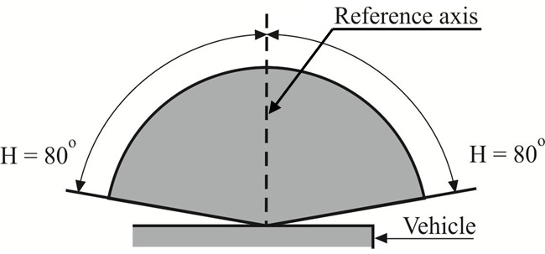
Front position lamps (for a pair of lamps)
V = +15° / -10°
However, in the case where a device is intended to be installed with its H plane at a mounting height less than 750 mm above the ground, the angle of 10° below the horizontal may be reduced to 5°.
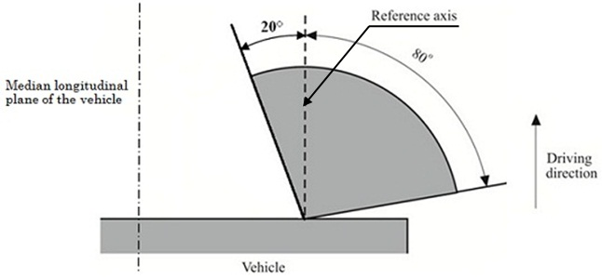
2. Rear position lamps
V = +15° / -10°
However, in the case where a device is intended to be installed with its H plane at a mounting height less than 750 mm above the ground, the angle of 10° below the horizontal may be reduced to 5°.

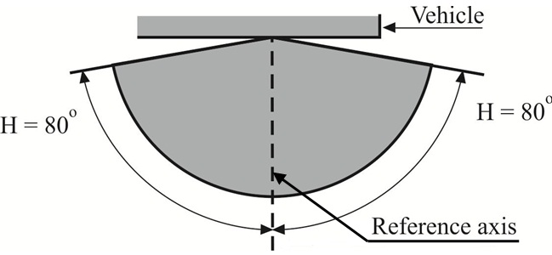
Rear position lamps (for a pair of lamps)
V = +15° / -10°
However, in the case where a device is intended to be installed with its H plane at a mounting height less than 750 mm above the ground, the angle of 10° below the horizontal may be reduced to 5°.
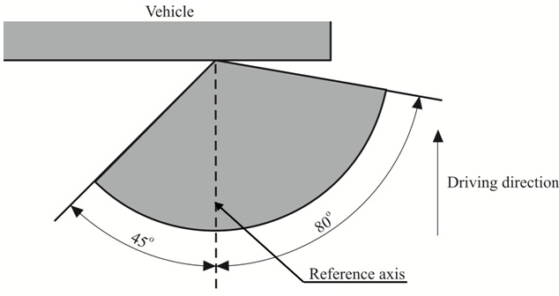
However, in the case where a device is intended to be installed with its H plane at a mounting height less than 750 mm above the ground, the inward angle of 45° may be reduced to 20° under the H plane.
3. Direction indicators of categories 11, 11a, 11b, 11c and 12
V = ±15°
However, in the case where a device is intended to be installed with its H plane at a mounting height less than 750 mm above the ground, the angle of 15° below the horizontal may be reduced to 5°.
Minimum horizontal angles of light distribution in space:
Categories 11, 11a, 11b and 11c: direction indicators for the front of the vehicle;
Category 11: for use at a distance not less than 75 mm from the passing-beam headlamp;
Category 11a: for use at a distance not less than 40 mm from the passing-beam headlamp;
Category 11b: for use at a distance not less than 20 mm from the passing-beam headlamp;
Category 11c: for use at a distance less than 20 mm from the passing-beam headlamp.
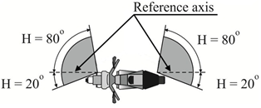
Reference axis

4. Stop lamps
V = + 15°/-10°
However, in the case where a device is intended to be installed with its H plane at a mounting height less than 750 mm above the ground, the angle of 10° below the horizontal may be reduced to 5°.
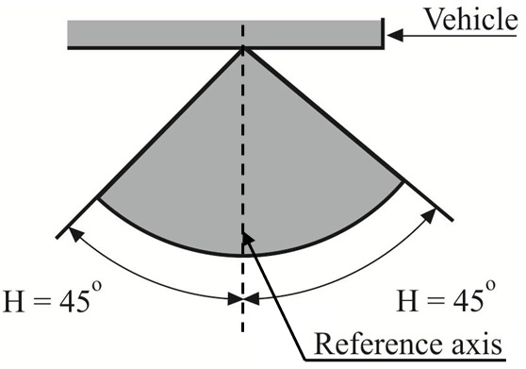
However, in the case of a pair of lamps, the inboard geometric visibility requirement is deemed to be satisfied if the lamps conform to the photometric values prescribed in the field of light distribution for the approval of the device.

Annex 2
Communication
(Maximum format: A4 (210 x 297 mm))

issued by : Name of administration:
.........................................
.........................................
.........................................
concerning: Approval granted
Approval extended
Approval refused
Approval withdrawn
Production definitively discontinued

of a type of front position lamps, rear position lamps, stop lamps, direction indicators and rear-registration-plate illuminating devices for mopeds, motor cycles and vehicles treated as such pursuant to UN Regulation No. 50
Approval No. ................................................ Extension No. ................................................
1. Trade name or mark of the device:
2. Manufacturer's name for the type of device:
3. Manufacturer's name and address:
4. If applicable, name and address of the manufacturer's representative:
5. Submitted for approval on:
6. Technical Service responsible for conducting approval tests:
7. Date of report issued by that Service
8. Number of report issued by that Service

9. Concise description:
By category of lamp:
Colour of light emitted: red / white / amber²
Number and category(ies) of light source(s):
Light source module: yes/no²
Light source module specific identification code:
Geometrical conditions of installation and relating variations, if any:
Application of an electronic light source control gear/variable intensity control:
(a) being part of the lamp: yes/no/not applicable²
(b) being not part of the lamp: yes/no/not applicable²
Input voltage(s) supplied by an electronic light source control gear/variable intensity control:
Electronic light source control gear/variable intensity control manufacturer and identification number (when the light source control gear is part of the lamp but is not included into the lamp body):
Only for limited mounting height of equal to or less than 750 mm above the ground: yes/no²
Function(s) produced by an interdependent lamp forming part of an interdependent lamp system:
Front position lamp: yes/no²
Rear position lamp: yes/no²
Stop lamp: yes/no²Sequential activation of light sources (see paragraph 6.9. of this Regulation): yes/no²
10. Position of the approval mark:
11. Reason(s) for extension (if applicable):
12. Approval granted/extended refused withdrawn²:
13. Place:
14. Date:
15. Signature:
16. The list of documents deposited with the Type Approval Authority which has granted approval is annexed to this communication and may be obtained on request

Annex 3
Examples of arrangements of the approval marks
(See paragraph 5.3. of this Regulation)

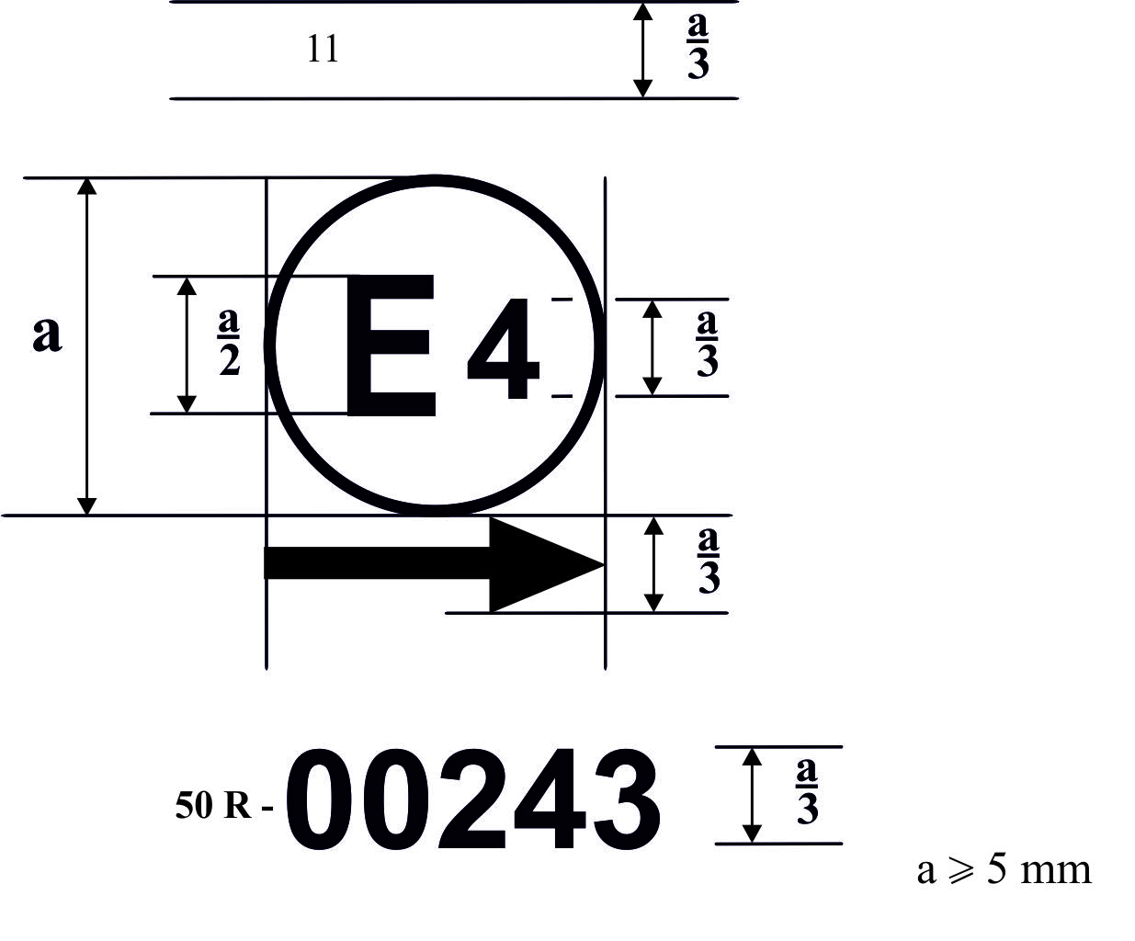
a/2
50R-00243
A device bearing the approval mark shown above is a direction indicator of the category 11 approved in the Netherlands (E 4) under the number 00243. The first two digits of the approval number indicate that the approval was granted in accordance with the requirements of UN Regulation No. 50 in its original form.
For a direction indicator, the arrow indicates that the luminous distribution is a symmetrical in a horizontal plane and that the photometric values required are satisfied up to an angle of 80° to the right, the device seen in the opposite sense of the light emitted.
The vertical arrow starting from a horizontal segment and directed downwards indicates a permissible mounting height of equal to or less than 750 mm from the ground for this device.
Light source modules

MD E3 17325

The light source module bearing the identification code shown above has been approved together with a lamp approved in Italy (E 3) under approval number 17325.
Note: The approval number shall be placed close to the circle and either above or below the letter "E" or to the left of right of that letter the digits of the approval number shall be on the same side of the "E" and face in the same direction. The use of Roman numbers as approval numbers should be avoided so as to prevent any confusion with other symbols.
Interdependent lamps
Marking of an interdependent lamp comprising part of an interdependent lamp system providing:
A rear position lamp (MRY) approved as an interdependent lamp forming part of an interdependent lamp system in accordance with the requirements of UN Regulation No. 50;
A stop-lamp (MSY) approved as an interdependent lamp forming part of an interdependent lamp system in accordance with the requirements of UN Regulation No. 50.

Marking of an interdependent lamp comprising part of an interdependent lamp system providing:
A rear direction indicator lamp (category 12) approved in accordance with the requirements of UN Regulation No. 50;
A rear position lamp (MRY) approved as an interdependent lamp forming part of an interdependent lamp system in accordance with the requirements of UN Regulation No. 50;
A stop-lamp (MSY) approved as an interdependent lamp forming part of an interdependent lamp system in accordance with the requirements of Regulation No. 50.
12 MRY MSY
50 R-00113
E13
MRY MSY
50 R-00113
E13

Annex 4
Photometric measurements
1. Measurement methods
1.1. During photometric measurements, stray reflections shall be prevented by appropriate masking.
1.2. Should the results of measurements be challenged, measurements shall be carried out in such a way as to meet the following requirements:
1.2.1. The distance of measurements shall be such that the law of the inverse of the square of the distance is applicable;
1.2.2. The measuring equipment shall be such that the angular aperture of the receiver viewed from the reference centre of the lamp is between 10' and 1°;
1.2.3. The intensity requirement for a particular direction of observation shall be deemed to be satisfied if that requirement is met in a direction deviating by not more than 15' from the direction of observation.
1.3. In the case where the device may be installed on the vehicle in more than one or in a field of different positions the photometric measurements shall be repeated for each position or for the extreme positions in the field of the reference axis specified by the manufacturer.
2. Standard luminous intensity distribution table
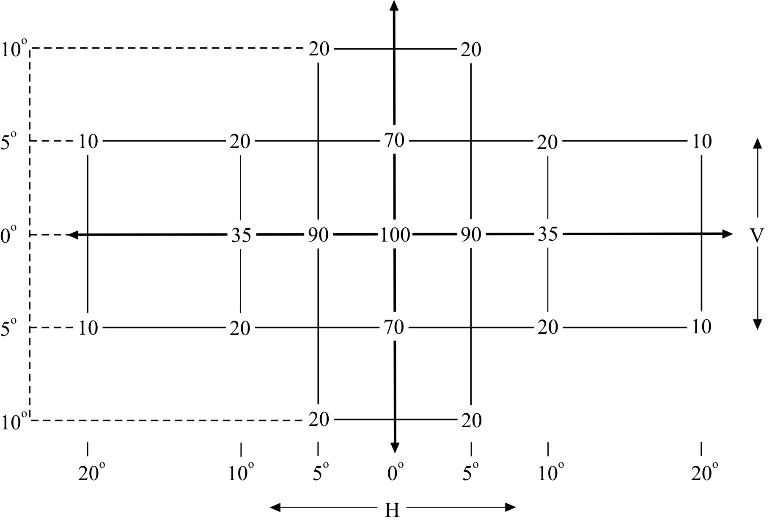
2.1. The direction H = 0° and V = 0° corresponds to the reference axis. (On the vehicle it is horizontal, parallel to the median longitudinal plane of the vehicle and oriented in the required direction of visibility). It passes through the centre of reference. The values shown in the table give, for the various directions of measurements, the minimum intensities as a percentage of the minimum required in the axis for each lamp (in the direction H = 0° and
V = 0°).
2.2. Within the field of light distribution of paragraph 2., schematically shown as a grid, the light pattern should be substantially uniform so that the light intensity in each direction of a part of the field formed by the grid lines meets at least the lowest minimum percentage value being shown on the grid lines surrounding the questioned direction.
2.3. However, in the case where a device is intended to be installed at a mounting height of equal to or less than 750 mm above the ground, the photometric intensity is verified only up to an angle of 5 degrees downwards."
3. Test conditions
The photometric performance shall be checked:
3.1. For non-replaceable light sources (filament light sources and others):
With the light sources present in the lamp, in accordance with the relevant subparagraph of paragraph 8.1. of this Regulation.
3.2. For replaceable light sources:
When equipped with light sources at 6.75 V or 13.5 V, the luminous intensity values produced shall be corrected.
For filament light sources the correction factor is the ratio between the reference luminous flux and the mean value of the luminous flux found at the voltage applied (6.75 V or 13.5 V).
For LED light sources the correction factor is the ratio between the objective luminous flux and the mean value of the luminous flux found at the voltage applied (6.75 V or 13.5 V).
The actual luminous fluxes of each light source used shall not deviate more than ±5 per cent from the mean value.
Alternatively and in case of filament light sources only, a standard filament light source may be used in turn, in each of the individual positions, operated at its reference flux, the individual measurements in each position being added together.
3.3. For any signalling lamps, except those equipped with filament light sources, the luminous intensities measured after one minute and after 30 minutes of operation shall comply with the minimum and maximum requirements; direction indicators shall be operated in the flashing mode (f = 1.5 Hz, duty factor 50 per cent). The luminous intensity distribution after one minute of operation can be calculated from the luminous intensity distribution after 30 minutes of operation by applying at each test point the ratio of luminous intensities measured at HV after one minute and after 30 minutes of operation.

Annex 5
Photometric measurements for the rear-registration-plate illuminating device
1. Space to be illuminated
The devices can be of category 1 or 2. The devices of category 1 shall be designed to illuminate a space of at least 130 x 240 mm, the devices of category 2 shall be designed to illuminate a space of at least 200 x 280 mm.
2. Colour of the light
The light of the illuminating device shall be sufficiently colourless in order not to modify noticeably the colour of the rear-registration-plate.
3. Angle of incidence
The manufacturer of the illuminating device shall specify one or more or a field of positions in which the device is to be fitted in relation to the space for the registration plate; when the lamp is placed in the position(s) specified by the manufacturer the angle of incidence of the light on the surface of the plate does not exceed 82° at any point of the surface to be illuminated, this angle being measured from the mid-point of the edge of the illuminating surface of the device which is furthest from the surface of the plate. If there is more than one illuminating device, the foregoing requirement shall apply only to the part of the plate intended to be illuminated by the device concerned.
The device shall be so designed that no light is emitted directly towards the rear, with the exception of red light if the device is combined or grouped with a rear lamp.
4. Measuring procedure
Luminance measurements shall be made on a diffuse colourless surface with known diffuse reflection factor. The diffuse colourless surface shall have the dimensions of the registration plate or the dimension exceeding one measuring point. Its centre shall be placed in the centre of the positions of the measuring points.
This diffuse colourless surface(s) shall be placed in the position normally occupied by the registration plate and 2 mm in front of its holder.
Luminance measurements shall be made perpendicularly to the surface of the diffuse colourless surface with the tolerance of 5° in each direction at the points shown in paragraph 5. of this annex, each point representing a circular area of 25 mm in diameter.
The measured luminance shall be corrected for the diffuse reflection
factor 1.0.
For an illuminating device not equipped with filament light sources, the luminance values measured after one minute and after 30 minutes of operation shall comply with the minimum requirements. The luminance distribution after one minute of operation can be calculated from the luminance distribution after 30 minutes of operation, by applying at each test point the ratio of luminance values measured at one point after one minute and after 30 minutes of operation.
5. Photometric characteristics
At each of the points of measurement shown below, the luminance B shall be not less than 2 cd/m².
Figure 1 Figure 2
Points of measurement for category 1 Points of measurement for category 2 (dimensions in mm) (dimensions in mm)

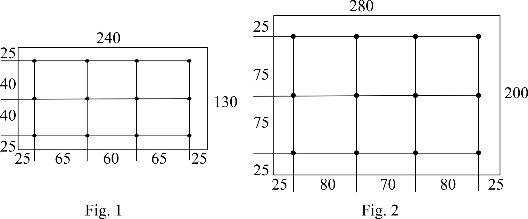
The gradient of the luminance between the values B₁ and B₂, measured at any two points 1 and 2 selected from among those mentioned above, shall not exceed 2 x B₀/cm, B₀ being the minimum luminance measured at the various points, that is to say:

* Former titles of the Agreement: Agreement Concerning the Adoption of Uniform Conditions of Approval and Reciprocal Recognition of Approval for Motor Vehicle Equipment and Parts, done at Geneva on 20 March 1958(original version); Agreement concerning the Adoption of Uniform Technical Prescriptions for Wheeled Vehicles, Equipment and Parts which can be Fitted and/or be Used on Wheeled Vehicles and the Conditions for Reciprocal Recognition of Approvals Granted on the Basis of these Prescriptions, done at Geneva on 5 October 1995 (Revision 2).
As defined in the Consolidated Resolution on the Construction of Vehicles (R.E.3.) (ECE/TRANS/WP.29/78/Rev.6)
The 01 series of amendments does not require changes in the approval number (TRANS/WP.29/815, para. 82).
The distinguishing numbers of the Contracting Parties to the 1958 Agreement are reproduced in Annex 3 to the Consolidated Resolution on the Construction of Vehicles (R.E.3) (ECE/TRANS/WP.29/78/Rev.6)
For the purpose of this Regulation "being part of the lamp" means to be physically included in the lamp body or to be external, separated or not, but supplied by the lamp manufacturer as part of the lamp system. The functioning and installation conditions of these additional systems will be defined by special provisions.
The 01 series of amendments does not require changes in the approval number (TRANS/WP.29/815, para. 82).
Distinguishing number of the country which has granted/extended/refused/withdrawn approval (see approval provisions in the Regulation).
Strike out what does not apply.
For the purpose of this Regulation "being part of the lamp" means to be physically included in the lamp body or to be external, separated or not, but supplied by the lamp manufacturer as part of the lamp system. The functioning and installation conditions of these additional systems will be defined by special provisions.
The 01 series of amendments does not require changes in the approval number (TRANS/WP.29/815, para. 82).
CIE Publication No. 17 - 1970, paragraph 45-20-040

