INF.10
Economic Commission for Europe  Inland Transport Committee  Working Party on the Transport of Perishable Foodstuffs  Eightieth session  Geneva, 24-27 October 2023  Item 3 (c) of the provisional agenda  Activities of other international organizations dealing  with issues of interest to the Working Party:  standardization organizations | 12 October 2023  English

Liaison with ISO TC 315
Transmitted by Tranfrigoroute International on behalf of the ISO liaison representatives
Summary
Executive summary: Report of liaison with ISO TC315
Action to be taken: Information only.
Related documents: NA.
Introduction
1. Back in 2021, a new ISO Technical Committee (TC) has been established with the intent to deal with Cold chain logistics.
2. It has been discussed that a liaison between WP 11 and this new TC 315 would be beneficial for both.
3. In April 2022, a liaison between UNECE and ISO/TC 315 has been officially approved
4. Accordingly, Yan Zhang (UNECE); Alibech Mireles Diaz (UNECE) and Lionel Pourcheresse (AFNOR expert) have been registered as a liaison representative from UNECE to TC 315 in the ISO database (ISO Global Directory).
Latest update from ISO/TC 315
5. Latest TC 315 Plenary and WG meetings was on 18 – 22 September 2023 (hybrid mode, Paris + online)
6. WG 2 - ISO 31511 - Requirements for contactless delivery services in cold chain logistics
Project leader : Xianghua ZHU (Chine)
- Vote New Work Item (NWIP) in 2022
- Vote Committee Draft (CD) in 2023
- Next step: Draft International Standard (DIS) + Public survey
7. WG 3 - ISO 31512 — Cold Chain Logistics services in B to B sector — Requirements for low temperature storage services and low temperature transport services
Project leader : Prof. Takayuki MORI (Japon)
- Vote New Work Item (NWIP) in 2022
- Vote Committee Draft (CD) in 2023
- Next step: Draft International Standard (DIS) + Public survey
8. WG 4 - ISO 31510 - Terminology
Project leader : Prof. Shigeo TOMITA (Japon) and Shuhuai XIAO (Chine)
- Vote New Work Item (NWIP) in 2022
- Next step: Committee Draft (CD)
9. WG 5 - ISO 31513
ISO/TC 315 approves the articulation of the scope of ISO/AWI 31513, noting that the change does not entail expansion of the scope. The new scope now reads:
“This document specifies general validation procedure and methods for temperature-controlled storages and road vehicles.”
Project leader : Kyoung Jong Kim (Corée du Sud)
- Vote New Work Item (NWIP) in 2023
- Next step: Committee Draft (CD)
10. WG 6 - ISO 31514 - Requirements and Guidelines for Food Traceability in Cold Chain Logistics
ISO/TC 315 resolves to appoint Mr. Richard Khaw as co-project leader of ISO TS 31514.
ISO/TC 315 asks CM to launch a CIB for confirmation.
Project leader : Holly Huang (Chine)
- Vote New Work Item (NWIP) in 2023
- Next step: Committee Draft (CD)
11. ISO/TC 315 agrees to plan its plenary twice a year, one virtual in Spring and another hybrid meeting in Fall.
12. ISO/TC 315 agrees to plan its next plenary meeting in Singapore in Fall, 2024.

Latest structure of ISO/TC 315
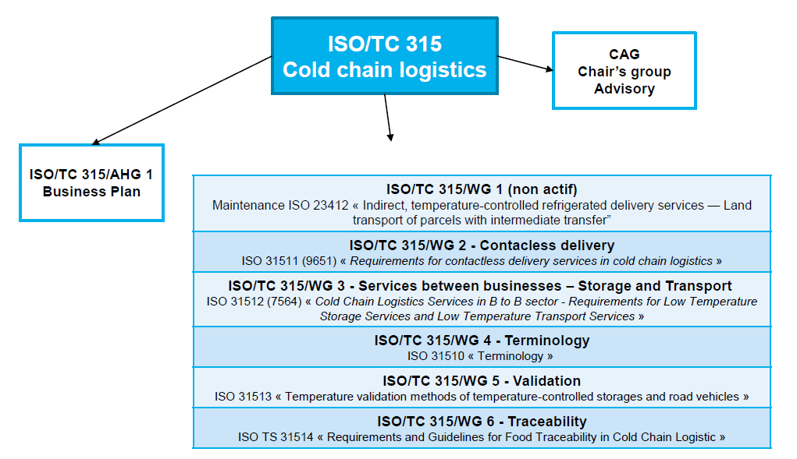
More information: https://www.iso.org/committee/6880159.html

