|  |  |  |  |
| --- | --- | --- | --- |
|  | United Nations | ECE/TRANS/WP.15/2024/2 | |
| _unlogo | **Economic and Social Council** | | Distr.: General  8 January 2024  English  Original: English and French |

**Economic Commission for Europe**

Inland Transport Committee

**Working Party on the Transport of Dangerous Goods**

**115th session**

Geneva, 2-5 April 2024

Item 5 (b) of the provisional agenda

**Proposals for amendments to annexes A and B of ADR**:

**Miscellaneous proposals**

Marking of a tank-vehicle carrying UN numbers 1202, 1203 and 3475

Transmitted by FuelsEurope[[1]](#footnote-2)\*

I. Introduction

1. In recent years we have noticed a strong increase in the consumption of E85-Superethanol fuel. This fuel is composed of between 50 percent and 85 percent ethanol and at least 15 percent gasoline (according to EN 15293). This product is carried under UN 3475.

2. If a tank-vehicle carries several products including UN 3475, it needs:

(a) orange-coloured plates at the front and the rear; and

(b) orange-coloured plates with hazard identification number and UN number for each of the substances carried in a compartment.

A standard semi-trailer is manufactured with 9 compartments, so, it is therefore necessary to fit 20 orange plates on this standard transport unit.

Below an example of a tank-vehicle with 6 compartments:

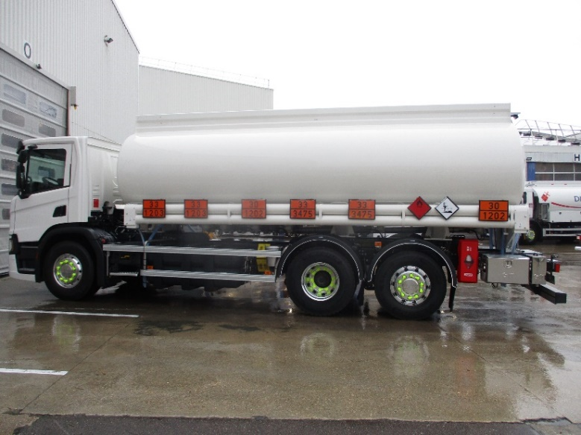

3. The contents and volume of the compartment are reliably indicated by a device as follows:

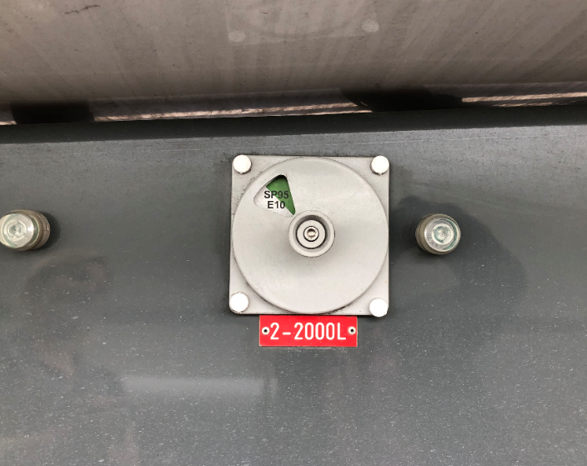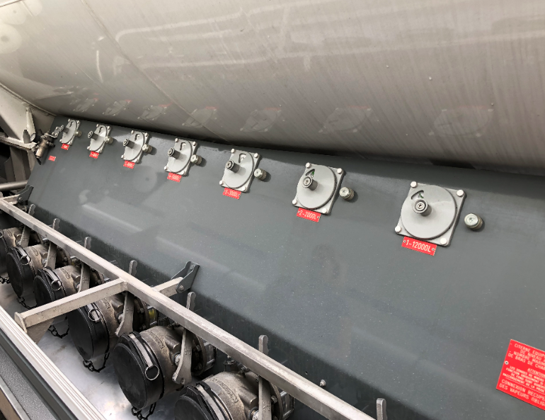

4. In the event of a fire involving polar products (UN 3475), it is advisable to use an alcohol-resistant foam called AR. The AR foam concentrate is now widely used in Europe and used by emergency services to cover the risks associated with the carriage of pure ethanol.

5. Below the consumption of E85 or the number of service stations distributing E85 in some European countries:

* + Finland: 14 million litres (2019),
  + France: 467 million litres (2021),
  + Sweden: 29.3 million litres (2021),
  + Switzerland: 5 million litres (2021),
  + Czech Republic: Around 50 E85 petrol stations,
  + Lithuania: 52 E 85 petrol stations,
  + Netherlands: 50 E85 petrol Stations.

II. Proposal

6. Amend 5.3.2.1.3 of ADR to read as follows (new wording is underlined):

“For tank-vehicles or transport units having one or more tanks carrying substances with UN Nos. 1202, 1203, ~~or~~ 1223 or 3475, or aviation fuel classified under UN Nos. 1268 or 1863, but no other dangerous substance, the orange-coloured plates prescribed in 5.3.2.1.2 need not be affixed if the plates affixed to the front and rear in accordance with 5.3.2.1.1 bear the hazard identification number and the UN number prescribed:

- for UN No. 3475; or

- for the most hazardous substance carried, i.e. the substance with the lowest flash-point in the absence of substance with UN No. 3475.”

III. Justification

7. This proposal would limit the risks of marking errors; indeed, for a vehicle with 9 compartments, 20 orange-colored plates are required (2 blanks and 9 coded on each side of the truck). We think the information on the side is more confusing, and it's easier to miss a UN No. 3475 plate in a dozen orange plates.

8. In many accident situations, the front or rear orange plate is the most visible information when firefighters arrive on the scene. Codification of this orange plate will provide firefighters with quicker information.

9. This proposal is an adaptation to the evolution of increasingly green fuels. More and more countries are introducing the obligation to use fuels with large amounts of ethanol such as the current study of E20 (fuel with 20 percent ethanol)

1. **\*** A/78/6 (Sect. 20), table 20.5. [↑](#footnote-ref-2)