|  |  |  |
| --- | --- | --- |
|  | E/ECE/324/Rev.1/Add.34/Rev.1/Amend.2−E/ECE/TRANS/505/Rev.1/Add.34/Rev.1/Amend.2 | |
|  |  | 2 July 2021 |

Agreement

Concerning the Adoption of Harmonized Technical United Nations Regulations for Wheeled Vehicles, Equipment and Parts which can be Fitted and/or be Used on Wheeled Vehicles and the Conditions for Reciprocal Recognition of Approvals Granted on the Basis of these United Nations Regulations[1]*

(Revision 3, including the amendments which entered into force on 14 September 2017)

_________

Addendum 34 – UN Regulation No. 35

Revision 1 – Amendment 2

01 series of amendments – Date of entry into force: 9 June 2021

Uniform provisions concerning the approval of vehicles with regard to the arrangement of foot controls

****This document is meant purely as documentation tool. The authentic and legal binding text is: ECE/TRANS/WP.29/2020/102.

_________

**UNITED NATIONS**

*Paragraph 1, footnote 1,* amend to read:

"1 As defined in the Consolidated Resolution on the Construction of Vehicles (R.E.3), document ECE/TRANS/WP.29/78/Rev.6, para. 2 - [www.unece.org/trans/main/wp29/wp29wgs/wp29gen/wp29resolutions.html](http://www.unece.org/trans/main/wp29/wp29wgs/wp29gen/wp29resolutions.html)**"**

*Paragraph 4.2.*, amend to read:

"4.2. An approval number shall be assigned to each type approved. Its first two digits (at present 01) shall indicate the series of amendments incorporating the most recent major technical amendments made to the UN Regulation at the time of issue of the approval. The same Contracting Party shall not assign the same number to another vehicle type."

*Paragraph 4.4.1., footnote 2*, amend to read:

"2 The distinguishing numbers of the Contracting Parties to the 1958 Agreement are reproduced in Annex 3 to the Consolidated Resolution on the Construction of Vehicles (R.E.3), document ECE/TRANS/WP.29/78/Rev.6, Annex 3 - [www.unece.org/trans/main/wp29/wp29wgs/wp29gen/wp29resolutions.html](http://www.unece.org/trans/main/wp29/wp29wgs/wp29gen/wp29resolutions.html)"

*Paragraph 5.5.*, amend to read:

"5.5. The distance**,** shown at "F" in [annex 4](https://raceonline.utac.com/fr/document/show/document_id/1197#A4_), between the orthogonal projections of the service-brake-pedal and the clutch-pedal bearing surfaces on to the reference plane "P" shall be ≥ 50 mm."

*Paragraph 5.6.*, amend to read:

"5.6. The distance**,** shown at "G" in [annex 4](https://raceonline.utac.com/fr/document/show/document_id/1197#A4_),between the contour points of the projection of the clutch pedal on to plane "P" and the intersection of the nearest wall with plane "P" shall be ≥ 50 mm."

*Paragraph 5.7.*, amend to read:

"5.7. The distances, respectively shown as "H" and "J" in Annex 4, between the projection of the service-brake pedal on to the reference plane "P" and the intersection of each of the walls with that plane shall be ≥ 130 mm to the right and ≥ 160 mm to the left for vehicles with three pedals, and ≥ 130 mm to the right and ≥ 120 mm to the left for vehicles with two pedals.

In the case of a foot rest as declared by the manufacturer, installed for the driver's left foot, the measurements for "J" and "G" in Annex 4 shall ignore the foot rest. The distance, shown at "K" in [annex 4](https://raceonline.utac.com/fr/document/show/document_id/1197#A4_), between the contour points of the projection of the left most pedal on to plane "P" and the intersection of the footrest with plane "P" shall be ≥ 50 mm."

Paragraph 7, *amend to read:*

"7. Conformity of production

The conformity of production procedures shall comply with those set out in the Agreement, Schedule 1 (E/ECE/TRANS/505/Rev.3), with the following requirements:

…"

*Insert new paragraphs 10. to 10.4.*, to read:

"10. Transitional provisions

10.1. As from the official date of entry into force of the 01 series of amendments, no Contracting Party applying this Regulation shall refuse to grant or refuse to accept type approvals under this Regulation as amended by the 01 series of amendments.

10.2. As from 1 September 2022, Contracting Parties applying this Regulation shall not be obliged to accept type approvals to the preceding series of amendments, first issued after 1 September 2022.

10.3. Contracting Parties applying this Regulation shall continue to accept type approvals issued according to the preceding series of amendments to this Regulation first issued before 1 September 2022.

10.4. Contracting Parties applying this Regulation shall not refuse to grant type approvals according to any preceding series of amendments to this Regulation or extensions thereof."

*Paragraph 10. (former),* renumber as paragraph 11.

*Annex 1, item 5,* amend to read:

"5. Brief description of the vehicle type as regards the arrangement of foot controls and foot rest..........................................................................................................."

*Annex 2,* amend to read:

"**Arrangements of approval marks**

**Model A**  
(See paragraph 4.4. of this Regulation)

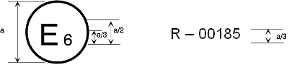  
a = 8 mm min

41 R - 0**4** 2439

**4**

41 R - 0**4** 2439

41 R - 0**4** 2439

41 R - 0**4** 2439

35 R - 01 2439

The above approval mark affixed to a vehicle shows that the vehicle type concerned has, with regard to the arrangement of foot controls, been approved in the Netherlands (E 4) under approval number 012439. The first two digits of the approval number indicate that the approval was granted in accordance with the requirements of UN Regulation No. 35, as amended by the 01 series of amendments.

**Model B**

(See paragraph 4.5. of this UN Regulation)

a

a

3

35 01 2439

24 * 1.30 03 1628

a

3

a

2

a

2

a

2

a = 8 mm min.

The above approval mark affixed to a vehicle shows that the vehicle type concerned has been approved in the Netherlands (E 4) pursuant to UN Regulation Nos. 35 and 24.1 (In the case of the latter UN Regulation the corrected absorption co-efficient is 1.30 m-1). The first two digits of the approval numbers indicate that, at the date on which the respective approvals were granted, UN Regulation No. 35 included the 01 series of amendments and UN Regulation No. 24 included the 03 series of amendments.

_____________

1 The second number is given merely as an example."

*Annex 3,* shall be deleted

*Insert a new Annex 3,* to read:

"Annex 3

Procedure for determining the "H" point and the actual   
torso angle for seating positions in motor vehicles1

Appendix 1 - Description of the three dimensional "H" point machine1

Appendix 2 - Three-dimensional reference system1

Appendix 3 - Reference data concerning seating positions1

_____________

1 The procedure is described in Annex 1 and its Appendices 1, 2 and 3 to the Consolidated Resolution on the Construction of Vehicles (R.E.3) (document ECE/TRANS/WP.29/78/Rev.6 - [www.unece.org/trans/main/wp29/wp29wgs/wp29gen/wp29resolutions.html](http://www.unece.org/trans/main/wp29/wp29wgs/wp29gen/wp29resolutions.html)"

*Annex 4,* amend to read:

"Annex 4

Arrangement of foot controls

Figure 1a

**Two pedals – Automatic transmission without footrest**

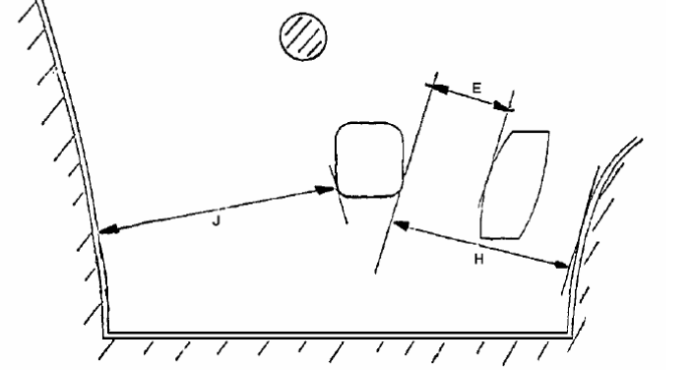

Figure 1b

**Two pedals – Automatic transmission with footrest**

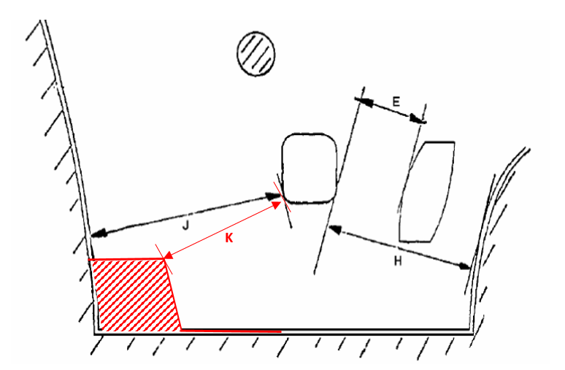

|  | *max.* | *min.* |
| --- | --- | --- |
| E | 100 | 50 |
| H | - | 130 |
| J | - | 120 |
| K | **-** | 50 |

# Figure 2a

# **Three-pedals – Conventional transmission without Footrest**



# Figure 2b

# **Three-pedals - Conventional transmission with Footrest**

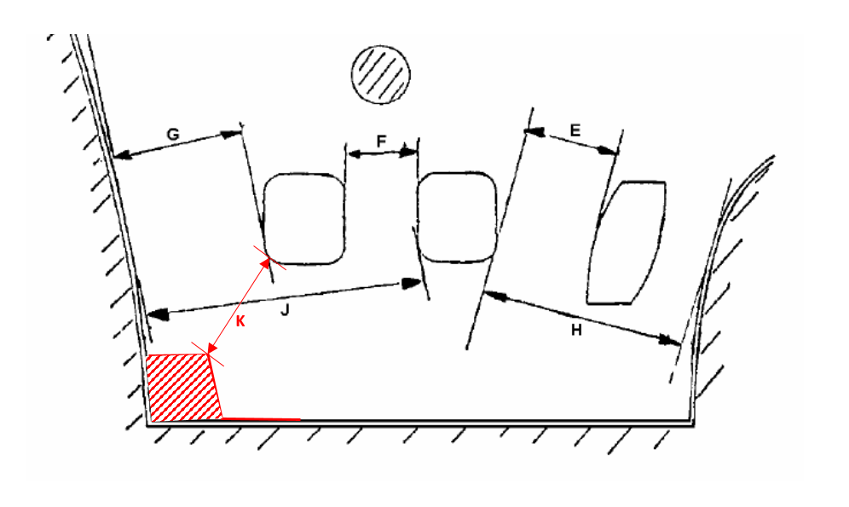

|  | *max.* | *min.* |
| --- | --- | --- |
| E | 100 | 50 |
| F | - | 50 |
| G | - | 50 |
| H | - | 130 |
| J | - | 160 |
| K | - | 50 |

"

1. * Former titles of the Agreement:

   Agreement concerning the Adoption of Uniform Conditions of Approval and Reciprocal Recognition of Approval for Motor Vehicle Equipment and Parts, done at Geneva on 20 March 1958 (original version);

   Agreement concerning the Adoption of Uniform Technical Prescriptions for Wheeled Vehicles, Equipment and Parts which can be Fitted and/or be Used on Wheeled Vehicles and the Conditions for Reciprocal Recognition of Approvals Granted on the Basis of these Prescriptions, done at Geneva on 5 October 1995 (Revision 2).