|  |  |  |  |
| --- | --- | --- | --- |
|  | United Nations | ECE/TRANS/WP.29/GRSP/2024/10 | |
| _unlogo | **Economic and Social Council** | | Distr.: General  18 March 2024  Original: English |

**Economic Commission for Europe**

Inland Transport Committee

**World Forum for Harmonization of Vehicle Regulations**

**Working Party on Passive Safety**

**Seventy-fifth session**

Geneva, 27–31 May 2024

Item 12 of the provisional agenda

**UN Regulation No. 127 (Pedestrian safety)**

Proposal for Supplement 3 to the 03 Series of Amendments and Supplement 2 to the 04 Series of Amendments to UN Regulation No. 127 (Pedestrian safety)

Submitted by the experts from Germany, France, the Netherlands, and the International Organization of Motor Vehicle Manufacturers [[1]](#footnote-2)\*, [[2]](#footnote-3)\*\*

The text reproduced below was prepared by the experts from Germany, France, the Netherlands, and the International Organization of Motor Vehicle Manufacturers (OICA) to amend documents ECE/TRANS/WP.29/GRSP/2023/49 and ECE/TRANS/WP.29/GRSP/2023/50, adopted at the June 2023 session of the World Forum for Harmonization of Vehicle Regulations (WP29), to clarify the definition of the "third of windscreen". The modifications to the current text of the UN Regulation (including ECE/TRANS/WP.29/GRSP/2023/49 and ECE/TRANS/WP.29/GRSP/2023/50) are marked in bold for new or strikethrough for deleted characters.

**I. Proposal**

*Paragraph 2.44.*, *Figure 13*, amend to read:

"Figure 13  
**Upper Corner Definition with "Shortest Distance"**

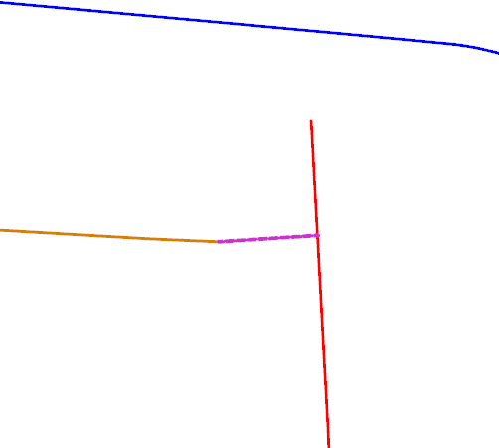

Rear offset is inboard of side offset"

Connecting curve

**Q**

S

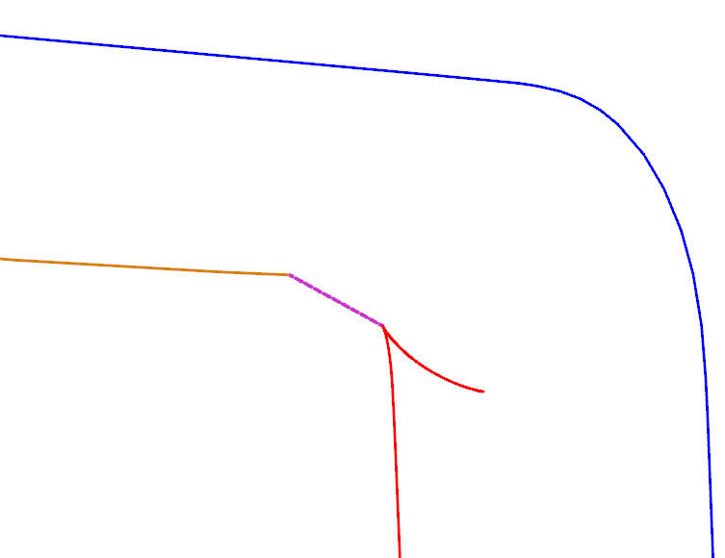

Both side offset and rear offset are short of intersection

Connecting curve

**Q**

S

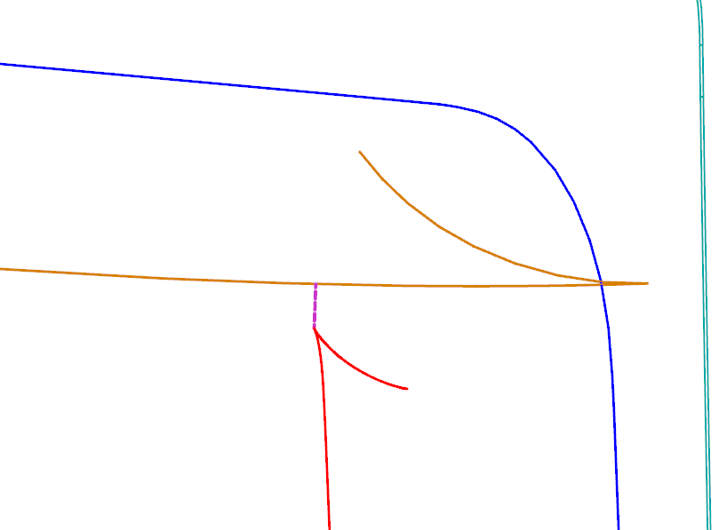

Side offset is forward of rear offset

Connecting curve

**Q**

S

*Paragraph 2.45.*, *Figure 14*, amend to read:

"Figure 14

**Lateral Limits of the Cowl Monitoring Area**

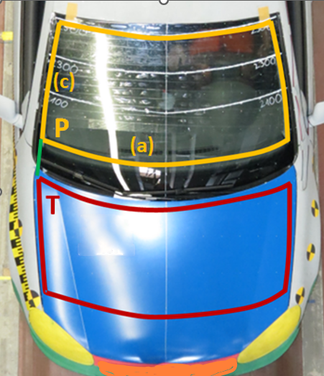"

*Paragraph 2.49.*, amend to read:

"2.49. "**One t**~~T~~hird of the windscreen test area" means ~~the geometric trace of~~ the area between the ~~lateral~~ **side** boundaries of the windscreen test area as defined in paragraph 2.44.(c), ~~measured with a flexible tape following the outer contour of the windscreen on any transverse section, divided in three equal parts~~ **divided by the lines passing through the third markings of the lines from P to P' and from Q to Q' (the upper corner points of the windscreen test area), as shown in Figure 17. All lines are to be drawn and the three equal parts to be measured with a flexible tape following the outer contour of the windscreen. In case Q and Q' are coincident with P and P’, Q and Q' are to be created on the side boundary lines as defined in paragraph 2.44. (c) rearward of P and P', respectively.**

**If there is no unique "Q point" where the lines defined in paragraph 2.44. (b) and (c) intersect, then the "Q point" is defined by the first contact of a vertical plane V45, intersecting the vertical longitudinal vehicle centre-plane at an angle of 45°, with the (b)-(c) transition of the windscreen test area boundary.**

**If there is no intersection between (b) and (c) and the open test area is closed by a connecting line, as illustrated in Figure 13, then the "Q point" is defined by the centre of this connecting line.**"

Figure 17 **Thirds of the windscreen test area**

|  |
| --- |
| **P**  **P'**  **Q'**  **1/3**  **1/3**  **1/3**  **1/3**  **1/3**  **1/3**  **(b)**  **(c)**  **Q**  **V45**  **V45**  **Third Markings** |

II. Justification

This proposal clarifies how to define the thirds of the windscreen test area, corrects the names of the upper corners as **Q** and **Q’** instead of R and R’ in Figure 13, and update Figure 14.

1. \* This document was scheduled for publication after the standard publication date owing to circumstances beyond the submitter's control. [↑](#footnote-ref-2)
2. \*\* In accordance with the programme of work of the Inland Transport Committee for 2024 as outlined in proposed programme budget for 2024 (A/78/6 (Sect. 20), table 20.5), the World Forum will develop, harmonize and update UN Regulations in order to enhance the performance of vehicles. The present document is submitted in conformity with that mandate. [↑](#footnote-ref-3)