Proposal for Supplement 3 to the Original Version of
UN Regulation No. 158 (Devices for means of rear visibility or detection)

The text reproduced below was prepared by the expert from the Republic of Korea. The modifications to the current text of UN Regulation No. 158 are displayed in bold for new or strikethrough for deleted characters.

- Proposal
Annex 9. Test methods for close-proximity rear-view field of vision
Paragraph 1.3.3.4., amend to read:
"1.3.3.4. Rear hatch and, trunk lids. and tail gates.
If the vehicle is equipped with rear hatches, or trunk lids, or tail gates, they are closed and latched in their normal vehicle operating condition."

Annex 10. Test methods for detection systems
Paragraph 1.1., amend to read:
"1.1. Test conditions.
The test object shall be as per paragraph 7.1. of ISO 17386:2010. During testing, the wind speed shall not exceed 1 m/s. The temperature shall be 20±5℃ and the humidity shall be 60±25 percent. There shall be no rain or snow. The test shall be performed on a flat, dry asphalt or concrete surface. The test shall not be affected by the reflection of sound waves or electromagnetic waves from any walls, auxiliary testing equipment or any other objects in the environment. If the vehicle is equipped with rear hatches, trunk lids or tail gates, they are closed and latched in their normal vehicle operating condition."

II. Justification
1. The vehicle conditions of the test methods for rear-view field of vision are clearly specified in the annex 9 in this Regulation, but in the case of detection systems in Annex 10, they are not clear. This is a problem of inconsistency between the rear-view field of vision and the detection systems, and it may also cause ambiguity in conducting the test for detection systems.

2. In addition, the test conditions should specify that not only rear hatches or trunk lids but also the tail gates of cargo trucks and van-type vehicles should be closed or latched in their normal vehicle operating condition during the test. For additional information on this matter, please refer to the following figures.

Figure 1. example of cargo truck tailgate.
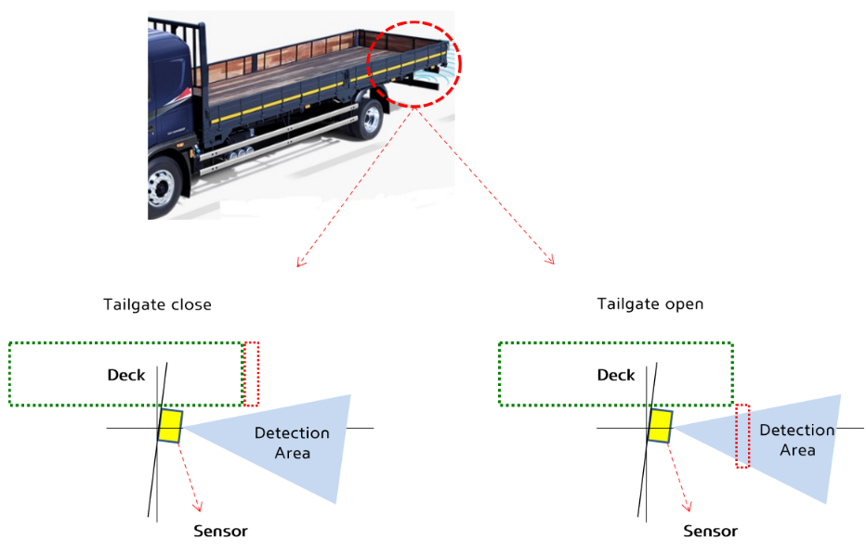

Figure 2. example of van type vehicle tail gate.

