|  |  |  |  |
| --- | --- | --- | --- |
|  | United Nations | ST/SG/AC.10/C.3/2024/17 | |
| _unlogo | **Secretariat** | | Distr.: General  9 April 2024  Original: English |

**Committee of Experts on the Transport of Dangerous Goods  
and on the Globally Harmonized System of Classification  
and Labelling of Chemicals**

**Sub-Committee of Experts on the Transport of Dangerous Goods**

**Sixty-fourth session**

Geneva, 24 June-3 July 2024

Item 3 of the provisional agenda

**Listing, classification and packing**

Transport of liquid organic hydrogen carrier – new special provision to UN 3082

Submitted by the expert from Germany[[1]](#footnote-2)\*

I. Introduction

1. Hydrogen will play an important role in decarbonizing the energy systems. There are different options for transportation, one being the chemical binding of hydrogen molecules to chemical carriers. Rules for transporting hydrogen via different pathways will have to be adapted in the future.

2. Germany is convinced that the transport conditions when transporting liquid organic hydrogen carriers (LOHC) based on benzyltoluene (BT) could benefit from clarification. In addition, Germany is of the opinion that the interpretations and amendments proposed in this document lead to a higher level of protection for the transport of hydrogen when chemically bound to this carrier and result in more coherent measures. Currently, the *Model Regulations* do not properly define the levels of physically dissolved hydrogen for benzyltoluene as a hydrogen carrier. By introducing the requirements proposed below, Germany intends to increase safety when transporting hydrogen via this carrier.

3. A working document was presented at the last session of the Sub-Committee. Considering the positive feedback to that document, Germany decided to resubmit this proposal with some additional information.

II. Discussion

4. There are various transport options for hydrogen. Hydrogen can be transported under high pressure as a gas, in refrigerated liquefied form or chemically bound to liquid carrier substances, so-called liquid organic hydrogen carriers (LOHC). One of the substances to which hydrogen can be chemically bound is benzyltoluene.

5. Benzyltoluene is a substance that has been well known for a long time and is assigned to UN No. 3082 ENVIRONMENTALLY DANGEROUS SUBSTANCE, LIQUID, N.O.S. as a dangerous good of Class 9. Six hydrogen molecules can be chemically bound to one benzyltoluene molecule in accordance with the following scheme (hydrogenation).

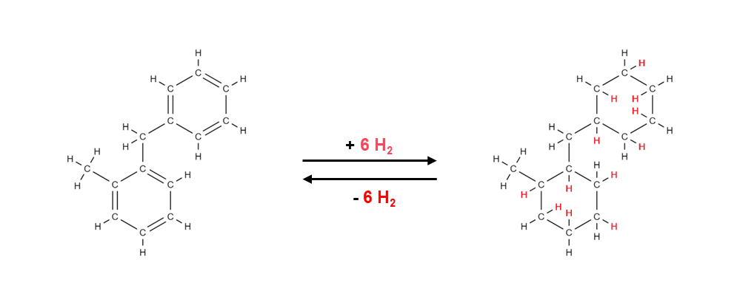

This means that, depending on the degree of hydrogenation, in one liter of benzyltoluene up to approximately 700 liters of hydrogen can be chemically bound.

6. Special reaction conditions are necessary to later release the chemically bound hydrogen. In this specific case, the chemical bonds are released with the help of a catalytic system at temperatures of 250 °C. This means that the chemically bound hydrogen cannot be released under transport conditions.

7. The problem, which Germany has furthermore considered from the point of view of safety, is the fact that in the process of binding hydrogen to the hydrogen carrier (hydrogenation) traces of hydrogen in physically dissolved form, i.e. not chemically bound, can remain in the hydrogen carrier. These traces of hydrogen that are only physically dissolved may potentially be released during transport.

8. To obtain reliable insights and to be able to carry out a well-founded safety assessment of the possible scenarios, the Physikalisch-Technische Bundesanstalt (PTB, National Metrology Institute of Germany) has carried out experimental tests. These tests were aimed at determining whether the release of the physically dissolved traces of hydrogen can lead to the formation of explosive atmospheres.

9. For the tests conducted at the PTB, extreme test conditions (worst case scenarios) were chosen. The degree of filling of the autoclave was 90 per cent and the samples were first cooled down to -30 °C and subsequently heated to 70 °C to achieve the greatest possible gas release (hydrogen).

III. Results

10. The tests showed that only for untreated samples and only under the above extreme conditions there is a small risk of formation of explosive atmospheres. In all other cases, no ignitions were detected.

11. The safety assessment was performed based on the provisions for Class 4.3 “Substances which in contact with water emit flammable gases”. For assigning substances to Class 4.3, the provisions contain a limit value for the gas evolution rate of 1 L (flammable gas) / kg (substance) in one hour. Against this background, a limit value for the physically dissolved hydrogen content of 0.5 L / kg (LOHC) is considered appropriate to ensure safe transport of hydrogen in liquid organic hydrogen carriers (LOHC).

12. Germany would like to explicitly point out again that within the context of these comparative assessments different processes with systematically different limit values were considered. On one hand, there is a chemical reaction (formation of flammable gases in contact with water) that can go on more or less continuously during the entire transport operation. On the other hand, there is a gas release process that is completed when the amount of the dissolved gas has escaped from the liquid hydrogen carrier.

13. The restrictive limit value for the physically dissolved hydrogen content of 0.5 L / kg (LOHC) can be achieved with reasonable efforts by means of measures such as targeted degassing or optimization of the process parameters. It is also possible to monitor the limit value by testing representative samples or by an online gas analysis.

14. This document supports Sustainable Development Goal 13 – Climate Action of the UN Agenda 2030 by promoting the safe transport of alternative low-carbon fuels.

IV. Proposal

15. Amend the Dangerous Goods List in chapter 3.2 as follows (new text is underlined):

| UN No. | Name and description | Class  or  division | Subsi-diary hazard | UN packing group | Special provi-sions | Limited and excepted quantities | | Packagings and IBCs | | Portable tanks and bulk containers | |
| --- | --- | --- | --- | --- | --- | --- | --- | --- | --- | --- | --- |
| Packing instruction | Special  packing provisions | Instruc-tions | Special provisions |
| (1) | (2) | (3) | (4) | (5) | (6) | (7a) | (7b) | (8) | (9) | (10) | (11) |
| 3082 | ENVIRONMENTALLY HAZARDOUS SUBSTANCE, LIQUID, N.O.S | 9 |  | III | 274  331  335  375  XXX | 5 L | E1 | P001  IBC03  LP01 | PP1 | T4 | TP1  TP29 |

16. Amend chapter 3.3 by introducing the following new special provision XXX:

“XXX Liquid organic hydrogen carriers (LOHC) based on benzyltoluene with physically dissolved hydrogen can be transported under this entry when the limit of physically dissolved hydrogen of 0.5 L (H2)/kg (LOHC) is not exceeded.”

1. \* A/78/6 (Sect. 20), table 20.5. [↑](#footnote-ref-2)