UNITED  NATIONS |  | E
 | Economic and Social  Council | Distr.  GENERAL  ECE/TRANS/WP.29/GRE/2009/47  16 July 2009  Original: ENGLISH  ENGLISH AND FRENCH ONLY

ECONOMIC COMMISSION FOR EUROPE

INLAND TRANSPORT COMMITTEE

World Forum for Harmonization of Vehicle Regulations

Working Party on Lighting and Light-Signalling

Sixty-second session
Geneva, 6 - 9 October 2009
Item 5(d) of the provisional agenda

COLLECTIVE AMENDMENTS

Regulations Nos. 19, 48, 98, 112 and 123

Proposal for draft 01 series of amendments to Regulation No. 123
(Adaptive front-lighting systems)

Submitted by the expert from the Working Party "Brussels 1952" ∗/

The text reproduced below was prepared by the expert from the Working Party "Brussels 1952" (GTB) in order to change the basis for the photometric requirements from 12.0v to 13.2v, to align the cut-off definitions with Regulations Nos. 98 and 112 and to correct some editorial errors. The text is based on informal document No. GRE-61-20 distributed during the sixty-first session of the Working Party on Lighting and Light-Signalling (GRE) (see report ECE/TRANS/WP.29/GRE/61, para. 26). It supersedes ECE/TRANS/WP.29/GRE/2009/23. The modifications to the current text of the Regulation, including Corrigendum 2 to Regulation No. 123, are marked in bold or strikethrough characters.
- PROPOSAL

The list of contents, amend to read:

"12. ……

13. Transitional provisions……………………………………………………….. "

Paragraph 2.2.2., amend to read:

"2.2.2. …
(g) the indication(s) 3/ according to the provisions of paragraph 6.4.6. of this Regulation with respect to the paragraphs 6.22.6.1.2.1. and 6.22.6.1.3. . of Regulation No. 48;
…"

Paragraph 4.1.3., amend to read:

"4.1.3. An approval number shall be assigned to each type approved. Its first two digits (at present 00) shall indicate the series of amendments incorporating the most recent major technical amendments made to the Regulation at the time of issue of the approval. The same Contracting Party may not assign the same number to another type of system covered by this Regulation."

Paragraph 4.2.2.2., amend to read:

"4.2.2.2. in addition to each symbol and above it a score, if the lighting function or mode thereof is provided by more than one installation unit from one or both side(s);"

Paragraph 4.2.4., amend to read:

"4.2.4. The two digits of the approval number (at present 00) which indicate the series of amendments incorporating the most recent major technical amendments made to the Regulation at the time of issue of the approval and, if necessary, the required arrow may be marked close to the above additional symbols."

Paragraph 5.7.1., amend to read:

"5.7.1. the device is robust enough to withstand 50,000 operations under normal conditions of use. In order to verify compliance with this requirement, the Technical Service responsible for approval tests may:
(a) require the applicant to supply the equipment necessary to perform the test;
(b) forego the test if the headlamp presented by the applicant is accompanied by a test report, issued by a Technical Service responsible for approval tests for headlamps of the same construction (assembly), confirming compliance with this requirement."

Paragraph 5.7.3., amend to read:

"5.7.3. in the case of failure it must be possible to obtain automatically a passing beam or a state with respect to the photometric conditions which yields values not exceeding 1.5 lx 1300 cd in the zone III b as defined in Annex 3 to this Regulation and at least 4 lx 3400 cd in a point of "segment Emax", by such means as e.g. switching off, dimming, aiming downwards, and/or functional substitution;

When performing the tests to verify compliance with these requirements, the Technical Service responsible for approval tests shall refer to the instructions supplied by the applicant."

Paragraphs 5.8.2.1. and 5.8.2.2., amend to read:

"5.8.2.1. Passing beam designed for right-hand traffic and adapted to left-hand traffic:
at 0.86D-1.72L at least 3 lux 2500 cd
at 0.57U-3.43R not more than 1.0 lux. 880 cd

5.8.2.2. Passing beam designed for left-hand traffic and adapted to right-hand traffic:
at 0.86D-1.72R at least 3 lux 2500 cd
at 0.57U-3.43L not more than 1.0 lux. 880 cd "

Paragraph 6.2.2., amend to read:

"6.2.2 The system or part(s) thereof shall be aimed according to the requirements of Annex 8 so that the position of the cut–off complies with the requirements indicated in the Table 2 of Annex 3 to this Regulation."

Paragraph 6.2.4., to be deleted and renumber subsequent paragraphs:

Paragraph 6.2.5. to 6.2.6.2.(former), renumber as paragraph 6.2.4. to 6.2.5.2.

Paragraph 6.2.6.3.(former), renumber as paragraph 6.2.5.3. and amend to read:

"6.2.5.3. when the T-signal corresponds to the vehicle's smallest turn radius to the left (or right), the sum of the illuminance luminous intensity values provided by all contributors of the right or the left side of the system shall be at least 3 lx 2500 cd at one or more points in the zone extending from H-H to 2 deg below H-H and from 10 to 45 deg left (or right)."

Paragraph 6.2.6.4.(former), renumber as paragraph 6.2.5.4.

Para.6.2.6.5.(former), renumber as paragraph 6.2.5.5. and amend to read:

"6.2.5.5. if approval is sought for a category 1 bending mode, the system is designed so that, in the case of a failure affecting the lateral movement or modification of the illumination, it must be possible to obtain automatically either photometric conditions corresponding to paragraph 6.2.4. above or a state with respect to the photometric conditions which yields values not exceeding 1.5 lx 1300 cd in the zone IIIb, as defined in Annex 3 to this Regulation, and at least 4 lx 3400 cd in a point of "segment Emax";"

Paragraph 6.2.6.5.1.(former), renumber as paragraph 6.2.5.5.1. and amend to read:

"6.2.5.5.1. however, this is not needed, if for positions, relative to the system reference axis up to 5 deg left, at 0.3 deg up from H-H, and greater than 5 deg left, at 0.57 deg up, a value of 1 lx 880 cd is in no case exceeded."

Paragraphs 6.2.7. to 6.2.9. (former), renumber as paragraphs 6.2.6. to 6.2.8.

Paragraph 6.2.9.1.(former), renumber as paragraph 6.2.8.1. and amend to read:

"6.2.8.1. any specified passing beam mode provides at least 3 lx 2500cd at point 50V from each side of the system;
the mode(s) of the Class V passing beam are exempted from this requirement;"

Paragraphs 6.2.9.2. and 6.2.9.3.(former), renumber as paragraphs 6.2.8.2. and 6.2.8.3.

Paragraphs 6.3.2. and 6.3.2.1., amend to read:

"6.3.2. When measured according to the provisions laid down in Annex 9 to this Regulation the illumination shall meet the following requirements:

Test Point | Angular Coordinates  Degrees | Required luminous intensity  cd
 |  | Min
Im |  | 40500
H-5L | 0.0 , 5.0 L | 5100
H-2.5L | 0.0 , 2.5 L | 20300
H-2.5R | 0.0 , 2.5 R | 20300
H-5R | 0.0 , 5.0 R | 5100

6.3.2.1. The point of intersection (HV) of lines h h and v v shall be situated within the isolux 80 per cent of maximum luminous intensity (Imax)."

Paragraph 6.3.2.1.1., amend to read:

"6.3.2.1.1. This maximum value (E_{M}) shall not be less than 48 lx. The maximum value (I_{M}) shall in no circumstances exceed 240 lx 215000 cd."

Paragraph 6.3.2.1.2., to be deleted:

Paragraph 6.3.2.1.3.(former), renumber as paragraph 6.3.2.1.2 and amend to read:

"6.3.2.1.2. The reference mark (I'_{M}) of this maximum intensity, referred to in paragraph 4.2.2.9. above, shall be obtained by the ratio:

I′m = Im/4300

This value shall be rounded off to the value of: 5 - 10 - 12.5 - 17.5 - 20 - 25 - 27.5 - 30 - 37.5 - 40 - 45 - 50."

Paragraph 6.3.2.2., to be deleted:

Paragraph 6.3.4.1., amend to read:

"6.3.4.1. the lighting unit(s) of the right side and of the left side provide each at least half of the minimum illumination luminous intensity value of the driving beam as specified by the paragraph 6.3.2.2. above:"

Paragraph 6.3.4.2., amend to read:

"6.3.4.2. four seconds after switching on the system, which has not been operated for 30 minutes or more, at least 42 lx must be reached at point HV of the driving beam;

6.3.4.2. In case of the driving beam using a gas-discharge light source, four seconds after ignition of a headlamp that has not been operated for 30 minutes or more:

6.3.4.2.1 At least 37500cd shall be attained at point HV, for a headlamp producing driving beam only.

6.3.4.2.2 At least 6250cd shall be attained at point 50V for headlamps producing passing beam only or alternately passing and driving beam functions as described in paragraph 5.4. of this Regulation.

6.3.4.2.3 In either case the power supply shall be sufficient to secure the required rise of the high current pulse."

Insert new paragraph 13, to read:

"13. TRANSITIONAL PROVISIONS

13.1. From the date of entry into force of the 01 series of amendments to this Regulation, no Contracting Party applying it shall refuse to grant approvals under this Regulation as amended by the 01 series of amendments.

13.2. As from 60 months after the date of entry into force of the 01 series of amendments, Contracting Parties applying this Regulation shall grant approvals only if the system meets the requirements of this Regulation as amended by the 01 series of amendments.

13.3. Existing approvals for systems already granted under this Regulation before the date of entry into force of the 01 series of amendments shall remain valid indefinitely.

13.4 Contracting Parties applying this Regulation shall not refuse to grant extensions of approvals to the preceding series to this Regulation."

Annex 1, item 9.3., amend to read:

"9.3. (a) Indications according to paragraph 6.4.6. of this Regulation (which lighting unit(s) provide a "cut-off" as defined in Annex 8 of this Regulation, that projects into a zone extending from 6 deg left to 4 deg right and upwards from a horizontal line positioned at 0.8 deg down)
(b) The adjustment of the "cut-off" has been determined at 10 m / 25 m. 2/

(c) The determination of the minimum sharpness of the "cut-off" has been carried out at 10 m / 25 m. 2/"

Annex 2, amend to read:

Example 1, amend to read:

"Example 1
…
The installation unit of a system, bearing one of the above approval marks has been approved in the Netherlands (E4) pursuant to this Regulation under approval number 19243, meeting the requirements of this Regulation in its original form (00). The passing beam is designed for right-hand traffic only. The letters "CT" (Figure 1) indicate that it concerns a passing beam with bending mode and the letters "CWR" (Figure 2) indicate that it concerns a class C passing beam and a class W passing beam and a driving beam.
Number 30 indicates that the maximum luminous intensity of the driving beam is between 86 250 123625 and 101 250 145125 candelas.
…"
Example 6, amend to read:

"Example 6: …

Installation unit 1

A front position lamp approved in accordance with the 02 series of amendments of Regulation No. 7;

One or more lighting unit(s), with a class C passing beam with bending mode provided to work with one or more other installation unit(s) on the same side of the system (as indicated by the score above "C") and a class V passing beam, both designed for right- and left-hand traffic and a driving beam with a maximum intensity comprised between 86 250 123625 and 101 250 145125 candelas approved in accordance with the requirements of this Regulation in its original form (00) and incorporating a lens of plastic material;
A daytime running light …"

Example 7, amend to read:

"Example 7:
…

The installation unit 1 (or 2) of the system bearing the above approval marks meeting the requirements of this Regulation (00 series of amendments) in respect of both a class C passing beam for left-hand traffic and a driving beam with a maximum luminous intensity comprised between 86 250 123625 and 101 250 145125 candelas. (indicated by the number 30), grouped with a front direction indicator lamp of category 1a, approved in accordance with the 01 series of amendments of Regulation No. 6.
…"

Annex 3,

Table 1, amend to read:
"Table 1: Passing beam photometric requirements

 |  |  | Position /deg |  |  |  |  |  | passing beam
tabled requirements expressed in cd |  |  | horizontal |  |  |  | vertical |  | class C |  |  |  | class V |  |  |  | class E |  |  |  |  | class W
 | No | Element | at/ | from | to |  | at |  | min | max |  |  | min | max |  |  | min |  | max |  |  | min | max
Part A | 1 | B50L 4/ | L | 3.43 |  |  | U | 0.57 |  | 350 |  |  |  | 350 |  |  |  |  | 625 |  | 8/ |  | 625
Part A | 2 | HV 4/ | V |  |  |  | H |  |  | 625 |  |  |  | 625
Part A | 3 | BR 4/ | R | 2.5 |  |  | U | 1 |  | 1750 |  |  |  | 880 |  |  |  |  | 1750 |  |  |  | 2650
Part A | 4 | Segment BRR 4/ | R | 8 | R | 20 | U | 0.57 |  | 3550 |  |  |  | 880 |  |  |  |  | 3550 |  |  |  | 5300
Part A | 5 | Segment BLL 4/ | L | 8 | L | 20 | U | 0.57 |  | 625 |  |  |  | 880 |  |  |  |  | 880 |  |  |  | 880
Part A | 6 | P | L | 7 |  |  | H |  | 63 |  |  |  |  |  |  |  |  |  |  |  |  | 63
Part A | 7 | Zone III (as specified by Table 3 of this annex) |  |  |  |  |  |  |  | 625 |  |  |  | 625 |  |  |  |  | 880 |  |  |  | 880
Part A | 8a | S50, S50LL, S50RR 5/ |  |  |  |  | U | 4 | 63 7/ |  |  |  |  |  |  |  |  | 63 7/ |  |  |  | 63 7/
Part A | 9a | S100, S100LL,S100RR 5/ |  |  |  |  | U | 2 | 125 7/ |  |  |  |  |  |  |  |  | 125 7/ |  |  |  | 1257/
Part A | 10 | 50 R | R | 1.72 |  |  | D | 0.86 |  |  |  |  | 5100
Part A | 11 | 75 R | R | 1.15 |  |  | D | 0.57 | 10100 |  |  |  |  |  |  |  |  | 15200 |  |  |  | 20300
Part A | 12 | 50 V | V |  |  |  | D | 0.86 | 5100 |  |  |  | 5100 |  |  |  |  | 10100 |  |  |  | 10100
Part A | 13 | 50 L | L | 3.43 |  |  | D | 0.86 | 3550 | 13200 | 9/ |  | 3550 | 13200 | 9/ |  |  | 6800 |  |  |  | 6800 | 26400 | 9/
Part A | 14 | 25 LL | L | 16 |  |  | D | 1.72 | 1180 |  |  |  | 845 |  |  |  |  | 1180 |  |  |  | 3400
Part A | 15 | 25 RR | R | 11 |  |  | D | 1.72 | 1180 |  |  |  | 845 |  |  |  |  | 1180 |  |  |  | 3400
Part A | 16 | Segment 20 and below it | L | 3.5 | V |  | D | 2 |  |  |  |  |  |  |  |  |  |  |  |  |  |  | 17600 | 2/
Part A | 17 | Segment 10 and below it | L | 4.5 | R | 2.0 | D | 4 |  | 12300 | 1/ |  |  | 12300 | 1/ |  |  |  | 12300 |  | 1/ |  | 7100 | 2/
Part A | 18 | Emax 3/ |  |  |  |  |  |  | 16900 | 44100 |  |  | 8400 | 44100 |  |  |  | 16900 | 79300 |  | 8/ | 29530 | 70500 | 2/
Part B (bending modes): Table 1 Part A applies, however with the lines Nos. 1, 2, 7, 13 and 18 being replaced by those listed hereunder
Part B | 1 | B50L 4/ | L | 3.43 |  |  | U | 0.57 |  | 530 |  |  |  | 530 |  |  |  |  |  |  |  |  | 790
Part B | 2 | HV 4/ |  |  |  |  |  |  |  | 880 |  |  |  | 880
Part B | 7 | Zone III (as specified by Table 3 of this annex) |  |  |  |  |  |  |  | 880 |  |  |  | 880 |  |  |  |  | 880 |  |  |  | 880
Part B | 13 | 50L | L | 3.43 |  |  | D | 0.86 | 1700 |  |  |  | 1700 |  |  |  | 3400 |  |  |  |  | 3400
Part B | 18 | Emax 6/ |  |  |  |  |  |  | 10100 | 44100 |  |  | 5100 | 44100 |  |  | 10100 |  | 79300 | 8/ |  | 20300 | 70500 | 2/
1/ | max 15900cd, if the system is designed to provide also a class W passing beam. | 2/ | Requirements according to the provisions indicated in Table 4 below apply in addition
3/ | Position requirements according to the provisions of Table 2 below ("Segment Emax"). | 4/ | The contribution of each side of the system, when measured according to the provisions of Annex 9 to this Regulation shall not be less than 85cd.
5/ | Position requirements according to the provisions of Table 5 below. | 6/ | Position requirements as indicated in paragraph 6.2.6.2. of this Regulation
7/ | One pair of position lamps, being incorporated with the system or being intended to be installed together with the system may be activated according to the indications of the applicant.
8/ | Requirements according to the provisions indicated in Table 6 below apply in addition.
9/ | The max. value may be multiplied by 1.4, if it is guaranteed according to the manufacturer's description that this value will not be exceeded in use, either by means of the system or, if the system's use is confined to vehicles, providing a corresponding stabilization/ limitation of the system's supply, as indicated in the communication form.

..."
Table 2, amend to read:

"Table 2: Passing beam elements angular position/extend, additional requirements
"
 | angular position / extend in deg | Class C passing beam |  | Class V passing beam |  |  |  | Class E passing beam |  |  | Class W passing beam
No | beam part designation and requirement | horizontal | vertical | horizontal |  | vertical |  | horizontal |  | vertical | horizontal |  |  | vertical
2.1. | Emax shall not be positioned outside of the rectangle extending (above "segment Emax") | 0.5L  to 3R | 0.3D  to 1.72D |  |  | 0.3D  to 1.72D |  | 0.5L  to 3R |  | 0.1D  to 1.72D | 0.5L  to 3R |  |  | 0.3D  to 1.72D
2.2. | the "cut-off" and part(s) of shall:  - comply with the requirements of paragraph 1. of Annex 8 to this Regulation and be positioned with its " kink" at V-V and
 | - be positioned with its "flat horizontal part" |  | at V = 0.57 D |  | not above 0.57D  not below 1.3D |  |  |  | not above 0.23D 8/  not below 0.57D |  |  |  | not above 0.23D  not below 0.57D
8/ | Requirements according to the provisions indicated in Table 6 below apply in addition.
Table 4, amend to read:

"Table 4: Additional provisions for class W passing beam, expressed in lx@25m cd
4.1. | Definition and Requirements for Segments E, F1, F2, and F3 (not shown in Fig.1 above)
4.1. | Not more than 175 cd is allowed: a) on a segment E extending at U 10 deg from L 20 to R 20 deg and b) on three vertical segments F1, F2 and F3 at horizontal positions L10 deg, V and R 10 deg, each extending from U 10 to U 60 deg.
4.2. | Alternative/ Additional Set of Requirements for Imax, segment 20 and segment 10:  Table 1 Part A or B applies, however with the max requirements in lines No. 16, 17 and 18 being replaced by those indicated hereunder
4.2. | If, according to the applicants specification according to paragraph 2.2.2.(e) of this Regulation a class W passing beam is designed to produce on segment 20 and below it not more than 8800 cd and on segment 10 and below it not more than 3550 cd, the design value for Imax of that beam shall not exceed 88100 cd
"
Table 6, amend to read:

"Table 6: Additional provisions for class E passing beam

Table 1 Part A or B and Table 2 above apply, however with the lines No.1 and 18 of Table 1 and item 2.2. of Table 2 being replaced as indicated hereunder
Item | Designation | Line 1 of Table 1 above, Part A or B | Line 18 of Table 1 above, Part A or B | Item 2.2. of Table 2 above
No. | Data Set | EB50L in cd | Imax in cd | cut-off flat part aimed in deg
 |  | max | max | not above
6.1. | E1 | 530 | 70500 | 0.34 D
6.2. | E2 | 440 | 61700 | 0.45 D
6.3. | E3 | 350 | 52900 | 0.57 D
"

Table headed "For information only", to be deleted

Annex 4,

Paragraph 1.1.1.2., amend to read:

"..…
(b) In case of replaceable gas discharge light source(s): The test voltage for the electronic light source control-gear is 13.5 13.2 + 0.1 volts for 12 V vehicle voltage system, or otherwise specified in the application for approval.

(c) In the case of non-replaceable light source operated directly under vehicle voltage system conditions: All measurements on lighting units equipped with nonreplaceable light sources (filament light sources and/or others) shall be made at 6.75 V, 13.5 V 6.3V, 13.2V or 28.0 V or at other voltages according to the vehicle voltage

(d) …..

(e) LED module(s) shall be measured at 6.75 V, 13.5 V 6.3V, 13.2V or 28.0 V respectively, if not otherwise specified within this Regulation. LED module(s) operated by an electronic light source control gear, shall be measured as specified by the applicant."

Paragraphs 1.2.1.1. and 1.2.1.2., amend to read:

"1.2.1.1. For a system or parts thereof with the outside lens in glass: A mixture of water and polluting agent to be applied to the test sample shall be composed of:

9 parts by weight of silica sand with a particle size of 0-100 micro meter corresponding to distribution prescribed in paragraph 2.1.3. 1.2.1.3.,

1 part by weight of vegetable carbon dust (beechwood) with a particle size of 0-100 micro meter,

0.2 parts by weight of NaCMC 5/, and

an appropriate quantity of distilled water with a conductivity of less than 1 mS/m.

1.2.1.2. For a system or parts thereof with the outside lens in plastic material:

The mixture of water and polluting agent to be applied to the test sample shall be composed of:

9 parts by weight of silica sand with a particle size of 0-100 micro meter corresponding to distribution prescribed in paragraph 2.1.3. 1.2.1.3,

1 part by weight of vegetable carbon dust (beechwood) with a particle size of 0-100 micro meter, 0.2 parts by weight of NaCMC 5/,

5 parts by weight of sodium chloride (pure at 99 per cent),
13 parts by weight of distilled water with a conductivity of less than 1 mS/m, and

2 + 1 parts by weight of surface-actant."

Annex 5,

Paragraph 1.2.1.1., amend to read:

"1.2.1.1. For the following values of the passing beam and its modes, the maximum unfavourable deviation may be respectively:

(a) maximum values at point B50L 0.2 lx 170 cd equivalent 20 per cent and 0.3 lx 255 cd equivalent 30 per cent;

(b) maximum values at zone III, HV and segment BLL: 0.3 lx 255 cd equivalent 20 per cent and 0.45 lx 380 cd equivalent 30 per cent;

(c) maximum values at segments E, F1, F2 and F3: 0.2 lx 170 cd equivalent 20 per cent and 0.3 lx 255 cd equivalent 30 per cent;

(d) minimum values at BR, P, S 50, S 50LL, S 50RR, S 100, S 100LL, S 100RR, and those required by footnote 4/ of Table 1 in Annex 3 of this Regulation (B50L, HV, BR, BRR, BLL): half of the required value equivalent 20 per cent and three quarter of the required value equivalent 30 per cent;"

Paragraph 1.2.1.2., amend to read:

"1.2.1.2. for the driving beam, HV being situated within the isolux 0.75 Emax Imax, a tolerance of +20 per cent for maximum values and -20 per cent for minimum values is observed for the photometric values at any measuring point specified in paragraph 6.3.2. of this Regulation."

Annex 7,

Paragraph 1.2.1.1., amend to read:

"1.2.1.1. For the following values of the passing beam and its modes, the maximum unfavourable deviation may be respectively:

- maximum values at point B50L 0.2 lx 170 cd equivalent 20 per cent and 0.3 lx 255 cd equivalent 30 per cent;

- maximum values at zone III, HV and segment BLL: 0.3 lx 255 cd equivalent 20 per cent and 0.45 lx 380 cd equivalent 30 per cent;

- maximum values at segments E, F1, F2 and F3: 0.2 lx 170 cd equivalent 20 per cent and 0.3 lx 255 cd equivalent 30 per cent;

- minimum values at BR, P, S 50, S 50LL, S 50RR, S 100, S 100LL, S 100RR, and those required by footnote 4/ of Table 1 in Annex 3 of this Regulation (B50L, HV, BR, BRR, BLL): half of the required value equivalent 20 per cent and three quarter of the required value equivalent 30 per cent;"

Paragraph 1.2.1.2., amend to read:

"1.2.1.2. for the driving beam, HV being situated within the isolux 0.75 Emax Imax, a tolerance of +20 per cent for maximum values and -20 per cent for minimum values is observed for the photometric values at any measuring point specified in paragraph 6.3.2. of this Regulation."

Paragraph 3., amend to read:

"3. REPEATED SAMPLING

In the case of A3, B2, B3 a repeated sampling, third sample C of two systems and fourth sample D of two systems, selected from stock manufactured after alignment, is necessary within two months' time after the notification."

Annex 8,

The title, delete the reference to footnote 1/ and footnote 1/.

Paragraphs 1 to 1.1.2., amend to read:

"1. Cut-off definition
The "cut-off", when projected on the aiming screen as defined in Annex 9 to this Regulation, shall be sufficiently sharp to permit aiming; it shall comply with the following requirements.

1.1. Shape (see Fig. A.8-1) See Figure 1
The "cut-off" shall provide
 a horizontal "flat part" towards the left, and
 a raised "shoulder part" to the right;
in addition it shall be such, that after being aimed in accordance with the provisions in paragraphs 2.1. to 2.5. below:

The "cut-off" shall provide:
(i) a straight "horizontal part" towards the left;
(ii) a raised "elbow - shoulder" part towards the right.

In each case the "elbow – shoulder" part shall have a sharp edge.

1.1.1. The "flat part" shall not deviate vertically by more than
 0.2 deg up or down from its horizontal median line within 0.5 deg and 4.5 deg left of V-V, and  0.1 deg up or down within two thirds of said length.

1.1.2. The raised "shoulder part"
 shall have a sufficiently defined left edge, and,
 the line whose origin is at the intersection of line A and the V-V line to be constructed as a tangent to this edge, shall have an inclination versus the line H-H of at least 10 deg and not exceeding 60 deg (see Fig. A.8-1 below)."

Paragraphs 2.2. and 2.3., amend to read:

"2.2. The beam shall be visually aimed by means of the "cut-off" (see figure 1 below). The aiming shall be carried out using a flat vertical screen set up at a distance of 10 m or 25 m (as indicated in section 9 of Annex 1) forward of the headlamp and at right angles to the H-V axis. The screen shall be sufficiently wide to allow examination and adjustment of the "cut-off" of the passing beam over at least 5° on either side of the V-V line.

2.3. for vertical adjustment: the horizontal part of the "cut-off" is moved upward from below line B and adjusted to its nominal position one per cent (25 cm) below the H-H line;
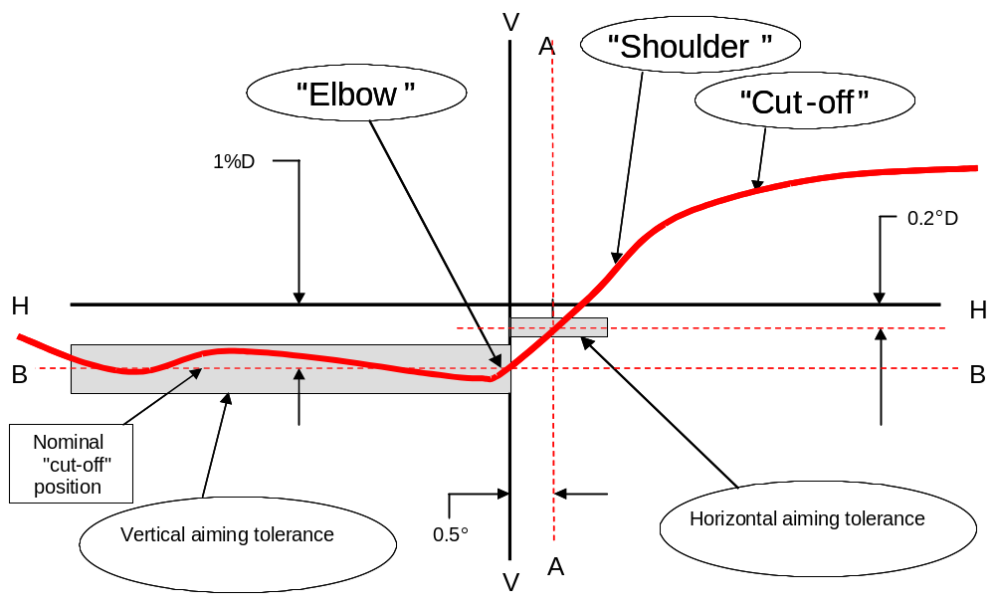

Note: The scales are different for vertical and horizontal lines."

Figure 1

Insert new paragraphs 2.4. to 2.6., to read:

"2.4. for horizontal adjustment: the "elbow–shoulder" part of the "cut-off" shall be moved:
(a) from right to left and shall be horizontally positioned after its movement so that:
(b) above the line 0.2° D its "shoulder" shall not exceed the line A to the left and
(c) on the the line 0.2° D or below its "shoulder" should cross the line A and
(d) the kink of the "elbow" is basically located within +/- 0.5 degrees to the left or right of the V-V line.

or

for left hand traffic
(a) from left to right and shall be horizontally positioned after its movement so that:
(b) above the line 0.2° D its "shoulder" shall not exceed the line A to the right and
(c) on the the line 0.2° D or below its "shoulder" should cross the line A and
(d) the kink of the "elbow" is basically located within +/- 0.5 degrees to the left or right of the V-V line.

2.5. Where a headlamp so aimed does not meet the requirements set out in annex 3 its alignment may be changed, provided that the axis of the beam is not displaced:

Horizontally, from line A by more than: 0.5° to the left or 0.75° to the right

Vertically not more than 0.25° up or down from line B.

2.6. If, however, vertical adjustment cannot be performed repeatedly to the required position within the tolerances described in paragraph 2.5 above, the instrumental method paragraph 3. shall be applied to test compliance with the required minimum quality of the "cut-off" and to perform the vertical and horizontal adjustment of the beam."

Paragraph 2.3.1.(former), renumber as paragraph 2.7.

Paragraphs 2.4. to 2.7.(former), renumber as paragraphs 2.8. to 2.11.

Figures A-8-1 and A-8-2., to be deleted.

Insert new paragraphs 3 to 3.2., to read:

"3. VERTICAL AND HORIZONTAL ADJUSTMENT

If the "cut-off" complies with the quality requirements of paragraph 2. of this annex, the beam adjustment may be performed instrumentally.

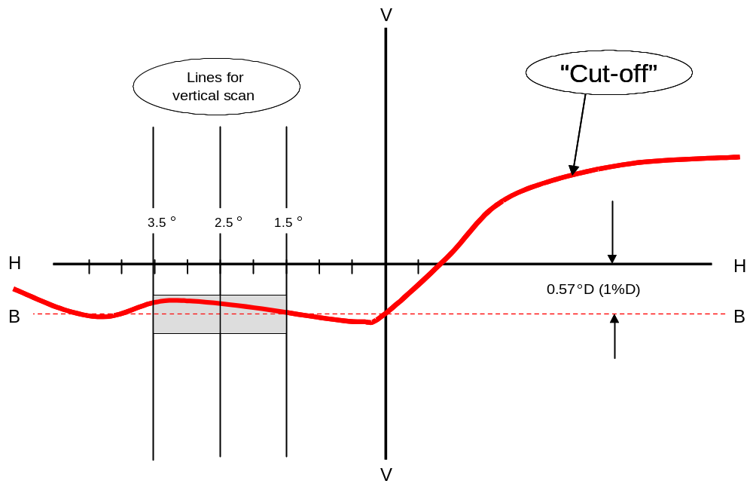

Note: The scales are different for vertical and horizontal lines.

Figure 1: Measurement of "cut-off" quality

3.1. Vertical adjustment

Moving upward from below the line B (see figure 2 below), a vertical scan is carried out through the horizontal part of the "cut-off" at 2.5° from V-V. The inflection point (where d² (log E) / dv² = 0) is determined and positioned on the line B situated one per cent below H-H.

3.2. Horizontal adjustment

The applicant shall specify one of the following horizontal aim methods:

(a) The "0.2 D line" method (see figure 2 below).

A single horizontal line at 0.2° D shall be scanned from 5° left to 5° right after the lamp has been aimed vertically. The maximum gradient "G" determined using the formula G = (log E_{β} – log E_{(β + 0.1°)}) where β is the horizontal position in degrees, shall not be less than 0.08.

The inflection point found on the 0.2 D line shall be positioned on the line A.

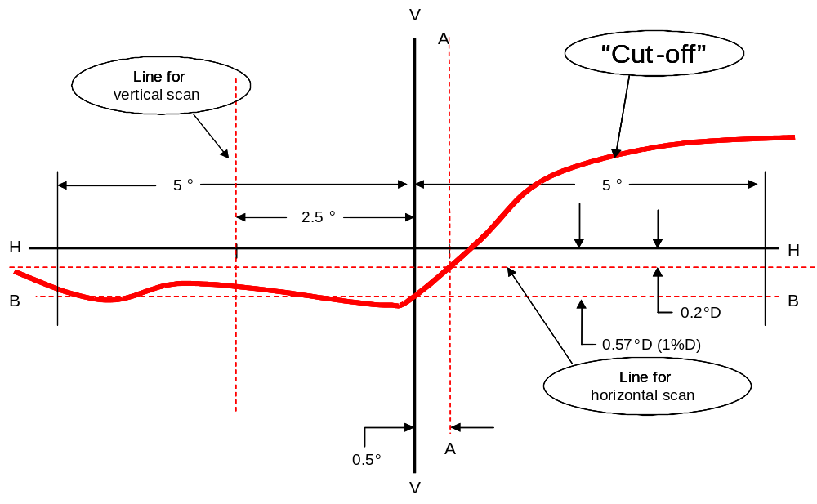

Figure 2

Note: The scales are different for vertical and horizontal lines.

Figure 2: Instrumental vertical and horizontal adjustment- horizontal line scan method
(b) The "3 line" method (see figure 3 below)

Three vertical lines shall be scanned from 2° D to 2° U at 1°R, 2°R, and 3°R after the lamp has been aimed vertically. The respective maximum gradients "G" determined using the formula:

G = (log E_{β} – log E_{(β + 0.1°)})

where β is the vertical position in degrees, shall not be less than 0.08. The inflection points found on the three lines shall be used to derive a straight line. The intersection of this line and the line B found while performing vertical aim shall be placed on the V line.

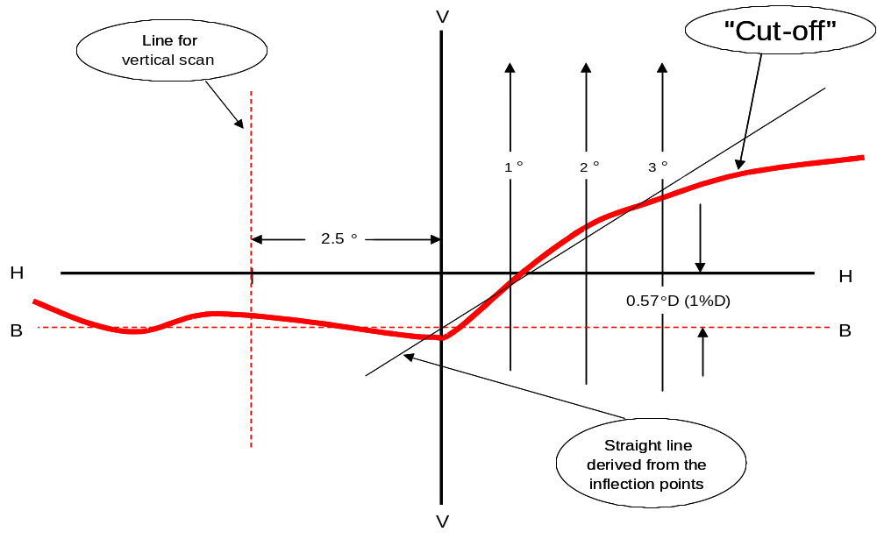

Note: The scales are different for vertical and horizontal lines.

Figure 3: Instrumental vertical and horizontal adjustment-three line scan method "

Annex 9,
Paragraph 1.2., amend to read:

"1.2. The illuminance luminous intensity values shall be determined by means of a photoreceptor contained within a square of 65 mm side and set up to a distance of at least 25 m forward of the centre of reference of each lighting unit perpendicular to the measurement axis from the origin of the goniometer;"

Paragraph 1.4., amend to read:

"1.4. The luminous intensities are measured and specified in form of illuminance values perpendicular to the direction of measurement, and, for at a nominal distance of 25 m."
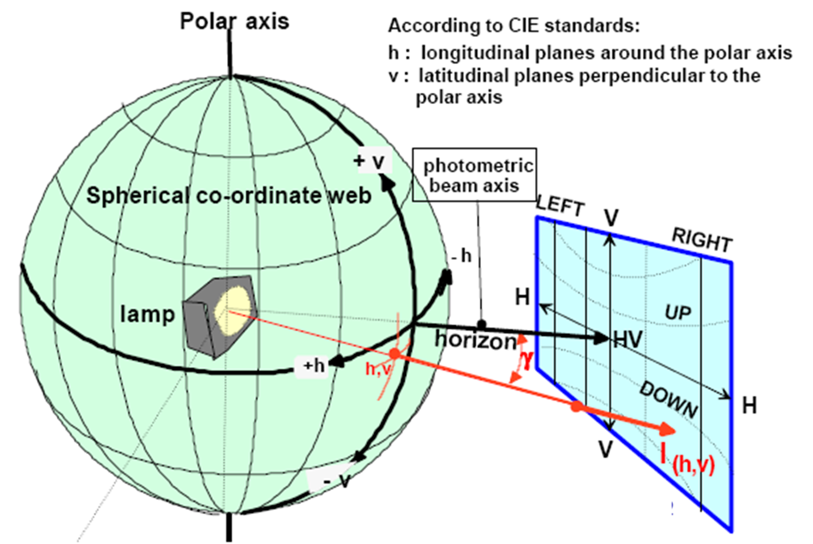
Polar Axis
Spherical Co-ordinate web
Lamp
Photometric Beam axis
UP
DOWN
Horizon
According to CIE standards:
h: longitudinal planes around the polar axis
v: latitudinal planes perpendicular to the polar axis
ECE projection screen at 25 meter distance
E_{25m}= l_{(h,v)}x cos γ/r²

Diagram 1 "

Paragraph 1.5., insert diagram1 and amend to read:
"1.5. The angular co-ordinates are specified in deg on a sphere with a vertical polar axis according to CIE publication No. 70, Vienna 1987, i.e. corresponding to a goniometer with a horizontal ("elevation") axis fixed to the ground and a second, moveable ("rotation") axis perpendicular to the fixed horizontal axis. (See diagram 1)"

Paragraphs 2.1. to 2.5., amend to read:

"2.1. In the case of replaceable filament lamps operated directly under vehicle voltage system conditions:

The system or parts thereof shall be checked by means of an uncoloured standard (étalon) filament lamp(s) designed for a rated voltage of 12 V. During checking of the system or part of, the voltage at the terminals of the filament lamp(s) shall be regulated so as to obtain the reference luminous flux 13.2 volts as indicated at the relevant data sheet of Regulation No. 37.

For the measurements, the flux of this filament lamp may differ from the reference luminous flux at 13.2 V specified in Regulation No. 37. In this case, the luminous intensity shall be corrected accordingly by the individual factor of the standard (étalon) filament lamp (F = Φ _{obj}. / Φ(Voltage) ).

The system or parts thereof shall be considered acceptable if the requirements of paragraph 6. of this Regulation are met with at least one standard (étalon) filament lamp, which may be submitted with the system.

2.2. In the case of a replaceable gas-discharge light source:

The voltage applied to the terminals of the ballast(s) is 13.2 V +/- 0.1 for 12 V systems.

The system or parts thereof using a replaceable gas-discharge light source shall comply with the photometric requirements set out in the relevant paragraphs of this Regulation with at least one standard (étalon) light source, which has been aged during at least 15 cycles, as specified in Regulation No. 99. The luminous flux of this gas-discharge light source may differ from the objective luminous flux specified in Regulation No. 99.

In this case, the measured photometric values shall be corrected accordingly. They shall be multiplied by a factor of 0.7 prior to the check for compliance.

2.3. In the case of a non-replaceable light source operating directly under vehicle voltage system conditions:

All measurements on lamps equipped with non-replaceable light sources (filament lamps and other) shall be made at 6.75 V, 13.5 V 13.2 V or 28.0 V, or at a voltage as specified by the applicant with respect to any other vehicle voltage system. The measured photometric values shall be multiplied by a factor of 0.7 prior to the check for compliance.

2.4. In the case of a light source, replaceable or non-replaceable, which is operated independently from vehicle supply voltage and fully controlled by the system, or in the case of a light source supplied by a special power supply, the test voltage as specified in paragraph 2.3. above shall be applied to the input terminals of that system/power supply. The test laboratory may require from the manufacturer this special power supply needed to supply the light sources.

The measured photometric values shall be multiplied by a factor of 0.7 prior to the check for compliance, except if this correction factor is already applied according to the provisions of paragraph 2.2. above.

2.5. LED module(s) shall be measured at 6.75 V, 13.5 V 6.3 V, 13.2 V or 28.0 V respectively, if not otherwise specified within this Regulation. LED module(s) operated by an electronic light source control gear, shall be measured as specified by the applicant.

The measured photometric values shall be multiplied by a factor of 0.7 prior to the check for compliance."

B. JUSTIFICATION

At its fifty-seventh session the Working Party on Lighting and Light-Signalling (GRE) accepted a proposal tabled by the expert from GTB (ECE/TRANS/WP.29/GRE/2006/36) to specify the luminous flux of Regulation 37 light sources at approximately 13.2 volts instead of 12 volts. Having introduced these changes into Regulation No. 37, it is now appropriate to align Regulation No. 123 by revising the photometric provisions in the main body of the text and in the tables of Annex 3.

Additionally, the opportunity has been taken to:

- include a revision of Annex 8 to align the cut-off requirements with those recently introduced into Regulations No. 98 and 112.

- correct editorial errors that have been found during the detailed study of the regulation to introduce the above-mentioned amendments.

The result of this work, along with similar amendments also being proposed to Regulations Nos. 98 and 112, is an alignment of the passing beam cut-off shape and photometric requirements of all current headlamp regulations.

These proposed amendments to the photometric requirements do not affect the validity of lamps type approved to earlier versions of this regulation. However, it is necessary to introduce transitional provisions to allow for the changes to be made to the procedures in the photometric laboratories to accommodate the revised photometric tables and measurement protocols.
- - - - -

/ In accordance with the programme of work of the Inland Transport Committee for 2006-2010 (ECE/TRANS/166/Add.1, programme activity 02.4), the World Forum will develop, harmonize and update Regulations in order to enhance performance of vehicles. The present document is submitted in conformity with that mandate.

