|  |  |
| --- | --- |
| Transmitted by the expert from the International Automotive Lighting and Light Signalling Expert Group (GTB) | Informal document **GRE-72-07**  (72nd GRE, 20-22 October 2014,  agenda item 4 (b) (ii)) |

**GTB Study Visibility and Glare**

**Suggestion on how to implement the outcome in Regulation No. 48**

**INTRODUCTION**

During the 71st session of GRE, the experts from GTB presented the outcome of a study on visibility and glare of automotive low beam headlamps; see informal document GRE-71-32. The study concentrated on levelling in relation to load. The major objectives of the study were to improve the understanding of different factors that influence visibility and glare and to identify results of the study that might reveal alternatives for automatic static levelling.

The deciding factors in headlamp glare have been determined to be the vehicle pitch angle, loading conditions and initial headlamp aim. Therefore, GTB suggested that the light source technology and the light source 2,000 lm criterion in UN Regulation No. 48 as criteria for the requirement for automatic levelling should be replaced and based upon these deciding factors.

In addition, the expert from OICA clarified the loading definitions as used in the GTB study.

The expert from Poland gave an explanation of the background of the Polish proposal. This Polish proposal was analysed by GTB and compared with the GTB suggestion as part of the study.

After consideration and discussion, GRE invited the experts from Poland, GTB and OICA to submit one coherent proposal for amendments to UN Regulation No. 48 addressing the visibility distance and glare issues to the next GRE session.

During its 117th session in May 2014, GTB evaluated the outcome of the 71st session of GRE and decided to arrange a dedicated all-day meeting on 14th of July to draft a tentative proposal for the amendment to Regulation No.48. The proposal in this document is the outcome of this meeting, but it has not been possible to fully meet the expectations of the expert from Poland who still has some reservations. Additionally, the expert from OICA requested more time to confirm the practical feasibility of this proposal.

NOTE: All the changes to present text of R48/06/Suppl.[4] are in ~~strike through~~ characters in case of deletions or **bold** characters in case of additions.

At this stage the proposal is not formatted according to the rules of the secretariat. When agreed the revised proposal will be submitted formally to GRE in the correct format.

**TENTATIVE PROPOSAL**

**Draft 07 series of amendments to Regulation No. 48**

*Paragraph 2.4,* amend to read:

2.4. "Unladen vehicle" means a vehicle without driver, crew, passengers and load**,** but~~with a full supply of fuel, spare wheel and the tools normally carried~~ **including 100% of normal fluids, at least 90% of fuel and, where provided as standard equipment, any tools and spare wheel.**

*Insert new paragraph 2.5* to read*:*

**2.5. “Mass in running order” means the mass of the unladen vehicle plus a mass of 75 kg located on the driver’s seat.**

*Paragraph 2.5,* renumber as 2.6. andamend to read:

2.**6.** "Laden vehicle" means a vehicle loaded to its technically ~~permissible~~ maximum **permissible** mass, as stated by the manufacturer, who shall also ~~fix the distribution of also~~ **distribute** this mass between the axles in accordance with the ~~method[s]~~ **conditions** described in Annex 5.

*Paragraph 2.6 to 2.33*., renumber as 2.7 to 2.34.

*Insert new paragraphs 6.2.6.1.1 to 6.2.6.1.1.2.,* to read:

**6.2.6.1.1. for vehicles of Category M1 [and N1, at the discretion of the manufacturer]**

**6.2.6.1.1.1. The initial downward inclination of the cut-off of the dipped-beam to be set in the unladen vehicle state with one person in the driver’s seat shall be specified within an accuracy of 0.1 per cent by the manufacturer and indicated in a clearly legible and indelible manner on each vehicle close to either headlamp or the manufacturer's plate by the symbol shown in Annex 7.**

**The value of this indicated downward inclination shall be defined in accordance with Paragraph 6.2.6.1.1.2.**

**6.2.6.1.1.2.** **Depending on the mounting height in metres (h) of the lower edge of the apparent surface in the direction of the reference axis of the dipped-beam headlamp, measured on the vehicles under the loading conditions as prescribed in Annex 5 - Part A of this Regulation, the downward inclination of the cut off of the dipped beam headlamp shall remain between the following limits (see diagram below):**

**Ll ≤ a ≤ Lu**

**0.5 ≤ h ≤ 1.2**

**Where:**

**a: aim (% D)**

**h: installation height (m)**

**Ll: Lower aiming [and initial downward inclination] limit Ll = (h-0.5) / 0.7**

**Lu: Upper aiming [and initial downward inclination] limit Lu = (h+0.48) / 0.7**

*Insert a new Paragraph 6.2.6.1.2.*, to read

**3.0**

**0.5**

**1.0**

**2.0**

**a (% D)**

**0.6**

**0.7**

**0.8**

**0.9**

**1.0**

**1.1**

**1.2**

**0.0**

**h (m)**

**Ll**

**Lu**

**1.4**

**2.4**

**6.2.6.1.2 for all other categories of vehicles**

*Paragraphs 6.2.6.1.1.to 6.2.6.1.2,* amend to read:

**6.2.6.1.2.1.** The initial downward inclination of the cut-off of the dipped-beam to be set in the unladen vehicle state with one person in the driver’s seat shall be specified within an accuracy of 0.1% by the manufacturer and indicated in a clearly legible and indelible manner on each vehicle close to either headlamp or the manufacturer's plate by the symbol shown in Annex 7.

The value of this indicated downward inclination shall be defined in accordance with Paragraph **6.2.6.1.2.2.**

**6.2.6.1.2.2.** Depending on the mounting height in metres (h) of the lower edge of the apparent surface in the direction of the reference axis of the dipped-beam headlamp, measured on the unladen vehicles, the vertical inclination of the cut-off of the dipped-beam shall, under all the static conditions of Annex 5, remain between the following limits and the initial aiming shall have the following values:

h ≤0.8

Limits: between –0.5% and –2.5%

Initial aiming: between –1.0% and –1.5%

0.8 ≤h ≤1.0

Limits: between –0.5% and –2.5%

Initial aiming: between –1.0% and –1.5%

Or, at the discretion of the manufacturer,

Limits: between –1.0% and –3.0%

Initial aiming: between –1.5% and –2.0%

The application for the vehicle type-approval shall, in this case, contain information as to which of the two alternatives is to be used.

h ≥1.0

Limits: between –1.0% and –3.0%

Initial aiming: between –1.5% and –2.0%

The above limits and the initial aiming values are summarised in the diagram below.

For Category N3G (off-road) vehicles where the headlamps exceed a height of 1,200mm, the limits for the vertical inclination of the cut-off shall be between: –1.5% and –3.5%.



*Insert new paragraph 6.2.6.2.1 and related sub-paragraphs,* to read

**6.2.6.2.1. For vehicles of category M1 [and N1, at the discretion of the manufacturer]**

**In the case where the vertical inclination limits prescribed in paragraph 6.2.6.1.1.2. of this Regulation are exceeded:**

**6.2.6.2.1.1. under the loading conditions indicated in paragraph 2.1.1.2. of Annex 5 to this Regulation, an automatic headlamp levelling device shall be installed;**

**6.2.6.2.1.2. under the loading conditions indicated in paragraph 2.1.1.3. of Annex 5 to this Regulation, a manual headlamp levelling device shall be installed.**

*Insert new paragraph 6.2.6.2.2,* to read

**6.2.6.2.2 For all other categories of vehicles,**

*Paragraphs 6.2.6.2.1 to 6.2.6.2*.*3.*, amend to read:

**6.2.6.2.2.1.** In the case where a headlamp levelling device is necessary to satisfy the requirements of paragraphs **6.2.6.1.2.1.** and **6.2.6.1.2.2.**, the device shall be automatic.

**6.2.6.2.2.2** However, devices which are adjusted manually, either continuously or non-continuously shall be permitted, provided they have a stop position at which the lamps can be returned to the initial inclination defined in paragraph **6.2.6.1.2.1.** by means of the usual adjusting screws or similar means.

These manually adjustable devices shall be operable from the driver's seat.

Continually adjustable devices shall have reference marks indicating the loading conditions that require adjustment of the dipped-beam.

The number of positions on devices which are not continuously adjustable shall be such as to ensure compliance with the range of values prescribed in paragraph **6.2.6.1.2.2.** in all the loading conditions defined in Annex 5.

For these devices also, the loading conditions of Annex 5 that require adjustment of the dipped beam shall be clearly marked near the control of the device (see Annex 8).

**6.2.6.2.2.3.** In the event of a failure of devices described in Paragraphs **6.2.6.1.2.1.** and **6.2.6.1.2.2.**, the dipped-beam shall not assume a position in which the dip is less than it was at the time when the failure of the device occurred.

*Paragraphs 6.2.6.3. to 6.2.6.4.* unchanged; they are reproduced below for quick reference only.

6.2.6.3. Measuring Procedure

6.2.6.3.1. After adjustment of the initial inclination, the vertical inclination of the dipped-beam, expressed in per cent, shall be measured in static conditions under all the loading conditions defined in Annex 5.

6.2.6.3.2. The measurement of the variation of dipped-beam inclination as a function of load shall be carried out in accordance with the test procedure set out in Annex 6.

6.2.6.4. Horizontal Orientation

The horizontal orientation of one or both dipped-beam headlamps may be varied to produce bend lighting, provided that if the whole beam or the kink of the elbow of the cut-off is moved, the kink of the elbow of the cut-off shall not intersect the line of the trajectory of the centre of gravity of the vehicle at distances from the front of the vehicle which are larger than 100 times the mounting height of the respective dipped-beam headlamps.

*Paragraph 6.2.9,* amend to read:

6.2.9. Other Requirements

The requirements of Paragraph 5.5.2. shall not apply to dipped-beam headlamps.

**Only dipped-beam headlamps according to Regulations Nos. 98 or 112 may be used to produce bend lighting.**

**If bend lighting is produced by a horizontal movement of the whole beam or the kink of the elbow of the cut-off, it shall be activated only if the vehicle is in forward motion; this shall not apply if bend lighting is produced for a right turn in right hand traffic (left turn in left hand traffic).**

Dipped-beam headlamps with a light source or LED module(s) producing the principal dipped beam and having a total objective luminous flux which exceeds 2,000 lm shall only be installed in conjunction with the installation of headlamp cleaning device(s) according to Regulation No. 45([1]).

**For vehicles of categoriesM & N other than M1 [and N1, in the case where paragraphs 6.2.6.1.1. and 6.2.6.2.1. are applied at the discretion of the manufacturer],** ~~W~~ **w**ith respect to vertical inclination the provisions of paragraph ~~6.2.6.2.2.~~ **6.2.6.2.2.2.** above shall not be applied for dipped-beam headlamps~~:~~

~~(a) With LED module(s) producing the principal dipped-beam, or~~

~~(b) W~~ **w**ith a light source producing the principal dipped-beam and having an objective luminous flux which exceeds 2,000 lumens.

In the case of filament lamps for which more than one test voltage is specified, the objective luminous flux which produces the principal dipped-beam, as indicated in the communication form for the type approval of the device, is applied.

In the case of dipped-beam headlamps equipped with an approved light source, the applicable objective luminous flux is the value at the relevant test voltage as given in the relevant data sheet in the Regulation, according to which the applied light source was approved, without taking into account the tolerances to the objective luminous flux specified on this datasheet.

~~Only dipped-beam headlamps according to Regulation Nos. 98 or 112 may be used to produce bend lighting.~~

~~If bend lighting is produced by a horizontal movement of the whole beam or the kink of the elbow of the cut-off, it shall be activated only if the vehicle is in forward motion; this shall not apply if bend lighting is produced for a right turn in right hand traffic (left turn in left hand traffic).~~

*Annex 5*, amend to read:

ANNEX 5

STATES OF LOADING TO BE TAKEN INTO CONSIDERATION IN DETERMINING VARIATIONS IN

THE VERTICAL ORIENTATION OF THE DIPPED-BEAM HEADLAMPS

Loading conditions on axles referred to in Paragraph**s** ~~6.2.6.1.~~ **6.2.6.1.1.2., 6.2.6.1.2.2., 6.2.6.2.1.1., 6.2.6.2.1.2.,** **6.2.6.2.2.2** and 6.2.6.3.1.

1. For the following tests, the mass of the passengers shall be calculated on the basis of 75kg per person.

2. Loading conditions for different types of vehicles:

2.1. Vehicles in Category M1~~:~~([2]3) **[and N1(3), at the discretion of the manufacturer]**.

2.1.1. The ~~angle of the light beam~~ **downward inclination of the cut off** of the dipped-beam headlamps shall be determined under the following load conditions:

2.1.1.1. One person in the driver's seat;

2.1.1.2. The driver, plus one passenger in the front seat farthest from the driver**,** ~~;~~ **one passenger in each seat of the row(s) of seats behind the driver`s seat (if it exists), plus an evenly distributed remaining loading in the load compartment to reach the 50 % of the difference between the laden and unladen state of the vehicle, as defined respectively in paragraph 2.4. and 2.6. of this Regulation. The passengers shall be positioned starting from the outboard seats of the row immediately behind the driver's seat;**

~~2.1.1.3.~~ ~~The driver, one passenger in the front seat farthest from the driver, all the seats farthest to the rear occupied;~~

~~2.1.1.4.~~ ~~All the seats occupied;~~

2.1.1.**3.** ~~5.~~ All the seats occupied, plus an evenly distributed load in the ~~luggage boot~~ **load compartment(s)**, in order to obtain the **technically maximum** permissible ~~load on the rear axle or on the front axle if the boot is at the front~~ **mass of the vehicle**. ~~If the vehicle has a front and a rear boot, the additional load shall be appropriately distributed in order to obtain the permissible axle loads. However, if the maximum permissible laden mass is obtained before the permissible load on one of the axles, the loading of the boot(s) shall be limited to the figure which enables that mass to be reached;~~

~~2.1.1.6.~~ ~~Driver, plus an evenly distributed load in the boot, in order to obtain the permissible load on the corresponding axle.~~

~~However, if the maximum permissible laden mass is obtained before the permissible load on the axle, the loading of the boot(s) shall be limited to the figure which enables that mass to be reached.~~

2.1.2. In determining the above loading conditions, account shall be taken of any loading restrictions laid down by the manufacturer.

2.2. Vehicles in Categories M2 and M3;(3)

The ~~angle of the light beam from~~ **downward inclination of the cut off of** the dipped-beam headlamps shall be determined under the following loading conditions:

2.2.1. Vehicle unladen and one person in the driver's seat;

2.2.2. Vehicles laden such that each axle carries its maximum technically permissible load or until the maximum permissible mass of the vehicle is attained by loading the front and rear axles proportionally to their maximum technically permissible loads, whichever occurs first.

2.3. Vehicles in Category N with load ~~surfaces~~ **compartment**:

2.3.1. The ~~angle of the light beam from~~ **downward inclination of the cut off of** the dipped-beam headlamps shall be determined under the following loading conditions;

2.3.1.1. Vehicle unladen and one person in the driver's seat;

2.3.1.2. Driver, plus a load so distributed as to give the maximum technically permissible load on the rear axle or axles, or the maximum permissible mass of the vehicle, whichever occurs first, without exceeding a front axle load calculated as the sum of the front axle load of the unladen vehicle plus 25% of the maximum permissible payload on the front axle.

Conversely, the front axle is so considered when the load ~~platform~~ **compartment** is at the front.

2.4. Vehicles in Category N without a load ~~surface~~ **compartment**:

2.4.1. Drawing vehicles for semi-trailers:

2.4.1.1. Unladen vehicle without a load on the coupling attachment and one person in the driver's seat;

2.4.1.2. One person in the driver's seat: technically permissible load on the coupling attachment in the position of the attachment corresponding to the highest load on the rear axle.

2.4.2. Drawing vehicles for trailers:

2.4.2.1. Vehicle unladen and one person in the driver's seat;

2.4.2.2. One person in the driver's seat, all the other places in the driving cabin being occupied.

*Annex 6*, amend to read:

Annex 6

Measurement of the variation of dipped‑beam inclination as a function of load

1. Scope

This annex specifies a method for measuring variations in motor vehicle dipped‑beam inclination, in relation to its initial inclination, caused by changes in vehicle attitude due to loading.

2. Definitions

2.1. Initial inclination

2.1.1. Stated initial inclination

The value of the dipped‑beam initial inclination specified by the motor vehicle manufacturer serving as a reference value for the calculation of permissible variations.

2.1.2. Measured initial inclination

The mean value of dipped‑beam inclination or vehicle inclination measured with the vehicle in **the first loading** condition ~~No. 1, as defined in Annex 5,~~ for the category of vehicle under test, **as defined in Annex 5 to this Regulation.** It serves as a reference value for the assessment of variations in beam inclination as the load varies.

2.2. Dipped‑beam inclination

It may be defined as follows:

Either as the angle, expressed in milliradians, between the direction of the beam towards a characteristic point on the horizontal part of the cut‑off in the luminous distribution of the headlamp and the horizontal plane,

Or by the tangent of that angle, expressed in percentage inclination, since the angles are small (for these small angles, 1 per cent is equal to 10 mrad).

If the inclination is expressed in percentage inclination, it can be calculated by means of the following formula:



where:

h1 is the height above the ground, in millimetres, of the above‑ mentioned characteristic point, measured on a vertical screen perpendicular to the vehicle longitudinal median plane, placed at a horizontal distance L.

h2 is the height above the ground, in millimetres, of the centre of reference (which is taken to be the nominal origin of the characteristic point chosen in h1):

L is the distance, in millimetres, from the screen to the centre of reference.

Negative values denote downward inclination (see Figure 1).

Positive values denote upward inclination.

**Figure 1**

**Dipped‑beam downward inclination of a category M1 vehicle**



*Notes:*

1. This drawing represents a category M1 vehicle, but the principle shown applies equally to vehicles of other categories.

2. Where the vehicle does not incorporate a headlamp levelling system, the variation in dipped‑beam inclination is identical with the variation in the inclination of the vehicle itself.

3. Measurement conditions

3.1. If a visual inspection of the dipped‑beam pattern on the screen or a photometric method is used, measurement shall be carried out in a dark environment (for example, a dark room) of sufficient area to allow the vehicle and the screen to be placed as shown in Figure 1. Headlamp centres of reference shall be at a distance from the screen of at least 10 m.

3.2. The ground on which measurements are made shall be as flat and horizontal as possible, so that the reproducibility of measurements of dipped‑beam inclination can be assured with an accuracy of ±0.5 mrad (±0.05 per cent inclination).

3.3. If a screen is used, its marking, position and orientation in relation to the ground and to the median longitudinal plane of the vehicle, shall be such that the reproducibility of the measurement of the dipped‑beam inclination can be assured with an accuracy of ±0.5 mrad (±0.05 per cent inclination).

3.4. During measurements, the ambient temperature shall be between 10 and 30 °C.

4. Vehicle preparation

4.1. Measurements shall be carried out on a vehicle which has travelled a distance of between 1,000 km and 10,000 km, preferably 5,000 km.

4.2. Tyres shall be inflated to the full‑load pressure specified by the vehicle manufacturer. The vehicle shall be ~~fully replenished (fuel, water, oil) and equipped with all the accessories and tools specified by the manufacturer. Full fuel replenishment means that the fuel tank shall be filled to not less than 90 per cent of its capacity.~~ **"unladen" as defined in paragraph 2.4. of this Regulation.**

4.3. The vehicle shall have the parking brake released and the gearbox in neutral.

4.4. The vehicle shall be conditioned for at least 8 h at the temperature specified in paragraph 3.4. above.

4.5. If a photometric or visual method is used, headlamps with a well‑ defined dipped-beam cut‑off should preferably be installed on the vehicle under test in order to facilitate the measurements. Other means are allowed to obtain a more precise reading (for example, removal of the headlamp lens).

5. Test procedure

5.1. General

The variations in either dipped‑beam or vehicle inclination, depending on the method chosen, shall be measured separately for each side of the vehicle. The results obtained from both left and right headlamps under all the load conditions specified in Annex 5, shall be within the limits set out in paragraph 5.5. below. The load shall be applied gradually without subjecting the vehicle to excessive shocks.

5.1.1. Where an AFS is fitted, the measurements shall be carried out with the AFS in its neutral state.

5.2. Determination of the measured initial inclination

The vehicle shall be prepared as specified in paragraph 4. above and laden **to the first loading condition for the category of vehicle under test,** as specified in Annex 5 ~~(first loading condition of the respective vehicle category)~~ **to this Regulation**. Before each measurement, the vehicle shall be rocked as specified in paragraph 5.4. below. Measurements shall be made three times.

5.2.1. If none of the three measured results differ by more than 2 mrad (0.2 per cent inclination) from the arithmetic mean of the results, that mean shall constitute the final result.

5.2.2. If any measurement differs from the arithmetic mean of the results by more than 2 mrad (0.2 per cent inclination), a further series of 10 measurements shall be made, the arithmetic mean of which shall constitute the final result.

5.3. Measurement methods

Any method may be used to measure variations of inclination provided that the readings are accurate to within ± 0.2 mrad (±0.02 per cent inclination).

5.4. Treatment of vehicle in each loading condition

The vehicle suspension and any other part likely to affect dipped‑beam inclination shall be activated according to the methods described below.

However, the technical authorities and manufacturers may jointly propose other methods (either experimental or based upon calculations), especially when the test poses particular problems, provided such calculations are clearly valid.

5.4.1. M1category vehicles with conventional suspension

With the vehicle standing on the measuring site and, if necessary, with the wheels resting on floating platforms (which shall be used if their absence would lead to restriction of the suspension movement likely to affect the results of measurements), rock the vehicle continuously for at least three complete cycles, for each cycle, first the rear and then the front end of the vehicle is pushed down.

The rocking sequence shall end with the completion of a cycle. Before making the measurements, the vehicle shall be allowed to come to rest spontaneously. Instead of using floating platforms, the same effect can be achieved by moving the vehicle backwards and forwards for at least a complete wheel revolution.

5.4.2. M2, M3 and N category vehicles with conventional suspension

5.4.2.1. If the treatment method for category M1 vehicles described in paragraph 5.4.1. is not possible, the method described in paragraphs 5.4.2.2. or 5.4.2.3. **below** may be used.

5.4.2.2. With the vehicle standing on the measuring site and the wheels on the ground, rock the vehicle by temporarily varying the load.

5.4.2.3. With the vehicle standing on the measuring site and the wheels on the ground, activate the vehicle suspension and all other parts which may affect the dipped‑beam inclination by using a vibration rig. This can be a vibrating platform on which the wheels rest.

5.4.3. Vehicles with non‑conventional suspension, where the engine has to be running.

Before making any measurement wait until the vehicle has assumed its final attitude with the engine running.

5.5. Measurements

The variation of the inclination of the dipped‑beam shall be assessed for each of the different loading conditions **as specified in Annex 5 to this Regulation,** in relation to the measured initial inclination determined in accordance with paragraph 5.2. above.

If the vehicle is fitted with a manual headlamp‑levelling system, the latter shall be adjusted to the positions specified by the manufacturer for given loading conditions (according to Annex 5 **to this Regulation**).

5.5.1. To begin with, a single measurement shall be made in each loading condition. Requirements have been met if, for all the loading conditions, the variation in inclination is within the calculated limits (for example, within the difference between the stated initial inclination and the lower and upper limits specified for approval) with a safety margin of 4 mrad (0.4 per cent inclination).

5.5.2. If the result(s) of any measurement(s) does (do) not lie within the safety margin indicated in paragraph 5.5.1. **above** or exceed(s) the limit values, a further three measurements shall be made in the loading conditions corresponding to this (these) result(s) as specified in paragraph 5.5.3. **below**.

5.5.3. For each of the above loading conditions:

5.5.3.1. If none of the three measured results differs by more than 2 mrad (0.2 per cent inclination) from the arithmetic mean of the results, that mean shall constitute the final result.

5.5.3.2. If any measurement differs from the arithmetic mean of the results by more than 2 mrad (0.2 per cent inclination), a further series of 10 measurements shall be made, the arithmetic mean of which shall constitute the final result.

5.5.3.3. If a vehicle is fitted with an automatic headlamp‑levelling system which has an inherent hysteresis loop, average results at the top and bottom of the hysteresis loop shall be taken as significant values.

All these measurements shall be made in accordance with paragraphs 5.5.3.1. and 5.5.3.2. **above**.

5.5.4. Requirements have been met, if, under all loading conditions, the variation between the measured initial inclination determined in accordance with paragraph 5.2. **above** and the inclination measured under each loading condition is less than the values calculated in paragraph 5.5.1. **above** (without safety margin).

5.5.5. If only one of the calculated upper or lower limits of variation is exceeded, the manufacturer shall be permitted to choose a different value for the stated initial inclination, within the limits specified for approval.

*Annex 7*, amend to read:

Annex 7

Indication of the downward inclination of the dipped-beam headlamps cut-off referred to in paragraph ~~6.2.6.1.1.~~ **6.2.6.1.1.1. and 6.2.6.1.2.1.** and **of the** downward inclination of the front fog lamp cut-off referred to

in paragraph 6.3.6.1.2. of this Regulation



**⇑ ⇑**

|  |  |
| --- | --- |
| Standard symbol for  dipped-beam headlamp | Value of the stated  initial adjustment |

Example 1

~~The size of the symbol and characters is left to the discretion of the manufacturer.~~



**⇑** **⇑**

|  |  |
| --- | --- |
| Standard symbol for  front fog lamp | Value of the downward inclination |

Example 2

~~The size of the symbol and characters is left to the discretion of the manufacturer.~~

**Note: The size of the symbol and characters is left to the discretion of the manufacturer.**

*Annex 8*, amend to read:

ANNEX 8

THE CONTROLS FOR THE HEADLAMP-LEVELLING DEVICES REFERRED

TO IN PARAGRAPH**S** ~~6.2.6.2.2.~~ **6.2.6.2.1.2. and 6.2.6.2.2.2** OF THIS REGULATION

1. SPECIFICATIONS

1.1. Downward inclination of the dipped-beam shall in all cases be produced in one of the following ways:

(a) By moving a control downwards or to the left;

(b) By rotating a control in a counter clockwise direction;

(c) By depressing a button (push-pull control).

If several buttons are used to adjust the beam, the button which gives the greatest downward inclination shall be installed to the left or below the button(s) for other dipped-beam positions.

A rotary control which is installed edge-on, or with only the edge visible, should follow the operating principles of control of Types (a) or (c)

* + 1. This control shall carry symbols indicating clearly the movements corresponding to the downward and upward inclination of the dipped-beam.
  1. The "0" position corresponds to the initial inclination according to Paragraph ~~6.2.6.1.1.~~ **6.2.6.1.1.1. and 6.2.6.2.1.1.** of this Regulation.
  2. The "0" position which, according to Paragraph ~~6.2.6.2.2.~~ **6.2.6.2.2.2.** of this Regulation has to be a "stop position", need not necessarily be at the end of the scale.
  3. The marks used on control shall be explained in the owner's handbook.
  4. Only the following symbols may be used to identify the controls:



~~Symbols employing five lines instead of four may also be used~~

Example 1



Example 2



Example 3



**Note: Symbols employing five lines instead of four may also be used**

*Paragraph 1.3.1. in Annex 9*, amend to read:

1.3.1. Initial downward inclination

The initial downward inclination of the cut‑off of the dipped-beam and the class "F3" front fog lamps shall be set to the plated figure as required and shown in Annex 7 **to this Regulation**.

Alternatively the manufacturer shall set the initial aim to a figure that is different from the plated figure where it can be shown to be representative of the type approved when tested in accordance with the procedures contained in Annex 6 **to this Regulation** and in particular **its** paragraph 4.1.

*Paragraph 1.3.2. in Annex 9*, amend to read:

1.3.2. Variation of inclination with load

The variation of the dipped-beam ~~downward~~ inclination as a function of the loading conditions specified within this section shall remain within the range:

**a) for vehicles of category M1** **[and N1, in the case where paragraphs 6.2.6.1.1. and 6.2.6.2.1. are applied at the discretion of the manufacturer]**

**[+ 0.3] per cent to [- 1.9] per cent for headlamp mounting height h = 0.5 m;**

**[- 0.7] per cent to [- 2.9] per cent for headlamp mounting height h = 1.2 m.**

**For the intermediate mounting heights, the vertical inclination limits change linearly between the above indicated values.**

**b) for all other categories of vehicles**

0.2 per cent to 2.8 per cent for headlamp mounting height h < 0.8;

0.2 per cent to 2.8 per cent for headlamp mounting height 0.8 ≤ h ≤ 1.0; or

0.7 per cent to 3.3 per cent (according to the aiming range chosen by the manufacturer at the approval);

0.7 per cent to 3.3 per cent for headlamp mounting height 1.0 < h ≤ 1.2 m;

1.2 per cent to 3.8 per cent for headlamp mounting height h > 1.2 m.

In the case of a class "F3" front fog lamp with (a) light source(s) having a total objective luminous flux which exceeds 2,000 lumens, the variation of the downward inclination as a function of the loading conditions specified within this section shall remain within the range:

0.7 per cent to 3.3 per cent for front fog lamp mounting height h ≤ 0.8 ;

1.2 per cent to 3.8 per cent for front fog lamp mounting height h > 0.8 m.

The ~~states of~~ loading **conditions defined in Annex 5 to this Regulation** to be used shall be ~~as follows, as indicated in Annex 5 of this Regulation~~, **the following:** [~~for every system adjusted accordingly~~].

*Paragraph 1.3.2.1. in Annex 9*, amend to read:

1.3.2.1. Vehicles in category M1:

Paragraph ~~2.1.1.1.~~ **2.1.1.2.**

Paragraph ~~2.1.1.6~~. **2.1.1.3.** taking into account

Paragraph 2.1.2.

--------------------------------------

**JUSTIFICATION**

The starting point for this proposal is informal document GRE-71-32, pages 160-170 where the essential aspects of the Polish and the GTB proposal are identified as:

1. the aiming limits;
2. the loading conditions;
3. the implementation in Regulation No.48.
4. **The aiming limits**

The Polish proposal; see GRE-71-32, page 162

The aiming limits as proposed by the expert from Poland focus on maintaining adequate road visibility distance. They are based upon the translation of the photometric requirements at the test points of the headlamp regulations into an estimate of values produced at points on the road surface and are “Worst Case”, taking account of the lowest performing headlamps that meet the type approval requirements. Avoidance of glare is not directly addressed. It assumes that the horizontal cut-off should not extend beyond 100m distance from the vehicle.

The GTB proposal; see GRE-71-32, page 163

The vehicle pitch is the influencing factor. Glare remains acceptable providing the horizontal cut-off remains below the H-H line as defined in the headlamp regulations (Based on a mounting height of 750mm). It is necessary to consider the relationship between actions to avoid glare complaints with the need to assure sufficient visibility range. The initial aim declared by the vehicle manufacturer becomes an important factor. Data have been produced by calculations, using the assessment method according to the standard [*CIE S 021/E:2011*](http://cie.co.at/index.php?i_ca_id=811)*: Vehicle Headlighting Systems Photometric Performance - Method of Assessment,* to enrich the Klettwitz results to validate the glare conclusions and investigate the relationship with visibility range.

In summary

See GRE-71-32 page 174:

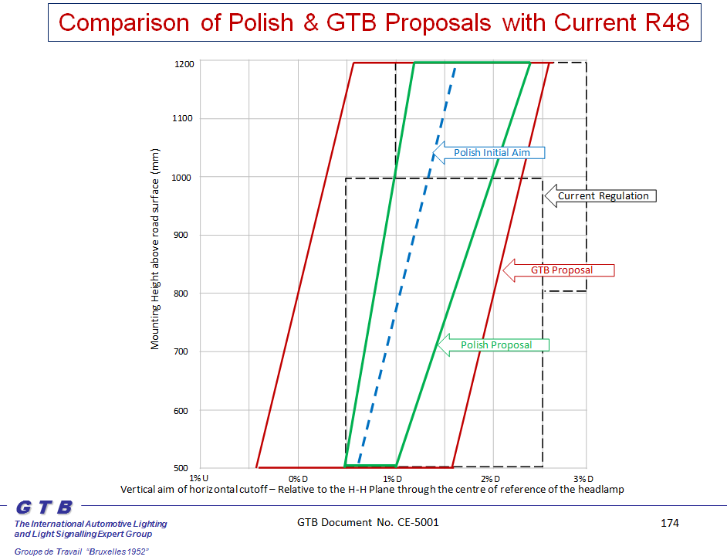

Merging the Polish and GTB proposals:

1. Considering the information from the expert from OICA (see GRE-67-27 and GRE-68-20), the final proposed aiming limits should be less narrow than the “worst case” limits proposed by the expert from Poland. So the green aiming limits in the drawing above should be shifted outwards.
2. On the other hand, the “current practice” limits proposed by GTB should be narrower to reflect progress of technology. So the red aiming limits in the drawing above should be shifted inwards.
3. Real world tolerances should be proposed. A shift of the GTB proposed aiming limits to take a 0.2% tolerance into account therefore can be considered to be a logical first step.
4. Despite the GTB explanation in GRE-71-32 pages 171 and 172 that aiming above HH should not create more glare problems; knowing that for some governments the priority is to avoid risk of glare; knowing that for other governments visibility distance at the cost of acceptable glare is important; it was concluded that aiming limits should stay below HH but should not be shifted more than that. This means another shift of 0.2% of the GTB proposed left limit. This additional shift can also be justified by the fact that the left aiming limit is mainly related to avoid glare and the right aiming limit is mainly related to provide sufficient road visibility distance. Glare and visibility distance are different mechanisms.
5. The result of shifting the GTB aiming limits is given below.

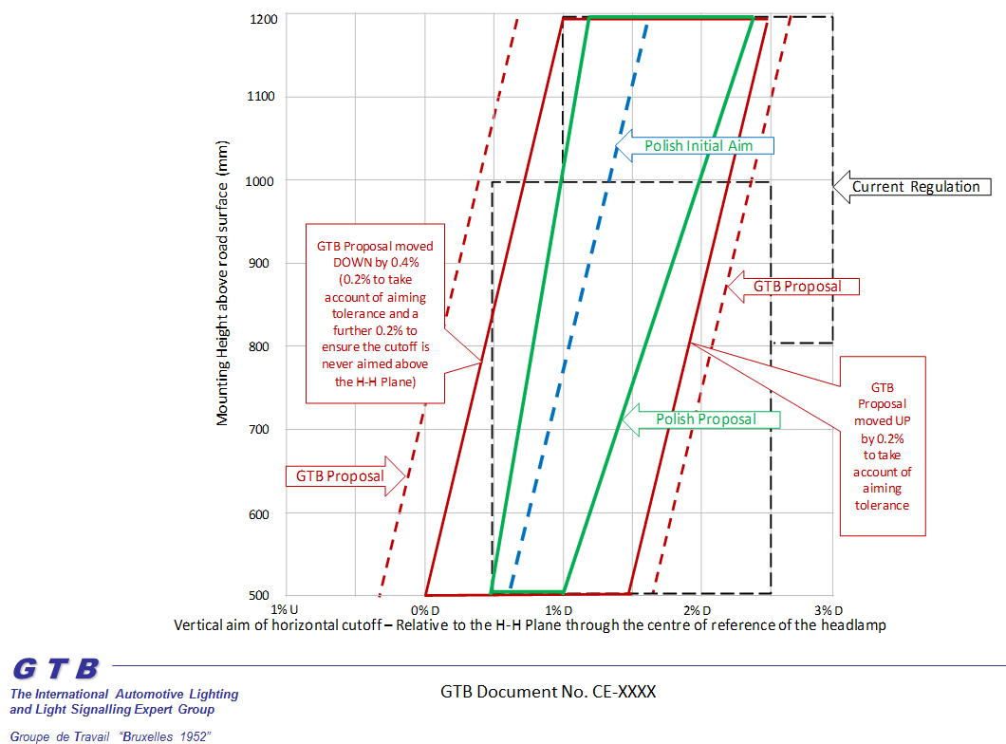

1. Since the aiming tolerance is only 1.5%, it was concluded that initial aiming should not be prescribed but should be specified by the manufacturer within these limits.
2. Since a drawing is less accurate, a mathematical description of the aiming limits is inserted next to the drawing.
3. The expert from Poland expressed that he may wish to reconsider the upper aiming limit on the right.
4. The expert from OICA requested more time to confirm whether the proposed aiming tolerances are achievable in daily practice.



1. **The loading conditions**

The Polish proposal; see GRE-71-32, page 175

The Polish proposal does not show an evaluation of the loading conditions but respects the loading conditions as described in Regulation No. 48, annex 5.

The GTB proposal; see GRE-71-32, page 161

The GTB proposal is using the concept of “50% loading” resulting from French study of lifetime use research data, referred to in GRE-65-17.

It was concluded that no other loading conditions will be inserted in the proposal as mentioned in GRE 71st session, unless these are based upon research. GTB does not have such other loading conditions or data available.

Elaborating the 50% loading condition

Although the aiming limits are independent of how they are implemented in Regulation No. 48 with regard to testing and possible aiming devices, the GTB proposal is based upon the concept of “50% loading”. Some vehicle manufacturers stated that these loading conditions only apply to M1 vehicles.

It was concluded that the concept of “50% loading” should only be proposed for M1 vehicles. For N1 and other vehicles additional study is needed. It is for GRE to decide whether to progress this proposal in advance of such additional study, if required.

The 50% loading condition was defined as:

* Take the difference between maximum and basic weight, divided by 2
* Use 75 kg for the front passenger car
* Use 150 kg for the two rear seats
* The remaining mass is reserved for the luggage space.

The full load condition was defined as:

* Take the difference between max and basic weight
* Use 75 kg for the front passenger car
* Use 150 kg for the two rear seats
* The remaining mass is reserved for the luggage space.

The expert from Poland and also vehicle manufacturers expressed a need for further precision of these loading conditions. In its July 2014 session, GTB concluded after a long discussion that:

* A standard test load is 75 kg
* A reduced test load is <75 kg
* Load on seats (passengers) has priority over load in the luggage space.
* The remaining mass is reserved for the luggage space.

For instance, if a vehicle is approved as a 4-seater and the 50% load is

1. 175 kg; 1 standard test load in the front;

2 reduced test loads of 100/2 kg distributed on rear seats

1. 250 kg: 3 standard test loads + 25 kg;

Remaining 25 kg in the luggage space

This has been elaborated in this proposal.

1. **The implementation in Regulation No.48**

The Polish proposal; see ECE/TRANS/WP.29/GRE/2014/11

The Polish proposal requires the manufacturer to specify the initial aim and requires maintenance of aim but does not prescribe how this maintenance shall be achieved.

The GTB proposal; see GRE-71-32, page 173

The GTB proposal is showing a decision diagram on when an automatic, manual or no levelling device is allowed or required.

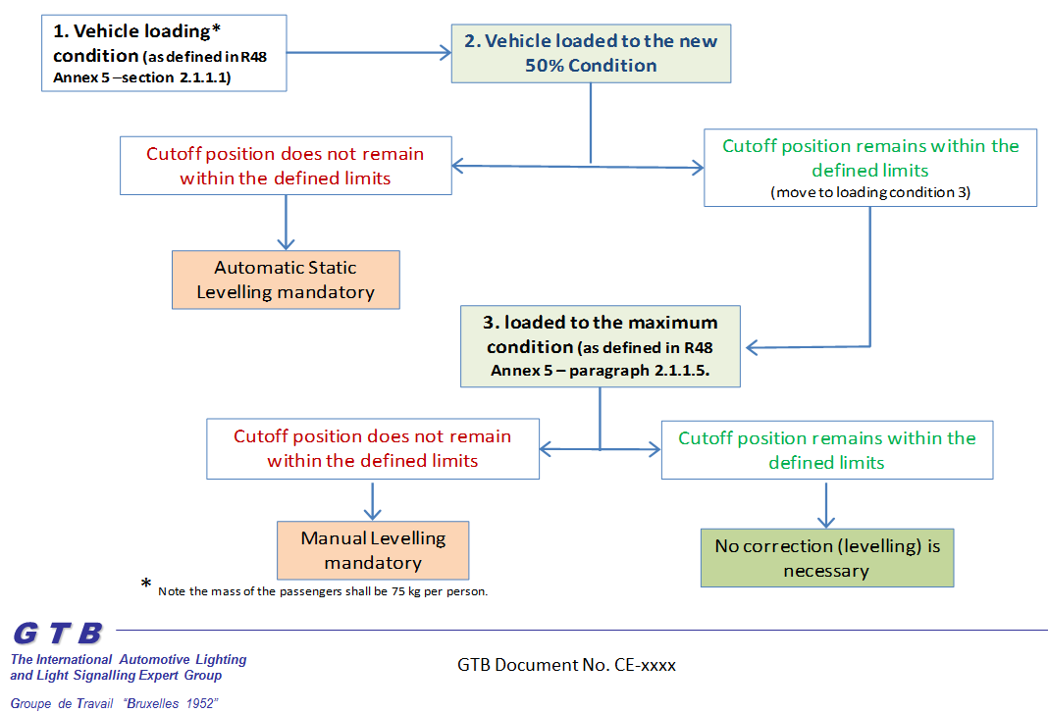

Merging both proposals

The GTB diagram is more or less a decision diagram. Analysis of the diagram for implementation in the text shows that the Polish way of implementation and the GTB way are not so much different except for the manual levelling device.

Several experts however expressed a need for further precision and specification that in the case of a manual levelling device is mentioned, a two positions device is intended: “LOW” or “HIGH” load.

**NEXT STEPS**

A validation of the final proposal will be executed as requested in the GRE 71st session.

The options under consideration are:

* Simulation, for instance by:
  + Using CIE S021/E: 2011;
  + Using another simulation program CHESS   
    (software update under consideration by UMTRI)
  + Calculation in the test points (following the approach in the proposal from the expert from Poland
* Another night drive test, which can only take place on the northern hemisphere between October and March.

It is intended to execute such a validation if no major objections to the proposal outlined in this document are forthcoming at the 72nd session of GRE.

1. Contracting Parties to the respective regulations can still prohibit the use of mechanical cleaning systems when headlamps with plastic lenses, marked 'PL', are installed.
2. (3) As defined in the Consolidated Resolution on the Construction of Vehicles (R.E.3) document ECE/TRANS/WP.29/78/Rev.2, para. 2.