|  |  |  |  |
| --- | --- | --- | --- |
|  | United Nations | ST/SG/AC.10/C.4/2015/14 | |
| _unlogo | **Secretariat** | | Distr.: General  17 September 2015  Original: English |

**Committee of Experts on the Transport of Dangerous Goods  
and on the Globally Harmonized System of Classification  
and Labelling of Chemicals**

**Sub-Committee of Experts on the Globally Harmonized  
System of Classification and Labelling of Chemicals**

**Thirtieth session**

Geneva, 9 – 11 December 2015

Item 4 (a) of the provisional agenda

**Hazard communication issues:   
Labelling of small packagings**

Labelling of small packagings

Transmitted by the European Chemical Industry Council (CEFIC) on behalf of the informal correspondence group[[1]](#footnote-2)

Introduction

1. At its 29th session the Sub-Committee noted that the correspondence group suggested some amendments to the proposed second example illustrating some of the general principles applicable to the labelling of small packagings (see document ST/SG/AC.10/C.4/2015/7) which had been proposed for inclusion in Annex 7 of the GHS.

Development of an example for fold-out labels

2. The example for fold-out labels has been further refined to take into account the suggestions made during the 29th session.

3. As this is a multilingual example, different languages are also presented in the drawing of the label. The group chose several languages to illustrate the concept, although in practice this combination of languages on a label may be rare.

4. This revised second example detailed below and its proposed inclusion in Annex 7 of the GHS are submitted for further consideration by the Sub-Committee.

Multilayer booklet format/fold-out label

(i) Product:

Activator

(ii) Packaging description and size

Metal container with 100 ml capacity

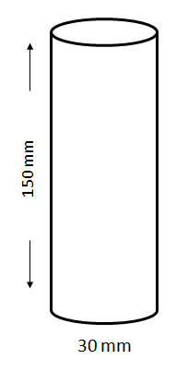

(iii) Labelling problems encountered

The product is required to carry a large number of GHS label elements.

Besides that, it will be sold in different countries, so different languages are required.

(iv) Possible options to address labelling problems encountered

| **Issue** | **Potential options** | **Comments** |
| --- | --- | --- |
| Not possible to put all applicable GHS label elements and directions for use on the immediate container in all languages (i.e. the metal container) due to its size and shape | Provide label elements in a fold-out label securely attached to the metal container | Possible practical solution – fold-out label must be securely attached to the container and remain so during foreseeable conditions and period of use  Provisions for fold-out labels e.g. what label elements must go on the front page and what elements could appear on the internal fold-out page(s)? Minimum size of pictograms or text to ensure the readability of the information?  Layout of the pictograms – can they be contiguous or do they have to be separate? |
|  | Provide label elements on a tie-on tag | Not practical as tie-on tag would need to be very large to accommodate all required labelling even with printing on both sides of the tag. Large tag may impede use of the product.  Could possibly attach a fold-out label to the tie-on tag but no guarantee the tag would remain attached to the container – may impede user during application thus could possibly be removed.  General principles require all applicable label elements to appear on immediate container where possible; also some label elements on the immediate container may need to be accessible to users throughout life of product. Would therefore also need to include minimum label elements on immediate container just in case the tie-on tag is removed by the user. |
|  | Provide label elements on an outer packaging | Not an option – product is not supplied in outer packaging  Also need to take account of sustainability considerations (e.g. packaging reduction, environmental footprint, etc.) |
|  | Increase the size of the container so that a larger label can be affixed | Increasing the size of the container is not practical from the intended use perspective.  Increasing the size of the container without increasing product volume may be misleading  Also need to take account of sustainability considerations (e.g. packaging reduction, environmental footprint, etc.) |

(v) Proposed/suggested solution

Multilayer booklet format/fold-out label which is securely affixed to the immediate container (i.e. the fold-out label is attached so that it remains affixed during the foreseeable conditions and period of use). The fold-out label is produced in such a way that the front part cannot be detached from the remainder of the label.

The information is structured as follows:

Front page

Information to be provided on the front page of the multilayer/fold-out label should contain at least:

GHS information:

* Product identifier
* Hazard pictogram(s)
* Signal word
* Supplier identification (name, address and telephone number of the company)

Additional information:

* A symbol to inform the user that the label can be opened to illustrate that additional information is available on inside pages
* If more than one language is used on the fold-out label: the country codes or language codes

Text pages/Pages inside

GHS information:

* Full product identifier including hazardous components as applicable
* Signal word
* Hazard statements
* Precautionary statements
* Additional information (e.g. directions for use, information required by other regulations, etc.)

Additional information:

* If more than one language is used on the fold-out label: the country codes or language codes

Back page (affixed to the immediate container):

* Product identifier
* Hazard pictogram(s)
* Signal word
* Supplier identification (name, address and telephone number of the company)

The product identifier (if applicable) and the signal words on the front page and the back page need to be in all languages used on the label.

If there is enough space on the front or on the back page, these pages can also be used to display text.

The text on the inside pages (text pages) can also be distributed on more than one page, if the available space is not sufficient. In general it is better to spread the text across more than one page than to have smaller letters that make the text difficult to read. In all cases, the visibility and easy legibility of the label elements should be ensured.

It is recognized that some regulatory systems (e.g. pesticides) may have specific requirements for the application of labels using a multilayer or booklet style format. Where this is the case, labelling would be undertaken in accordance with the competent authority’s requirements.

The size of the fold-out label and the number of folds should be in a rational relationship to the size of the container. This may limit the number of languages, which can be displayed on the fold-out label.

Examples on formats:

Examples of formats for multilayer booklet format/fold-out labels which could be used for the proposed/suggested solution are (this is not a complete list, other formats may also be found):

Book style



Front page

Back page

Text pages

Order book style



Front page

Back page

Text pages

“Window style”



Front

page

Text

page

Back page

Text pages



Text

page

Front

page

Back page

Text pages

Front

page

Front

page

Back page

Text pages

“Accordion” style

**Front page**:

Front

page

Back

page

Text pages

Holds information listed under the heading “front page”. If there is enough space, the front page can also contain some texts.

**Text page**:

Holds the text in the different languages (see heading “pages inside”).

**Back page**:

Holds the information described under the heading “back page”. If there is enough space, the back page can also contain some texts.

Proposal

5. Add a new example in annex 7 of the GHS as set out hereafter.

“Example 9: Example for fold-out label

Metal container with 100 ml capacity



A fold-out label is securely affixed to the immediate container (i.e. the fold-out label is attached so that it remains affixed during the foreseeable conditions and period of use). The fold-out label is produced in such a way that the front part cannot be detached from the remainder of the label.

The information is structured as follows and is provided, if applicable, in all the languages used for the label:

Front page

Information to be provided on the front page of the multilayer/fold-out label should contain at least:

GHS information:

* Product identifier
* Hazard pictogram(s)
* Signal word
* Supplier identification (name, address and telephone number of the company)

Additional information:

* A symbol to inform the user that the label can be opened to illustrate that additional information is available on inside pages.
* If more than one language is used on the fold-out label: the country codes or language codes

Text pages/Pages inside

GHS information:

* Full product identifier including hazardous components as applicable
* Signal word
* Hazard statements
* Precautionary statements
* Additional information (e.g. directions for use, information required by other regulations, etc.)

Additional information:

* If more than one language is used on the fold-out label: the country codes or language codes

Back page (affixed to the immediate container):

* Product identifier
* Hazard pictogram(s)
* Signal word
* Supplier identification (name, address and telephone number of the company)

The product identifier (if applicable) and the signal words on the front page and the back page are in all languages used on the label.

If there is enough space on the front or on the back page, these pages can also be used to display text.

The text on the inside pages (text pages) can also be distributed on more than one page, if the available space is not sufficient. In general it is better to spread the text across more than one page than to have smaller letters that make the text difficult to read. In all cases, the visibility and easy legibility of the label elements should be ensured.

It is recognized that some regulatory systems (e.g. pesticides) may have specific requirements for the application of labels using a multilayer or booklet style format. Where this is the case, labelling would be undertaken in accordance with the competent authority’s requirements.

The size of the fold-out label and the number of folds should be in a rational relationship to the size of the container. This may limit the number of languages, which can be displayed on the fold-out label.

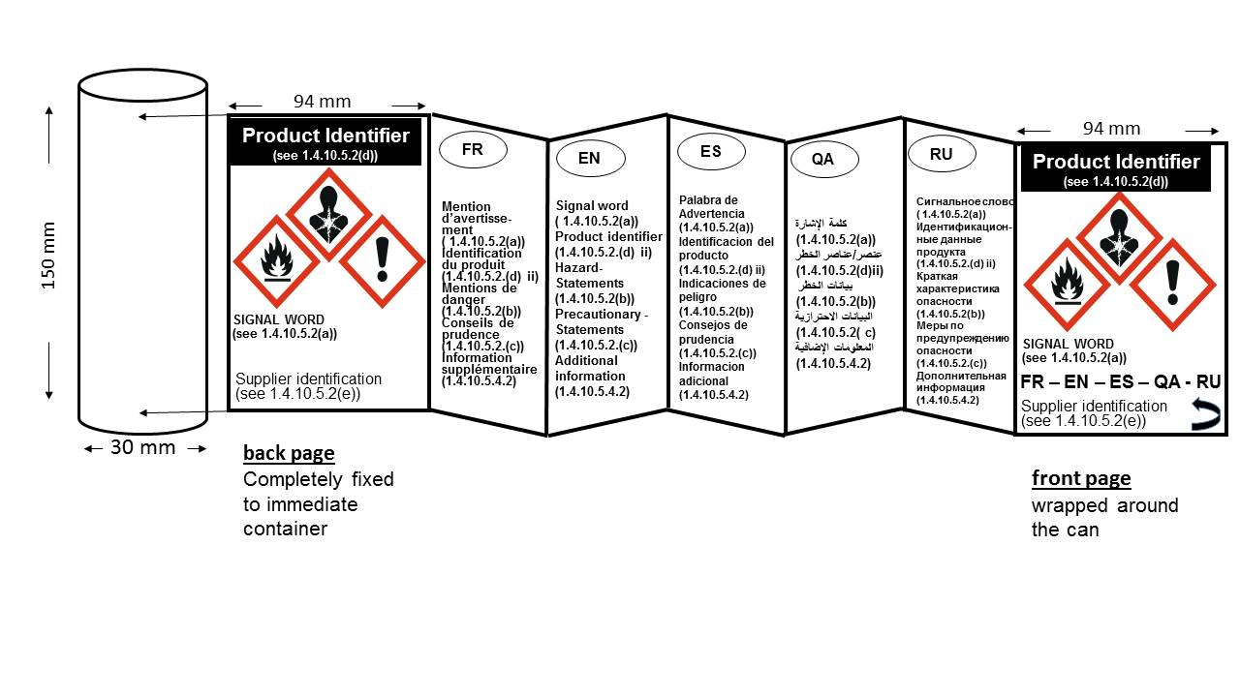

1. In accordance with the programme of work of the Sub-Committee for 2015–2016 approved by the Committee at its seventh session (see ST/SG/AC.10/C.3/92, paragraph 95 and ST/SG/AC.10/42, para. 15). [↑](#footnote-ref-2)