UN/SCEGHS/30/INF.25
Committee of Experts on the Transport of Dangerous Goods
and on the Globally Harmonized System of Classification
and Labelling of Chemicals
Sub-Committee of Experts on the Globally Harmonized
System of Classification and Labelling of Chemicals 7 December 2015
Thirtieth session
Geneva, 9-11 December 2015
Item 4 (a) of the provisional agenda
Hazard communication issues: labelling of small packagings
Labelling of small packagings
Transmitted by the European Chemical Industry Council (CEFIC) on behalf of the informal correspondence group
Introduction
1. At its 29th session the Sub-Committee noted that the informal correspondence group intended to develop a third example addressing other labelling issues than the first and second ones and their possible solutions.
Development of an example for sets or kits
2. The proposed third set of examples to be presented during the 30th session is to acquaint the correspondence group on labelling of small packaging with the issues surrounding sets or kits.
3. The proposed examples are to be reviewed by the informal correspondence group on labelling of small packaging at its meeting scheduled for 9 December 2015.
Definition of sets or kits
4. A set or kit is a combination package, which includes two or more individual inner packages or single compartments with different components. Because of the variety they are divided as follows:
(a) sets or kits with removable single containers;
(b) sets or kits with single containers or individual chambers;
(c) sets or kits with individual chambers where the dividing wall has to be punctured for mixing. Hereby results a hazardous mixture, which contains different hazards when compared to the original components (combination package).
5. Set or kits are subject to the provisions of the GHS if the combination package contains at least one hazardous substance or mixture.
Recommended procedure for sets or kits (combination packages)
6. The number of hazardous single components contained within the set or kit relative to the physical size of the outer package is an important first step in determining the feasibility of labeling. If possible, all labelling information for each hazardous substance, mixture or article must be displayed on the outer package.
The supplier information need only appear once.
The GHS required labelling elements must be clearly and prominently displayed on a surface that is visible under normal conditions of use, easily legible without the aid of any device other than corrective lenses and contrasted with any other information on the hazardous product or the container.
7. If it is not possible to affix all appropriate labelling elements for each hazardous single component directly on the outer label (due to technical reasons) additional options, always carried out with maximum care and with regard to the nature of the set or kit, can be chosen.
Minimum information on the outer label:
Possibility 1:
(a) supplier information (see 1.4.10.5.2 (e))
(b) product identifier (see 1.4.10.5.2 (d)ii)
(c) pictograms of each hazardous single component, without duplication (see 1.4.10.5.3.1)
(d) signal word (see1.4.10.5.2 (a))
(e) hazard statements of each hazardous single component (a clear allocation has to be ensured) (see1.4.10.5.2(b))
(f) supplemental information of each hazardous single component (a clear allocation has to be ensured) (see1.4.10.5.4.2)
(g) accumulated precautionary statements of each hazardous single component (see 1.4.10.5.2.(c))
Possibility 2:
(a) supplier identification (see 1.4.10.5.2(e));
(b) product identifier (see 1.4.10.5.2.(d)ii);
(c) pictograms of each single hazardous component without duplication (see 1.4.10.5.3.1)
(d) signal word (see1.4.10.5.2(a));
(e) full labelling information of each hazardous single component affixed in the inside of the combination package (see 1.4.10.5.2(a) - 1.4.10.5.2(d)(ii))
Minimum information on the inner label:
8. If single containers are designed to be taken out of the combination package, and there is no technical possibility to label them completely, then it is sufficient to use:
(a) supplier information (see 1.4.10.5.2(e));
(b) product identifier (see 1.4.10.5.2.(d)ii);
(c) pictogram;
(d) signal word (see1.4.10.5.2(a));
(e) “Read outer label”
9. A labelling of the single components can be omitted if it can be assured that they cannot be removed from the combination package.
Example 1 based on possibility 1:
Reagent-Kit for water analysis consisting of two different products in a small size outer package, which is used to store the immediate containers until ready for use.
Packaging description and size:
Styrofoam box containing 15 glass ampoules, each ampoule filled with 3.5 ml of the same mixture (total volume: 52.5 ml), and two bottles filled with 5 ml of a mixture (total volume 10 ml).

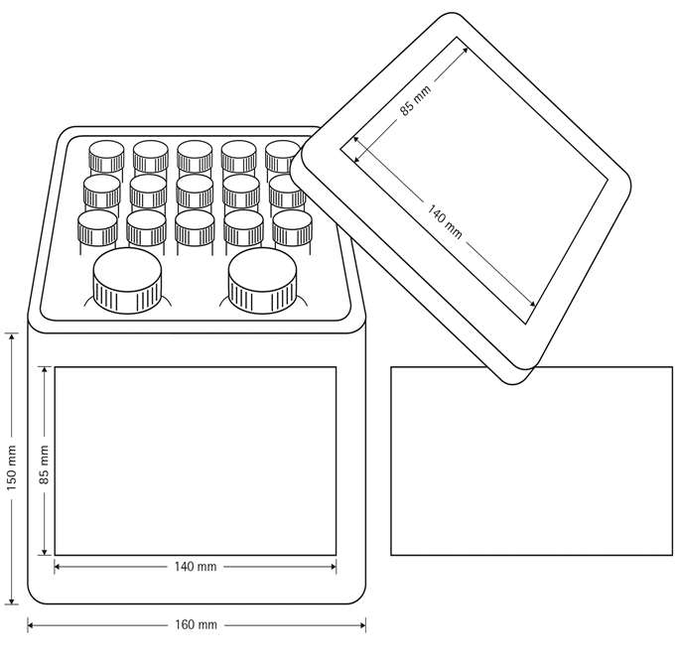
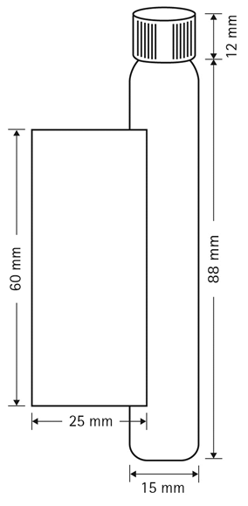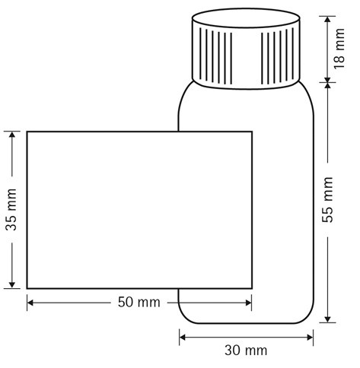
Reagent 1: : (Glass ampoule) Mixture containing ammonia solution and potassium cyanide

Classification: Acute toxicity cat.3 (dermal, inhalation)

Acute toxicity cat.4 (oral)

Skin corrosion cat. 1B

chronic aquatic hazard cat.3

Labelling:

Pictogram:
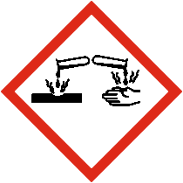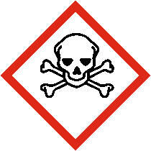
Signal Word: Danger

Hazard Statements:
H311+H331: Toxic in contact with skin or if inhaled

H302: Harmful if swallowed

H412: Harmful to aquatic life with long lasting effects

Precautionary Statements

Prevention:

P264: Wash…thoroughly after handling

P270: Do not eat drink or smoke when using this product

P280: Wear protective gloves/protective clothing/eye protection/face protection

P260: Do not breath fume/vapour

P271: Use only outdoors or in a well ventilated area

P273: Avoid release to the environment

Response:
P390: Adsorb spillage to prevent material-damage
P321: Specific treatment (see … on this label)
P330: Rinse mouth
P302+P352: IF ON SKIN: wash with plenty of water/…
P310: Immediately call a POISON CENTER/doctor/…
P311: Call a POISON CENTER/doctor/…
P312: Call a POISON CENTER/ doctor/… if you feel unwell
P301+P310: Get medical advice/attention if you feel unwell.
P314: Get medical advice/attention if you feel unwell
P361+P364: Take off immediately all contaminated clothing and wash it before reuse
P363: Wash contaminated clothing before reuse
P304+P340: IF INHALED: Remove person to fresh air and keep comfortable for breathing P301+P330+P331: IF SWALLOWED: Rinse mouth. Do not induce vomiting
P303+P361+P353: IF ON SKIN (or hair): Take off immediately all contaminated clothing. Rinse skin with water/shower
P305+P351+P338: IF IN EYES: Rinse cautiously with water for several minutes. Remove contact lenses, if present and easy to do. Continue rinsing.

Storage:
P406: Store in a corrosive resistant container with a resistant inner liner
P405: Store locked up
P403+P233:Store in a well-ventilated place. Keep container tightly closed

Diposal:
P501: Dispose of contents/container to…

Reagent 2: (Bottle) Mixture containing hydroxylammonium chloride

Classification: Corrosive to metals cat.1

Skin irritation cat.2

Eye irritation cat.2

Skin sensitization cat.1

Carcinogenicity cat.2

STOT repeated cat.2

Labelling:

Pictogram:
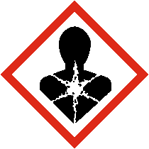 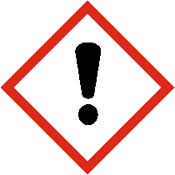
Signal word: Warning
Hazard statements:

H290: Maybe corrosive to metals

H315: Causes skin irritation

H319: causes serious eye irritation:

H317:May cause an allergic skin reaction

H351: Suspected of causing cancer

H373: May cause damage to organs through prolonged or repeated exposure

Precautionary statements

Prevention:

P201:Obtain special instructions before use

P202: Do not handle until all safety precautions have been read and understood.

P264: Wash…thoroughly after handling

P280: Wear protective gloves/protective clothing/eye protection/face protection

P260: Do not breath fume/vapour

P272: Contaminated work clothing should not be allowed out of the workplace

Response:
P321: Specific treatment (see … on this label)
P302+P352: IF ON SKIN: wash with plenty of water/…
P310: Immediately call a POISON CENTER/doctor/…
P314: Get medical advice/attention if you feel unwell
P308+P313: If exposed or concerned: Get medical advice/attention.
P337+P313: If eye irritation persist: Get medical advice attention
P332+P313: If skin irritation occurs: Get medical advice attentionP362+P364: Take off contaminated clothing and wash it before reuse
P303+P361+P353: IF ON SKIN (or hair): Take off immediately all contaminated clothing. Rinse skin with water/shower
P305+P351+P338: IF IN EYES: Rinse cautiously with water for several minutes. Remove contact lenses, if present and easy to do. Continue rinsing.

Storage:
P405:Store locked up

Diposal:

P501: Dispose of contents/container to…

Possible options to address labelling problems encountered

Issue | Potential options | Comments
Divide the outer label in so many pieces to provide all label elements of each hazardous single component on the outer packaging/label |  | due to size and shape of the combination package it is not possible to divide the outer label in so many pieces as are necessary for enabling a labelling of each hazardous single component  (the main reason are 10-30 precautionary statements for each hazardous single component )
 | Matched pictograms of each hazardous component, without duplication | A clear visual appearance is guaranteed
 | Accumulate all appropriate precautionary statements of each hazardous single components | redundant information can be omitted, a better fond size could be used

Reagent 1  precautionary statements | Reagent 2  precautionary statements | Combined appropriate  precautionary statements
P201:Obtain special instructions before use | P264: Wash…thoroughly after handling | P201:Obtain special instructions before use
P202: Do not handle until all safety precau-tions have been read and understood | P270: Do not eat drink or smoke when using this product | P202: Do not handle until all safety precau-tions have been read and understood
P264: Wash…thoroughly after handling | P280: Wear protective gloves/protective clothing/eye protection/face protection | P264: Wash…thoroughly after handling
P280: Wear protective gloves/protective clothing/eye protection/face protection | P260: Do not breath fume/vapour | P308+P313: If exposed or concerned: Get medical advice/attention.
P260: Do not breath fume/vapour | P271: Use only outdoors or in a well ventilated area | P302+P352: IF ON SKIN: wash with plenty of water/…
P272: Contaminated work clothing should not be allowed out of the workplace | P273: Avoid release to the environment | P280: Wear protective gloves/protective clothing/eye protection/face protection
P390: Adsorb spillage to prevent material- | P321: Specific treatment (see … on this label) | P302+P352: IF ON SKIN: wash with plenty of water/…
P321: Specific treatment (see … on this label) |  | P301+P330+P331: IF SWALLOWED: Rinse mouth. Do not induce vomiting
P330: Rinse mouth |  | P310: Immediately call a POISON CENTER/doctor/…
P302+P352: IF ON SKIN: wash with plenty of water/… | P314: Get medical advice/attention if you feel unwell | P305+P351+P338: IF IN EYES: Rinse cautiously with water for several minutes. Remove contact lenses, if present and easy to do. Continue rinsing
P310: Immediately call a POISON CENTER/doctor/… | P308+P313: If exposed or concerned: Get medical advice/attention.
P311: Call a POISON CENTER/doctor/… | P337+P313: If eye irritation persist: Get medical advice attention
P312: Call a POISON CENTER/ doctor/… if you feel unwell | P332+P313: If skin irritation occurs: Get medical advice/attention
 | P362+P364: Take off contaminated clothing and wash it before reuse
P301+P310: Get medical advice/attention if you feel unwell | P303+P361+P353: IF ON SKIN (or hair): Take off immediately all contaminated clothing. Rinse skin with water/shower
P314: Get medical advice/attention if you feel unwell | P305+P351+P338: IF IN EYES: Rinse cautiously with water for several minutes. Remove contact lenses, if present and easy to do. Continue rinsing.
P361+P364: Take off immediately all contaminated clothing and wash it before reuse | P302+P352: IF ON SKIN: wash with plenty of water/…
P363: Wash contaminated clothing before reuse | P310: Immediately call a POISON CENTER/doctor/…
P304+P340: IF INHALED: Remove person to fresh air and keep comfortable for breathing
P301+P330+P331: IF SWALLOWED: Rinse mouth. Do not induce vomiting
P303+P361+P353: IF ON SKIN (or hair): Take off immediately all contaminated clothing. Rinse skin with water/shower
P305+P351+P338: IF IN EYES: Rinse cautiously with water for several minutes. Remove contact lenses, if present and easy to do. Continue rinsing
P406: Store in a corrosive resistant container with a resistant inner liner | P405:Store locked up
P405:Store locked up
P403+P233:Store in a well ventilated place. Keep container tightly closed
P501: Dispose of contents/container to… | P501: Dispose of contents/container to…

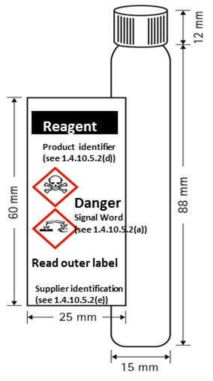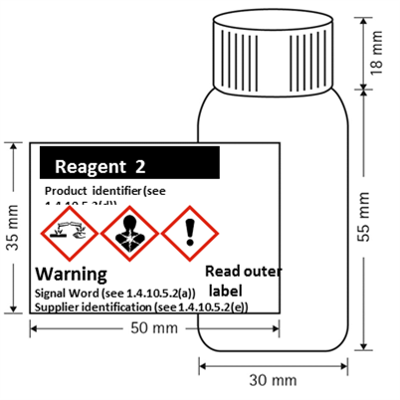

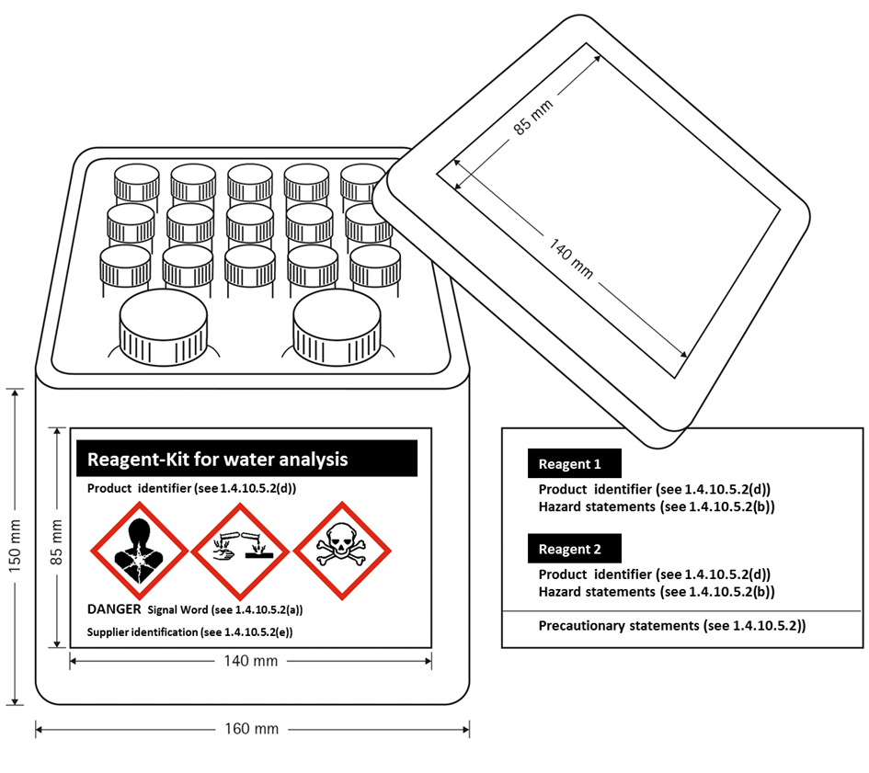
Example 1 based on possibility 2:
The Sample Kit is used for marketing purposes and consists of 156 different products in individual 10 ml bottles presented in an outer package. The inner bottles are stored in the outer package throughout the lifecycle of the Sample Kit. Customers may select individual bottles and remove them from the box to check clarity, color or odor and then replace it into the open slot within the outer box.

Packaging description and size:

Each sample test kit is constructed of a plastic outer box containing 156 bottle. Each bottle is filled with 10 ml of 156 different mixtures (total volume: 1560 ml). Depending upon the product mix, some or all of the 156 different materials may be considered hazardous.

Possible options to address labelling problems encountered
Issue | Potential options | Comments
Kits contain many small inner packages containing many different hazardous products in one outer box/container. |  | Inner containers are too small to accommodate full GHS labels. There is limited space on the outer box to affix complete labels for each hazardous product due to size and shape of the combination package
 | Provide label elements on a tie-on tag | Not practical as tie-on tag would need to be large to accommodate all required labelling even with printing on both sides of the tag. Large tag on a very small bottle may impede use of the product and users may remove tag in frustration..  General principles require all applicable label elements to appear on immediate container where possible; also some label elements on the immediate container may need to be accessible to users throughout life of product. Would therefore also need to include minimum label elements on immediate container just in case the tie-on tag is removed by the user.
 | Increase the size of the container so that a larger label can be affixed | Not a practical solution. Increasing the size of the container is not practical from the intended use perspective.  Increasing the size of the container without increasing product volume may introduce oxygen into the contents of the container causing oxidation of the material which could change the aroma, flavour or potentcy.  Also need to take account of sustainability considerations (e.g. packaging reduction, environmental footprint, etc.)
 | Use already accepted limited information on inner packaging | 5 label elements can be displayed in a font size to make highly visible and comprehensible hazard communication.
 | Apply modified label format to outside of kit | Emphasizes most important label elements (identifier, manufacturer information, unique pictogram(s), signal word, hazard statement relative to each inner package.
 | Display pictograms of each hazardous component, without duplication on outer label along with signal word | A clear visual appearance is guaranteed. In the case of breakage, not knowing which inners have broken, the user immediately is apprised of the hazards that are contained within.
 | For a kit with many hazardous inners, the label space available may still not be adequate; allow the manufacturer to include slip sheets identifying each hazardous material and its full GHS labelling on the inside of the box. | This accommodation allows the user access to all GHS hazard communication label elements for each individual bottle containing a hazardous substance or mixture.

Example 1 based on possibility 2

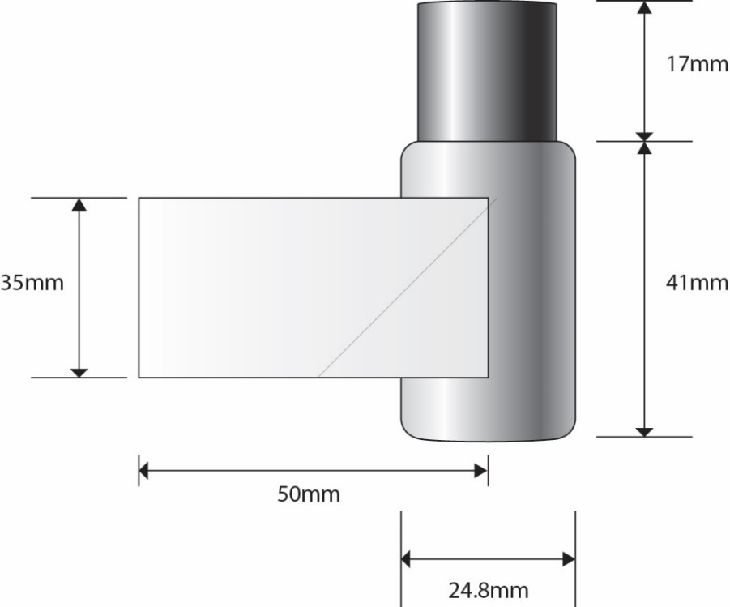

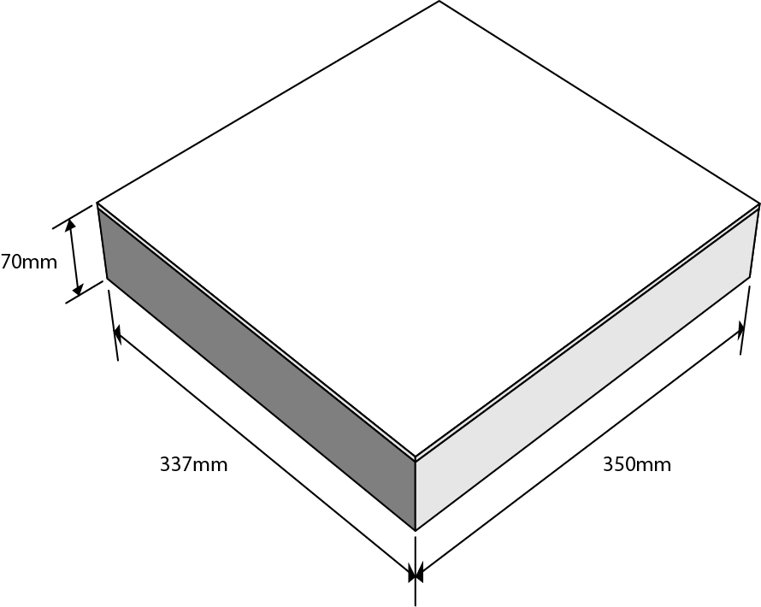
Outer kit labelling:
The outer box, given the limited area for labeling, will display;
(a) supplier identification (see 1.4.10.5.2(e))
(b) product identifier (see 1.4.10.5.2.(d)ii)
(c) pictograms of each single hazardous component without duplication (see 1.4.10.5.3.1)
(d) signal word (see1.4.10.5.2(a))
Inside kit labelling:
Full labelling information regarding each hazardous single component will be affixed in the inside of the combination package .

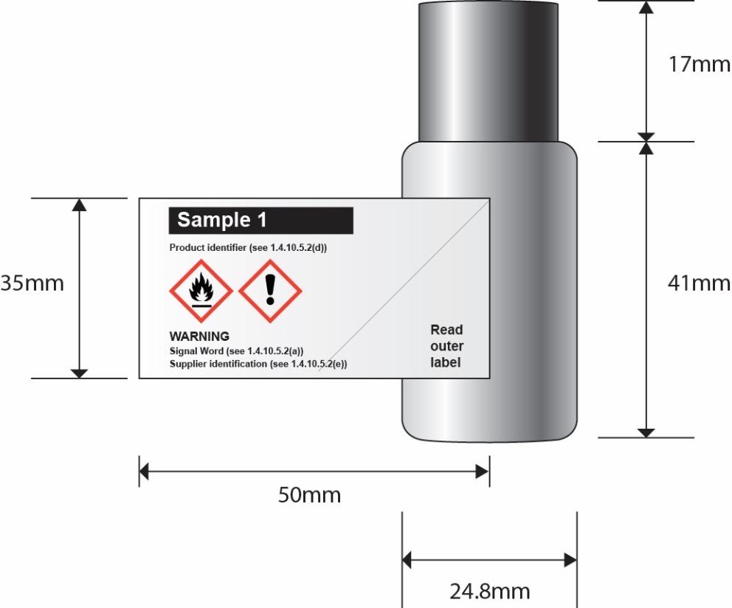

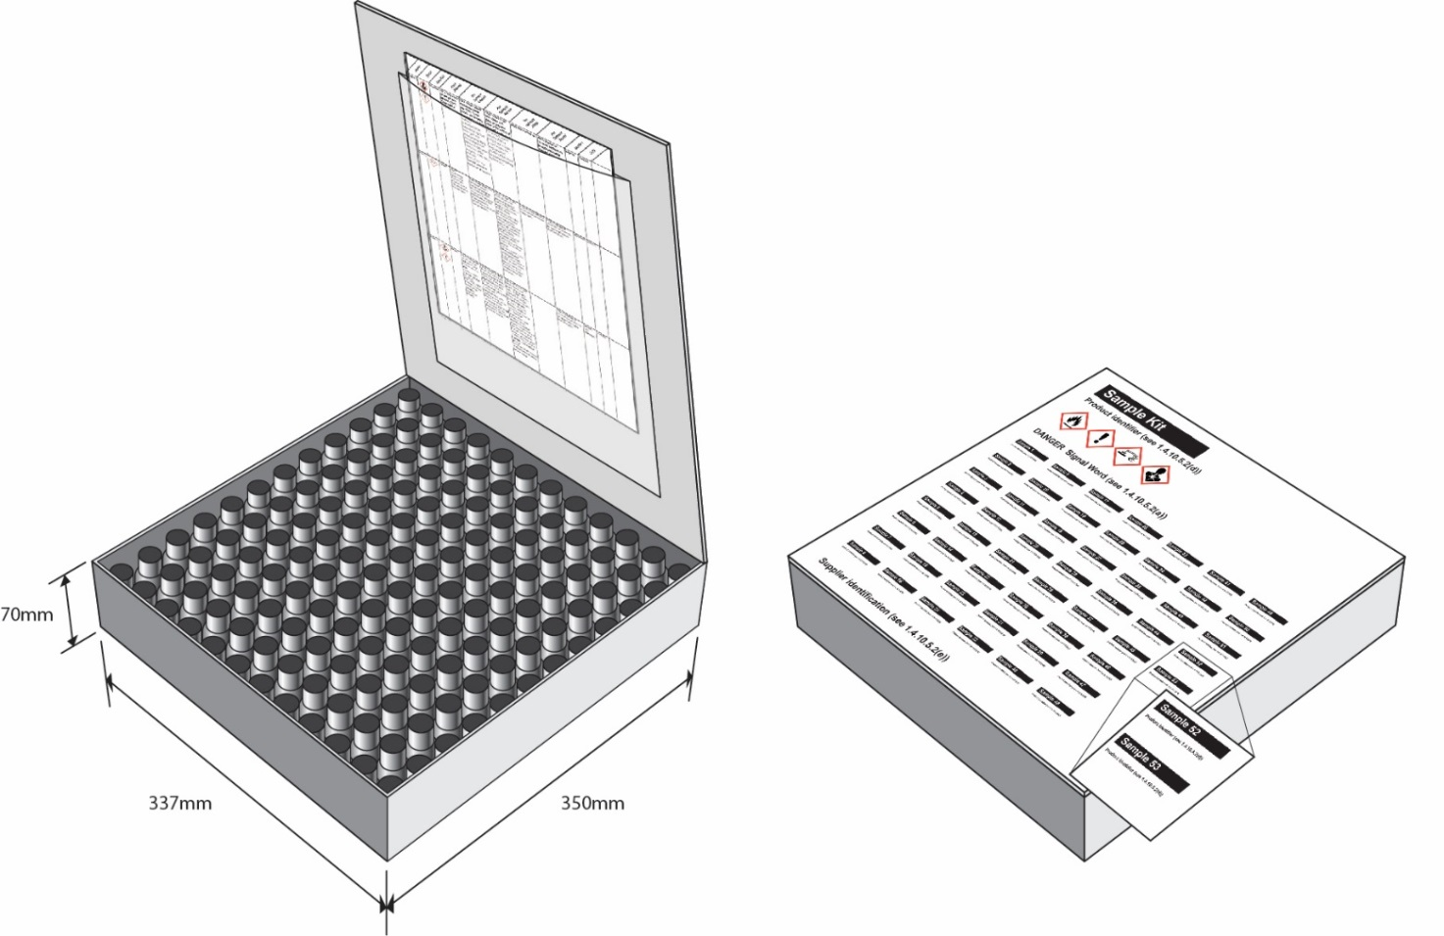

 |  |  |  | Precautionary Statements
Identifier | Picto- grams | Signal Word | Hazard Statements | Prevention | Response | Storage | Disposal
Sample 1 | 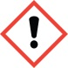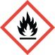 | Warning | H226: Flammable liquid and vapour.;  H319: Causes serious eye irritation. | P210: Keep away from heat/sparks/open flames/hot surfaces. - No smoking.;  P233: Keep container tightly closed.;  P240: Ground/bond container and receiving equipment.;  P241: Use explosion-proof electrical/ ventilating/ lighting/ equipment.;  P242: Use only non-sparking tools.;  P243: Take precautionary measures against static discharge.;  P264: Wash skin thoroughly after handling.;  P280: Wear protective gloves/ eye protection/ face protection. | P303 + P361 + P353: IF ON SKIN (or hair): Remove/ Take off immediately all contaminated clothing. Rinse skin with water/ shower.;  P305 + P351 + P338: IF IN EYES: Rinse cautiously with water for several minutes. Remove contact lenses, if present and easy to do. Continue rinsing.;  P337 + P313: If eye irritation persists: Get medical advice/ attention.;  P370 + P378: In case of fire: Use dry sand, dry chemical or alcohol-resistant foam for extinction. | P403 + P235: Store in a well-ventilated place. Keep cool. | P501: Dispose of contents/ container to an approved waste disposal plant.
Sample 2 |  | Warning | H317: May cause an allergic skin reaction. | P261: Avoid breathing dust/ fume/ gas/ mist/ vapours/ spray.;  P272: Contaminated work clothing should not be allowed out of the workplace.;  P280: Wear protective gloves. | P302 + P352: IF ON SKIN: Wash with plenty of soap and water.;  P333 + P313: If skin irritation or rash occurs: Get medical advice/ attention.;  P363: Wash contaminated clothing before reuse. |  | P501: Dispose of contents/ container to an approved waste disposal plant.
Sample 3 |  | Warning | H315: Causes skin irritation.;  H319: Causes serious eye irritation. | P264: Wash skin thoroughly after handling.;  P280: Wear eye protection/ face protection.;  P280: Wear protective gloves. | P302 + P352: IF ON SKIN: Wash with plenty of soap and water.;  P305 + P351 + P338: IF IN EYES: Rinse cautiously with water for several minutes. Remove contact lenses, if present and easy to do. Continue rinsing.;  P332 + P313: If skin irritation occurs: Get medical advice/ attention.;  P337 + P313: If eye irritation persists: Get medical advice/ attention.;  P362: Take off contaminated clothing and wash before reuse.
Sample 4 |  | Danger | H225: Highly flammable liquid and vapour.;  H319: Causes serious eye irritation. | P210: Keep away from heat/sparks/open flames/hot surfaces. - No smoking.;  P233: Keep container tightly closed.;  P240: Ground/bond container and receiving equipment.;  P241: Use explosion-proof electrical/ ventilating/ lighting/ equipment.;  P242: Use only non-sparking tools.;  P243: Take precautionary measures against static discharge.;  P264: Wash skin thoroughly after handling.;  P280: Wear protective gloves/ eye protection/ face protection. | P303 + P361 + P353: IF ON SKIN (or hair): Remove/ Take off immediately all contaminated clothing. Rinse skin with water/ shower.;  P305 + P351 + P338: IF IN EYES: Rinse cautiously with water for several minutes. Remove contact lenses, if present and easy to do. Continue rinsing.;  P337 + P313: If eye irritation persists: Get medical advice/ attention.;  P370 + P378: In case of fire: Use dry sand, dry chemical or alcohol-resistant foam for extinction. | P403 + P235: Store in a well-ventilated place. Keep cool. | P501: Dispose of contents/ container to an approved waste disposal plant.
Sample 5 | 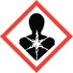 | Warning | H317: May cause an allergic skin reaction.;  H351: Suspected of causing cancer. | P201: Obtain special instructions before use.;  P202: Do not handle until all safety precautions have been read and understood.;  P261: Avoid breathing dust/ fume/ gas/ mist/ vapours/ spray.;  P272: Contaminated work clothing should not be allowed out of the workplace.;  P280: Wear protective gloves.;  P281: Use personal protective equipment as required. | P302 + P352: IF ON SKIN: Wash with plenty of soap and water.;  P308 + P313: IF exposed or concerned: Get medical advice/ attention.;  P333 + P313: If skin irritation or rash occurs: Get medical advice/ attention.;  P363: Wash contaminated clothing before reuse. | P405: Store locked up. | P501: Dispose of contents/ container to an approved waste disposal plant.
Sample 6 |  | Warning | H317: May cause an allergic skin reaction. | P261: Avoid breathing dust/ fume/ gas/ mist/ vapours/ spray.;  P272: Contaminated work clothing should not be allowed out of the workplace.;  P280: Wear protective gloves. | P302 + P352: IF ON SKIN: Wash with plenty of soap and water.;  P333 + P313: If skin irritation or rash occurs: Get medical advice/ attention.;  P363: Wash contaminated clothing before reuse. |  | P501: Dispose of contents/ container to an approved waste disposal plant.
Sample 7 |  | Warning | H351: Suspected of causing cancer. | P201: Obtain special instructions before use.;  P202: Do not handle until all safety precautions have been read and understood.;  P281: Use personal protective equipment as required. | P308 + P313: IF exposed or concerned: Get medical advice/ attention. | P405: Store locked up. | P501: Dispose of contents/ container to an approved waste disposal plant.
Sample 8 |  | Warning | H227: Combustible liquid. | P210: Keep away from heat/sparks/open flames/hot surfaces. - No smoking.;  P280: Wear protective gloves/ eye protection/ face protection. | P370 + P378: In case of fire: Use dry sand, dry chemical or alcohol-resistant foam for extinction. | P403 + P235: Store in a well-ventilated place. Keep cool. | P501: Dispose of contents/ container to an approved waste disposal plant.
Sample 9 |  | Warning | H227: Combustible liquid. | P210: Keep away from heat/sparks/open flames/hot surfaces. - No smoking.;  P280: Wear protective gloves/ eye protection/ face protection. | P370 + P378: In case of fire: Use dry sand, dry chemical or alcohol-resistant foam for extinction. | P403 + P235: Store in a well-ventilated place. Keep cool. | P501: Dispose of contents/ container to an approved waste disposal plant.
Sample 10 | 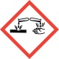 | Danger | H227: Combustible liquid.;  H315: Causes skin irritation.;  H318: Causes serious eye damage. | P210: Keep away from heat/sparks/open flames/hot surfaces. - No smoking.;  P264: Wash skin thoroughly after handling.;  P280: Wear protective gloves/ eye protection/ face protection. | P302 + P352: IF ON SKIN: Wash with plenty of soap and water.;  P305 + P351 + P338 + P310: IF IN EYES: Rinse cautiously with water for several minutes. Remove contact lenses, if present and easy to do. Continue rinsing. Immediately call a POISON CENTER or doctor/ physician.;  P332 + P313: If skin irritation occurs: Get medical advice/ attention.;  P362: Take off contaminated clothing and wash before reuse.;  P370 + P378: In case of fire: Use dry sand, dry chemical or alcohol-resistant foam for extinction. | P403 + P235: Store in a well-ventilated place. Keep cool. | P501: Dispose of contents/ container to an approved waste disposal plant.
Sample 11 |  | Warning | H317: May cause an allergic skin reaction. | P261: Avoid breathing dust/ fume/ gas/ mist/ vapours/ spray.;  P272: Contaminated work clothing should not be allowed out of the workplace.;  P280: Wear protective gloves. | P302 + P352: IF ON SKIN: Wash with plenty of soap and water.;  P333 + P313: If skin irritation or rash occurs: Get medical advice/ attention.;  P363: Wash contaminated clothing before reuse. |  | P501: Dispose of contents/ container to an approved waste disposal plant.
Sample 12 |  | Warning | H226: Flammable liquid and vapour.;  H317: May cause an allergic skin reaction. | P210: Keep away from heat/sparks/open flames/hot surfaces. - No smoking.;  P233: Keep container tightly closed.;  P240: Ground/bond container and receiving equipment.;  P241: Use explosion-proof electrical/ ventilating/ lighting/ equipment.;  P242: Use only non-sparking tools.;  P243: Take precautionary measures against static discharge.;  P261: Avoid breathing dust/ fume/ gas/ mist/ vapours/ spray.;  P272: Contaminated work clothing should not be allowed out of the workplace.;  P280: Wear protective gloves/ eye protection/ face protection. | P303 + P361 + P353: IF ON SKIN (or hair): Remove/ Take off immediately all contaminated clothing. Rinse skin with water/ shower.;  P333 + P313: If skin irritation or rash occurs: Get medical advice/ attention.;  P363: Wash contaminated clothing before reuse.;  P370 + P378: In case of fire: Use dry sand, dry chemical or alcohol-resistant foam for extinction. | P403 + P235: Store in a well-ventilated place. Keep cool. | P501: Dispose of contents/ container to an approved waste disposal plant.
Sample 13 |  | Warning | H317: May cause an allergic skin reaction. | P261: Avoid breathing dust/ fume/ gas/ mist/ vapours/ spray.;  P272: Contaminated work clothing should not be allowed out of the workplace.;  P280: Wear protective gloves. | P302 + P352: IF ON SKIN: Wash with plenty of soap and water.;  P333 + P313: If skin irritation or rash occurs: Get medical advice/ attention.;  P363: Wash contaminated clothing before reuse. |  | P501: Dispose of contents/ container to an approved waste disposal plant.
Sample 14 |  | Danger | H317: May cause an allergic skin reaction.;  H319: Causes serious eye irritation.;  H372: Causes damage to organs through prolonged or repeated exposure if inhaled. | P260: Do not breathe dust/ fume/ gas/ mist/ vapours/ spray.;  P264: Wash skin thoroughly after handling.;  P270: Do not eat, drink or smoke when using this product.;  P272: Contaminated work clothing should not be allowed out of the workplace.;  P280: Wear eye protection/ face protection.;  P280: Wear protective gloves. | P302 + P352: IF ON SKIN: Wash with plenty of soap and water.;  P305 + P351 + P338: IF IN EYES: Rinse cautiously with water for several minutes. Remove contact lenses, if present and easy to do. Continue rinsing.;  P314: Get medical advice/ attention if you feel unwell.;  P333 + P313: If skin irritation or rash occurs: Get medical advice/ attention.;  P337 + P313: If eye irritation persists: Get medical advice/ attention.;  P363: Wash contaminated clothing before reuse. |  | P501: Dispose of contents/ container to an approved waste disposal plant.
Sample 15 |  | Warning | H315: Causes skin irritation.;  H319: Causes serious eye irritation. | P264: Wash skin thoroughly after handling.;  P280: Wear eye protection/ face protection.;  P280: Wear protective gloves. | P302 + P352: IF ON SKIN: Wash with plenty of soap and water.;  P305 + P351 + P338: IF IN EYES: Rinse cautiously with water for several minutes. Remove contact lenses, if present and easy to do. Continue rinsing.;  P332 + P313: If skin irritation occurs: Get medical advice/ attention.;  P337 + P313: If eye irritation persists: Get medical advice/ attention.;  P362: Take off contaminated clothing and wash before reuse.
Sample 16 | 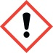 | Danger | H226: Flammable liquid and vapour.;  H304: May be fatal if swallowed and enters airways.;  H315: Causes skin irritation.;  H317: May cause an allergic skin reaction. | P210: Keep away from heat/sparks/open flames/hot surfaces. - No smoking.;  P233: Keep container tightly closed.;  P240: Ground/bond container and receiving equipment.;  P241: Use explosion-proof electrical/ ventilating/ lighting/ equipment.;  P242: Use only non-sparking tools.;  P243: Take precautionary measures against static discharge.;  P261: Avoid breathing dust/ fume/ gas/ mist/ vapours/ spray.;  P264: Wash skin thoroughly after handling.;  P272: Contaminated work clothing should not be allowed out of the workplace.;  P280: Wear protective gloves/ eye protection/ face protection. | P301 + P310: IF SWALLOWED: Immediately call a POISON CENTER or doctor/ physician.;  P303 + P361 + P353: IF ON SKIN (or hair): Remove/ Take off immediately all contaminated clothing. Rinse skin with water/ shower.;  P331: Do NOT induce vomiting.;  P333 + P313: If skin irritation or rash occurs: Get medical advice/ attention.;  P362: Take off contaminated clothing and wash before reuse.;  P370 + P378: In case of fire: Use dry sand, dry chemical or alcohol-resistant foam for extinction. | P403 + P235: Store in a well-ventilated place. Keep cool.;  P405: Store locked up. | P501: Dispose of contents/ container to an approved waste disposal plant.
Sample 17 |  | Warning | H317: May cause an allergic skin reaction.;  H351: Suspected of causing cancer. | P201: Obtain special instructions before use.;  P202: Do not handle until all safety precautions have been read and understood.;  P261: Avoid breathing dust/ fume/ gas/ mist/ vapours/ spray.;  P272: Contaminated work clothing should not be allowed out of the workplace.;  P280: Wear protective gloves.;  P281: Use personal protective equipment as required. | P302 + P352: IF ON SKIN: Wash with plenty of soap and water.;  P308 + P313: IF exposed or concerned: Get medical advice/ attention.;  P333 + P313: If skin irritation or rash occurs: Get medical advice/ attention.;  P363: Wash contaminated clothing before reuse. | P405: Store locked up. | P501: Dispose of contents/ container to an approved waste disposal plant.
Sample 18 |  | Warning | H317: May cause an allergic skin reaction. | P261: Avoid breathing dust/ fume/ gas/ mist/ vapours/ spray.;  P272: Contaminated work clothing should not be allowed out of the workplace.;  P280: Wear protective gloves. | P302 + P352: IF ON SKIN: Wash with plenty of soap and water.;  P333 + P313: If skin irritation or rash occurs: Get medical advice/ attention.;  P363: Wash contaminated clothing before reuse. |  | P501: Dispose of contents/ container to an approved waste disposal plant.
Sample 19 |  | Warning | H227: Combustible liquid.;  H319: Causes serious eye irritation. | P210: Keep away from heat/sparks/open flames/hot surfaces. - No smoking.;  P264: Wash skin thoroughly after handling.;  P280: Wear protective gloves/ eye protection/ face protection. | P305 + P351 + P338: IF IN EYES: Rinse cautiously with water for several minutes. Remove contact lenses, if present and easy to do. Continue rinsing.;  P337 + P313: If eye irritation persists: Get medical advice/ attention.;  P370 + P378: In case of fire: Use dry sand, dry chemical or alcohol-resistant foam for extinction. | P403 + P235: Store in a well-ventilated place. Keep cool. | P501: Dispose of contents/ container to an approved waste disposal plant.
Sample 20 |  | Warning | H227: Combustible liquid. | P210: Keep away from heat/sparks/open flames/hot surfaces. - No smoking.;  P280: Wear protective gloves/ eye protection/ face protection. | P370 + P378: In case of fire: Use dry sand, dry chemical or alcohol-resistant foam for extinction. | P403 + P235: Store in a well-ventilated place. Keep cool. | P501: Dispose of contents/ container to an approved waste disposal plant.
Sample 21 |  | Warning | H227: Combustible liquid. | P210: Keep away from heat/sparks/open flames/hot surfaces. - No smoking.;  P280: Wear protective gloves/ eye protection/ face protection. | P370 + P378: In case of fire: Use dry sand, dry chemical or alcohol-resistant foam for extinction. | P403 + P235: Store in a well-ventilated place. Keep cool. | P501: Dispose of contents/ container to an approved waste disposal plant.
Sample 22 |  | Warning | H227: Combustible liquid.;  H315: Causes skin irritation.;  H319: Causes serious eye irritation. | P210: Keep away from heat/sparks/open flames/hot surfaces. - No smoking.;  P264: Wash skin thoroughly after handling.;  P280: Wear protective gloves/ eye protection/ face protection. | P302 + P352: IF ON SKIN: Wash with plenty of soap and water.;  P305 + P351 + P338: IF IN EYES: Rinse cautiously with water for several minutes. Remove contact lenses, if present and easy to do. Continue rinsing.;  P332 + P313: If skin irritation occurs: Get medical advice/ attention.;  P337 + P313: If eye irritation persists: Get medical advice/ attention.;  P362: Take off contaminated clothing and wash before reuse.;  P370 + P378: In case of fire: Use dry sand, dry chemical or alcohol-resistant foam for extinction. | P403 + P235: Store in a well-ventilated place. Keep cool. | P501: Dispose of contents/ container to an approved waste disposal plant.
Sample 23 |  | Danger | H225: Highly flammable liquid and vapour.;  H319: Causes serious eye irritation. | P210: Keep away from heat/sparks/open flames/hot surfaces. - No smoking.;  P233: Keep container tightly closed.;  P240: Ground/bond container and receiving equipment.;  P241: Use explosion-proof electrical/ ventilating/ lighting/ equipment.;  P242: Use only non-sparking tools.;  P243: Take precautionary measures against static discharge.;  P264: Wash skin thoroughly after handling.;  P280: Wear protective gloves/ eye protection/ face protection. | P303 + P361 + P353: IF ON SKIN (or hair): Remove/ Take off immediately all contaminated clothing. Rinse skin with water/ shower.;  P305 + P351 + P338: IF IN EYES: Rinse cautiously with water for several minutes. Remove contact lenses, if present and easy to do. Continue rinsing.;  P337 + P313: If eye irritation persists: Get medical advice/ attention.;  P370 + P378: In case of fire: Use dry sand, dry chemical or alcohol-resistant foam for extinction. | P403 + P235: Store in a well-ventilated place. Keep cool. | P501: Dispose of contents/ container to an approved waste disposal plant.
Sample 24 |  | Warning | H317: May cause an allergic skin reaction. | P261: Avoid breathing dust/ fume/ gas/ mist/ vapours/ spray.;  P272: Contaminated work clothing should not be allowed out of the workplace.;  P280: Wear protective gloves. | P302 + P352: IF ON SKIN: Wash with plenty of soap and water.;  P333 + P313: If skin irritation or rash occurs: Get medical advice/ attention.;  P363: Wash contaminated clothing before reuse. |  | P501: Dispose of contents/ container to an approved waste disposal plant.
Sample 25 |  | Warning | H315: Causes skin irritation.;  H317: May cause an allergic skin reaction.;  H319: Causes serious eye irritation. | P261: Avoid breathing dust/ fume/ gas/ mist/ vapours/ spray.;  P264: Wash skin thoroughly after handling.;  P272: Contaminated work clothing should not be allowed out of the workplace.;  P280: Wear eye protection/ face protection.;  P280: Wear protective gloves. | P302 + P352: IF ON SKIN: Wash with plenty of soap and water.;  P305 + P351 + P338: IF IN EYES: Rinse cautiously with water for several minutes. Remove contact lenses, if present and easy to do. Continue rinsing.;  P333 + P313: If skin irritation or rash occurs: Get medical advice/ attention.;  P337 + P313: If eye irritation persists: Get medical advice/ attention.;  P362: Take off contaminated clothing and wash before reuse. |  | P501: Dispose of contents/ container to an approved waste disposal plant.
Sample 26 |  | Warning | H317: May cause an allergic skin reaction. | P261: Avoid breathing dust/ fume/ gas/ mist/ vapours/ spray.;  P272: Contaminated work clothing should not be allowed out of the workplace.;  P280: Wear protective gloves. | P302 + P352: IF ON SKIN: Wash with plenty of soap and water.;  P333 + P313: If skin irritation or rash occurs: Get medical advice/ attention.;  P363: Wash contaminated clothing before reuse. |  | P501: Dispose of contents/ container to an approved waste disposal plant.
Sample 27 |  | Warning | H226: Flammable liquid and vapour.;  H319: Causes serious eye irritation. | P210: Keep away from heat/sparks/open flames/hot surfaces. - No smoking.;  P233: Keep container tightly closed.;  P240: Ground/bond container and receiving equipment.;  P241: Use explosion-proof electrical/ ventilating/ lighting/ equipment.;  P242: Use only non-sparking tools.;  P243: Take precautionary measures against static discharge.;  P264: Wash skin thoroughly after handling.;  P280: Wear protective gloves/ eye protection/ face protection. | P303 + P361 + P353: IF ON SKIN (or hair): Remove/ Take off immediately all contaminated clothing. Rinse skin with water/ shower.;  P305 + P351 + P338: IF IN EYES: Rinse cautiously with water for several minutes. Remove contact lenses, if present and easy to do. Continue rinsing.;  P337 + P313: If eye irritation persists: Get medical advice/ attention.;  P370 + P378: In case of fire: Use dry sand, dry chemical or alcohol-resistant foam for extinction. | P403 + P235: Store in a well-ventilated place. Keep cool. | P501: Dispose of contents/ container to an approved waste disposal plant.
Sample 28 |  | Danger | H225: Highly flammable liquid and vapour.;  H319: Causes serious eye irritation. | P210: Keep away from heat/sparks/open flames/hot surfaces. - No smoking.;  P233: Keep container tightly closed.;  P240: Ground/bond container and receiving equipment.;  P241: Use explosion-proof electrical/ ventilating/ lighting/ equipment.;  P242: Use only non-sparking tools.;  P243: Take precautionary measures against static discharge.;  P264: Wash skin thoroughly after handling.;  P280: Wear protective gloves/ eye protection/ face protection. | P303 + P361 + P353: IF ON SKIN (or hair): Remove/ Take off immediately all contaminated clothing. Rinse skin with water/ shower.;  P305 + P351 + P338: IF IN EYES: Rinse cautiously with water for several minutes. Remove contact lenses, if present and easy to do. Continue rinsing.;  P337 + P313: If eye irritation persists: Get medical advice/ attention.;  P370 + P378: In case of fire: Use dry sand, dry chemical or alcohol-resistant foam for extinction. | P403 + P235: Store in a well-ventilated place. Keep cool. | P501: Dispose of contents/ container to an approved waste disposal plant.
Sample 29 |  | Danger | H225: Highly flammable liquid and vapour.;  H319: Causes serious eye irritation. | P210: Keep away from heat/sparks/open flames/hot surfaces. - No smoking.;  P233: Keep container tightly closed.;  P240: Ground/bond container and receiving equipment.;  P241: Use explosion-proof electrical/ ventilating/ lighting/ equipment.;  P242: Use only non-sparking tools.;  P243: Take precautionary measures against static discharge.;  P264: Wash skin thoroughly after handling.;  P280: Wear protective gloves/ eye protection/ face protection. | P303 + P361 + P353: IF ON SKIN (or hair): Remove/ Take off immediately all contaminated clothing. Rinse skin with water/ shower.;  P305 + P351 + P338: IF IN EYES: Rinse cautiously with water for several minutes. Remove contact lenses, if present and easy to do. Continue rinsing.;  P337 + P313: If eye irritation persists: Get medical advice/ attention.;  P370 + P378: In case of fire: Use dry sand, dry chemical or alcohol-resistant foam for extinction. | P403 + P235: Store in a well-ventilated place. Keep cool. | P501: Dispose of contents/ container to an approved waste disposal plant.
Sample 30 |  | Warning | H351: Suspected of causing cancer. | P201: Obtain special instructions before use.;  P202: Do not handle until all safety precautions have been read and understood.;  P281: Use personal protective equipment as required. | P308 + P313: IF exposed or concerned: Get medical advice/ attention. | P405: Store locked up. | P501: Dispose of contents/ container to an approved waste disposal plant.
Sample 31 |  | Warning | H227: Combustible liquid. | P210: Keep away from heat/sparks/open flames/hot surfaces. - No smoking.;  P280: Wear protective gloves/ eye protection/ face protection. | P370 + P378: In case of fire: Use dry sand, dry chemical or alcohol-resistant foam for extinction. | P403 + P235: Store in a well-ventilated place. Keep cool. | P501: Dispose of contents/ container to an approved waste disposal plant.
Sample 32 |  | Warning | H315: Causes skin irritation.;  H319: Causes serious eye irritation. | P264: Wash skin thoroughly after handling.;  P280: Wear eye protection/ face protection.;  P280: Wear protective gloves. | P302 + P352: IF ON SKIN: Wash with plenty of soap and water.;  P305 + P351 + P338: IF IN EYES: Rinse cautiously with water for several minutes. Remove contact lenses, if present and easy to do. Continue rinsing.;  P332 + P313: If skin irritation occurs: Get medical advice/ attention.;  P337 + P313: If eye irritation persists: Get medical advice/ attention.;  P362: Take off contaminated clothing and wash before reuse.
Sample 33 |  | Danger | H225: Highly flammable liquid and vapour.;  H319: Causes serious eye irritation. | P210: Keep away from heat/sparks/open flames/hot surfaces. - No smoking.;  P233: Keep container tightly closed.;  P240: Ground/bond container and receiving equipment.;  P241: Use explosion-proof electrical/ ventilating/ lighting/ equipment.;  P242: Use only non-sparking tools.;  P243: Take precautionary measures against static discharge.;  P264: Wash skin thoroughly after handling.;  P280: Wear protective gloves/ eye protection/ face protection. | P303 + P361 + P353: IF ON SKIN (or hair): Remove/ Take off immediately all contaminated clothing. Rinse skin with water/ shower.;  P305 + P351 + P338: IF IN EYES: Rinse cautiously with water for several minutes. Remove contact lenses, if present and easy to do. Continue rinsing.;  P337 + P313: If eye irritation persists: Get medical advice/ attention.;  P370 + P378: In case of fire: Use dry sand, dry chemical or alcohol-resistant foam for extinction. | P403 + P235: Store in a well-ventilated place. Keep cool. | P501: Dispose of contents/ container to an approved waste disposal plant.
Sample 34 |  | Danger | H225: Highly flammable liquid and vapour.;  H319: Causes serious eye irritation. | P210: Keep away from heat/sparks/open flames/hot surfaces. - No smoking.;  P233: Keep container tightly closed.;  P240: Ground/bond container and receiving equipment.;  P241: Use explosion-proof electrical/ ventilating/ lighting/ equipment.;  P242: Use only non-sparking tools.;  P243: Take precautionary measures against static discharge.;  P264: Wash skin thoroughly after handling.;  P280: Wear protective gloves/ eye protection/ face protection. | P303 + P361 + P353: IF ON SKIN (or hair): Remove/ Take off immediately all contaminated clothing. Rinse skin with water/ shower.;  P305 + P351 + P338: IF IN EYES: Rinse cautiously with water for several minutes. Remove contact lenses, if present and easy to do. Continue rinsing.;  P337 + P313: If eye irritation persists: Get medical advice/ attention.;  P370 + P378: In case of fire: Use dry sand, dry chemical or alcohol-resistant foam for extinction. | P403 + P235: Store in a well-ventilated place. Keep cool. | P501: Dispose of contents/ container to an approved waste disposal plant.
Sample 35 |  | Danger | H225: Highly flammable liquid and vapour.;  H319: Causes serious eye irritation. | P210: Keep away from heat/sparks/open flames/hot surfaces. - No smoking.;  P233: Keep container tightly closed.;  P240: Ground/bond container and receiving equipment.;  P241: Use explosion-proof electrical/ ventilating/ lighting/ equipment.;  P242: Use only non-sparking tools.;  P243: Take precautionary measures against static discharge.;  P264: Wash skin thoroughly after handling.;  P280: Wear protective gloves/ eye protection/ face protection. | P303 + P361 + P353: IF ON SKIN (or hair): Remove/ Take off immediately all contaminated clothing. Rinse skin with water/ shower.;  P305 + P351 + P338: IF IN EYES: Rinse cautiously with water for several minutes. Remove contact lenses, if present and easy to do. Continue rinsing.;  P337 + P313: If eye irritation persists: Get medical advice/ attention.;  P370 + P378: In case of fire: Use dry sand, dry chemical or alcohol-resistant foam for extinction. | P403 + P235: Store in a well-ventilated place. Keep cool. | P501: Dispose of contents/ container to an approved waste disposal plant.
Sample 36 |  | Danger | H314: Causes severe skin burns and eye damage. | P264: Wash skin thoroughly after handling.;  P280: Wear protective gloves/ protective clothing/ eye protection/ face protection. | P301 + P330 + P331: IF SWALLOWED: Rinse mouth. Do NOT induce vomiting.;  P303 + P361 + P353: IF ON SKIN (or hair): Remove/ Take off immediately all contaminated clothing. Rinse skin with water/ shower.;  P304 + P340 + P310: IF INHALED: Remove victim to fresh air and keep at rest in a position comfortable for breathing. Immediately call a POISON CENTER or doctor/ physician.;  P305 + P351 + P338 + P310: IF IN EYES: Rinse cautiously with water for several minutes. Remove contact lenses, if present and easy to do.Continue rinsing. Immediately call a POISON CENTER or doctor/ physician.;  P363: Wash contaminated clothing before reuse. | P405: Store locked up. | P501: Dispose of contents/ container to an approved waste disposal plant.
Sample 37 |  | Danger | H225: Highly flammable liquid and vapour.;  H319: Causes serious eye irritation. | P210: Keep away from heat/sparks/open flames/hot surfaces. - No smoking.;  P233: Keep container tightly closed.;  P240: Ground/bond container and receiving equipment.;  P241: Use explosion-proof electrical/ ventilating/ lighting/ equipment.;  P242: Use only non-sparking tools.;  P243: Take precautionary measures against static discharge.;  P264: Wash skin thoroughly after handling.;  P280: Wear protective gloves/ eye protection/ face protection. | P303 + P361 + P353: IF ON SKIN (or hair): Remove/ Take off immediately all contaminated clothing. Rinse skin with water/ shower.;  P305 + P351 + P338: IF IN EYES: Rinse cautiously with water for several minutes. Remove contact lenses, if present and easy to do. Continue rinsing.;  P337 + P313: If eye irritation persists: Get medical advice/ attention.;  P370 + P378: In case of fire: Use dry sand, dry chemical or alcohol-resistant foam for extinction. | P403 + P235: Store in a well-ventilated place. Keep cool. | P501: Dispose of contents/ container to an approved waste disposal plant.
Sample 38 |  | Warning | H227: Combustible liquid. | P210: Keep away from heat/sparks/open flames/hot surfaces. - No smoking.;  P280: Wear protective gloves/ eye protection/ face protection. | P370 + P378: In case of fire: Use dry sand, dry chemical or alcohol-resistant foam for extinction. | P403 + P235: Store in a well-ventilated place. Keep cool. | P501: Dispose of contents/ container to an approved waste disposal plant.
Sample 39 |  | Danger | H318: Causes serious eye damage. | P280: Wear eye protection/ face protection. | P305 + P351 + P338 + P310: IF IN EYES: Rinse cautiously with water for several minutes. Remove contact lenses, if present and easy to do. Continue rinsing. Immediately call a POISON CENTER or doctor/ physician.
Sample 40 |  | Warning | H227: Combustible liquid. | P210: Keep away from heat/sparks/open flames/hot surfaces. - No smoking.;  P280: Wear protective gloves/ eye protection/ face protection. | P370 + P378: In case of fire: Use dry sand, dry chemical or alcohol-resistant foam for extinction. | P403 + P235: Store in a well-ventilated place. Keep cool. | P501: Dispose of contents/ container to an approved waste disposal plant.
Sample 41 |  | Warning | H317: May cause an allergic skin reaction. | P261: Avoid breathing dust/ fume/ gas/ mist/ vapours/ spray.;  P272: Contaminated work clothing should not be allowed out of the workplace.;  P280: Wear protective gloves. | P302 + P352: IF ON SKIN: Wash with plenty of soap and water.;  P333 + P313: If skin irritation or rash occurs: Get medical advice/ attention.;  P363: Wash contaminated clothing before reuse. |  | P501: Dispose of contents/ container to an approved waste disposal plant.
Sample 42 |  | Warning | H351: Suspected of causing cancer. | P201: Obtain special instructions before use.;  P202: Do not handle until all safety precautions have been read and understood.;  P281: Use personal protective equipment as required. | P308 + P313: IF exposed or concerned: Get medical advice/ attention. | P405: Store locked up. | P501: Dispose of contents/ container to an approved waste disposal plant.
Sample 43 |  | Warning | H351: Suspected of causing cancer. | P201: Obtain special instructions before use.;  P202: Do not handle until all safety precautions have been read and understood.;  P281: Use personal protective equipment as required. | P308 + P313: IF exposed or concerned: Get medical advice/ attention. | P405: Store locked up. | P501: Dispose of contents/ container to an approved waste disposal plant.
Sample 44 |  | Warning | H317: May cause an allergic skin reaction. | P261: Avoid breathing dust/ fume/ gas/ mist/ vapours/ spray.;  P272: Contaminated work clothing should not be allowed out of the workplace.;  P280: Wear protective gloves. | P302 + P352: IF ON SKIN: Wash with plenty of soap and water.;  P333 + P313: If skin irritation or rash occurs: Get medical advice/ attention.;  P363: Wash contaminated clothing before reuse. |  | P501: Dispose of contents/ container to an approved waste disposal plant.
Sample 45 |  | Warning | H317: May cause an allergic skin reaction. | P261: Avoid breathing dust/ fume/ gas/ mist/ vapours/ spray.;  P272: Contaminated work clothing should not be allowed out of the workplace.;  P280: Wear protective gloves. | P302 + P352: IF ON SKIN: Wash with plenty of soap and water.;  P333 + P313: If skin irritation or rash occurs: Get medical advice/ attention.;  P363: Wash contaminated clothing before reuse. |  | P501: Dispose of contents/ container to an approved waste disposal plant.
Sample 46 |  | Warning | H317: May cause an allergic skin reaction. | P261: Avoid breathing dust/ fume/ gas/ mist/ vapours/ spray.;  P272: Contaminated work clothing should not be allowed out of the workplace.;  P280: Wear protective gloves. | P302 + P352: IF ON SKIN: Wash with plenty of soap and water.;  P333 + P313: If skin irritation or rash occurs: Get medical advice/ attention.;  P363: Wash contaminated clothing before reuse. |  | P501: Dispose of contents/ container to an approved waste disposal plant.
Sample 47 |  | Warning | H317: May cause an allergic skin reaction. | P261: Avoid breathing dust/ fume/ gas/ mist/ vapours/ spray.;  P272: Contaminated work clothing should not be allowed out of the workplace.;  P280: Wear protective gloves. | P302 + P352: IF ON SKIN: Wash with plenty of soap and water.;  P333 + P313: If skin irritation or rash occurs: Get medical advice/ attention.;  P363: Wash contaminated clothing before reuse. |  | P501: Dispose of contents/ container to an approved waste disposal plant.
Sample 48 |  | Danger | H226: Flammable liquid and vapour.;  H304: May be fatal if swallowed and enters airways.;  H315: Causes skin irritation.;  H317: May cause an allergic skin reaction. | P210: Keep away from heat/sparks/open flames/hot surfaces. - No smoking.;  P233: Keep container tightly closed.;  P240: Ground/bond container and receiving equipment.;  P241: Use explosion-proof electrical/ ventilating/ lighting/ equipment.;  P242: Use only non-sparking tools.;  P243: Take precautionary measures against static discharge.;  P261: Avoid breathing dust/ fume/ gas/ mist/ vapours/ spray.;  P264: Wash skin thoroughly after handling.;  P272: Contaminated work clothing should not be allowed out of the workplace.;  P280: Wear protective gloves/ eye protection/ face protection. | P301 + P310: IF SWALLOWED: Immediately call a POISON CENTER or doctor/ physician.;  P303 + P361 + P353: IF ON SKIN (or hair): Remove/ Take off immediately all contaminated clothing. Rinse skin with water/ shower.;  P331: Do NOT induce vomiting.;  P333 + P313: If skin irritation or rash occurs: Get medical advice/ attention.;  P362: Take off contaminated clothing and wash before reuse.;  P370 + P378: In case of fire: Use dry sand, dry chemical or alcohol-resistant foam for extinction. | P403 + P235: Store in a well-ventilated place. Keep cool.;  P405: Store locked up. | P501: Dispose of contents/ container to an approved waste disposal plant.
Sample 49 |  | Warning | H227: Combustible liquid. | P210: Keep away from heat/sparks/open flames/hot surfaces. - No smoking.;  P280: Wear protective gloves/ eye protection/ face protection. | P370 + P378: In case of fire: Use dry sand, dry chemical or alcohol-resistant foam for extinction. | P403 + P235: Store in a well-ventilated place. Keep cool. | P501: Dispose of contents/ container to an approved waste disposal plant.

