|  |  |  |  |
| --- | --- | --- | --- |
|  | United Nations | ECE/TRANS/WP.29/2015/99 | |
| _unlogo | **Economic and Social Council** | | Distr.: General  24 August 2015  Original: English |

**Economic Commission for Europe**

Inland Transport Committee

**World Forum for Harmonization of Vehicle Regulations**

**167th session**

Geneva, 10-13 November 2015

Item 4.8.8 of the provisional agenda

**1958 Agreement – Consideration of draft amendments  
to existing Regulations submitted by GRSP**

Proposal for 02 series of amendments to Regulation No. 127 (Pedestrian safety)

Submitted by the Working Party on Passive Safety [[1]](#footnote-2)\*

The text reproduced below was adopted by the Working Party on Passive Safety (GRSP) at its fifty-seventh session (ECE/TRANS/WP.29/GRSP/57, para. 28). It is based on ECE/TRANS/WP.29/2015/8 as amended by Annex IV to the report. It is submitted to the World Forum for Harmonization of Vehicle Regulations (WP.29) and to the Administrative Committee AC.1 for consideration.

*Insert new paragraph 2.12.,* to read:

"2.12. "*Bumper beam*" means the structural cross member, rearward of the bumper fascia if present, protecting the front of the vehicle. The beam does not include foam, cover support or any pedestrian protection devices."

*Former paragraph 2.12.,* renumber as paragraph 2.13.

*Former paragraph 2.13.,* renumber as paragraph 2.14. and amend to read:

"2.14. "*Bumper test area*" means either the front vehicle fascia between the left and right corner of bumper as defined in paragraph 2.17., minus the areas covered by the distance of 42 mm inboard of each corner of bumper as measured horizontally and perpendicular to the longitudinal median plane of the vehicle, or between the outermost ends of the bumper beam as defined in paragraph 2.12. (see Figure 5D), minus the areas covered by the distance of 42 mm inboard of each end of the bumper beam, as measured horizontally and perpendicular to the longitudinal median plane of the vehicle, whichever area is wider."

*Former paragraphs 2.14. and 2.15.,* renumber as paragraphs 2.15. and 2.16.

*Former paragraph 2.16.(including Figure 5),* renumber as paragraph 2.17. and amend to read:

"2.17. "*Corner of bumper*" means the transversal position of the vehicle's point of contact with a corner gauge as defined in Figure 5B.

For determination of the corner of bumper, the front surface of the corner gauge is moved parallel to a vertical plane with an angle of 60° to the vertical longitudinal centre plane of the vehicle (see Figures 5A and 5C) at any height of the centre point of the corner gauge between:

(a) Equal to and above the point found on the vertical line intersecting the Lower Bumper Reference Line at the assessment position in transversal direction or at 75 mm above the ground reference plane, whichever is higher.

(b) Equal to and below the point found on the vertical line intersecting the Upper Bumper Reference Line at the assessment position in transversal direction or at 1,003 mm above the ground reference plane, whichever is lower.

For determination of the corner of bumper, the gauge is moved to contact the outer contour/front fascia of the vehicle touching at the vertical centre line of the gauge. The horizontal centre line of the gauge is kept parallel to the ground plane.

The corners of bumper on both sides are subsequently defined as the outermost points of contact of the gauge with the outer contour/front fascia of the vehicle as determined in accordance with this procedure. Any points of contact on the top and the bottom edges of the gauge are not taken into account. The external devices for indirect vision and the tyres shall not be considered."

Figure 5A  
**Corner of bumper example (see paragraph 2.17., note that the corner gauge is to be moved in vertical and horizontal directions to enable contact with the outer contour/ front fascia of the vehicle)**



**Vertical plane /  
corner gauge**

Figure 5B  
**Corner gauge**

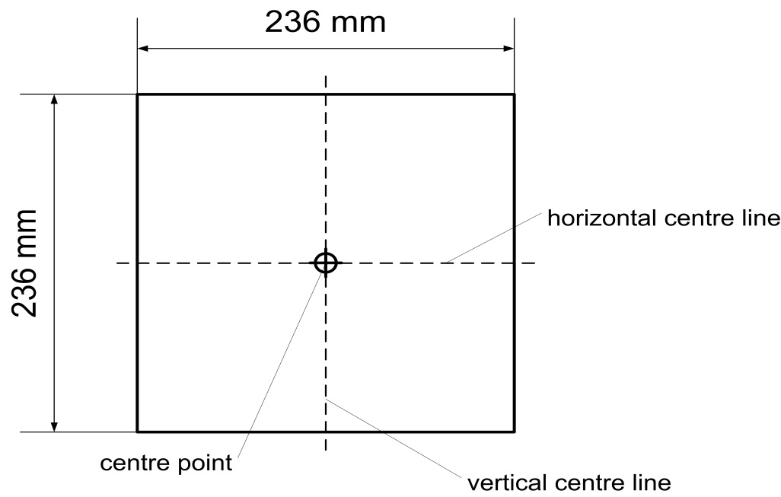

The front surface of the corner gauge is flat.

The centre point is the intersection of the vertical and horizontal centre lines on the front surface.

Figure 5C  
**Determination of the corner of bumper with the corner gauge (shown in random location)**

**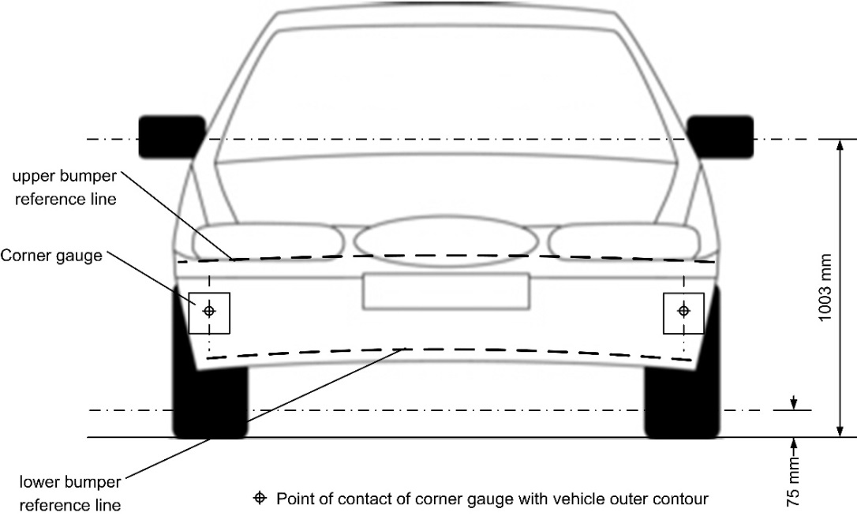**

Figure 5D  
**Determination of bumper test area (note that the corner gauges are to be moved in vertical and horizontal directions to enable contact with the outer contour/front fascia of the vehicle)**

**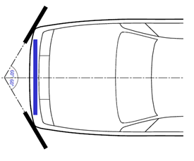**"

*Former paragraphs 2.17. to 2.42.,* renumber as paragraphs 2.18. to 2.43.

*Paragraph 4.2.*, amend to read:

"4.2. An approval number shall be assigned to each type approved; its first two digits (at present 02 corresponding to the 02 series of amendments)… … number to another vehicle type."

*Paragraphs 11.1. to 11.4.,* amend to read:

"11.1. As from the official date of entry into force of the 02 series of amendments, no Contracting Party applying this Regulation shall refuse to grant or refuse to accept type approvals under this Regulation as amended by the 02 series of amendments.

11.2. As from 31 December 2017, Contracting Parties applying this Regulation shall grant type approvals only if the vehicle type to be approved meets the requirements of this Regulation as amended by the 02 series of amendments.

11.3. Contracting Parties applying this Regulation shall not refuse to grant extensions of type approvals for existing vehicle types which have been granted according to the original series of this Regulation or to the 01 series of amendments to this Regulation.

11.4. Contracting Parties applying this Regulation shall continue to accept type approvals to the original series of this Regulation and to the 01series of amendments to the Regulation."

*Annex 2*, amend to read:

"Annex 2

Arrangements of approval marks

(See paragraphs 4.4. to 4.4.2. of this Regulation)

**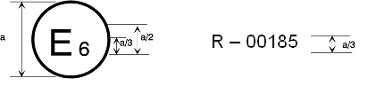**

127R - 02185

a = 8 mm min

The above approval mark affixed to a vehicle shows that the vehicle type concerned has been approved in Belgium (E 6) with regard to its pedestrian safety performance pursuant to Regulation No. 127... … as amended by the 02 series of amendments."

*Annex 5*

*Paragraph 1.5.*, amend to read:

"1.5. A minimum of three lower legform to bumper tests shall be carried out, one each to the middle and the outer thirds of the bumper test area at positions judged to be the most likely to cause injury. Tests shall be to different types of structure, where they vary throughout the area to be assessed. The selected test points shall be a minimum of 84 mm apart as measured horizontally and perpendicular to the longitudinal median plane of the vehicle. The positions tested by the laboratories shall be indicated in the test report."

*Paragraph 2.5.*, amend to read:

"2.5. A minimum of three upper legform to bumper tests shall be carried out, one each to the middle and the outer thirds of the bumper test area at positions judged to be the most likely to cause injury. Tests shall be to different types of structure, where they vary throughout the area to be assessed. The selected measuring points shall be a minimum of 84 mm apart as measured horizontally and perpendicular to the longitudinal median plane of the vehicle. The positions tested by the laboratories shall be indicated in the test report."

1. \* In accordance with the programme of work of the Inland Transport Committee for 2012–2016 (ECE/TRANS/224, para. 94 and ECE/TRANS/2012/12, programme activity 02.4), the World Forum will develop, harmonize and update Regulations in order to enhance the performance of vehicles. The present document is submitted in conformity with that mandate. [↑](#footnote-ref-2)