UN/SCEGHS/31/INF.14
Committee of Experts on the Transport of Dangerous Goods
and on the Globally Harmonized System of Classification
and Labelling of Chemicals
Sub-Committee of Experts on the Globally Harmonized
System of Classification and Labelling of Chemicals 22 June 2016

Thirty-first session
Geneva, 5– 8 July 2016
Item 4 (a) of the provisional agendaHazard communication issues:
labelling of small packagings

Labelling of small packagings
Transmitted by the European Chemical Industry Council (CEFIC) on behalf of the informal correspondence group
Introduction
1. At its 29th session the Sub-Committee noted that the informal correspondence group intended to develop a third example addressing other labelling issues than the first and second ones and their possible solutions.
Development of examples for sets or kits
2. The proposed third set of examples to be presented during the 31st session is to acquaint the correspondence group on labelling of small packaging with the issues surrounding sets or kits.
3. The proposed examples are to be reviewed by the informal correspondence group on labelling of small packaging at its meeting scheduled for July 6th 2016
Definition of sets or kits
4. A set or kit is a combination package, which includes two or more individual inner packages or single compartments with different components. Because of the variety they are divided as follows:
(a) sets or kits with removable and different number of single containers
(b) sets or kits with different numbers of single containers or individual chambers
5. Set or kits are subject to the provisions of the GHS if the combination package contains at least one hazardous substance or mixture or hazardous article.
Recommended procedure for sets or kits (combination packages)
6. The number of hazardous single components contained within the set or kit relative to the physical size of the outer package is an important first step in determining the feasibility of labelling. If possible, all labelling information for each hazardous substance, mixture or article shall be displayed on the outer package.
The supplier information need only appear once.
The GHS required labelling elements should be clearly and prominently displayed on a surface that is visible under normal conditions of use, easily legible without the aid of any device other than corrective lenses and contrasted with any other information on the hazardous product or the container.
To ensure a clear readability and understanding of all safety-relevant information it is recommended to extend chapter 1.4.10.5.4.1 “Location of GHS information on the label” as follows:
The GHS hazard pictograms, signal word and hazard statements should be located together on the label. The competent authority may choose to provide a specified layout for the presentation of these and for the presentation of precautionary statements, or allow supplier discretion.
Example for a specific layout: To maintain readability, especially for a combination package (set or kit) it might, in individual cases, be necessary to locate the p-statements together on the outer label. Specific guidance and examples are provided in the chapters on individual hazard classes.
7. If it is not possible to affix all appropriate labelling elements for each hazardous single component directly on the outer label (due to technical reasons such as the size and shape) additional options, always carried out with maximum care and with regard to the nature of the set or kit, can be chosen (see also 1.4.10.5.4.1)
Minimum information on the outer label:
Possibility 1:
(a) supplier information (see 1.4.10.5.2(e))
(b) product identifier (see 1.4.10.5.2.(d)ii)
(c) pictograms of each hazardous single component, without duplication (see 1.4.10.5.3.1)
(d) signal word (see1.4.10.5.2(a))
(e) hazard statements of each hazardous single component (a clear allocation has to be ensured) (see1.4.10.5.2(b))
(f) supplemental information of each hazardous single component (a clear allocation has to be ensured) (see1.4.10.5.4.2)
(g) summarized presentation of precautionary statements of each hazardous single component (see 1.4.10.5.2.(c)
Possibility 2:
(a) supplier identification (see 1.4.10.5.2(e))
(b) product identifier (see 1.4.10.5.2.(d)ii)
(c) pictograms of each single hazardous component without duplication (see 1.4.10.5.3.1)
(d) signal word (see1.4.10.5.2(a))
(e) full labelling information of each hazardous single component affixed in the inside of the combination package (see 1.4.10.5.2(a) – 1.4.10.5.2(d)(ii)
Minimum information on the inner label:
8. If single containers are designed to be taken out of the combination package, and there is no technical possibility to label them completely, then it is sufficient to use:
(a) supplier information (see 1.4.10.5.2(e))
(b) product identifier (see 1.4.10.5.2.(d)ii)
(c) hazard pictogram
(d) signal word (see1.4.10.5.2(a))
(e) “Read outer label”
9. A labelling of the single components can be omitted if it can be assured that they cannot be removed from the combination package.

Example 1 based on possibility 1:
Reagent-Kit for water analysis consisting of two different products in a small size outer package, which is used to store the immediate containers until ready for use.
Packaging description and size:
Styrofoam box containing 15 glass ampoules, each ampoule filled with 3.5 ml of the same mixture (total volume: 52.5 ml), and two bottles filled with 5 ml of a mixture (total volume 10 ml).
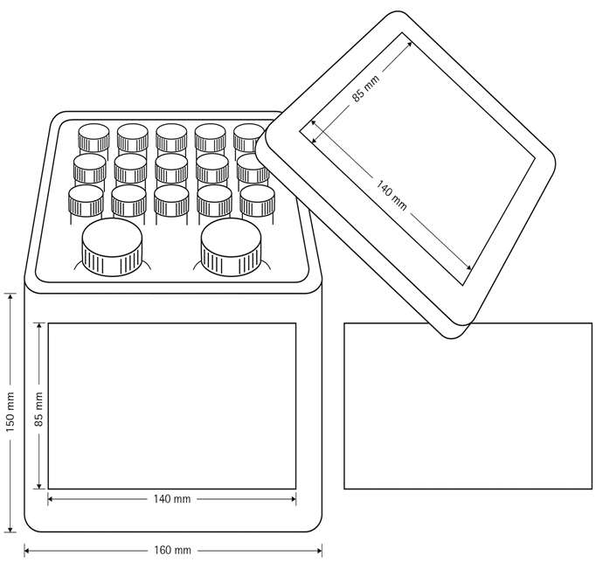
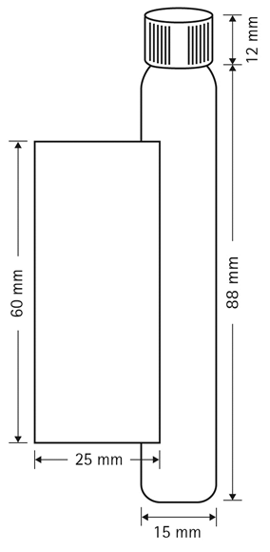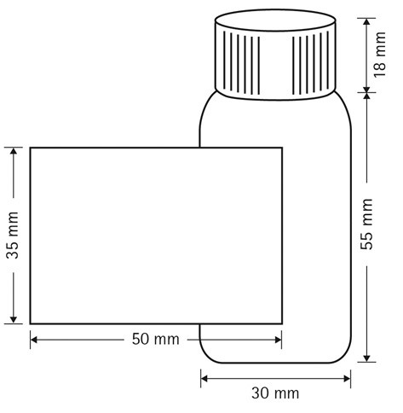

Reagent 1: (Glass ampoule) Mixture containing ammonia solution and potassium cyanide

Classification: Acute toxicity cat.3 (dermal, inhalation)

Acute toxicity cat.4 (oral)

Skin corrosion cat. 1B

Chronic aquatic hazard cat.3

Labelling:

Pictogram:
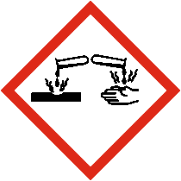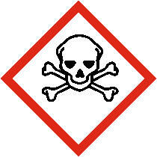
Signal Word: Danger

Hazard Statements:

H311+H331: Toxic in contact with skin or if inhaled

H302: Harmful if swallowed

H314: Causes severe skin burns and eye irritation

H412: Harmful to aquatic life with long lasting effects

Precautionary Statements

Prevention:

P264: Wash…thoroughly after handling

P270: Do not eat drink or smoke when using this product

P280: Wear protective gloves/protective clothing/eye protection/face protection

P260: Do not breath fume/vapour

P271: Use only outdoors or in a well ventilated area

P273: Avoid release to the environment

Response:

P390: Adsorb spillage to prevent material-damage

P321: Specific treatment (see … on this label)

P330: Rinse mouth

P302+P352: IF ON SKIN: wash with plenty of water/…

P310: Immediately call a POISON CENTER/doctor/…

P311: Call a POISON CENTER/doctor/…

P312: Call a POISON CENTER/ doctor/… if you feel unwell

P301+P310: Get medical advice/attention if you feel unwell.

P314: Get medical advice/attention if you feel unwell

P361+P364: Take off immediately all contaminated clothing and wash it before reuse

P363: Wash contaminated clothing before reuse

P304+P340: IF INHALED: Remove person to fresh air and keep comfortable for breathing

P301+P330+P331: IF SWALLOWED: Rinse mouth. Do not induce vomiting

P303+P361+P353: IF ON SKIN (or hair): Take off immediately all contaminated clothing. Rinse skin with water/shower

P305+P351+P338: IF IN EYES: Rinse cautiously with water for several minutes. Remove contact lenses, if present and easy to do. Continue rinsing.

Storage:

P406: Store in a corrosive resistant container with a resistant inner liner

P405: Store locked up

P403+P233:Store in a well-ventilated place. Keep container tightly closed

Diposal:

P501: Dispose of contents/container to…

Reagent 2: (Bottle) Mixture containing hydroxylammonium chloride
Classification: Corrosive to metals cat.1

Skin irritation cat.2

Eye irritation cat.2

Skin sensitization cat.1

Carcinogenicity cat.2
STOT repeated cat.2
Labelling:

Pictogram:
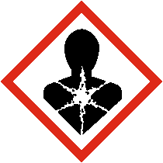 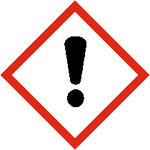
Signal word: Warning

Hazard Statements:

H290: Maybe corrosive to metals

H315: Causes skin irritation

H319: causes serious eye irritation:

H317:May cause an allergic skin reaction

H351: Suspected of causing cancer

H373: May cause damage to organs through prolonged or repeated exposure

Precautionary Statements

Prevention:
P201:Obtain special instructions before use
P202: Do not handle until all safety precautions have been read and understood.
P264: Wash…thoroughly after handling
P280: Wear protective gloves/protective clothing/eye protection/face protection
P260: Do not breath fume/vapour
P272: Contaminated work clothing should not be allowed out of the workplace

Response:
P321: Specific treatment (see … on this label)
P302+P352: IF ON SKIN: wash with plenty of water/…
P310: Immediately call a POISON CENTER/doctor/…
P314: Get medical advice/attention if you feel unwell
P308+P313: If exposed or concerned: Get medical advice/attention.
P337+P313: If eye irritation persist: Get medical advice attention
P332+P313: If skin irritation occurs: Get medical advice attention
P362+P364: Take off contaminated clothing and wash it before reuse
P303+P361+P353: IF ON SKIN (or hair): Take off immediately all contaminated clothing. Rinse skin with water/shower
P305+P351+P338: IF IN EYES: Rinse cautiously with water for several minutes. Remove contact lenses, if present and easy to do. Continue rinsing.
Storage:
P405:Store locked up
Disposal:
P501: Dispose of contents/container to…

Possible options to address labelling problems encountered

Issue | Potential options | Comments
Divide the outer label in so many pieces to provide all label elements of each hazardous single component on the outer packaging/label |  | Due to size and shape of the combination package it is not possible to divide the outer label in so many pieces as are necessary for enabling a labelling of each hazardous single component  (the main reason are 10-30 precautionary statements for each hazardous single component )
 | Matched pictograms of each hazardous component, without duplication | A clear visual appearance is guaranteed
 | Accumulate all appropriate precautionary statements of each hazardous single components | Redundant information can be omitted, resulting in a larger more readable font size

Reagent 2 (Bottle)  precautionary statements | Reagent 1 (Glass ampoule)  precautionary statements | Combined appropriate  precautionary statements
P201:Obtain special instructions before use | P264: Wash…thoroughly after handling | P201:Obtain special instructions before use
P202: Do not handle until all safety precau-tions have been read and understood | P270: Do not eat drink or smoke when using this product | P202: Do not handle until all safety precau-tions have been read and understood
P264: Wash…thoroughly after handling | P280: Wear protective gloves/protective clothing/eye protection/face protection | P264: Wash…thoroughly after handling
P280: Wear protective gloves/protective clothing/eye protection/face protection | P260: Do not breath fume/vapour | P308+P313: If exposed or concerned: Get medical advice/attention.
P260: Do not breath fume/vapour | P271: Use only outdoors or in a well ventilated area | P302+P352: IF ON SKIN: wash with plenty of water/…
P272: Contaminated work clothing should not be allowed out of the workplace | P273: Avoid release to the environment | P280: Wear protective gloves/protective clothing/eye protection/face protection
P390: Adsorb spillage to prevent material- | P321: Specific treatment (see … on this label) | P302+P352: IF ON SKIN: wash with plenty of water/…
P321: Specific treatment (see … on this label) |  | P301+P330+P331: IF SWALLOWED: Rinse mouth. Do not induce vomiting
P330: Rinse mouth |  | P310: Immediately call a POISON CENTER/doctor/…
P302+P352: IF ON SKIN: wash with plenty of water/… | P314: Get medical advice/attention if you feel unwell | P305+P351+P338: IF IN EYES: Rinse cautiously with water for several minutes. Remove contact lenses, if present and easy to do. Continue rinsing
P310: Immediately call a POISON CENTER/doctor/… | P308+P313: If exposed or concerned: Get medical advice/attention.
P311: Call a POISON CENTER/doctor/… | P337+P313: If eye irritation persist: Get medical advice attention
P312: Call a POISON CENTER/ doctor/… if you feel unwell | P332+P313: If skin irritation occurs: Get medical advice/attention
 | P362+P364: Take off contaminated clothing and wash it before reuse
P301+P310: Get medical advice/attention if you feel unwell | P303+P361+P353: IF ON SKIN (or hair): Take off immediately all contaminated clothing. Rinse skin with water/shower
P314: Get medical advice/attention if you feel unwell | P305+P351+P338: IF IN EYES: Rinse cautiously with water for several minutes. Remove contact lenses, if present and easy to do. Continue rinsing.
P361+P364: Take off immediately all contaminated clothing and wash it before reuse | P302+P352: IF ON SKIN: wash with plenty of water/…
P363: Wash contaminated clothing before reuse | P310: Immediately call a POISON CENTER/doctor/…
P304+P340: IF INHALED: Remove person to fresh air and keep comfortable for breathing
P301+P330+P331: IF SWALLOWED: Rinse mouth. Do not induce vomiting
P303+P361+P353: IF ON SKIN (or hair): Take off immediately all contaminated clothing. Rinse skin with water/shower
P305+P351+P338: IF IN EYES: Rinse cautiously with water for several minutes. Remove contact lenses, if present and easy to do. Continue rinsing
P406: Store in a corrosive resistant container with a resistant inner liner | P405:Store locked up
P405:Store locked up
P403+P233:Store in a well ventilated place. Keep container tightly closed
P501: Dispose of contents/container to… | P501: Dispose of contents/container to…

Inner kit-label:

The inner packaging label contains the minimum required information:
(a) supplier information (see 1.4.10.5.2(e))
(b) product identifier (see 1.4.10.5.2.(d)ii)
(c) hazard pictogram
(d) signal word (see1.4.10.5.2(a))
(e) “Read outer label”

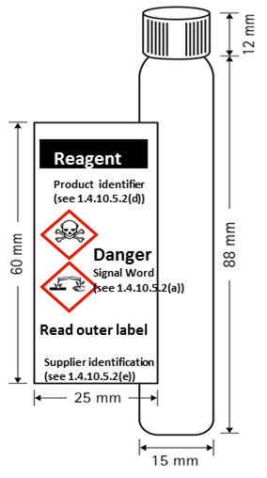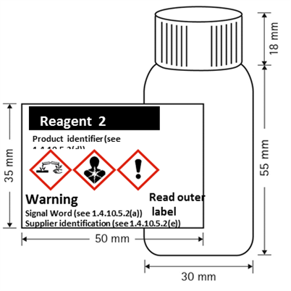

Outer kit label:
(a) supplier information (see 1.4.10.5.2(e))
(b) product identifier (see 1.4.10.5.2.(d)ii)
(c) pictograms of each hazardous single component, without duplication (see 1.4.10.5.3.1)
(d) signal word (see1.4.10.5.2(a))
(e) hazard statements of each hazardous single component (a clear allocation has to be ensured) (see1.4.10.5.2(b))
(f) supplemental information of each hazardous single component (a clear allocation has to be ensured) (see1.4.10.5.4.2)
(g) summarized presentation of precautionary statements of each hazardous single component (see 1.4.10.5.2.(c))

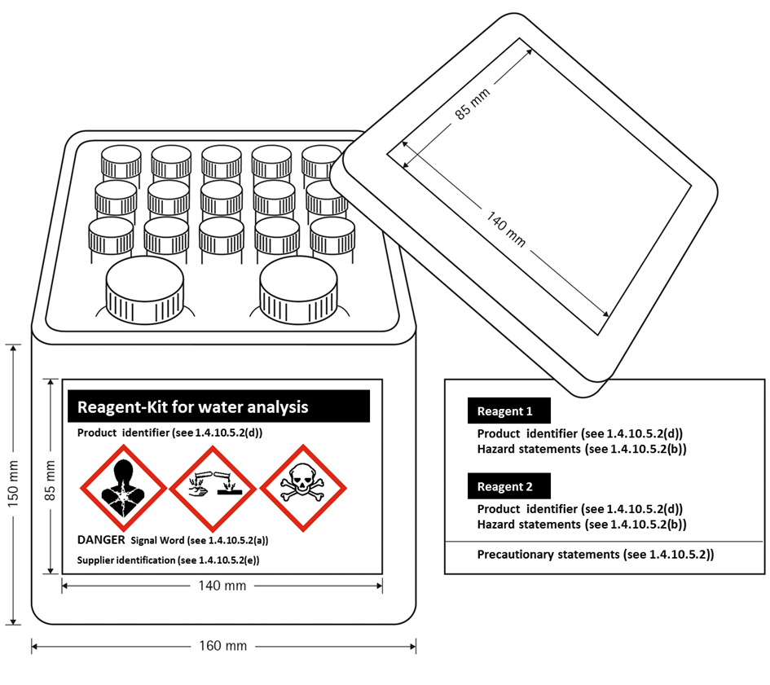
Example 2 based on possibility 2:
Sample Kit: Used for marketing purposes and consists of 156 different products in individual 10 ml bottles presented in an outer package. The inner bottles are stored in the outer package throughout the lifecycle of the Sample Kit. Customers may select individual bottles and remove them from the box to check clarity, color or odor and then replace it into the open slot within the outer box.
Packaging description and size:
Each sample test kit is constructed of a plastic outer box containing 156 bottles. Each bottle is filled with 10 ml of 156 different mixtures (total volume: 1560 ml). Depending upon the product mix, some or all of the 156 different materials may be considered hazardous.

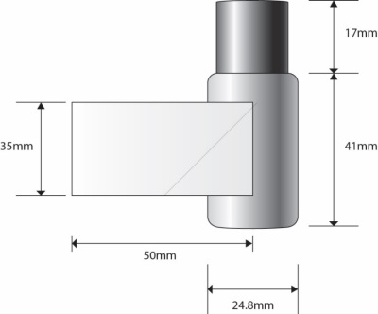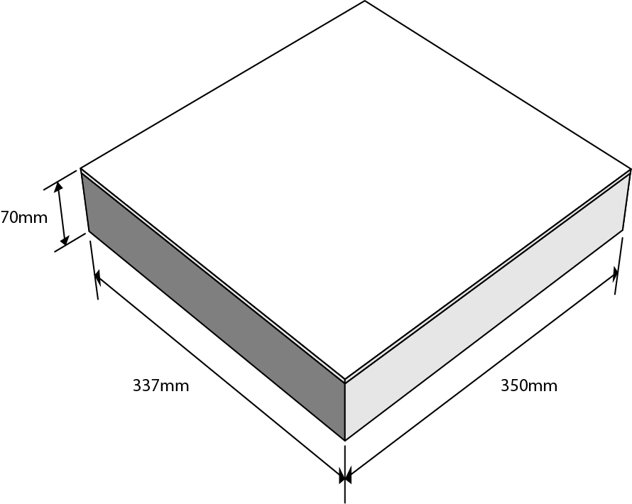

Inner Packaging Outer Packaging
(sample bottle)

Possible options to address labelling problems encountered
Issue | Potential options | Comments
Kits contain many small inner packages containing many different hazardous products in one outer box/container. |  | Inner containers are too small to accommodate full GHS labels. There is limited space on the outer box to affix complete labels for each hazardous product due to size and shape of the combination package
 | Provide label elements on a tie-on tag | Not practical as tie-on tag would need to be large to accommodate all required labelling even with printing on both sides of the tag. Large tag on a very small bottle may impede use of the product and users may remove tag in frustration..  General principles require all applicable label elements to appear on immediate container where possible; also some label elements on the immediate container may need to be accessible to users throughout life of product. Would therefore also need to include minimum label elements on immediate container just in case the tie-on tag is removed by the user.
 | Increase the size of the container so that a larger label can be affixed | Not a practical solution. Increasing the size of the container is not practical from the intended use perspective.  Increasing the size of the container without increasing product volume may introduce oxygen into the contents of the container causing oxidation of the material which could change the aroma, flavour or potency.  Also need to take account of sustainability considerations (e.g. packaging reduction, environmental footprint, etc.)
 | Use already accepted limited information on inner packaging | 5 label elements can be displayed in a font size to make highly visible and comprehensible hazard communication.
 | Apply modified label format to outside of kit | Emphasizes most important label elements (identifier, manufacturer information, unique pictogram(s), signal word, hazard statement relative to each inner package.
 | Display pictograms of each hazardous component, without duplication on outer label along with signal word | A clear visual appearance is guaranteed. In the case of breakage, not knowing which inners have broken, the user immediately is apprised of the hazards that are contained within.
 | For a kit with many hazardous inners, the label space available may still not be adequate; allow the manufacturer to include slip sheets identifying each hazardous material and its full GHS labelling on the inside of the box. | This accommodation allows the user access to all GHS hazard communication label elements for each individual bottle containing a hazardous substance or mixture.
Outer kit label:

The outer box, given the limited area for labeling, will display;
(a) supplier identification (see 1.4.10.5.2(e))
(b) product identifier (see 1.4.10.5.2.(d)ii)
(c) pictograms of each single hazardous component without duplication (see 1.4.10.5.3.1)
(d) signal word (see1.4.10.5.2(a))

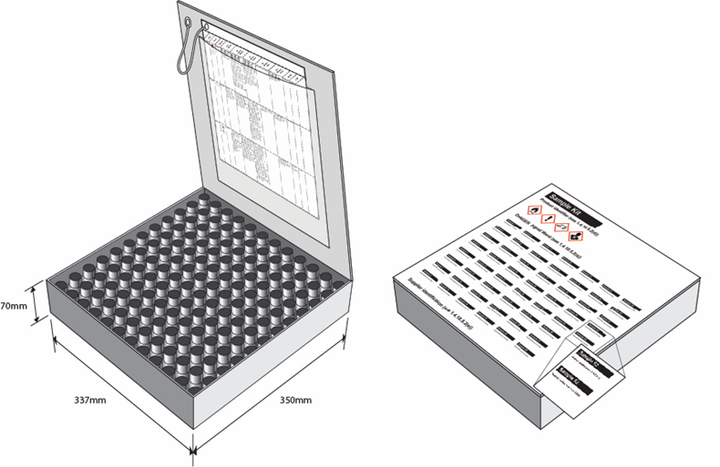

Inner kit-label:

The inner packaging label contains the minimum required information:
(a) supplier information (see 1.4.10.5.2(e))
(b) product identifier (see 1.4.10.5.2.(d)ii)
(c) pictogram
(d) signal word (see1.4.10.5.2(a))
(e) “Read outer label”

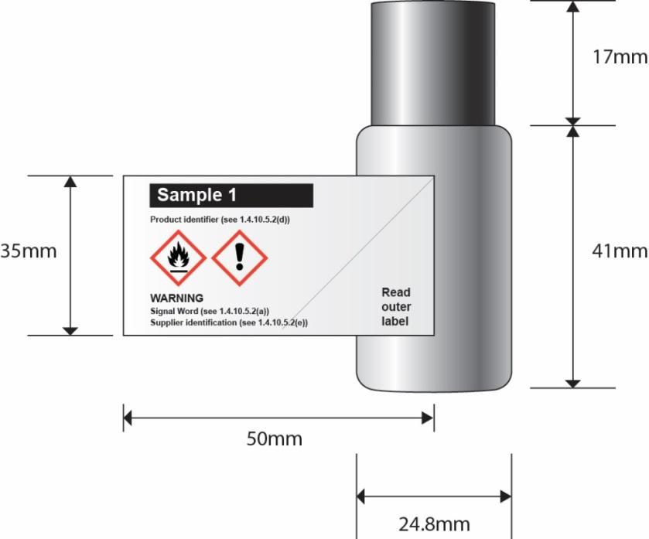
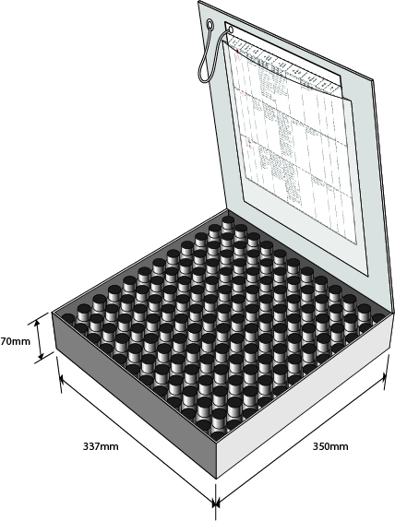
As shown to the right, full labelling information regarding each hazardous single component is contained within the outer packaging.

The sheets of full labeling information are permanently connected to the inside of the combination package using a secure method of attachment (e.g. fold out label adhered to box tie on tag as shown..

