Economic Commission for Europe
Inland Transport Committee
Working Party on the Transport of Dangerous Goods 14 September 2016
Joint Meeting of the RID Committee of Experts and the
Working Party on the Transport of Dangerous Goods
Geneva, 19–23 September 2016
Item 5 (b) of the provisional agenda
Proposals for amendments to RID/ADR/ADN:
new proposals
Use of the term placard / große zettel / placardage (plaques -étiquettes)/ information board (информационное табло) in the Model Regulations, ADR, ADN, RID and annex 2 to SMGS
Transmitted by the Government of the Russian Federation
Introduction
In accordance with the requirements of interstate standard GOST 19433-88 "Dangerous Goods. Classification and labeling "[1] Rules of transportation of dangerous goods (Annex 2 to SMGS) [2], each loading unit containing dangerous goods must be marked, which characterizes the type and severity of the cargo. The marking should contain:
- On the packaging and (or) transport package - a label (sign of danger), the proper shipping name, the UN number;
- On large packagings, wagon or container - a label, the UN number and the number of emergency cards during transportation by rail (if this number is set).
Labels shall be in the form of a square set at an angle of 45 ° (diamond). The size of the square should be for labels applied to:
- Packaging and (or) transport package - not less than 100 mm;
- Wagon or a container - not less than 250 mm.
Labelling must meet prescribed models and affixed in such a way that they do not wear and were clearly visible, for example by paint or other means.
From the text it is clear that in the Russian Federation and other CIS countries, only one the term "label (danger sign – знак опасности)". It is used both for labeling packages (minimum dimensions of 100 x 100 mm) and wagons, containers and large containers (minimum dimensions of 250 x 250 mm).
At the same time the UN Model Regulations (19th Edition) [3], the rules of ADR [4] ADN [5], RID [6] in the labeling of wagons, containers and large packagings used an additional term denoting placard (minimum dimensions of 250 x 250 mm), painted on the wagon, container and large packagings. Moreover, the terms used in different language versions of the documents:
- Placard (poster, the poster) - the texts in English;
- Große zettel (big label) in the German language;
- Placardage (plaques-étiquettes) - poster-label - in French;
- Information board (information table – информационное табло) - the texts in Russian.
The analysis shows that the term «placard / große zettel / placardage (plaques-étiquettes) / Information board (информационное табло)" is used in the text:
- UN Model Regulations - 13 times (including the table of contents);
- ADR, ADN, RID - more than 100 times (including the table of contents).
In our opinion, extremely unsuccessfully used the term "Information board (информационное табло)" in Russian, because in the Russian-speaking environment, the word "board" is used in areas far enough from the transport of dangerous goods, for example:
a) The board at the stadium:

b) The board in the waiting areas of bus terminals and train stations:
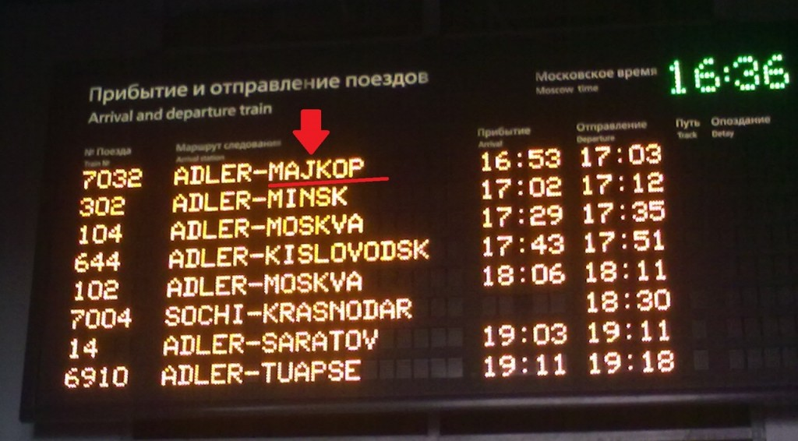
c) The board in the waiting areas of airports:

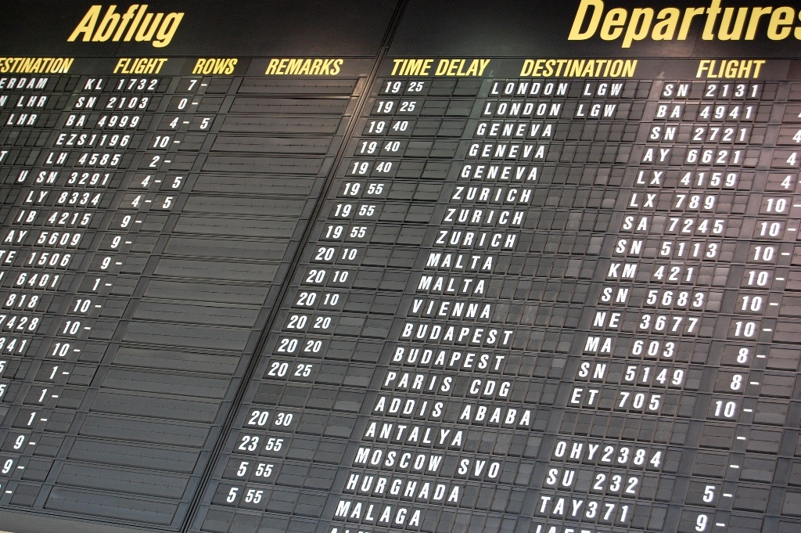
Proposal
Based on the above, we offer when updating the text of international regulations on the transport of dangerous goods in Russian in the future, the term "Information table (информационное табло)" to withdraw and use the term “Label, applied to the wagons and containers (Знак опасности, наносимый на вагон и контейнер)” or use the term “Large label (Большой знак опасности)”.
Justification
This amendment will create for Russian participants in the carriage of conditions aimed at the correct interpretation of the requirements for the labeling of wagons, containers and large packagings.
Enforcement
No difficulties of enforcement are expected.
List of sources used
1. GOST 19433-88 "Dangerous Goods. Classification and labeling. "
2. Terms of transport of dangerous goods (Annex 2 to SMGS) as of 01/07/2015, the
3. Model UN Recommendations on the Transport of Dangerous Goods (19th edition).
4. ADR.
5. ADN.
6. RID (RID)

