|  |  |  |  |
| --- | --- | --- | --- |
|  | United Nations | ECE/TRANS/WP.15/AC.1/2017/21 | |
| _unlogo | **Economic and Social Council** | | Distr.: General  21 December 2016  English  Original: French |

**Economic Commission for Europe**

Inland Transport Committee

**Working Party on the Transport of Dangerous Goods**

**Joint meeting of the RID Committee of Experts and the**

**Working Party on the Transport of Dangerous Goods**

Bern, 13-17 March 2017

Item 2 of the provisional agenda

**Tanks**

Demountable tanks and tank-containers — Interpretation of definitions

Transmitted by the Government of France[[1]](#footnote-1)\*, [[2]](#footnote-2)\*\*

Introduction

|  |
| --- |
| *Summary* |
| **Executive summary**: Establish whether a tank meets the definition of a demountable tank or a tank-container |
| **Reference documents**:ADR 2017, Chapter 1.2 |
|  |

1. According to Chapter 1.2 of ADR, the term “*demountable tank*” means a tank, other than a fixed tank, a portable tank, a tank-container or an element of a battery-vehicle or a MEGC which has a capacity of more than 450 litres, is not designed for the carriage of goods without breakage of load, and normally can only be handled when it is empty.

2. According to Chapter 1.2 of RID/ADR, “*tank-container*” means an article of transport equipment meeting the definition of a container, and comprising a shell and items of equipment, including the equipment to facilitate movement of the tank-container without significant change of attitude, used for the carriage of gases, liquid, powdery or granular substances and, when used for the carriage of gases as defined in 2.2.2.1.1, having a capacity of more than 0.45 m3 (450 litres).

3. “*Container*” means an article of transport equipment (lift van or other similar structure):

* Of a permanent character and accordingly strong enough to be suitable for repeated use;
* Specially designed to facilitate the carriage of goods, by one or more means of transport, without breakage of load;
* Fitted with devices permitting its ready stowage and handling, particularly when being transloaded from one means of transport to another;
* So designed as to be easy to fill and empty;
* Having an internal volume of not less than 1 m3, except for containers for the carriage of radioactive material.

4. A demountable tank is used only for road transport, while a tank-container is usually a multimodal unit.

5. The question arises of whether a tank intended for the carriage of gases, such as that shown in annex, whose service equipment is protected by a cabinet that is located at the rear when the tank is mounted on a road vehicle and is lower than the chassis of the vehicle, can be considered as a tank-container or must be seen as a removable tank.

6. We are of the view that such a tank, which can be attached only to a specific chassis frame, cannot be transloaded from one means of transport to another and simply cannot be removed because of the position of the cabinet, cannot be considered to be a tank-container.

7. We would like to know the opinion of the Joint Meeting on this issue.

Annex

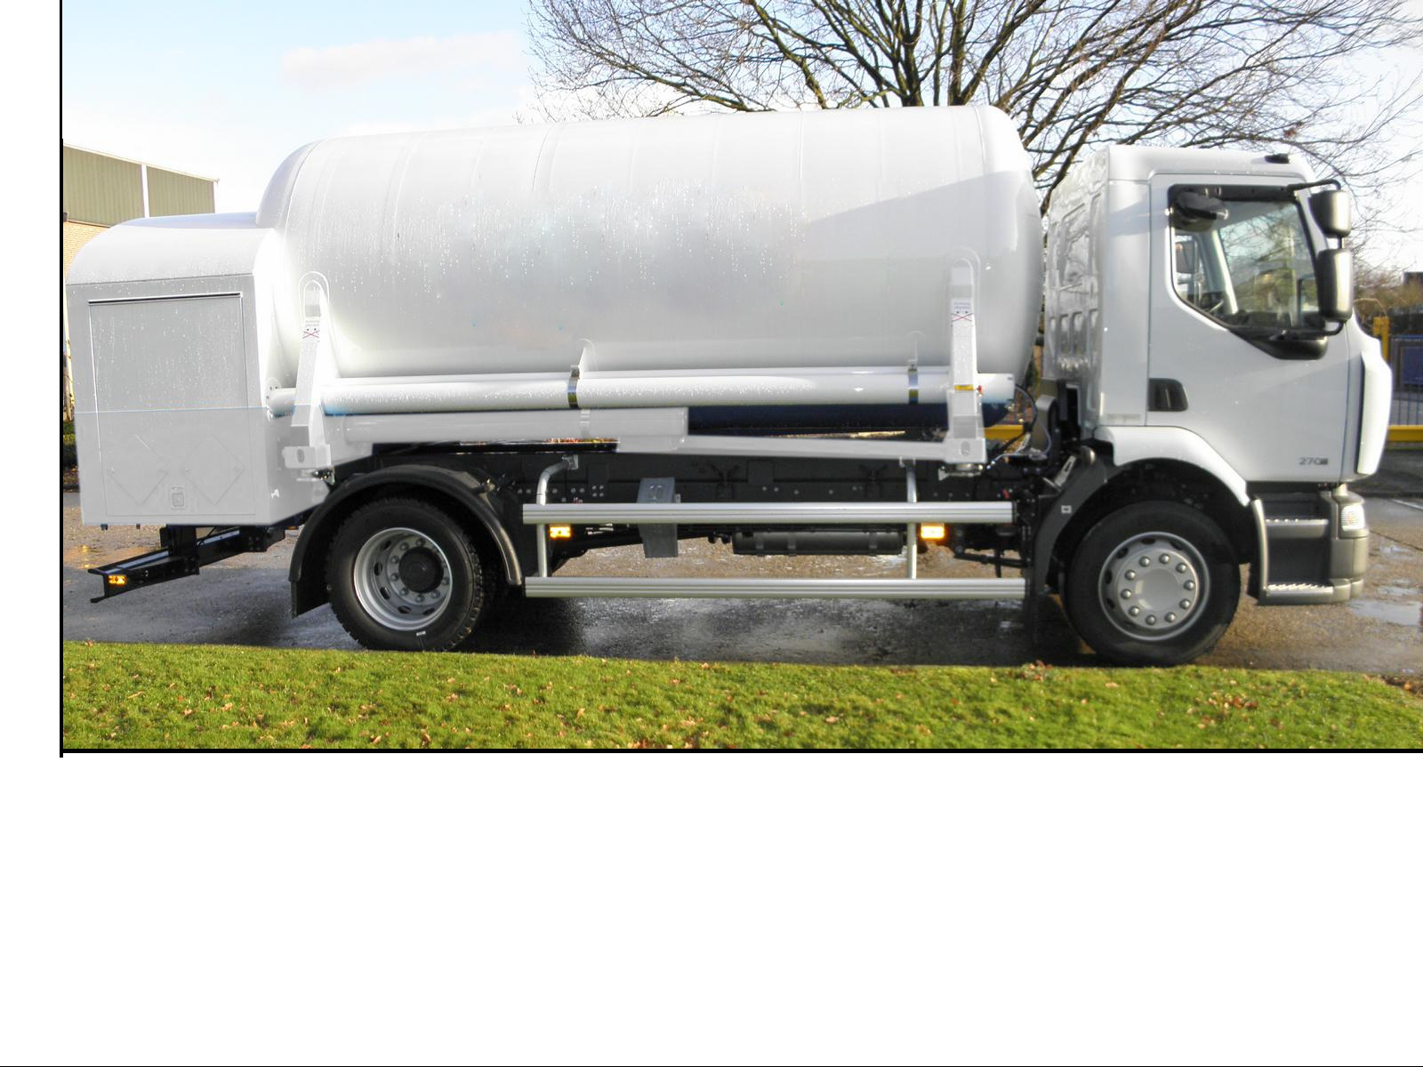

1. \* In accordance with the programme of work of the Inland Transport Committee for 2016-2017, (ECE/TRANS/2016/28/Add.1 (9.2)). [↑](#footnote-ref-1)
2. \*\* Circulated by the Intergovernmental Organisation for International Carriage by Rail (OTIF) under the symbol OTIF/RID/RC/2017/21. [↑](#footnote-ref-2)