INF.7
Economic Commission for Europe
Inland Transport Committee
Working Party on the Transport of Dangerous Goods
Joint Meeting of the RID Committee of Experts and the
Working Party on the Transport of Dangerous Goods 26 July 2017
Geneva, 19-29 September 2017
Item 8 of the provisional agenda
Accidents and risk management
Overview of the future framework of guides on the risk management in the context of road, railways and inland waterways Transport of Dangerous Goods
Transmitted by the European Union Agency for Railways (ERA)
Introduction
In accordance with the conclusions of the Report of the Joint Meeting of the RID Committee of Experts and the Working Party on the Transport of Dangerous Goods on its spring 2017 session (see paragraphs 48 to 51 of ECE/TRANS/WP.15/AC.1/146) the Agency is pleased to provide an overview of the proposed framework of the guides.
The framework of guides will be the main deliverable of the first phase of the TDG roadmap.
Framework structure
In accordance with the conclusions of the 10th Workshop of the TDG Roadmap the future structure of the roadmap will be composed of three guides and one glossary, as shown in the diagram below.
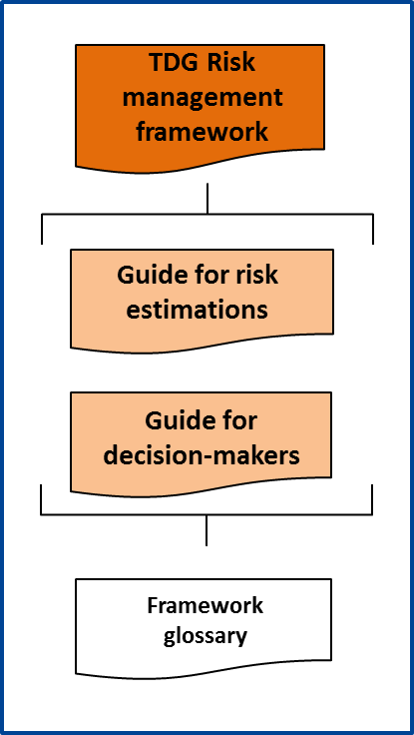
TDG Risk management framework
Framework guide
The framework guide will give an overview of the objectives of the risk management framework, the scope of application and the process of maintenance of the framework, as well as a short introduction of the other guides composing the framework, namely the ‘Risk estimation guide’ and the ‘Risk management and decision-making guide’.
The TDG risk management framework will 1) allow the use of a harmonised risk estimation method which will 2) allow mutual recognition of risk-based decision making between parties who will implement the guides.
The implementation scope of the framework was set with due consideration of the application scope of RID/ADR/ADN agreements, in particular:
- Any participant to the transport chain (RID/ADR/ADN chapter 1.4) may be interested in using the framework,
- The transport operations, starting from filling (or loading) operations until un-filling (or unloading) operations are considered in the framework scope of application,
- The framework will be applicable to risk situations involving railways, roads and inland waterways mode of transport, in isolation or in combination,
- Trans-boarding areas, multimodal platforms, and other infrastructures necessary for performing the transport operation are also considered by the harmonised framework.
Any interested parties were invited to take part to the developments and were involved since the setting of the framework objectives. The maintenance of the framework itself will be described in the framework document. The key objective will be that the framework is sustainable and can continue being improved in the future, in a collaborative manner.
In accordance with the conclusion of the 10th workshop, it was proposed that maintenance and continuous improvement of the framework should continue being steered in the future by an Agency standing group of expert users in collaboration with the Joint Meeting.
A review of the current framework achievements led the participants to the 9th workshop assessed that the framework of guide will have the potential to solve most of the issues initially identified and reported in annex of the document “Roadmap on risk management in the context of inland transport of dangerous goods”.
Guide on risk estimations
The guide on risk estimation will be fully compatible with the guidelines “General Guideline for the Calculation of Risks in the Transport of Dangerous Goods [by Rail] [by Road] - An introduction to the basic principles of risk assessment for chapter 1.9 [RID] [ADR]”, adopted respectively in 2006 by the RID Committee of Experts and in 2008 by the Working Party on Transport of Dangerous Goods. In addition to these guidelines introducing the basic principles, the new guide on risk estimations will provide further detailed assistance to the user on how to perform – in practice - harmonised risk estimations.
The new guide will cover a - multimodal - harmonised approach to the description of the system studied, the description of the considered risks and a harmonised method for the estimation of the risks.
The guide will be structured in two parts, as shown in the following diagram.
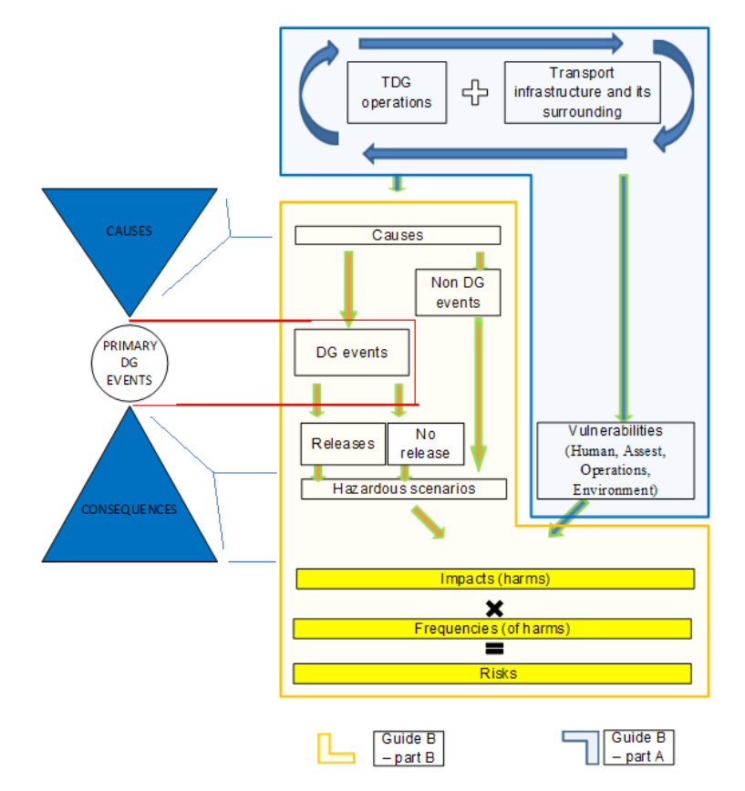
The part A will allow the description of the risk situation studied by the user while the part B will explain in detail how the harmonised risk estimations are performed.
The guide will provide a method which will be fully compatible with the current – non-harmonised – existing practices for risk estimations. As it will be harmonised, the guide will allow the users to deliver risk estimations that can be recognised by interested parties and which can easily be scrutinised.
In practice, the user of the guide will be able to perform harmonised risk estimations, when implementing the following harmonised steps:
  - Description of the infrastructure(s) on which are performed the transport operation(s),
  - Description of the traffic/operation volumes/characteristics,
  - Description of the vulnerabilities located on, or in the surrounding of, the considered infrastructure(s) for which the risks needs to be estimated.
These steps are covered by the part A of the guide and broadly correspond to the risk analysis part of a given risk situation described in a harmonised way by the user.
The part B of the guide will explain the process of risk estimation which uses the description made by the user of the risk analysis inputs.
As in the former guidelines, the new guide considers that the risks are defined as being the combination of the probability of harms (in practice, the frequency) with the intensity of these harms (impacts).
In detail, the following risk estimation steps are performed to obtain the risk estimation results:
Detailed risk estimation workflow

The risk estimation workflow described in the above diagram will result in – by default – risk estimation results, most of the steps being potentially corrected by the user, when justified.
The possibility to perform both ‘by default’ or ‘user-corrected’ estimations will allow substantial flexibility of the entire risk management framework. For example:
- It will allow non-expert user to obtain easily a quick risk estimation,
- It will allow expert users to correct the default settings of the model and to obtain more accurate estimation of the risks for specific situations,
- It will allow to model the effect of risk control measures on the risk estimates,
- It will allows regional calibrations of the risk estimations.
The justifications of user corrections will allow the user to provide transparent and recognised risk estimations results and to allow scrutiny by interested parties.
Combined in the risk management framework, the risk estimation results may be directly used as input to the guide on risk management and decision-making.
Important remark on the Risk estimation guide:
The guides will introduce simple tools to assist the user in the implementation of the harmonised method however these tools should only be considered as a first step towards a more -professional- IT assistance.
While a considerable progress will be reached with this new guide compared to the RID/ADR guidelines in terms of process harmonisation, it must also be recognised that if a -professional- IT platform is not established to assist interested users in the practical implementation of the risk estimation guide, the harmonised method might only be -fully- practicable by a small number of experienced risk estimation experts able to code the described method in the form of IT tools.
This is why the Agency considers that the set-up of a harmonised IT platform (including a risk calculation engine) is necessary to establish in the future a wide spread usage of risk-based decision-making in the TDG sector and to complete the necessary assistance to less experienced users.
The establishment of a risk estimation platform would also be a way for assuring a high implementation quality, facilitating the mutual-recognition of produced results.
Guide on risk management and decision-making
The guide on risk management and decision-making will supplement the existing RID/ADR guidelines with additional harmonisation covering risk-based decision-making processes.
The guide on risk management and decision-making will fully cover the risk evaluation and decision part of a risk management process, and will facilitate the preparation of risk-based decisions by decision-makers based on harmonised decision-making principles and harmonised decision-making indicators.
The content of the guide will cover the topics that are generally covered in decision-making literature while proposing a specific process designed to solve the issues reported in annex of the document ECE-TRANS-WP15-AC1-2014-GE-INF16e, as identified at the beginning of the TDG roadmap. The guide will also use some of the decision-making principles proposed in the DNV-GL study performed on behalf of the European Commission in 2014.
However, in contrast to one of the proposals of the DVN-GL study, the TDG roadmap participants considered that it was not desirable to introduce risk acceptance criteria in the first version of the guide. Instead, a process allowing to take care of the recurring issues encountered in TDG decision-making processes, leaving the final responsibility on the actual (end of process) decision to the decision–maker was preferred. In simple words it means that the guide will not make the decision for the decision-maker but will assist the decision-maker in the analysis of important decision-making steps.

The decision-making process will follow the structure shown in the diagrams and will detail out the following aspects:
- Risk management quality objectives,
- Optimisation cycle for a risk-based decision-making,
- Justification and Communication of decisions.

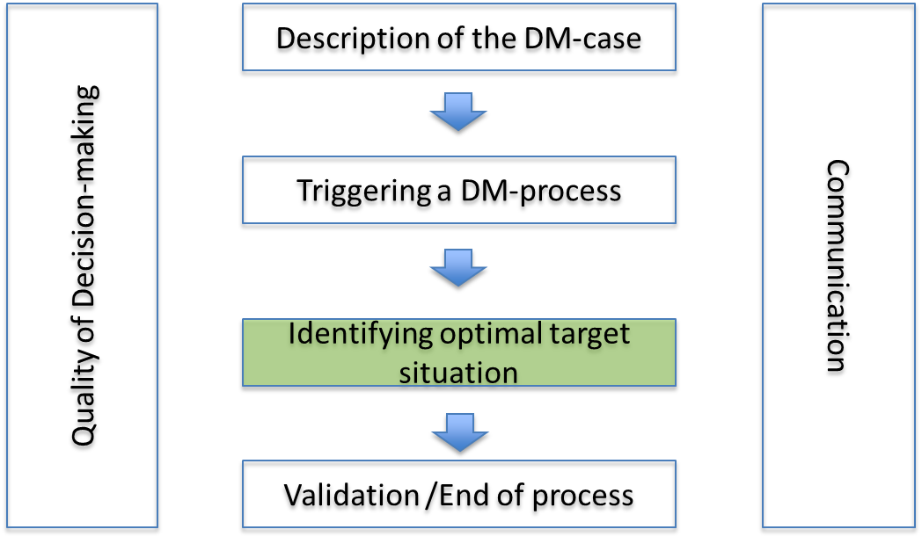
Content of the decision-making guide

The quality of risk management will describe the main principles that are considered important for a good quality risk management, as following:
- Consider compliance with legal requirements as a minimum standard,
- Manage risks in accordance with best practice,
- Inform all concerned parties about the risk situation as required,
- Reduce the risk level if it is economically practicable and proportionate to the problem to be solved,
- Identify possible solutions to a risk situation within a given tier (actor/geography combinations),
- Avoid solutions involving uncontrolled risk shifting,
- Ensure that risks are monitored on a regular basis at all levels,
- Evaluate whether implemented solutions address sufficiently the identified risk situation.

The decision optimisation cycle will describe how to integrate risk estimation results in the decision-making process and how to evaluate the relevance of potential decisions with harmonised -risk-based- decision-making principles.

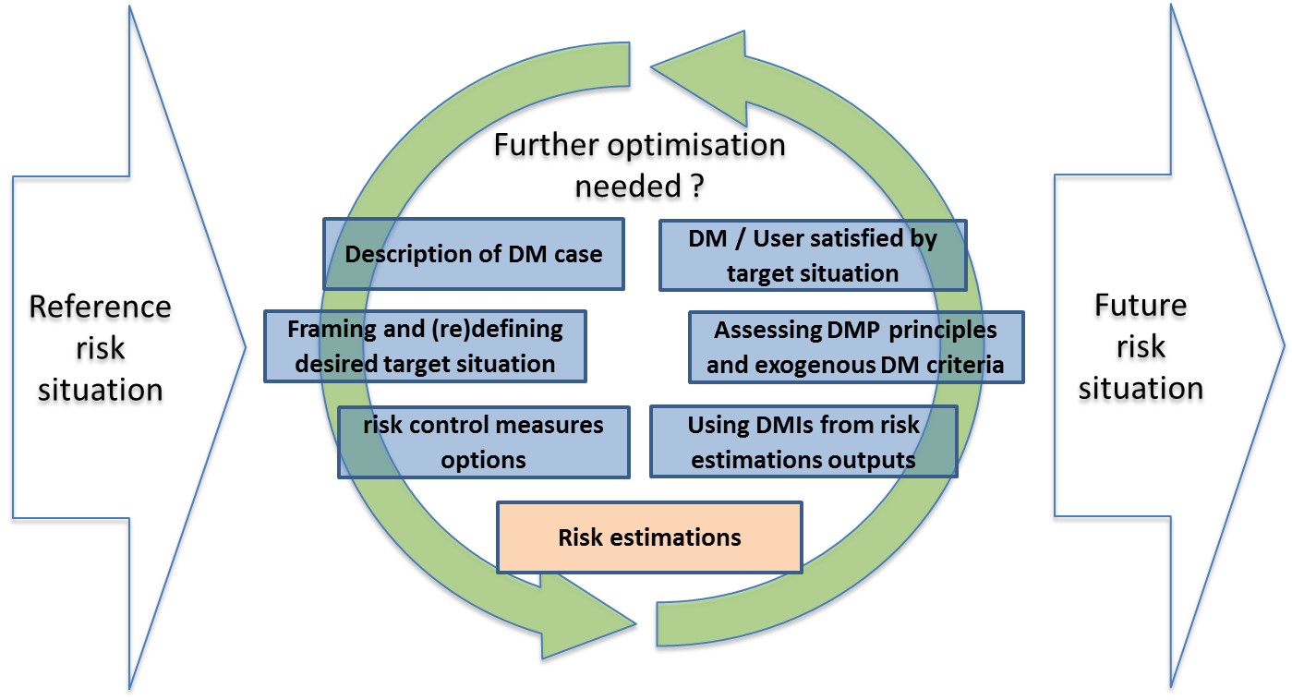
Risk-based decision-making optimisation cycle

The risk-based decision-making indicators will be the ones obtained from the implementation of the risk estimation guide and will be used for assessing the harmonised decision-making principles. Indicators will use societal risks and individual risks results. The guide will also integrate the possibility to assess the economical practicability of decision options using a risk-based safety–economy test.
The decision-making principles were inspired from the DNV-GL study and have been collectively reviewed and agreed by the TDG roadmap participants in order to solve identified risk management issues. The decision-making principles integrated in the harmonised process are the following:
- Non-regression of existing systems’ safety,
- Continuous safety improvement,
- Utility for society,
- Fair treatment of individuals and groups of individuals,
- Avoidance of uncontrolled risk shifting.
These principles will be assessed for each decision-making option in the evaluation phase. On this basis a risk-based ranking of decision options is allowed. To these risk-based assessment exogenous decision criteria may be added by the decision-maker under his/her full responsibility.
The justification and the communication good practices will also be described in the guide concerning the following aspects:
- Ex-ante justification of decisions,
- Ex-post justification of decisions,
- Transparency,
- Shared information,
- (Mutual) recognition of decisions by third parties.
Important remark on the Decision-making guide:
While key links between the risk estimation guide and the decision-making guide will be described in both guides, it is foreseen that each guide may also be used independently.
This situation will be valid for the decision-making guide until there is no formalised decision-making criteria using risk estimation results thresholds. Such a situation would lead to firmly link the decision-making guide with the calibration of the harmonised risk estimations.
On contrary, even in this case, the risk estimation guide may continue being used independently from the decision-making guide.
Framework glossary
It was necessary to develop a framework glossary in order to allow the user sufficient understanding of the content of the guides. Many reference documents have been consulted however, to the exception of some definitions already given in the RID/ADR guidelines, many definitions of other references have been considered too general or too specific or not adapted to the jargon used in TDG sector.
This is why the framework glossary was established, giving priority to the use of definitions already existing in international legislative texts, then in international norms, then in recognised international guides. When necessary definitions well-adapted to the framework of guides were derived from these references.
Conclusion
The guides presented in this document are in the final stage of drafting and should be published beginning 2018.

September 2014/INF.16 (ERA) Roadmap on risk management in the context of inland transport of dangerous goods. English DOC / PDF.
See ECE-TRANS-WP15-AC1-2014-GE-INF16e.
See A81-03-501.2006/Add.2 for Railways and ECE/TRANS/WP.15/2008/6 for Roads.
The framework will be applicable to railways, roads and inland waterways, including also intermodal platforms.
Harmonised risk acceptance criteria for Transport of Dangerous Goods, DNV-GL, for the European Commission DG MOVE, Report No. PP070679/4, rev.2, 2014-03-25.
Uncontrolled risk shifting means that (a) risk control measure(s) has(have) unexpected consequences on the risk situation to be managed and the measure(s) lead(s) to a new situation where the risk is unexpectedly transferred to another party in an uncontrolled manner and/or is increased instead of being reduced.
The list of recurring issues is reported in annex of document ECE-TRANS-WP15-AC1-2014-GE-INF16e.

