Manipulations on EURO V and VI trucks by suppression
of AdBlue injection
Detection of manipulated trucks
Points to be observed
There are several indications which may help to detect a manipulated truck:
- Empty AdBlue tank;

- The inner part of the AdBlue’s tank cap contains a crystalline deposit as well as the filling pipe (evaporation residue when AdBlue tank is not refilled regularly, see 3 fotos below);

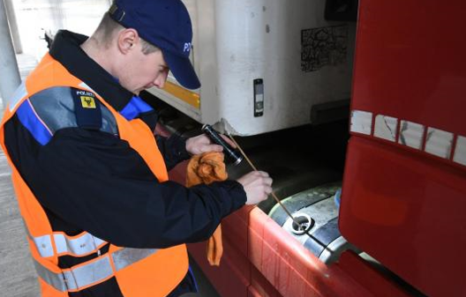

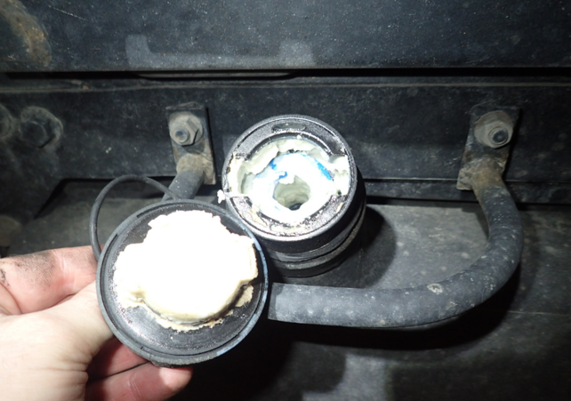
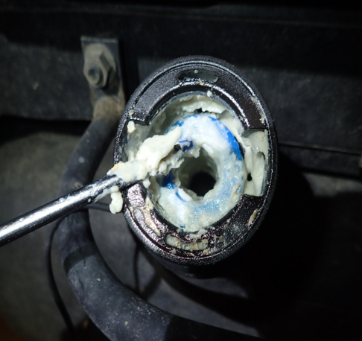

- The filling level indication located in the dashboard does not coincide with the filling level in the AdBlue tank. In manipulated trucks the filling level indication shows quite often ¼, ½, ¾, or full;

- The temperature display of the ambient temperature in the dashboard shows -12° C or less;

- The exhaust system of the vehicle is sooted;

- Missing fuses in the fuse box (see foto below);

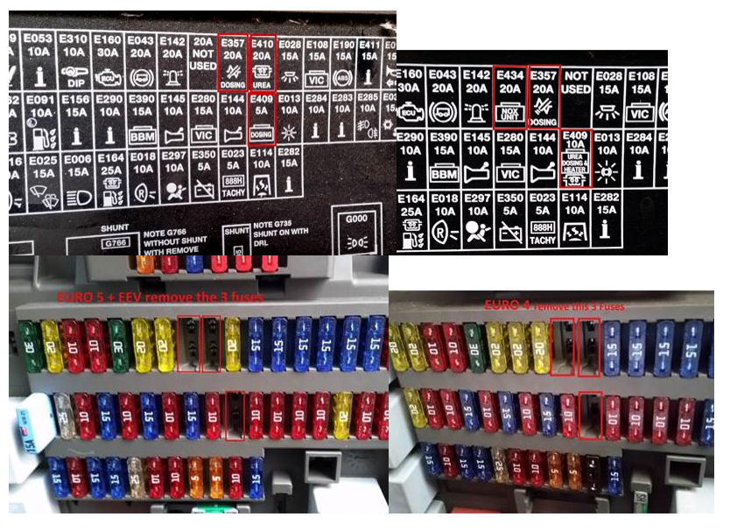

- Non-original wiring, cables or hardware (see 2 fotos below);

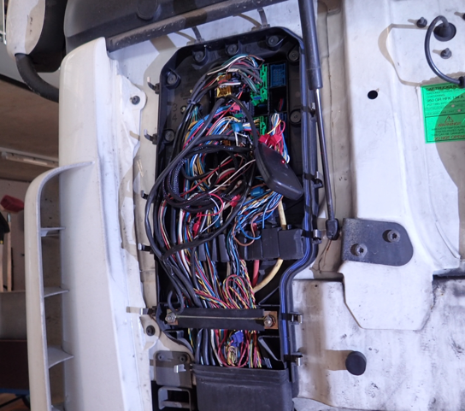

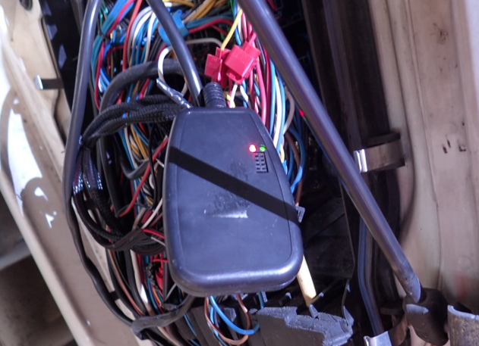

- Disconnected or modified connectors/connection assemblies at the AdBlue control unit/injection unit (see foto below);

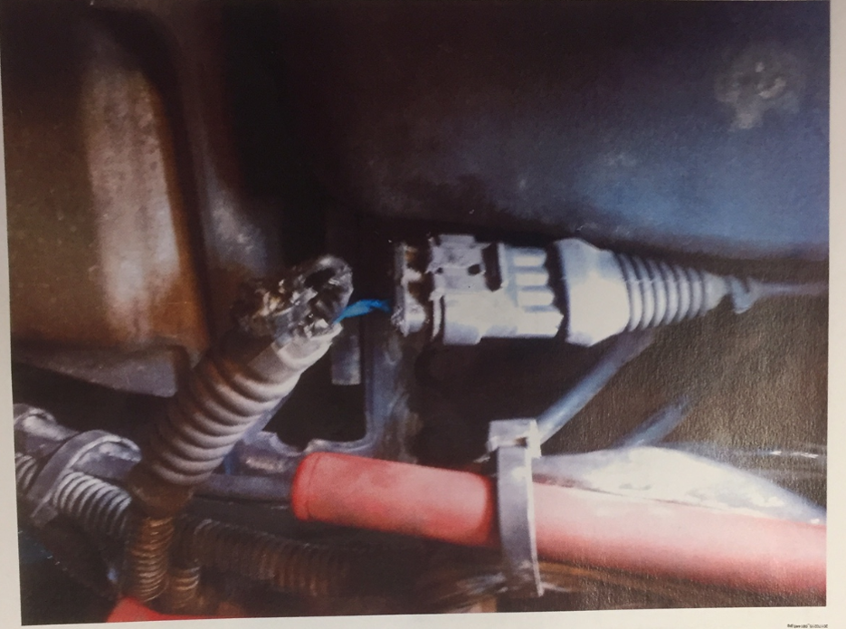

- Hidden switch for reactivation of AdBlue injection, needed in countries with stringent vehicle controls;

- The driver is not able to present sales receipts for AdBlue refillment.

Conclusion
There is strong evidence of a manipulated truck when a cumulation of such irregularities takes place.

