Note by the secretariat | Informal document GRRF-84-36  84th GRRF, 19-22 September 2017  Agenda item 9

Draft consolidated amendments to Regulation No 79 discussed during the eighty-fourth session of GRRF
Regulation No. 79,
Insert a new paragraph 2.3.4.3., to read:
"2.3.4.3 "Emergency Steering Function (ESF)" means a control function which can automatically detect a potential collision and automatically activate the vehicle steering system for a limited duration, to steer the vehicle with the purpose of avoiding or mitigating a collision, with:
(a) another vehicle driving/* in an adjacent lane,
(i) drifting towards the path of the subject vehicle and/or,
(ii) into which path the subject vehicle is drifting and/or,
(iii) into which lane the driver initiates a lane change manoeuver.
(b) an obstacle obstructing the path of the subject vehicle or when the obstruction of the subject vehicle’s path is deemed imminent.
ESF shall cover one or more use cases from the list above.
------------
* the vehicle may be driving in the same or the opposite direction as the subject vehicle."
Insert a new paragraph 2.4.16. and 2.4.17., to read:
"2.4.16. A ‘lane change procedure’ in the case of ACSF of Category [C1] starts when the direction indicator lamps are activated by a deliberate action of the driver and ends when the direction indicator lamps are deactivated. It comprises the following operations:
(a) Activation of the direction indicator lamps by a deliberate action of the driver
(b) Lateral movement of the vehicle towards the lane boundary
(c) Lane change manoeuvre
(d) Resumption of the lane keeping function
(e) Deactivation of direction indicator lamps
2.4.17. A "lane change manoeuvre" is part of the lane change procedure and,
(a) Starts when the outside edge of the tyre tread of the vehicle’s front wheel closest to the lane markings touches the inside edge of the lane marking to which the vehicle is being manoeuvred,
(b) Ends when the rear wheels of the vehicle have fully crossed the lane marking."
Insert a new paragraph 5.1.6.2., to read:
"5.1.6.2. Provisions for ESF
Any ESF shall fulfil the following requirements.
5.1.6.2.1. ESF shall only start an intervention in case a risk of a collision is detected.
5.1.6.2.2. An automatic avoidance manoeuver initiated by an ESF shall not steer the vehicle out of the lane of travel. However, if the intervention starts during a lane change manoeuvre performed by the driver or during an unintentional drift into the adjacent lane, the system may steer the vehicle back into its original lane of travel.
In case of an ESF able to intervene in the absence of lane markings, the ESF intervention on such roads shall not lead to a lateral offset of more than 0.75 m. The vehicle shall not leave the road due to the ESF intervention. For that purpose, the system shall be able to detect the road edge.
Any vehicle fitted with ESF shall be equipped with means to detect lane markings and to monitor the driving environment (e.g. other road users) in line with the specified use case in the system information data. The system shall monitor the driving environment at any time the ESF is active.
The ESF intervention shall not lead the vehicle to collide with another road user.
The manufacturer shall demonstrate during type approval, to the satisfaction of the technical service, which means to detect lane markings and to monitor the driving environment, are fitted to the vehicle to satisfy these provisions.
5.1.6.2.3. Any intervention of an ESF shall be indicated to the driver with an optical and with an acoustic or haptic warning signal to be provided at the latest with the start of the ESF intervention.
[For this purpose directionally appropriate signals used by other warning systems (e.g. blind spot detection, lane departure warning, forward collision warning) are deemed to be sufficient to fulfil the requirements for the respective optical, acoustic or haptic signals above.]
5.1.6.2.4. A system failure shall be indicated to the driver with an optical warning signal. However, when the system is manually deactivated, the indication of failure mode may be suppressed.
5.1.6.2.5. The steering control effort necessary to override the directional control provided by the system shall not exceed [50 N].
5.1.6.2.6 The ESF shall be subject to the requirements of Annex 6.
5.1.6.2.7 The vehicle shall be tested in accordance with the relevant vehicle tests specified in Annex 8 of this Regulation.
5.1.6.2.8. System information data
The following data shall be provided together with the documentation package required in Annex 6 of this regulation to the Technical Service at the time of type approval:
- Use case(s) where ESF is designed to operate (among the use cases a.i, a.ii, a.iii and b. specified in the ESF definition 2.3.4.3),
- The conditions under which the system is active, e.g. the vehicle speed range V_{smax} , V_{smin}.
- How ESF detects a risk of a collision.
- How to deactivate/reactivate the function"
Amend paragraph 5.1.10., to read:
[5.1.11. …
Manual steering equipment and power-assisted steering equipment are exempted from the application of Annex 6 to this Regulation, provided they are not part of a complex system as defined in paragraph 2.4 of Annex 6 to this Regulation.]
Insert a new paragraph 5.6.3, to read:
"(Reserved for ACSF of category B2.)"
Insert a new paragraph 5.6.4, to read:
"5.6.4. Special Provisions for ACSF of Category [C1]
Any ACSF system of Category [C1] shall fulfil the following requirements.
5.6.4.1. General
5.6.4.1.1. A vehicle equipped with an ACSF of Category [C1] shall also be equipped with an ACSF of Category B1 complying with the requirements of this Regulation.
5.6.4.2. Activation/deactivation of the ACSF of Category [C1] system
5.6.4.2.1. The default status of the system shall be off at the initiation of each new engine start/run cycle.
[At the time of the first system activation] after a new engine start/run cycle, a disclaimer shall be provided to inform the driver of their duty to monitor the traffic and road conditions prior to and throughout the lane change procedure.
This requirement does not apply when a new engine start/run cycle is performed automatically, e.g. the operation of a stop/start system.
5.6.4.2.2. The vehicle shall be equipped with a means for the driver to activate (standby mode) and deactivate (off mode) the system. The same means as for an ACSF of Category B1 may be used.
5.6.4.2.3. The system shall only be activated (standby mode) after a deliberate action by the driver.
Activation by the driver shall only be possible on roads where pedestrians and cyclists are prohibited and which, by design, are equipped with a physical separation that divides the traffic moving in opposite directions and which have at least two lanes in the direction the vehicles are driving. These conditions shall be ensured by the use of at least two independent means.
In the case of a transition from a road type with a classification permitting an ACSF of Category [C1], to a type of road where an ACSF of Category [C1] is not permitted, the system shall be deactivated automatically.
5.6.4.2.4. It shall be possible to deactivate the system (off mode) at any time by a single action of the driver. Following this action, the system shall only be able to be reactivated (standby mode) by a deliberate action of the driver.
5.6.4.2.5. Notwithstanding the requirements above it shall be possible to perform the corresponding tests in Annex 8 of this Regulation on a test track.
5.6.4.3. Overriding
A steering input by the driver shall override the steering action of the system. The steering control effort necessary to override the directional control provided by the system shall not exceed [30 or 50] N.
The system may remain activated (standby mode) provided that priority is given to the driver during the overriding period.
5.6.4.4. Lateral acceleration
The lateral acceleration induced by the system during the lane change manoeuvre:
(a) Shall not exceed 1 m/s² in addition to the lateral acceleration generated by the lane curvature, and
(b) Shall not cause the total vehicle lateral acceleration to exceed the maximum values indicated in tables of paragraph 5.6.2.1.3.
[The moving average over half a second of the lateral jerk generated by the system shall not exceed 5 m/s³.]
5.6.4.5. Human Machine Interface (HMI)
5.6.4.5.1. Unless otherwise specified, the optical signals identified in paragraph 5.6.4.5. shall be easily distinguishable from each other (e.g. different symbol, colour, blinking, text).
5.6.4.5.2. When the system is in standby mode (i.e. ready to intervene), an optical signal shall be provided to the driver.
5.6.4.5.3. When the lane change procedure is ongoing an optical signal shall be provided to the driver.
5.6.4.5.4. When the lane change procedure is suppressed, in accordance with paragraph 5.6.4.6.8., the system shall clearly inform the driver about this system status by an optical warning signal and additionally by an acoustic or haptic warning signal. In case the suppression is initiated by the driver, an optical warning is sufficient.
5.6.4.5.5. A system failure shall be signalled immediately to the driver by an optical warning signal. However, when the system is manually deactivated by the driver, the indication of failure mode may be suppressed.
If a system failure occurs during a lane change manoeuvre, the failure shall be signalled to the driver by an optical, and an acoustic or haptic warning.
5.6.4.5.6. The system shall provide a means of detecting that the driver is holding the steering control and shall warn the driver in accordance with the warning strategy below:
If, after a period of no longer than 3 seconds after the initiation of the lane change procedure, the driver is not holding the steering control, an optical warning signal shall be provided. This signal shall be the same as the signal specified in paragraph 5.6.2.2.5.
The warning signal shall be active until the driver is holding the steering control, or until the system is deactivated, either manually or automatically.
5.6.4.6. Lane change procedure
5.6.4.6.1. The initiation of a lane change procedure of an ACSF of Category [C1] shall only be possible if an ACSF of Category B1 is already active.
5.6.4.6.2. The lane change procedure requires, and shall start immediately after, a manual activation by the driver of the direction indicator to the intended side for the lane change.
5.6.4.6.3. When the lane change procedure starts, the ACSF of Category B1 shall be suspended, and the ACSF of Category [C1] shall carry on the lane keeping function of ACSF of category B1, until the lane change manoeuvre starts.
5.6.4.6.4. The lane change manoeuvre shall not be initiated before a period of 3.0 s and not later than 5.0 s after the deliberate action of the driver described in paragraph 5.6.4.6.2.
5.6.4.6.5. The lane change manoeuvre shall be completed in less than:
(a) 5 s for M₁, N₁ vehicle categories,
(b) 10 s for M₂, M₃, N₂, N₃ vehicle categories.
5.6.4.6.6. Once the lane change manoeuvre has completed, ACSF of Category B1 lane keeping function shall resume automatically.
5.6.4.6.7. The direction indicator shall remain active throughout the whole period of the lane change manoeuvre and shall be deactivated by the system no later than 0.5 seconds after the resumption of ACSF of Category B1 lane keeping function as described in paragraph 5.6.4.6.6.
5.6.4.6.8. Suppression of the lane change procedure
5.6.4.6.8.1. The lane change procedure shall be suppressed automatically by the system when at least one of the following situations occurs before the lane change manoeuvre has started:
(a) The system detects a critical situation (as defined in para. 5.6.4.7),
(b) The system is overridden or switched off by the driver,
(c) The system reaches its boundaries (e.g. lane markings are no longer detected)
(d) The system has detected that the driver is not holding the steering control at the start of the lane change manoeuvre,
(e) The direction indicator lamps are manually deactivated by the driver,
(f) The lane change manoeuvre has not commenced within 5.0 s following the deliberate action of the driver described in para. 5.6.4.6.2.
5.6.4.6.8.2. Manual deactivation of the lane change procedure, using the manual control of the direction indicator, shall be possible for the driver at any time.
5.6.4.7. Critical situation
A situation is deemed to be critical when, at the time a lane change manoeuvre starts, an approaching vehicle in the target lane would have to decelerate at 3m/s² [0.0 or 1.2] seconds after the lane change manoeuvre has started, to ensure the distance between the two vehicles is never less than that the ACSF vehicle travels in [1] second.
For the purpose of this requirement, it is assumed that the maximum speed of the approaching vehicle (Vrear) is 130km/h, and that the ACSF vehicle speed is constant.
[5.6.4.8. Minimum distance and minimum operation speed
5.6.4.8.1. The ACSF of Category [C1] shall be able to detect vehicles approaching from the rear in an adjacent lane up to a distance S_{rear} as specified below:
The minimum distance S_{rear} shall be declared by the vehicle manufacturer. The declared value shall not be less than 55m.
The declared distance shall be tested according to the relevant test in Annex 8 using a two-wheeled motor vehicle of Category L3 as the approaching vehicle. */
The minimum operation speed V_{smin} , down to which the ACSF C is permitted to perform a lane change manoeuvre, shall be calculated with minimum distance S_{rear} using the following formula:
$$V_{Smin}= a*\left(t_{B}-t_{G}\right)+v_{app}-\sqrt{a^{2}*{(t_{B}-t_{G})}^{2}- 2*a*(v_{app}*t_{G}-S_{rear})}$$
Where:
S_{rear} = Minimum distance declared by the manufacturer in [m]
v_{app} = 36.1 m/s (Speed of the approaching vehicle = 130 km/h)
a = 3 m/s² (Deceleration of the approaching vehicle)
t_{B} = [0.0 or 1.2]s (Time after the start of the manoeuvre at which the deceleration of the approaching vehicle starts)
t_{G} = [1]s (Remaining gap of the vehicles after the deceleration of the approaching vehicle)
V_{smin} = x [m/s] Resulting minimum activation speed of the ACSF of Category C1
Notwithstanding the requirements above, the system may become active also at speeds lower than the calculated V_{smin} provided that the following conditions are met:
(a) The system has detected another vehicle in the adjacent lane into which the lane change is planned at a distance lower than S_{rear} and
(b) The situation is not deemed to be critical according to paragraph 5.6.5.7 (e.g. at low speed differences and V_{app}< 130 km/h)
(c) [S_{rear} = (v_{app} - v_{Smin}) * t_{B} + (v_{rear} – v_{Smin})² / (2 * a) + v_{Smin} * t_{G} ] ]
[ Footnote:
* Until a uniform test target, having the radar cross section (rcs) characteristics of an appropriate L3 vehicle have been agreed, the motorcycle used for type approval shall have an engine capacity greater than 500cm³. The choice of the motorcycle shall be agreed with the Technical Service and the details recorded in the Test Report.]
5.6.4.8.2. The vehicle system detection area on ground level shall be at minimum as shown in the figure below.
Fig. 1
Figure Minimum detection area
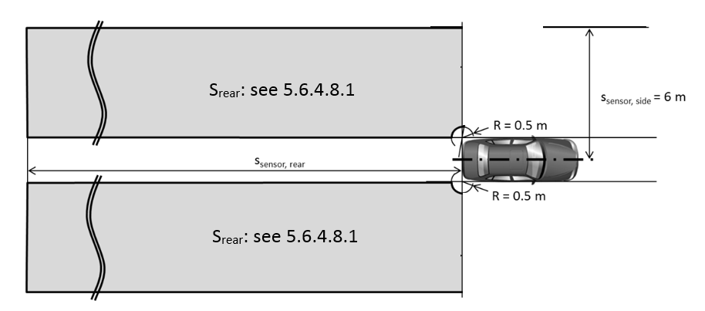
5.6.4.8.3. After each vehicle new engine start/run cycle (other than when performed automatically, e.g. the operation of a stop/start systems), the ACSF of Category [C1] function shall be prevented from performing a lane change manoeuvre until the system has detected, at least once, a moving object at a distance greater than [x] m.
5.6.4.8.4. The ACSF of Category [C1] shall be able to detect blindness of the sensor (e.g. due to accumulation of dirt, ice or snow). The ACSF of Category [C1] shall be prevented, upon detection of blindness, from performing the lane change manoeuvre procedure. The status of the system shall be signalled to the driver no later than on the initiation of the lane change manoeuvre. The same warning as the one specified in paragraph 5.6.4.5.5. (system failure warning) may be used.
5.6.4.9. System information data
5.6.4.9.1. Following data shall be provided together with the documentation package required in Annex 6 of this regulation to the Technical Service at the time of type approval.
5.6.4.9.1.1. The conditions under which the system can be activated and the boundaries for operation (boundary conditions). The vehicle manufacturer shall provide values for V_{smax} , V_{smin} and ay_{smax} for every speed range as mentioned in the table of paragraph 5.6.2.1.3. of this Regulation.
5.6.4.9.1.2. Information about how the system detects that the driver is holding the steering control.
5.6.4.9.1.3. The means to override and to suppress or cancel.
[5.6.4.9.1.4. Information about how the failure warning signal status and the confirmation of the valid software version related ACSF performance can be checked via the use of an electronic communication interface.]
[5.6.4.9.1.5. Documentation about which system software version related ACSF performance is valid. This documentation shall be updated whenever a software version was amended.]
5.6.4.9.1.6. Information on the sensor range over lifetime. The sensor range shall be specified such way that any influence on deterioration of the sensor shall not affect the fulfilment of paragraph 5.6.4.8.3. and 5.6.4.8.4. of this regulation.
5.6.4.10. The vehicle with ACSF of Category [C1] shall be tested in accordance with relevant vehicle test(s) specified in Annex 8 of this Regulation. [For driving situations not covered by the tests of Annex 8, the safe operation of the ACSF shall be demonstrated by the vehicle manufacturer on the base of Annex 6 of this Regulation.]
Insert new paragraph 12.7., to read:
[12.7. As a derogation, Annex 6 to this Regulation, as amended by [Supp.1 to the 02 series of amendments], shall not be applicable when granting extensions to approvals for Auxiliary Steering Equipment approved to earlier versions of this Regulation and when assessed in accordance with Annex 4 to this Regulation.]
Annex 6,
Paragraph 1., amend to read (insert a last subparagraph):
"1. General
…
This annex [may shall also apply be called, by special paragraphs in this Regulation, for to] safety related functions identified in this Regulation which are controlled by electronic system(s).
This information shall show that "The System" respects, under normal non-fault and fault conditions, all the appropriate performance requirements specified elsewhere in this Regulation and that it is designed to operate in such a way that it does not induce safety critical risks.
Insert new paragraph 2.1., discussion on new definition to read:
"2.1. “The System” means an electronic control system or complex electronic control system that provides or forms part of the control transmission of a function to which this Regulation applies. This also includes any other system covered in the scope of this Regulation, as well as transmission links to or from other systems that are outside the scope of this Regulation, that acts on a function to which this Regulation applies.
Paragraph 2.1. (former), amend to read and renumber:
"2.2. "Safety concept" is a description of the measures designed into the system, for example within the electronic units, so as to address system integrity and thereby ensure safe operation under fault and non-fault conditions, including even in the event of an electrical failure. The possibility of a fall-back to partial operation or even to a back-up system for vital vehicle functions may be a part of the safety concept.
Paragraph 2.2. (former), amend to read and renumber:
"2.3. "Electronic control system" means a combination of units, designed to co-operate in the production of the stated vehicle control function by electronic data processing. Such systems, often controlled by software, are built from discrete functional components such as sensors, electronic control units and actuators and connected by transmission links. They may include mechanical, electro-pneumatic or electro-hydraulic elements. "The System", referred to herein, is the one for which type approval is being sought.
Paragraph 2.3. (former), discussion on amending and renumber:
"2.4. "Complex electronic vehicle control systems" are those electronic control systems which are subject to a hierarchy of control in which a controlled function controlled by an electronic system or the driver may be over-ridden by a higher level electronic control system/function. A function which is over-ridden function becomes part of the complex system, [as well as any overriding system/function within the scope of this Regulation. The transmission links to and from overriding systems/function outside of the scope of this Regulation shall also be included.]
Paragraph 2.4. (former), discussion on amending and renumber:
"2.5. "Higher-Level electronic control" systems/functions are those which employ additional processing and/or sensing provisions to modify vehicle behaviour by commanding variations in the normal function(s) of the vehicle control system. This allows complex systems to automatically change their objectives with a priority which depends on the sensed circumstances.
Paragraphs 2.5. to 2.8. (former), no changes and renumber to 2.6. to 2.9.
Paragraph 3.1., amend to read:
"3.1. …
The Technical Service shall assess the documentation package to show that “The System”:
- is designed to operate in such a way that it does not induce a response that negatively affects the safety
- is designed so that it in fault condition does not induce a risk or can be permanently switched off without affecting the performance of other systems.
- Respects, under non-fault and fault conditions, all the appropriate performance requirements specified elsewhere in this Regulation, and
- Was developed according to the development process/method declared by the manufacturer
Paragraph 3.1.1., amend to read:
"3.1.1. Documentation shall be made available in two parts:
(a) The formal documentation package for the approval, containing the material listed in paragraph 3. (with the exception of that of paragraph 3.4.4.) which shall be supplied to the technical service at the time of submission of the type approval application. This documentation package shall be used by the Technical Service will be taken as the basic reference for the verification process set out in paragraph 4. of this annex.
…
Paragraph 3.2., discussion on amending:
"3.2. Description of the functions of "The System" A description shall be provided which gives a simple explanation of all the control functions of "The System" and the methods employed to achieve the objectives, including a statement of the mechanism(s) by which control is exercised.
Paragraph 3.3.3., amend to read:
"3.3.3. Interconnections within "The System" shall be shown by a circuit diagram for the electric transmission links, by a piping diagram for pneumatic or hydraulic transmission equipment and by a simplified diagrammatic layout for mechanical linkages. The transmission links both to and from other systems shall also be shown.
Paragraph 3.3.4., discussion on amending to read:
"3.3.4. There shall be a clear correspondence between these transmission links and the signals carried between Units. Priorities of signals on multiplexed data paths shall be stated wherever priority may be an issue affecting performance or safety.
Insert new paragraph 3.3.4.1., discussion on new requirement to read:
"3.3.4.1. Any function which can affect the fulfilment of the requirements of this Regulation, shall be declared by the manufacturer. The declaration shall include a description of the rationale of the function’s operation.
In addition, any declared function that can be over-ridden shall be identified and a further description of the changed rationale of the function’s operation provided.
These declarations shall include any functions that are present but not enabled at the time of type approval.
Paragraph 3.4.1., discussion on amending:
"3.4.1. The manufacturer shall provide a statement which affirms that the strategy chosen to achieve "The System" objectives will not, under non-fault conditions, prejudice the safe operation of systems which are subject to the prescriptions of this Regulation.
Paragraph 3.4.2., amend to read:
"3.4.2. In respect of software employed in "The System", the outline architecture shall be explained and the design methods and tools used shall be identified. The manufacturer shall show evidence of the means by which they determined the realization of the system logic, during the design and development process.
Paragraph 3.4.3., amend to read:
"3.4.3. The Manufacturer shall provide the Technical Service with an explanation of the design provisions built into "The System" so as to generate safe operation under fault conditions. Possible design provisions for failure in "The System" are for example:
…
Paragraph 3.4.4., amend to read:
"3.4.4. The documentation shall be supported, by an analysis which shows, in overall terms, how the system will behave on the occurrence of any one of those specified hazards or faults which will have a bearing on vehicle control performance or safety.
This may be based on a Failure Mode and Effect Analysis (FMEA), a Fault Tree Analysis (FTA) or any similar process appropriate to system safety considerations.
The chosen analytical approach(es) shall be established and maintained by the Manufacturer and shall be made open for inspection by the technical service at the time of the type approval.
[The Technical Service shall perform an assessment of the application of the analytical approach(es). The audit shall include:
• Inspection of the safety approach at the concept (vehicle) level with confirmation that it includes consideration of interactions with other vehicle systems. This may be based on a Hazard and Operability analysis (HAZOP) or any similar process appropriate to system safety.
• Inspection of the safety approach at the system level. This may be based on a Failure Mode and Effect Analysis (FMEA), a Fault Tree Analysis (FTA) or any similar process appropriate to system safety.
• Inspection of the validation plans and results. This shall include validation testing appropriate for validation, for example, Hardware in the Loop (HIL) testing, vehicle on–road operational testing, or any testing appropriate for validation.
The assessment shall consist of spot checks of selected hazards and faults to establish that argumentation supporting the safety concept is understandable and logical and validation plans are suitable and have been completed.
The Technical Service may perform or may require to perform tests as specified in paragraph 4 to verify the safety concept.]
Insert new paragraph 3.4.4.2., to read:
["3.4.4.2. This documentation shall describe the resistance of "The System" to environmental influences, e.g. climate and mechanical resistance.]
Paragraph 4.1.1., amend to read:
["4.1.1. Verification of the function of “The System”
As the means of establishing the normal operational levels, verification of the performance of the vehicle system The Technical Service shall verify “The System” under non-fault conditions by randomly testing at least [10%] of the instances where a function to which this Regulation applies can be over-ridden, as declared by the manufacturer in 3.3.4.1. The requirements of this Regulation shall not be comprised when any function to which this Regulation applies is overridden. shall be conducted against the manufacturer's basic benchmark specification unless this is subject to a specified performance test as part of the approval procedure of this or another Regulation.]
Paragraph 4.1.2., amend to read:
"4.1.2. Verification of the safety concept of paragraph 3.4.
The reaction of "The System" shall, at the discretion of the type approval authority, be checked under the influence of a failure in any individual unit by applying corresponding output signals to electrical units or mechanical elements in order to simulate the effects of internal faults within the unit. The Technical Service shall conduct this check for at least one individual unit, but shall not check the reaction of “The System” to multiple simultaneous failures of individual units." [The vehicle manufacturer may propose to the Technical Service when is the most relevant time during the development process to perform the test, provided the system is at a sufficient technical level reflecting the final production of the system to be approved.]
[The Technical Service shall verify that these tests include aspects that may have an impact on vehicle controllability and user information (HMI aspects).]
Insert new Paragraph 5., to read:
[5. Reporting by technical service
Reporting of the assessment by technical service shall be performed in such a manner that allows traceability, e.g. versions of documents inspected are coded and listed in the records of the technical service.
An example of a possible layout for the report from the technical service to the type approval authority is given in the template in Part II of this document.]
[II. Example of Report Layout [English only]
– please provide original document –

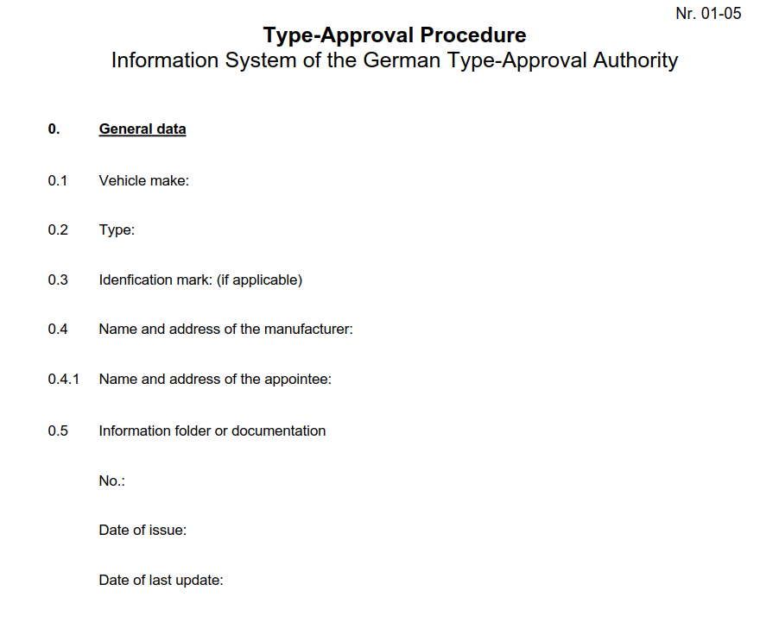
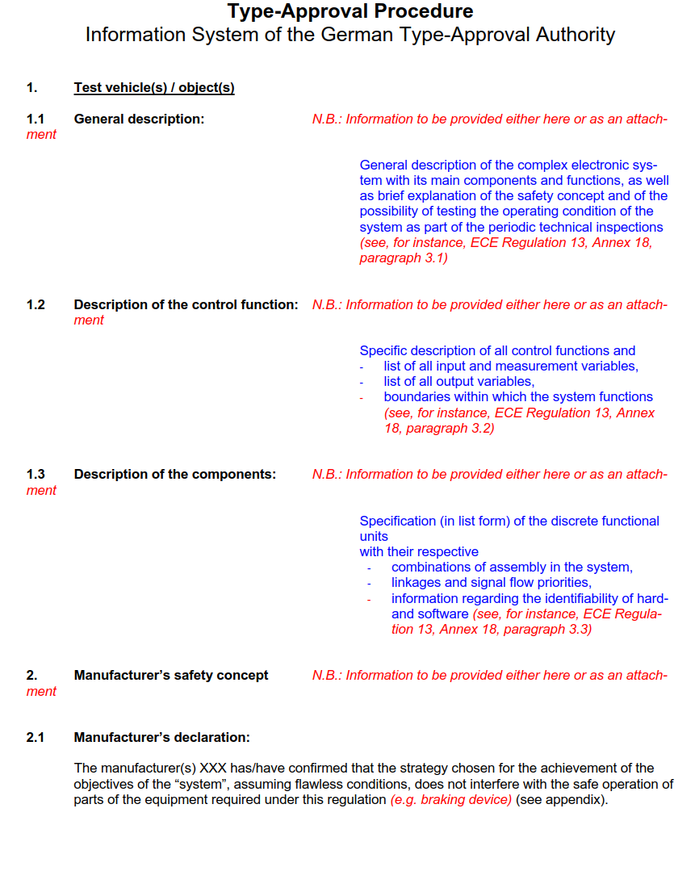

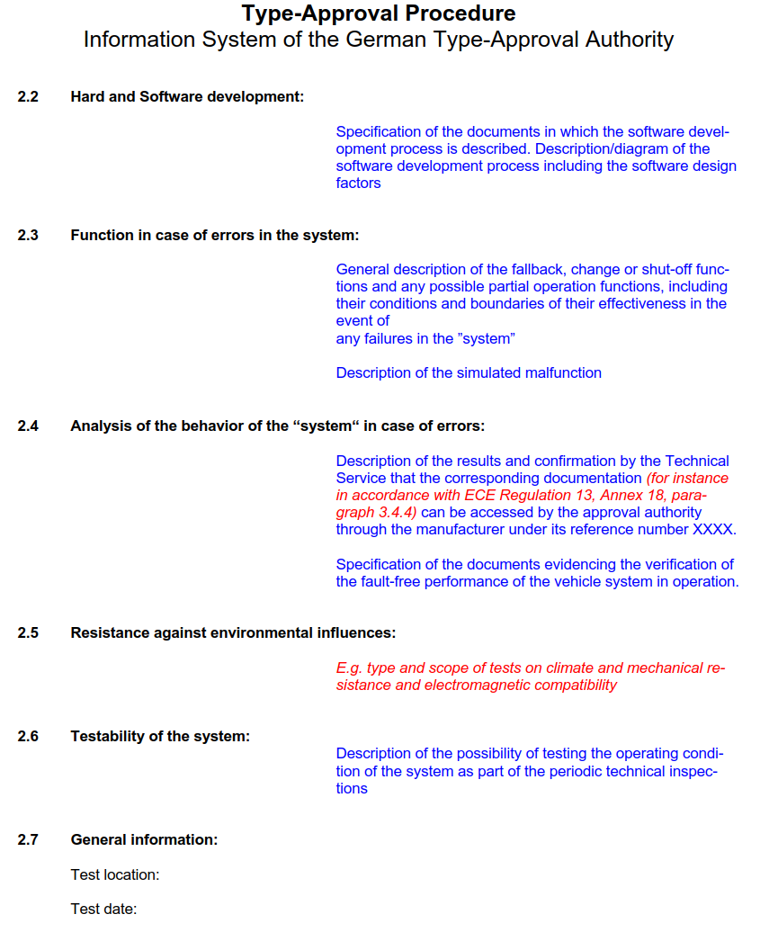

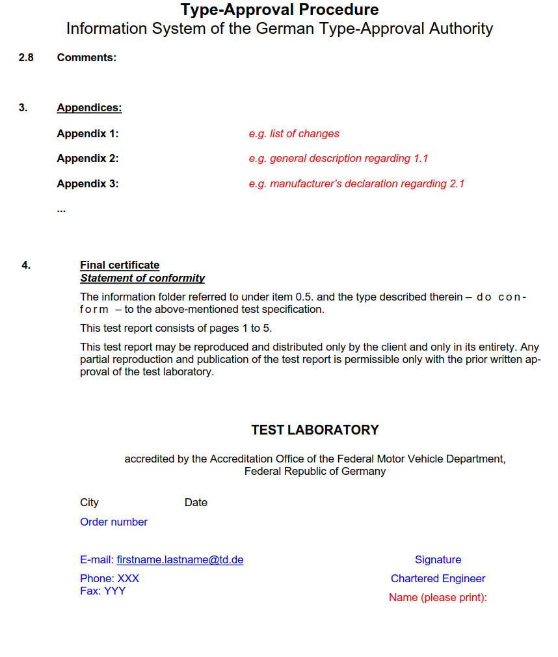]"
Annex 8,
Paragraph 3.3, insert to read:
"3.3 Tests for ESF
The vehicle shall be driven with activated ESF on a road with lane markings on each side, positioned within the lane markings.
The test conditions and the vehicle speeds shall be within the operating range of the system as declared by the manufacturer.
Further details of the tests described below shall be discussed and agreed between the vehicle manufacturer and the technical service to adapt the required testing to the declared use case(s) the ESF is designed to operate.
In addition, the manufacturer shall demonstrate to the satisfaction of the Technical Service that the requirements defined in paragraph 5.1.6.2.1 to 5.1.6.2.6. are fulfilled in the whole range of the ESF operation range (specified by the OEM vehicle manufacturer in the system information data) This may be achieved on the basis of appropriate documentation appended to the test report.
[3.3.1 Test for ESF Type a. i/ii: (unintentional lateral manoeuvre)
A target vehicle driving in the adjacent lane shall approach the vehicle under test and one of the vehicles shall minimize their lateral distance.
The tests requirements are fulfilled if:
(a) an ESF intervention is started, and
(b) the warnings are provided no later than the ESF intervention starts, and
(c) the ESF intervention does not lead the vehicle to leave its original lane.]
[3.3.2 Test for ESF Type a.iii: (intentional lateral manoeuvre)
The vehicle under test starts a lane change while another vehicle is driving in the adjacent lane such that no intervention of the ESF system would lead to a collision.
The test requirements are fulfilled if:
(a) an ESF intervention is started, and
(b) the warnings are provided no later than the ESF intervention starts, and
(c) the ESF intervention does not lead the vehicle to leave its original lane. ]
[3.3.3 Test for ESF Type b.:
The vehicle under test shall approach an object positioned within its trajectory. The object shall be of such size and positioned in a way that the vehicle can pass the object without crossing the lane markings.
The tests requirements are fulfilled if:
(a) the ESF intervention avoids or mitigates the collision, and
(b) the warnings are provided no later than the ESF intervention starts, and
(b) the ESF intervention does not lead the vehicle to leave its lane.]
[3.3.4 Tests for systems able to operate in the absence of lane markings
In case any system works in absence of any lane markings the corresponding above tests from sections 3.3.1 to 3.3.3 need to be repeated on a test track without lane markings.
These test requirements are fulfilled if,
(a) an ESF intervention is started, and
(b) the warnings are provided no later than the ESF intervention starts, and
(c) the lateral offset during the manoeuvre is 0.75 m, as specified in paragraph 5.1.6.2.2., at maximum and
(d) the vehicle has not left the road due to the ESF intervention.]
[3.3.5 False reaction test for ESF Type b
The vehicle under test shall approach a [coloured] plastic sheet with a thickness less than [3mm] and a length less than [2m] positioned between the lane markings in the trajectory of the vehicle. The plastic sheet shall be of such size and positioned in a way that the vehicle could pass the sheet without crossing the lane markings
The test requirements are fulfilled if:
(a) The ESF does not start any intervention.]"
Insert a new paragraph 3.5 in Annex 8, to read:
"[3.5. Tests for ACSF of Category [C1] Systems
3.5.1. Lane change functional test
3.5.2. Suppression of lane change procedure test
3.5.3. Overriding test
3.5.4. Deactivation test
3.5.5. Sensor performance test
3.5.6. Sensor blindness test
3.5.7. “Engine start/run cycle test”]"
Remark: Details of the tests will be defined in 15th ACSF session (November 2017)

