UN/SCEGHS/35/INF.7

Committee of Experts on the Transport of Dangerous Goods
and on the Globally Harmonized System of Classification
and Labelling of Chemicals 19 April 2018
Sub-Committee of Experts on the Globally Harmonized System of Classification and Labelling of Chemicals
Thirty-fifth session
Geneva, 4-6 July 2018
Item 4 (b) of the provisional agenda
Hazard communication:
improvement of annexes 1 to 3 and further rationalization of precautionary statements
Proposed changes to Annex 3 of the GHS to reflect hazard sub-categories
Transmitted by the expert from the United Kingdom on behalf of the informal working group on improving annexes 1, 2 and 3 of the GHS

The amendments proposed in ST/SG/AC.10/C.4/2018/6 are reflected in the consolidated text below. New text is shown in red
Annex 1
Classification and labelling summary tables
A1.19 Skin corrosion/irritation (see Chapter 3.2 for classification criteria)
Classification |  | Labelling |  |  |  | Hazard statement codes
Hazard class | Hazard category | Pictogram |  | Signal word | Hazard statement
 |  | GHS | UN Model Regulations
Skin corrosion/irritation | 1  1A, 1B, 1Cª | 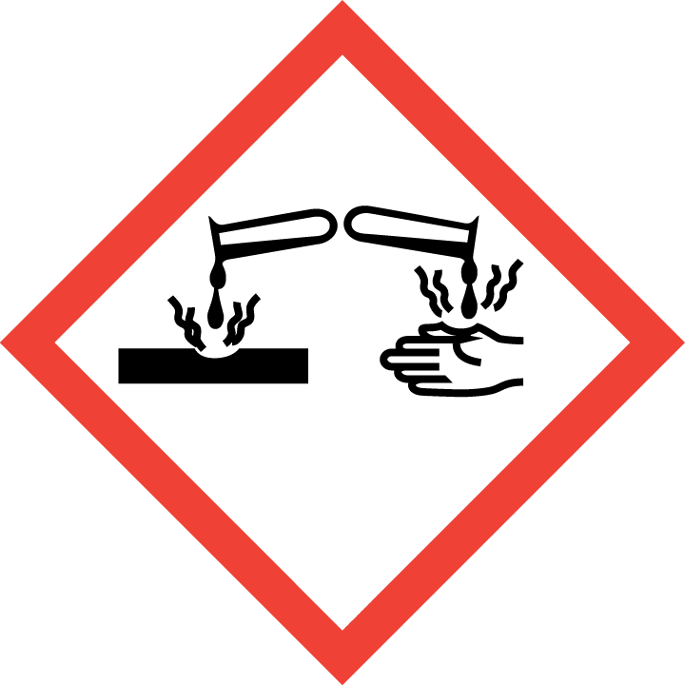 | 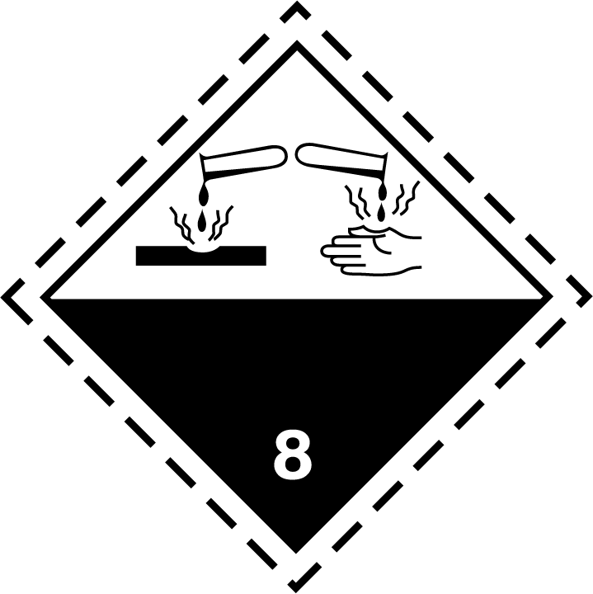 | Danger | Causes severe skin burns and eye damage | H314
 | 2 |  | Not required | Warning | Causes skin irritation | H315
 | 3^{b} | No pictogram | Not required | Warning | Causes mild skin irritation | H316
ª Sub-categories may be applied where data are sufficient and where required by a competent authority
^{b} Applies to some authorities

Annex 3
Section 1
Table A3.1.2: Hazard statement codes for health hazards
Code | Health hazard statements | Hazard class (GHS chapter) | Hazard category
(1) | (2) | (3) | (4)
H314 | Causes severe skin burns and eye damage | Skin corrosion/irritation (chapter 3.2) | 1, 1A, 1B, 1C
H319 | Causes serious eye irritation | Serious eye damage/eye irritation (chapter 3.3) | 2/2A

Section 2
4
UN/SCEGHS/35/INF.7
Table A3.2.2: Codification of prevention precautionary statements
Code | Prevention precautionary statements | Hazard class | Hazard category | Conditions for use
(1) | (2) | (3) | (4) | (5)
P260 | Do not breathe dust/fume/gas/mist/vapours/spray. | Acute toxicity – inhalation (chapter 3.1) | 1, 2 | Manufacturer/supplier or the competent authority to specify applicable conditions.
 |  | Specific target organ toxicity, single exposure  (chapter 3.8) | 1, 2
 |  | Specific target organ toxicity, repeated exposure (chapter 3.9) | 1, 2
 |  | Skin corrosion (chapter 3.2) | 1, 1A, 1B, 1C | – specify do not breathe dusts or mists  – if inhalable particles of dusts or mists may occur during use.
 |  | Reproductive toxicity – effects on or via lactation (chapter 3.7) | Additional category
P264 | Wash ... thoroughly after handling. | Acute toxicity – oral (chapter 3.1) | 1, 2, 3, 4 | ...Manufacturer/supplier or the competent authority to specify parts of the body to be washed after handling.
 |  | Acute toxicity – dermal (chapter 3.1) | 1, 2
 |  | Skin corrosion (chapter 3.2) | 1, 1A, 1B, 1C
 |  | Skin irritation (chapter 3.2) | 2
 |  | Eye irritation (chapter 3.3) | 2/2A, 2B
 |  | Reproductive toxicity – effects on or via lactation (chapter 3.7) | Additional category
 |  | Specific target organ toxicity, single exposure  (chapter 3.8) | 1, 2 | ...Manufacturer/supplier or the competent authority to specify parts of the body to be washed after handling.
 |  | Specific target organ toxicity, repeated exposure (chapter 3.9) | 1
P280 | Wear protective gloves/protective clothing/eye protection/face protection/hearing protection/... | Explosives (chapter 2.1) | Unstable explosive and divisions 1.1, 1.2, 1.3, 1.4, 1.5 | Manufacturer/supplier or the competent authority to specify the appropriate personal protective equipment.
 |  | Flammable gases (chapter 2.2) | Pyrophoric gas
 |  | Flammable liquids (chapter 2.6) | 1, 2, 3, 4
 |  | Flammable solids (chapter 2.7) | 1, 2
 |  | Self-reactive substances and mixtures  (chapter 2.8) | Types  A, B, C, D, E, F
 |  | Pyrophoric liquids (chapter 2.9) | 1
 |  | Pyrophoric solids (chapter 2.10) | 1
 |  | Self-heating substances and mixtures  (chapter 2.11) | 1, 2
 |  | Substances and mixtures which, in contact with water, emit flammable gases (chapter 2.12) | 1, 2, 3
 |  | Oxidizing liquids (chapter 2.13) | 1, 2, 3
 |  | Oxidizing solids (chapter 2.14) | 1, 2, 3

P280  (suite) | Wear protective gloves/protective clothing/eye protection/face protection/hearing protection/... | Organic peroxides (chapter 2.15) | Types  A, B, C, D, E, F | Manufacturer/supplier or the competent authority to specify the appropriate personal protective equipment
 |  | Desensitized explosives (chapter 2.17) | 1, 2, 3, 4
 |  | Acute toxicity – dermal (chapter 3.1) | 1, 2, 3, 4 | – Specify protective gloves/clothing.  Manufacturer/supplier or the competent authority may further specify type of equipment where appropriate.
 |  | Skin corrosion (chapter 3.2) | 1, 1A, 1B, 1C | – Specify protective gloves/clothing and eye/face protection.  Manufacturer/supplier or the competent authority may further specify type of equipment where appropriate.
 |  | Skin irritation (chapter 3.2) | 2 | – Specify protective gloves.  Manufacturer/supplier or the competent authority may further specify type of equipment where appropriate.
 |  | Skin sensitization (chapter 3.4) | 1, 1A, 1B
 |  | Serious eye damage (chapter 3.3) | 1 | – Specify eye/face protection.  Manufacturer/supplier or the competent authority may further specify type of equipment where appropriate.
 |  | Eye irritation (chapter 3.3) | 2/2A
 |  | Germ cell mutagenicity (chapter 3.5) | 1A, 1B, 2 | Manufacturer/supplier or the competent authority to specify the appropriate personal protective equipment.
 |  | Carcinogenicity (chapter 3.6) | 1A, 1B, 2
 |  | Reproductive toxicity (chapter 3.7) | 1A, 1B, 2

Table A3.2.3: Codification of response precautionary statements
Code | Response precautionary statements | Hazard class | Hazard category | Conditions for use
(1) | (2) | (3) | (4) | (5)
P301 | IF SWALLOWED: | Acute toxicity, oral (chapter 3.1) | 1, 2, 3, 4, 5
 |  | Skin corrosion (chapter 3.2) | 1, 1A, 1B, 1C
 |  | Aspiration hazard (chapter 3.10) | 1, 2
P303 | IF ON SKIN (or hair): | Flammable liquids (chapter 2.6) | 1, 2, 3
 |  | Skin corrosion (chapter 3.2) | 1, 1A, 1B, 1C
P304 | IF INHALED: | Acute toxicity, inhalation (chapter 3.1) | 1, 2, 3, 4, 5
 |  | Skin corrosion (chapter 3.2) | 1, 1A, 1B, 1C
 |  | Respiratory sensitization (chapter 3.4) | 1, 1A, 1B
 |  | Specific target organ toxicity, single exposure; respiratory tract irritation (chapter 3.8) | 3
 |  | Specific target organ toxicity, single exposure; narcotic effects (chapter 3.8) | 3
P305 | IF IN EYES: | Skin corrosion (chapter 3.2) | 1, 1A, 1B, 1C
 |  | Serious eye damage (chapter 3.3) | 1
 |  | Eye irritation (chapter 3.3) | 2/2A, 2B
P310 | Immediately call a POISON CENTER/doctor/… | Acute toxicity, oral (chapter 3.1) | 1, 2, 3 | …Manufacturer/supplier or the competent authority to specify the appropriate source of emergency medical advice.
 |  | Acute toxicity, dermal (chapter 3.1) | 1, 2
 |  | Acute toxicity, inhalation (chapter 3.1) | 1, 2
 |  | Skin corrosion (chapter 3.2) | 1, 1A, 1B, 1C
 |  | Serious eye damage (chapter 3.3) | 1
 |  | Aspiration hazard (chapter 3.10) | 1, 2
 |  | Specific target organ toxicity, single exposure; narcotic effects (chapter 3.8) | 3
P313 | Get medical advice/attention. | Skin irritation (chapter 3.2) | 2, 3 | Manufacturer/supplier or the competent authority to select medical advice or attention as appropriate.
 |  | Eye irritation (chapter 3.3) | 2/2A, 2B
 |  | Skin sensitization (chapter 3.4) | 1, 1A, 1B
 |  | Germ cell mutagenicity (chapter 3.5) | 1A, 1B, 2
 |  | Carcinogenicity (chapter 3.6) | 1A, 1B, 2
 |  | Reproductive toxicity (chapter 3.7) | 1A, 1B, 2
 |  | Reproductive toxicity, effects on or via lactation (chapter 3.7) | Additional category
P321 | Specific treatment (see ... on this label). | Acute toxicity, oral (chapter 3.1) | 1, 2, 3 | – if immediate administration of antidote is required.  ...Reference to supplemental first aid instruction.
 |  | Acute toxicity, dermal (chapter 3.1) | 1, 2, 3, 4 | – if immediate measures such as specific cleansing agent is advised.  ...Reference to supplemental first aid instruction.
 |  | Acute toxicity, inhalation (chapter 3.1) | 3 | – if immediate specific measures are required.  ...Reference to supplemental first aid instruction.
 |  | Skin corrosion (chapter 3.2) | 1, 1A, 1B, 1C | ...Reference to supplemental first aid instruction.  Manufacturer/supplier or the competent authority may specify a cleansing agent if appropriate.
 |  | Skin irritation (chapter 3.2) | 2
 |  | Skin sensitization (chapter 3.4) | 1, 1A, 1B
 |  | Specific target organ toxicity, single exposure (chapter 3.8) | 1 | – if immediate measures are required.  ...Reference to supplemental first aid instruction.
P330 | Rinse mouth. | Acute toxicity, oral (chapter 3.1) | 1, 2, 3, 4
 |  | Skin corrosion (chapter 3.2) | 1, 1A, 1B, 1C
P331 | Do NOT induce vomiting. | Skin corrosion (chapter 3.2) | 1, 1A, 1B, 1C
 |  | Aspiration hazard (chapter 3.10) | 1, 2
P337 | If eye irritation persists: | Eye irritation (chapter 3.3) | 2/2A, 2B
P338 | Remove contact lenses, if present and easy to do. Continue rinsing. | Skin corrosion (chapter 3.2) | 1, 1A, 1B, 1C
 |  | Serious eye damage (chapter 3.3) | 1
 |  | Eye irritation (chapter 3.3) | 2/2A, 2B
P340 | Remove person to fresh air and keep comfortable for breathing. | Acute toxicity, inhalation (chapter 3.1) | 1, 2, 3, 4
 |  | Skin corrosion (chapter 3.2) | 1, 1A, 1B, 1C
 |  | Respiratory sensitization (chapter 3.4) | 1, 1A, 1B
 |  | Specific target organ toxicity, single exposure; respiratory tract irritation (chapter 3.8) | 3
 |  | Specific target organ toxicity, single exposure; narcotic effects (chapter 3.8) | 3
P351 | Rinse cautiously with water for several minutes. | Skin corrosion (chapter 3.2) | 1, 1A, 1B, 1C
 |  | Serious eye damage (chapter 3.3) | 1
 |  | Eye irritation (chapter 3.3) | 2/2A, 2B
P353 | Rinse skin with water [or shower]. | Flammable liquids (chapter 2.6) | 1, 2, 3 | – text in square brackets to be included where the manufacturer/supplier or the competent authority considers it appropriate for the specific chemical.
 |  | Skin corrosion (chapter 3.2) | 1, 1A, 1B, 1C
P361 | Take off immediately all contaminated clothing. | Flammable liquids (chapter 2.6) | 1, 2, 3
 |  | Acute toxicity, dermal (chapter 3.1) | 1, 2, 3
 |  | Skin corrosion (chapter 3.2) | 1, 1A, 1B, 1C
P363 | Wash contaminated clothing before reuse. | Skin corrosion (chapter 3.2) | 1, 1A, 1B, 1C
P304  +  P340 | IF INHALED: Remove person to fresh air and keep comfortable for breathing. | Acute toxicity, inhalation (chapter 3.1) | 1, 2, 3, 4
 |  | Skin corrosion (chapter 3.2) | 1, 1A, 1B, 1C
 |  | Respiratory sensitization (chapter 3.4) | 1, 1A, 1B
 |  | Specific target organ toxicity, single exposure; respiratory tract irritation (chapter 3.8) | 3
 |  | Specific target organ toxicity, single exposure; narcotic effects (chapter 3.8) | 3
P337  +  P313 | If eye irritation persists: Get medical advice/attention. | Eye irritation (chapter 3.3) | 2/2A, 2B | Manufacturer/supplier or the competent authority to select medical advice or attention as appropriate.
P301  +  P330  +  P331 | IF SWALLOWED: Rinse mouth. Do NOT induce vomiting. | Skin corrosion (chapter 3.2) | 1, 1A, 1B, 1C
P303  +  P361  +  P353 | IF ON SKIN (or hair): Take off immediately all contaminated clothing. Rinse skin with water [or shower]. | Flammable liquids (chapter 2.6) | 1, 2, 3 | – text in square brackets to be included where the manufacturer/supplier or the competent authority considers it appropriate for the specific chemical.
 |  | Skin corrosion (chapter 3.2) | 1, 1A, 1B, 1C
P305  +  P351  +  P338 | IF IN EYES: Rinse cautiously with water for several minutes. Remove contact lenses, if present and easy to do. Continue rinsing. | Skin corrosion (chapter 3.2) | 1, 1A, 1B, 1C
 |  | Serious eye damage (chapter 3.3) | 1
 |  | Eye irritation (chapter 3.3) | 2/2A, 2B

Table A3.2.4: Codification of storage precautionary statements

Code | Storage precautionary statements | Hazard class | Hazard category | Conditions for use
(1) | (2) | (3) | (4) | (5)
P405 | Store locked up. | Acute toxicity, oral (chapter 3.1) | 1, 2, 3
 |  | Acute toxicity, dermal (chapter 3.1) | 1, 2, 3
 |  | Acute toxicity, inhalation (chapter 3.1) | 1, 2, 3
 |  | Skin corrosion (chapter 3.2) | 1, 1A, 1B, 1C
 |  | Germ cell mutagenicity (chapter 3.5) | 1A, 1B, 2
 |  | Carcinogenicity (chapter 3.6) | 1A, 1B, 2
 |  | Reproductive toxicity (chapter 3.7) | 1A, 1B, 2
 |  | Specific target organ toxicity, single exposure  (chapter 3.8) | 1, 2
 |  | Specific target organ toxicity, single exposure; respiratory tract irritation (chapter 3.8) | 3
 |  | Specific target organ toxicity, single exposure; narcotic effects (chapter 3.8) | 3
 |  | Aspiration hazard (chapter 3.10) | 1, 2

Table A3.2.5: Codification of disposal precautionary statements
Code | Disposal precautionary statements | Hazard class | Hazard category | Conditions for use
(1) | (2) | (3) | (4) | (5)
P501 | Dispose of contents/container to ... | Flammable liquids (chapter 2.6) | 1, 2, 3, 4 | ... in accordance with local/regional/ national/international regulation (to be specified).  Manufacturer/supplier or the competent authority to specify whether disposal requirements apply to contents, container or both.
 |  | Self-reactive substances and mixtures (chapter 2.8) | Types  A, B, C, D, E, F
 |  | Substances and mixtures which, in contact with water, emit flammable gases (chapter 2.12) | 1, 2, 3
 |  | Oxidizing liquids (chapter 2.13) | 1, 2, 3
 |  | Oxidizing solids (chapter 2.14) | 1, 2, 3
 |  | Organic peroxides (chapter 2.15) | Types  A, B, C, D, E, F
 |  | Desensitized explosives (chapter 2.17) | 1, 2, 3, 4
 |  | Acute toxicity, oral (chapter 3.1) | 1, 2, 3, 4
 |  | Acute toxicity, dermal (chapter 3.1) | 1, 2, 3, 4
 |  | Acute toxicity, inhalation (chapter 3.1) | 1, 2, 3
P501  (cont’d) | Dispose of contents/container to ... | Skin corrosion (chapter 3.2) | 1, 1A, 1B, 1C | ... in accordance with local/regional/ national/international regulation (to be specified).  Manufacturer/supplier or the competent authority to specify whether disposal requirements apply to contents, container or both.
 |  | Respiratory sensitization (chapter 3.4) | 1, 1A, 1B
 |  | Skin sensitization (chapter 3.4) | 1, 1A, 1B
 |  | Germ cell mutagenicity (chapter 3.5) | 1A, 1B, 2
 |  | Carcinogenicity (chapter 3.6) | 1A, 1B, 2
 |  | Reproductive toxicity (chapter 3.7) | 1A, 1B, 2
 |  | Specific target organ toxicity, single exposure (chapter 3.8) | 1, 2
 |  | Specific target organ toxicity, single exposure; respiratory tract irritation (chapter 3.8) | 3
 |  | Specific target organ toxicity, single exposure; narcotic effects (chapter 3.8) | 3
 |  | Specific target organ toxicity, repeated exposure (chapter 3.9) | 1, 2
 |  | Aspiration hazard (chapter 3.10) | 1, 2
 |  | Hazardous to the aquatic environment, acute hazard  (chapter 4.1) | 1, 2, 3
 |  | Hazardous to the aquatic environment, long-term hazard (chapter 4.1) | 1, 2, 3, 4

Annex 3
Section 3
Skin corrosion/irritation (Chapter 3.2)
Hazard category  1, 1A to 1C | Symbol  Corrosion | 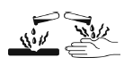 | Signal word  Danger | Hazard statement  H314 Causes severe skin burns  and eye damage

Precautionary statements
Prevention | Response | Storage | Disposal
P260  Do not breathe dusts or mists.  – if inhalable particles of dusts or mists may occur during use.  P264  Wash …thoroughly after handling.  …Manufacturer/supplier or the competent authority to specify parts of the body to be washed after handling.  P280  Wear protective gloves/protective clothing/eye protection/face protection.  Manufacturer/supplier or the competent authority may further specify type of equipment where appropriate. | P301 + P330 + P331  IF SWALLOWED: Rinse mouth. Do NOT induce vomiting.  P303 + P361 + P353  IF ON SKIN (or hair): Take off immediately all contaminated clothing. Rinse skin with water [or shower].  – text in square brackets to be included where the manufacturer/supplier or the competent authority considers it appropriate for the specific chemical.  P363  Wash contaminated clothing before reuse.  P304 + P340  IF INHALED: Remove person to fresh air and keep comfortable for breathing.  P310  Immediately call a POISON CENTER/doctor/...  …Manufacturer/supplier or the competent authority to specify the appropriate source of emergency medical advice.  P321  Specific treatment (see ... on this label)  ... Reference to supplemental first aid instruction.  Manufacturer/supplier or the competent authority may specify a cleansing agent if appropriate.  P305 + P351 + P338  IF IN EYES: Rinse cautiously with water for several minutes. Remove contact lenses, if present and easy to do. Continue rinsing. | P405  Store locked up. | P501  Dispose of contents/container to...  ... in accordance with local/regional/national/international regulations (to be specified).  Manufacturer/supplier or the competent authority to specify whether disposal requirements apply to contents, container or both.

Eye damage/irritation (Chapter 3.3)
Hazard category  2/2A | Symbol  Corrosion |  | Signal word  Warning | Hazard statement  H319 Causes serious eye irritation

Precautionary statements
Prevention | Response | Storage | Disposal
P264  Wash … thoroughly after handling.  …Manufacturer/supplier or the competent authority to specify parts of the body to be washed after handling.  P280  Wear eye protection/face protection.  Manufacturer/supplier or the competent authority may further specify type of equipment where appropriate. | P305 + P351 + P338  IF IN EYES: Rinse cautiously with water for several minutes. Remove contact lenses, if present and easy to do. Continue rinsing.  P337 + P313  If eye irritation persists: Get medical advice/attention.  Manufacturer/supplier or the competent authority to select medical advice or attention as appropriate.

Germ cell mutagenicity (Chapter 3.5)
Hazard category | Symbol |  |  | Signal word | Hazard statement
1A, 1B | Health hazard |  |  | Danger | H340 | May cause genetic defects <...>
2 | Health hazard |  |  | Warning | H341 | Suspected of causing genetic defects <...>
 |  |  |  |  | <...> (state route of exposure if it is conclusively proven that no other routes of exposure cause the hazard)
Precautionary statements
Prevention |  |  | Response |  |  |  | Storage | Disposal
P201  Obtain special instructions before use.  - omit for consumer products where P202 is used.  P202  Do not handle until all safety precautions have been read and understood.  P280  Wear protective gloves/protective clothing/eye protection/face protection/hearing protection/...  Manufacturer/supplier or the competent authority to specify the appropriate personal protective equipment. |  |  | P308 + P313  IF exposed or concerned: Get medical advice/attention.  Manufacturer/supplier or the competent authority to select medical advice or attention as appropriate. |  |  |  | P405  Store locked up. | P501  Dispose of contents/container to...  ... in accordance with local/regional/national/international regulations (to be specified).  Manufacturer/supplier or the competent authority to specify whether disposal requirements apply to contents, container or both.

Carcinogenicity (Chapter 3.6)
Hazard category | Symbol |  | Signal word | Hazard statement
1A, 1B | Health hazard |  | Danger | H350 | May cause cancer <...>
2 | Health hazard |  | Warning | H351 | Suspected of causing cancer <...>
 |  |  |  | <...> (state route of exposure if it is conclusively proven that no other routes of exposure cause the hazard)

Precautionary statements
Prevention | Response | Storage | Disposal
P201  Obtain special instructions before use.  - omit for consumer products where P202 is used.  P202  Do not handle until all safety precautions have been read and understood.  P280  Wear protective gloves/protective clothing/eye protection/face protection/hearing protection/...  Manufacturer/supplier or the competent authority to specify the appropriate personal protective equipment. | P308 + P313  IF exposed or concerned: Get medical advice/attention.  Manufacturer/supplier or the competent authority to select medical advice or attention as appropriate. | P405  Store locked up. | P501  Dispose of contents/container to...  ... in accordance with local/regional/national/international regulations (to be specified).  Manufacturer/supplier or the competent authority to specify whether disposal requirements apply to contents, container or both.

Reproductive toxicity (Chapter 3.7)
 | Hazard category | Symbol |  |  | Signal word | Hazard statement
 | 1A, 1B | Health hazard |  |  | Danger | H360 | May damage fertility or the unborn child <...> <<...>>
 | 2 | Health hazard |  |  | Warning | H361 | Suspected of damaging fertility or the unborn child <...> <<...>>
 |  |  |  |  |  | <...> (state specific effect if known)
 |  |  |  |  |  | <<...>> (state route of exposure if it is conclusively proven that no other routes of exposure cause the hazard)
Precautionary statements
Prevention |  |  |  | Response |  |  |  | Storage | Disposal
P201  Obtain special instructions before use.  - omit for consumer products where P202 is used.  P202  Do not handle until all safety precautions have been read and understood.  P280  Wear protective gloves/protective clothing/eye protection/face protection/hearing protection/...  Manufacturer/supplier or the competent authority to specify the appropriate personal protective equipment. |  |  |  | P308 + P313  IF exposed or concerned: Get medical advice/attention.  Manufacturer/supplier or the competent authority to select medical advice or attention as appropriate. |  |  |  | P405  Store locked up. | P501  Dispose of contents/container to...  ... in accordance with local/regional/national/international regulations (to be specified).  Manufacturer/supplier or the competent authority to specify whether disposal requirements apply to contents, container or both.

