|  |  |  |  |
| --- | --- | --- | --- |
|  | United Nations | ECE/TRANS/WP.11/2018/6 | |
| _unlogo | **Economic and Social Council** | | Distr.: General  29 June 2018  Original: English |

**Economic Commission for Europe**

Inland Transport Committee

**Working Party on the Transport of Perishable Foodstuffs**

**Seventy-fourth session**

Geneva, 8-12 October 2018

Item 7 of the provisional agenda

**ATP Handbook**

ATP Handbook: Annex 1, Appendix 2, paragraph 1.2

Transmitted by the governments of Germany and United Kingdom

Introduction

1. At the seventy-first session of WP.11 the United Kingdom submitted a revised proposal to harmonise the external surface area measurements of panel vans and test reports (ECE/TRANS/WP.11/2015/2), this was adopted.

2. At last year’s seventy-third session of WP.11 the proposal was published in the latest ATP agreement dated 6 January 2018. Subsequently at the latest CERTE meeting in Germany it was noted that the equations were different compared to the CEN standard, these corrections to the equations are to harmonise the ATP and CEN standards.

3. Germany and the United Kingdom propose to amend the figures in paragraph 1.2 in the ATP handbook with the following:

Original Text

**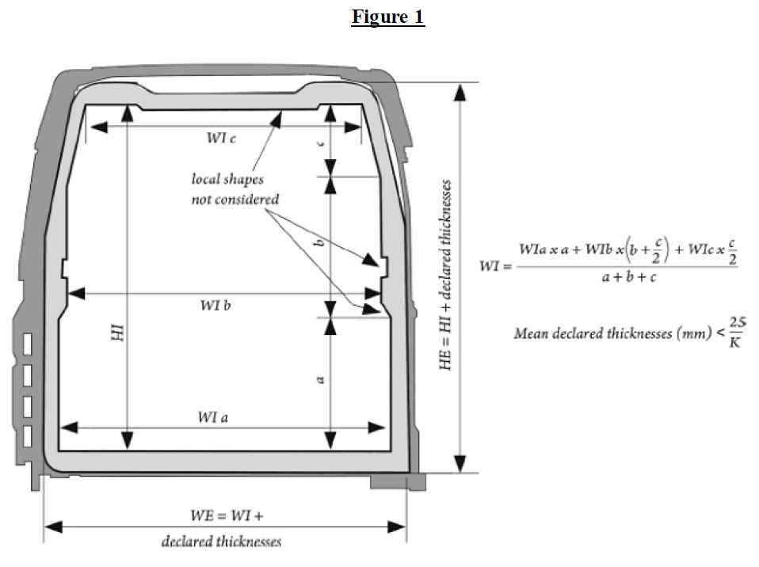**

**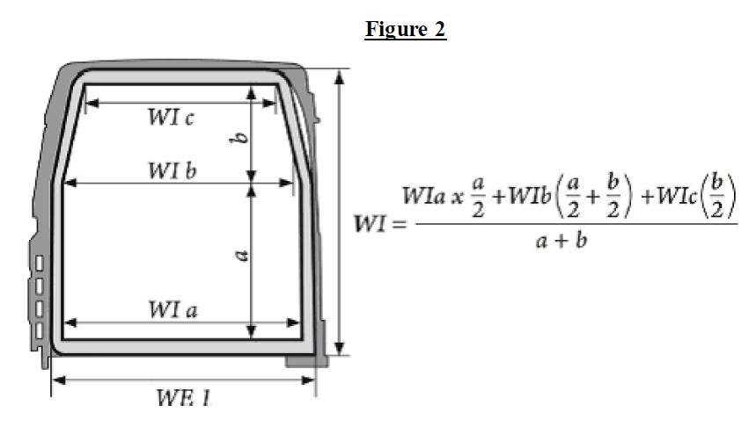**

**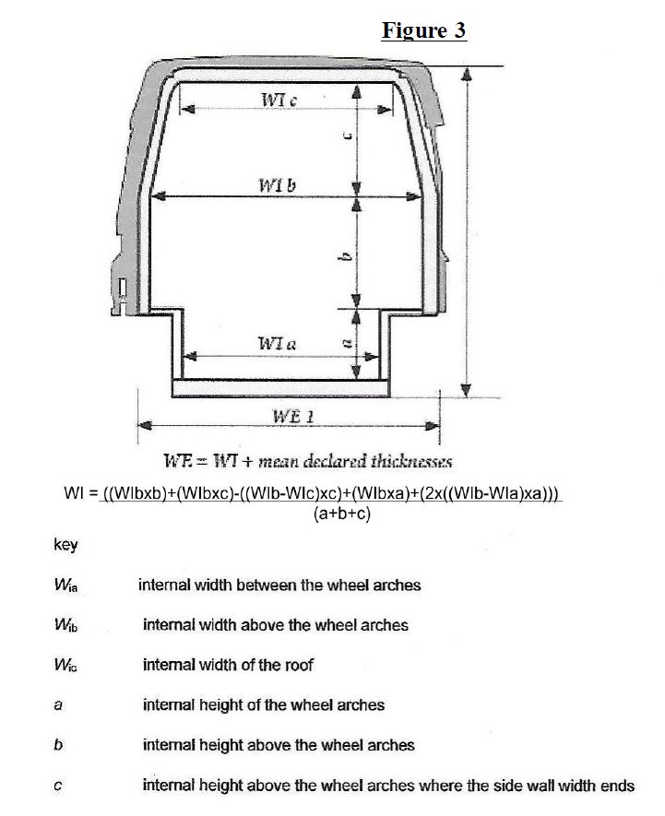**

**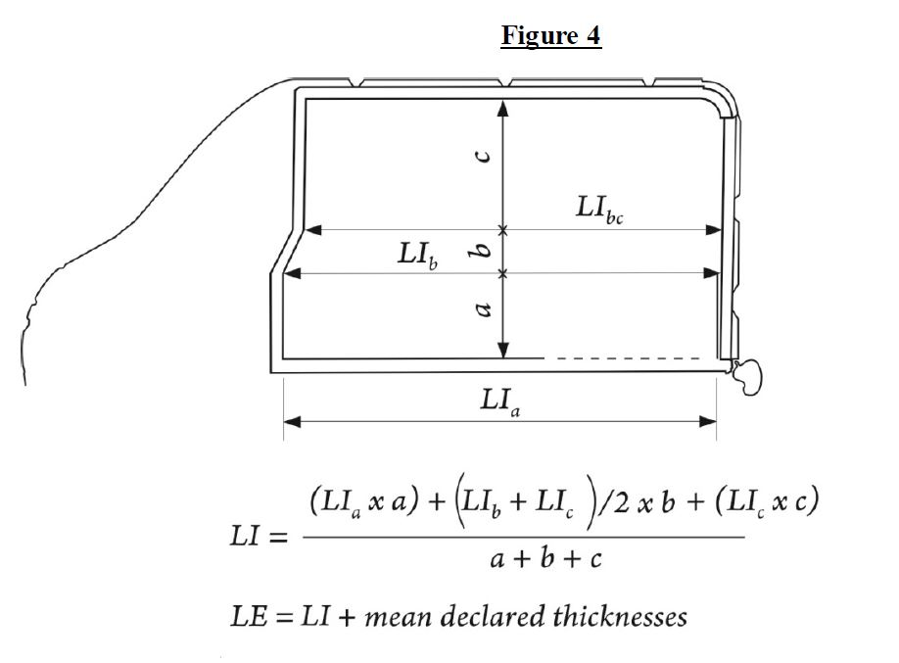**

*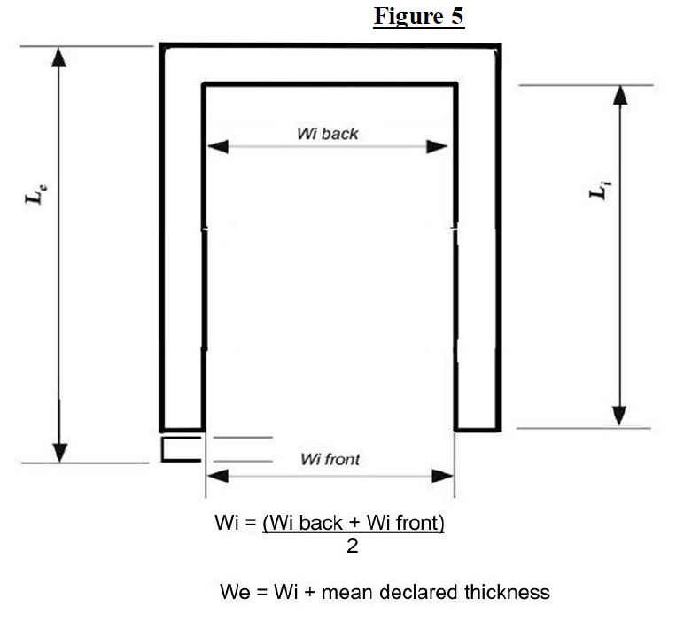*

Proposed amendment

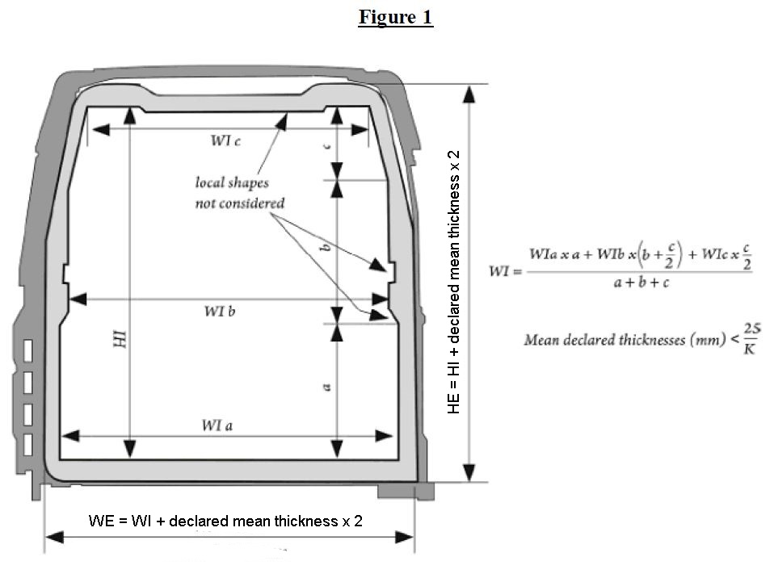

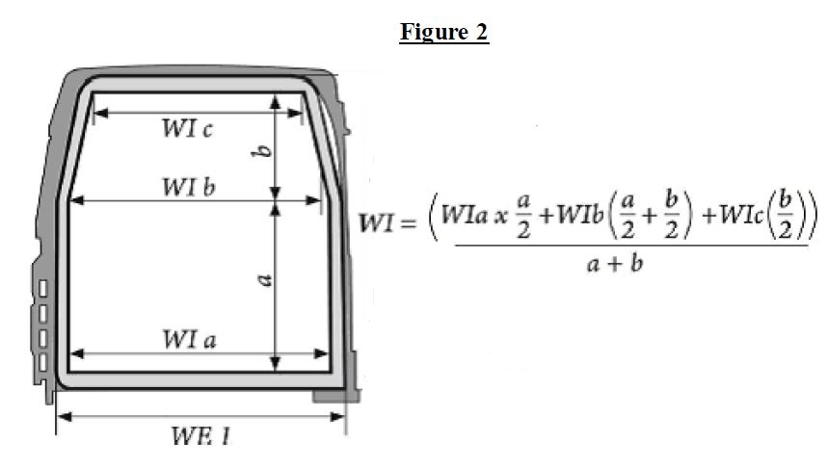

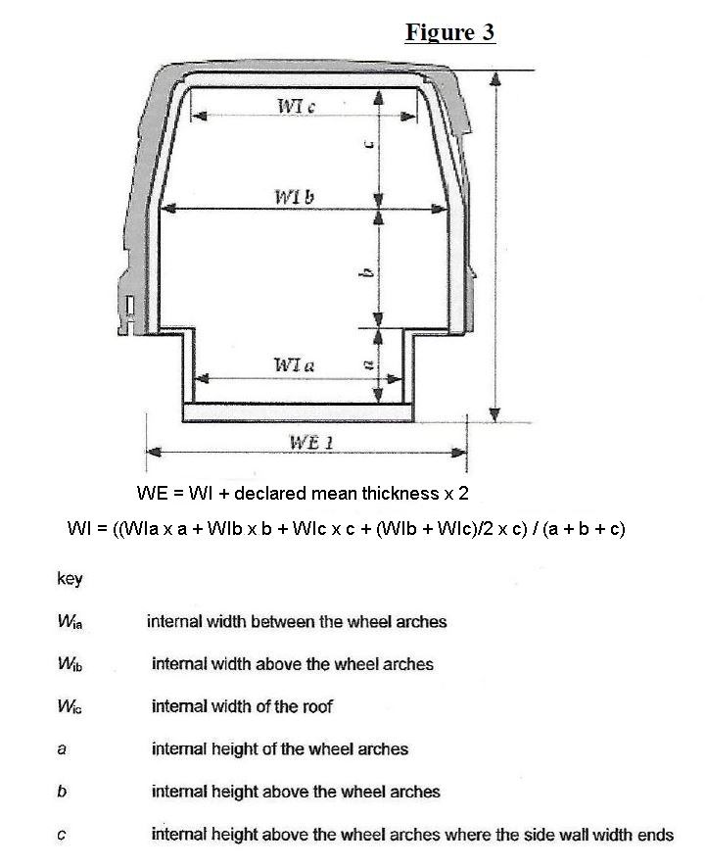



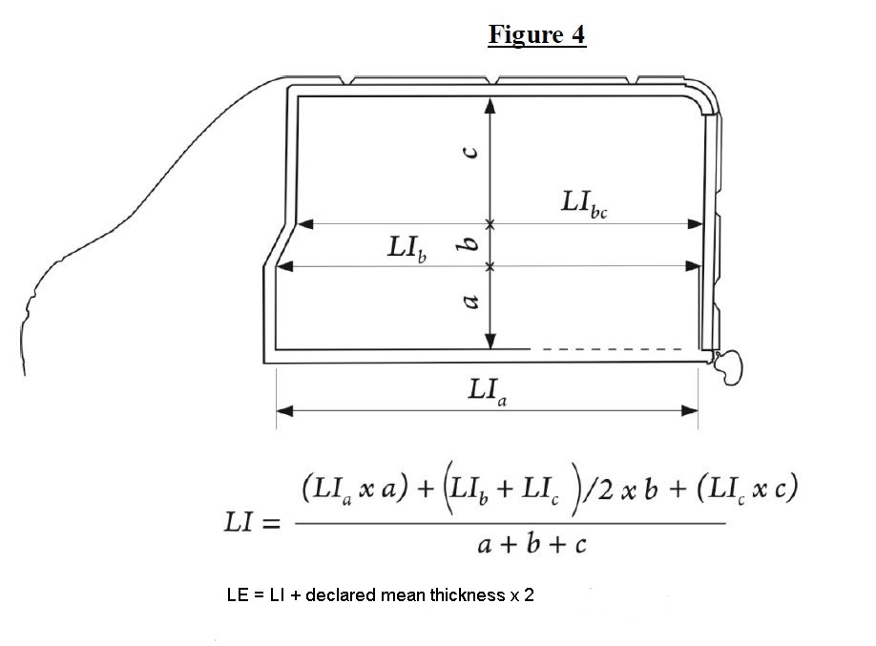

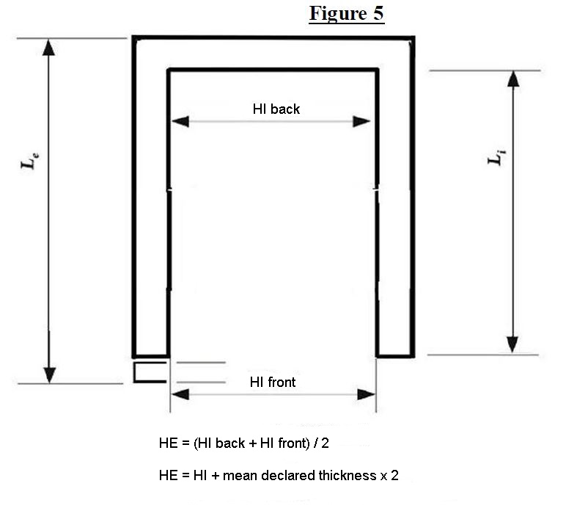

WI back

WI front

$$WI= \frac{WI back+WI front}{2}$$

WE = WI + mean declared thickness x 2

Impact

4. There would be no financial impact to industry.