|  |  |  |  |
| --- | --- | --- | --- |
|  | United Nations | ECE/TRANS/WP.29/2018/42 | |
| _unlogo | **Economic and Social Council** | | Distr.: General  9 April 2018  Original: English |

**Economic Commission for Europe**

Inland Transport Committee

**World Forum for Harmonization of Vehicle Regulations**

**175th session**

Geneva, 19-22 June 2018

Item 4.6.6 of the provisional agenda

**1958 Agreement:  
Consideration of draft amendments**

**to existing UN Regulations submitted by GRSP**

Proposal for Supplement 3 to the 02 series of amendments to UN Regulation No. 129 (Enhanced Child Restraint Systems)

**Submitted by the Working Party on Passive Safety**[[1]](#footnote-2)\*

The text reproduced below was adopted by the Working Party on Passive Safety (GRSP) at its sixty-second session (ECE/TRANS/WP.29/GRSP/62, paras. 29, 31 and 32). It is based on ECE/TRANS/WP.29/GRSP/2017/29, not amended, ECE/TRANS/WP.29/GRSP/2017/36, not amended and on GRSP-62-23 as reproduced in Annex VII to the report. It is submitted to the World Forum for Harmonization of Vehicle Regulations (WP.29) and to the Administrative Committee AC.1 for consideration at their June 2018 sessions.

Supplement 3 to the 02 series of amendments to UN Regulation No. 129 (Enhanced Child Restraint Systems)

*Paragraph 6.2.1.6*., amend to read:

"6.2.1.6. For i-Size or specific vehicle booster seats, the lap portion of the adult safety-belt shall be positively guided to ensure that the loads transmitted by the adult lap belt are transmitted through the pelvis. The shoulder portion of the adult safety belt shall be positively guided to ensure that the child torso and neck do not escape.

During the dynamic tests, the standard safety-belt used to install a non-integral Enhanced Child Restraint System, shall not become disengaged from any guide or locking device utilized for the test conducted; however, for the shoulder portion of the standard safety-belt this shall be judged up to the moment that the maximum horizontal head excursion of the dummy is reached."

*Paragraph 6.3.1.1.,* amend to read:

"6.3.1.1. The Enhanced Child Restraint System manufacturer shall declare in writing that the toxicity of materials used in the manufacture of restraint systems and accessible to the restrained child is in conformity with the relevant parts of EN 71-3:2013+A1:2014 (paragraph 4.2., Table 2, Category III for specific requirements and paragraph 7.3.3. for test methodology). Tests confirming the validity of the declaration may be carried out at the discretion of the Technical Service**.** This paragraph does not apply to Non-integral ECRS with a stature range starting at 100 cm or above."

*Paragraph 7.2.8.,* amend to read:

"7.2.8. The complete seat, or the component fitted with ISOFIX attachments (e.g. ISOFIX base) if it has a release button, is attached rigidly to a test rig in such a way that ISOFIX connectors are aligned as shown in Figure 3. A 6 mm diameter bar, 350 mm long, shall be attached to the ISOFIX connectors. A force of 50 ± 1 N shall be applied to the extremities of the bar."

*Figure 3*, amend to read:

"Figure 3

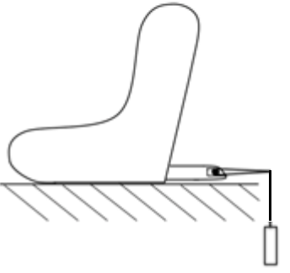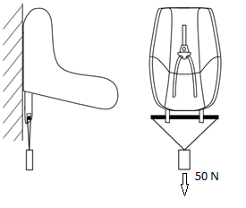

"

1. \* In accordance with the programme of work of the Inland Transport Committee for 2018–2019 (ECE/TRANS/274, para. 123 and ECE/TRANS/2018/21/ Add.1, cluster 3.1), the World Forum will develop, harmonize and update UN Regulations in order to enhance the performance of vehicles. The present document is submitted in conformity with that mandate. [↑](#footnote-ref-2)