|  |  |  |  |
| --- | --- | --- | --- |
|  | United Nations | ECE/TRANS/WP.29/2018/156 | |
| Description: _unlogo | **Economic and Social Council** | | Distr.: General  22 August 2018  Original: English |

**Economic Commission for Europe**

Inland Transport Committee

**World Forum for Harmonization of Vehicle Regulations**

**176th session**

Geneva, 13-16 November 2018

Item 4.10.5 of the provisional agenda

**1958 Agreement:  
Consideration of draft corrigenda to existing   
UN Regulations submitted by GRs, if any**

Proposal for Corrigendum 2 to Revision 5 to UN Regulation No. 14 (Safety-belt anchorages)

Submitted by the Working Party on Passive Safety[[1]](#footnote-2)\*

The text reproduced below was adopted by the Working Party on Passive Safety (GRSP) at its sixty-third session (ECE/TRANS/WP.29/GRSP/63, para. 15). It is based on on ECE/TRANS/WP.29/GRSP/2018/12, as reproduced in Annex IV to the report. It is submitted to the World Forum for Harmonization of Vehicle Regulations (WP.29) and to the Administrative Committee AC.1 for consideration at their November 2018 sessions.

Corrigendum 2 to Revision 5 to UN Regulation No. 14 (Safety-belt anchorages)

*Annex 5,*

*Figure 1,* correct to read:

"

All dimensions in millimetres (mm)"

**510**

*Figure 1a,* correct to read:

"

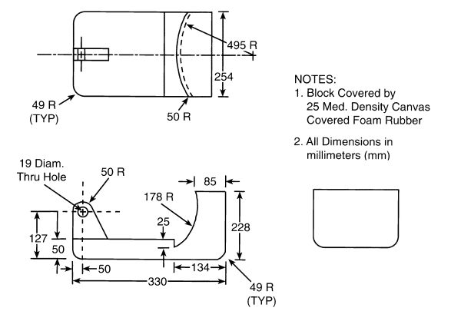 "

1. \* In accordance with the programme of work of the Inland Transport Committee for 2018–2019 (ECE/TRANS/274, para. 123 and ECE/TRANS/2018/21/Add.1, cluster 3.1), the World Forum will develop, harmonize and update UN Regulations in order to enhance the performance of vehicles. The present document is submitted in conformity with that mandate. [↑](#footnote-ref-2)