|  |  |  |  |
| --- | --- | --- | --- |
|  | United Nations | ECE/TRANS/WP.29/GRE/2018/27 | |
| _unlogo | **Economic and Social Council** | | Distr.: General  21 February 2018  Original: English |

**Economic Commission for Europe**

Inland Transport Committee

**World Forum for Harmonization of Vehicle Regulations**

**Working Party on Lighting and Light-Signalling**

**Seventy-ninth session**

Geneva, 24-27 April 2018

Item 7 (b) of the provisional agenda

**Other Regulations:**

**Regulation No. 50 (Position, stop, direction indicator lamps for mopeds and motorcycles)**

Proposal for a new Supplement to the 01 series of amendments to Regulation No. 50

Submitted by the expert from the International Motorcycle Manufacturers Association (IMMA)[[1]](#footnote-2)\*, [[2]](#footnote-3)\*\*

The text reproduced below was prepared by the expert from IMMA with the aim to propose amendments to Regulation No. 50 regarding inward geometric visibility requirements for rear position lamps. The modifications to the existing text of the Regulation No. 50 are marked in bold for new or strikethrough for deleted characters.

**I. Proposal**

*Annex 1,*

*Paragraphs 1. and 2.,* amendto read:

"1. Front position lamps

**1.1. Front position lamps (not paired)**

**1.1.1.** V = +15° / -10°

**1.1.2.** However, in the case where a device is intended to be installed with its H plane at a mounting height less than 750 mm above the ground, the angle of 10° below the horizontal may be reduced to 5°.

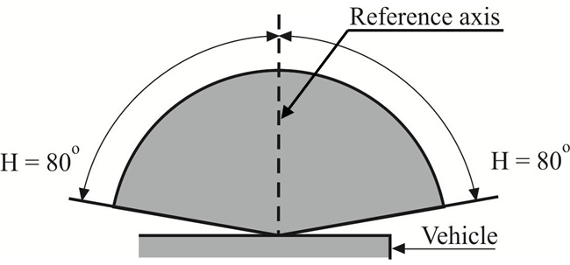

**1.2.** Front position lamps (for a pair of lamps)

**1.2.1.** V = +15° / -10°

**1.2.2.** However, in the case where a device is intended to be installed with its H plane at a mounting height less than 750 mm above the ground, the angle of 10° below the horizontal may be reduced to 5°.

**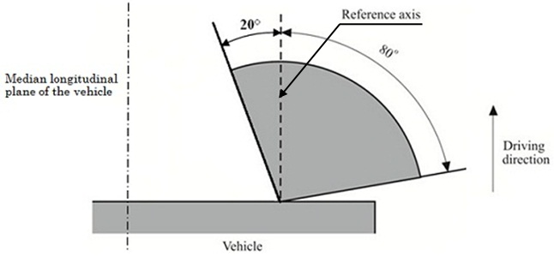**

2. Rear position lamps

**2.1. Rear position lamps (not paired)**

**2.1.1.** V = +15° / -10°

**2.1.2.** However, in the case where a device is intended to be installed with its H plane at a mounting height less than 750 mm above the ground, the angle of 10° below the horizontal may be reduced to 5°.

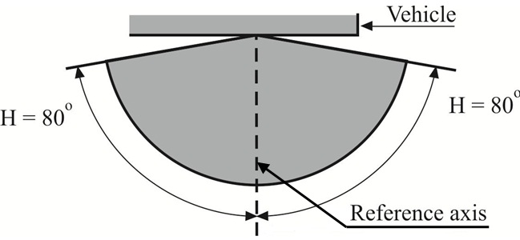

**2.2.** Rear position lamps (for a pair of lamps)

**2.2.1.** V = +15° / -10°

**2.2.2.** However, in the case where a device is intended to be installed with its H plane at a mounting height less than 750 mm above the ground, the angle of 10° below the horizontal may be reduced to 5°.

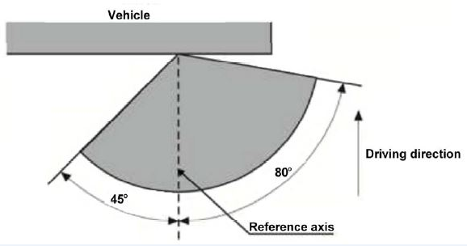[[3]](#footnote-4)\*\*

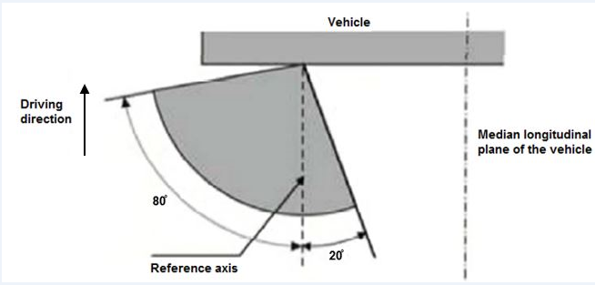

~~However, in the case where a device is intended to be installed with its H plane at a mounting height less than 750 mm above the ground, the inward angle of 45° may be reduced to 20° under the H plane.~~"

II. Justification

1. This proposal aims to align the angle of visibility requirements of rear position lamps with the angle of visibility requirements of front position lamps, leading to the following:

(a) Inward angle (or the angle towards the median longitudinal plane of the vehicle) of 20° (and not of 45°); see the above angles in red.

(b) Last sentence of paragraph 2 shall be deleted.

1. The last picture could be changed as follows:

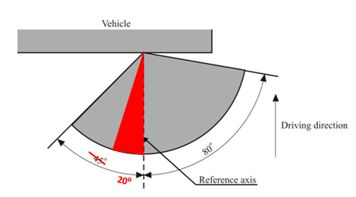

or, symmetrically, as follows:



1. This proposal is linked to a corresponding proposal on Regulation No. 53 (ECE/TRANS/WP.29/GRE/2018/28).

1. \* This document was submitted after the official deadline due to the late arrival of the original author's proposal. [↑](#footnote-ref-2)
2. \*\* In accordance with the programme of work of the Inland Transport Committee for 2014–2018 (ECE/TRANS/240, para. 105 and ECE/TRANS/2014/26, programme activity 02.4), the World Forum will develop, harmonize and update Regulations in order to enhance the performance of vehicles. The present document is submitted in conformity with that mandate. [↑](#footnote-ref-3)
3. \*\* Picture deleted. [↑](#footnote-ref-4)