|  |  |  |  |
| --- | --- | --- | --- |
|  | United Nations | ECE/TRANS/WP.29/GRSP/2018/9 | |
| _unlogo | **Economic and Social Council** | | Distr.: General  28 February 2018  Original: English |

**Economic Commission for Europe**

Inland Transport Committee

**World Forum for Harmonization of Vehicle Regulations**

**Working Party on Passive Safety**

**Sixty-third session**

Geneva, 14-18 May 2018

Item 24 of the provisional agenda

**Collective amendments to UN Regulations Nos. 16, 44, 94, 129 and 137**

Collective amendments to UN Regulations Nos. 16, 94 and 137

Submitted by the expert from the International Organization of Motor Vehicle Manufacturers[[1]](#footnote-2)\*

The text reproduced below has been prepared by the expert from International Organization of Motor Vehicle Manufacturers (OICA) to harmonize information in the airbag warning label about the correct installation of Child Restraint Systems (CRS) on a passenger seat with an activated frontal airbag. It represents an alternative proposal to ECE/TRANS/WP29/GRSP/2017/27 submitted by the European Commission regarding UN Regulations Nos. 16, 94 and 137. It does not address the proposed amendments to UN Regulation Nos. 44 and 129, to which OICA has no comments. It is based on informal document GRSP-62-14 distributed during the sixty-second session of the Working Party on Passive Safety (GRSP) (ECE/TRANS/WP.29/GRSP/62, para. 41). The modifications to the current text of the Regulation and to the proposal are marked in bold for new or strikethrough for deleted characters.

I. Proposal for the 08 series of amendments to UN Regulation No. 16 (Safety-belts)

*Insert new paragraphs 8.1.8. and 8.1.8.1.*, to read:

"**8.1.8. The vehicle shall carry information to the effect that it is equipped with airbags for seats."**

**8.1.8.1. For a vehicle fitted with an airbag assembly intended to protect the driver, this information shall consist of the inscription "AIRBAG" located in the interior of the circumference of the steering wheel; this inscription shall be durably affixed and easily visible.**"

*Paragraph 8.1.8. (former)*, renumber as paragraph 8.1.8.2 and amend to read:

"8.1.8.2. Every passenger seating position which is fitted with a frontal protection airbag shall be provided with a warning against the use of a rearward-facing child restraint in that seating position. ~~As a minimum,~~ This information shall consist of a label containing clear warning pictograms as indicated below:

**Figure 1  
Warning label**

…

The overall dimensions **of the label** shall be at least 120 x 60 mm or the equivalent area.

The label ~~shown above~~ may be adapted in such a way that the layout differs from the example **shown here** ~~above~~; however, the content shall meet the **precise** ~~above~~ prescriptions. **Furthermore, no other type of information shall be included on the label unless it is placed outside a clearly marked rectangle with at least the overall dimensions as required above. In derogation to the aforementioned, a part number, bar code or similar identification mark not exceeding 8 mm x 35 mm or the equivalent area may be placed on the label.**

**It shall also be ensured that no deviations in the shape and orientation of the provided pictograms are permitted, notably that any customised appearance of the prescribed pictogram images shall be prohibited, with the exception of the hand with the pointing index finger and the open face booklet with letter 'i' on its right page provided that they are clearly recognisable as such.**

**Small irregularities concerning line thickness, label imprinting and other relevant production tolerances shall be accepted.**

**Figure 2  
Pictogram according to ISO 2575:2004 - Z.01 that shall be used and that shall have an outer diameter of at least 38 mm**

****

**Figure 3**

**Pictogram depicting airbag deployment danger that shall be used and that shall measure 40 mm in width and 28 mm in height or proportionally larger.**



"

*Paragraph 8.1.9.(former)*, renumber as paragraph 8.1.8.3. and amend to read:

"8.1.8.3. In the case of a frontal protection airbag in the front passenger seat, the warning shall be durably affixed ….of the vehicle.

If the vehicle does not have … at all times.

In the case of a frontal protection airbag for other seats … on that seat. The requirements of this paragraph and paragraph ~~8.1.8..~~ **8.1.8.2.** do not apply to those seating positions equipped with a device which automatically deactivates the frontal protection airbag assembly when any rearward facing child restraint is installed.

*Paragraph 8.1.10. (former)*, renumber as paragraph 8.1.8.4.

*Paragraph 8.1.11. (former)*, renumber as paragraph 8.1.9.

*Insert new paragraphs 15.11. to 15.11.6.*, to read:

"**15.11. As from the official date of entry into force of the 08 series of amendments, no Contracting Party applying this UN Regulation shall refuse to grant or refuse to accept UN type approvals under this UN Regulation as amended by the 08 series of amendments.**

**15.11.1. As from 1 September 2020, Contracting Parties applying this UN Regulation shall not be obliged to accept UN type-approvals to the preceding series of amendments that were first issued on or after 1 September 2020.**

**15.11.2. Until 1 September 2022, Contracting Parties applying this UN Regulation shall accept UN type-approvals to the preceding series of amendments that were first issued before 1 September 2020.**

**15.11.3. As from 1 September 2022, Contracting Parties applying this Regulation shall not be obliged to accept type-approvals issued to the preceding series of amendments to this Regulation.**

**15.11.4. Notwithstanding paragraph 15.11.3., Contracting Parties applying the UN Regulation shall continue to accept UN type-approvals of safety-belts and restraint systems to the preceding series of amendments to the UN Regulation.**

**15.11.5. Notwithstanding paragraph 15.11.3., Contracting Parties applying the UN Regulation shall continue to accept UN type-approvals to the preceding series of amendments to the UN Regulation, for vehicles which are not affected by the changes introduced by the 08 series of amendments.**

**15.11.6. Contracting Parties applying this UN Regulation shall not refuse to grant UN type-approvals according to any preceding series of amendments to this UN Regulation or extensions thereof.**"

*Annex 2*, amend to read:

"Annex 2

Arrangements of the approval marks

1. Arrangements of the vehicle approval marks concerning the installation of safety-belts

# Model A

# (See paragraph 5.2.4. of this Regulation)

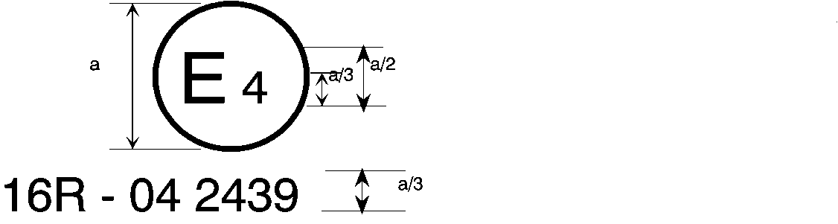

0**8** 2439

a = 8 mm min.

The above approval mark affixed to a vehicle shows that the vehicle type concerned has, with regard to safety-belts, been approved in the Netherlands (E4) pursuant to **UN** Regulation No. 16. The approval number indicates that the approval was granted according to the requirements of **UN** Regulation No. 16 as amended by the 0**8** series of amendments.

# Model B

# (See paragraph 5.2.5. of this Regulation)

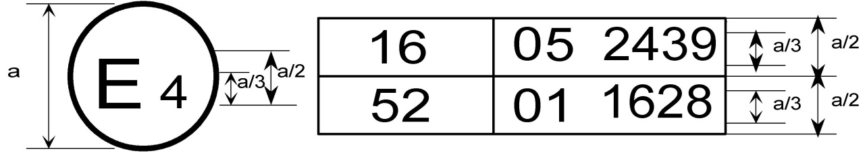

0**8**  2439

a = 8 mm min.

The above approval mark affixed to a vehicle shows that the vehicle type concerned has been approved in the Netherlands (E4) pursuant to **UN** Regulations Nos. 16 and 52[[2]](#footnote-3)F The approval numbers indicate that, at the dates when the respective approvals were given, **UN** Regulation No. 16 included the 0**8** series of amendments and **UN** Regulation No. 52 the 01 series of amendments.

2. Arrangements of the safety-belt approval marks (See paragraph 5.3.5. of this Regulation)



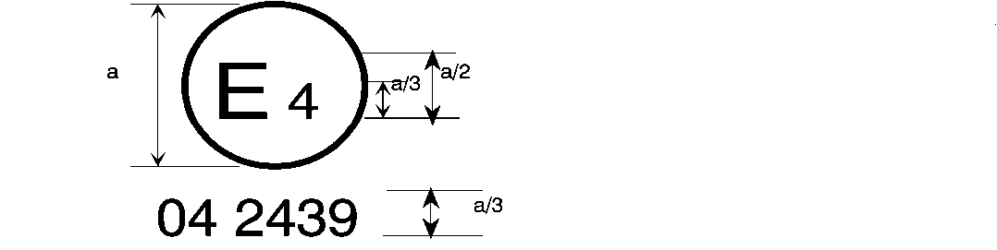

0**8** 2439

a = 8 mm min.

The belt bearing the above approval mark is a three-point belt ("A"), fitted with an energy absorber ("e") and approved in the Netherlands (E4) under the number 0**8**2439, the Regulation already incorporating the 0**8** series of amendments at the time of approval.

###### B → 4 m



0**8** 2489

The belt bearing the above approval mark is a lap belt ("B"), fitted with a retractor, type 4, with multiple sensitivity (m) and approved in the Netherlands (E4) under the number 0**8**2489, the Regulation already incorporating the 0**8** series of amendments at the time of approval.

*Note:* The approval number and additional symbol(s) must be placed close to the circle and either above or below the "E" or to left or right of that letter. The digits of the approval number must be on the same side of the "E" and orientated in the same direction. The additional symbol(s) must be diametrically opposite the approval number. The use of roman numerals as approval numbers should be avoided so as to prevent any confusion with other symbols.

0**8** 22439

The belt bearing the above approval mark is a special type belt ("S"), fitted with an energy absorber ("e") and approved in the Netherlands (E4) under the number 0**8**22439, the Regulation already incorporating the 0**8** series of amendments at the time of approval.

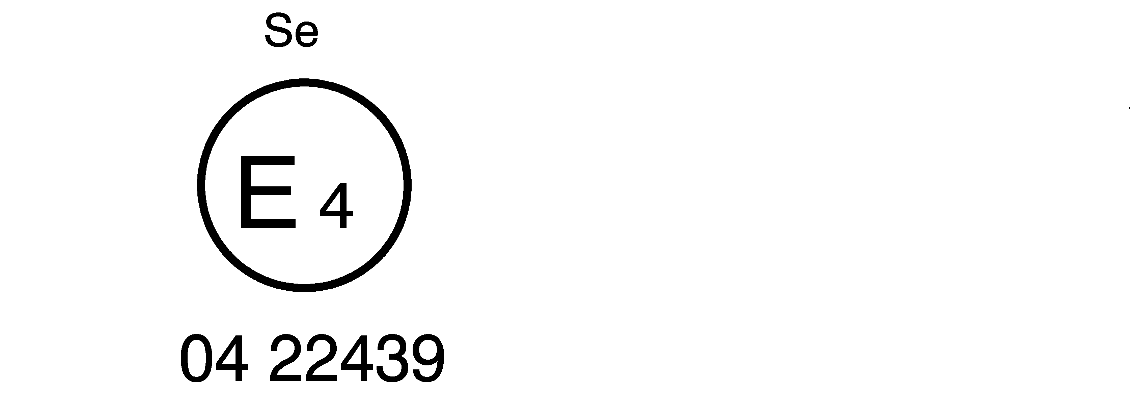

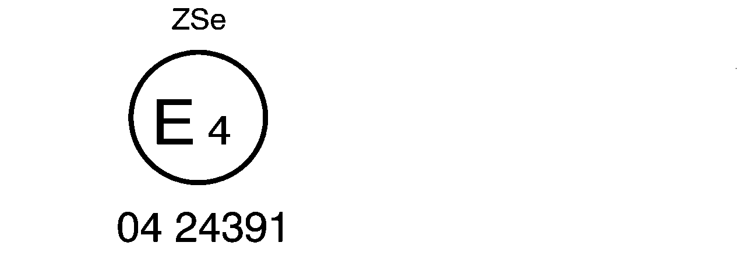

0**8** 24391

The belt bearing the above approval mark is part of a restraint system ("Z"), it is a special type belt ("S") fitted with an energy absorber ("e"). It has been approved in the Netherlands (E4) under the number 0**8**24391, the Regulation already incorporating the 0**8** series of amendments at the time of approval.



a ≥ 8 mm

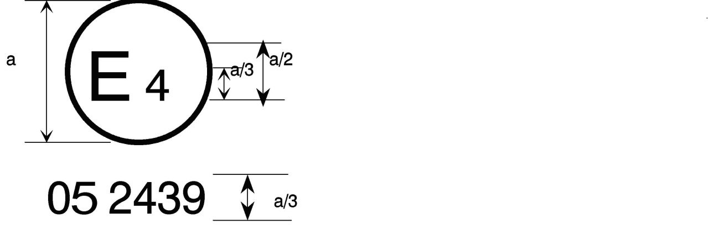 a = 8 mm min.

0**8** 2439



The belt bearing this type-approval mark is a three-point belt ("A") with a multiple-sensitivity ("m") type 4N ("r4N") retractor, in respect of which type-approval was granted in the Netherlands ("E4") under number 0**8**2439, the Regulation already incorporating the 0**8** series of amendments at the time of approval. This belt shall not be fitted to vehicles of category M1.

**Aer4m**

**E4**

**082439**

**AIRBAG**

The safety-belt bearing this type-approval mark is a three-point belt ("A") fitted with an energy absorber ("e"), approved as meeting the specific requirements of paragraph 6.4.1.3.3. of this Regulation, and with a multiple-sensitivity ("m") type 4 ("r4") retractor, in respect of which type approval was granted in the Netherlands ("E4") under the approval number 0**8**2439. The first two digits indicate that the Regulation already incorporated the 0**8** series of amendments at the time of the approval. This safety-belt has to be fitted to a vehicle equipped with an airbag in the given seating position."

II. Proposal for Supplement 6 to the 01 series of Amendments, Supplement 7 to the 02 series of Amendments and Supplement 1 to the 03 series of Amendments to UN Regulation No. 94 (Frontal collision)

*Paragraphs 6. to 6.2.3*., shall be deleted

*Paragraph 7. (former),* renumber as paragraph 8., including the sub-paragraphs

*Paragraph 8. (former),* renumber as paragraph 9. and amend to read:

"9. Conformity of production

The conformity of production procedures shall comply with those set out in the Agreement, ~~Appendix 2~~ (**Schedule** **1** E/ECE/TRANS/505/Rev.**3**), with the following requirements: …"

*Paragraphs 8.1. to 12. (former)*, renumber as paragraphs 9.1. to 13.

III. Proposal for Supplement 2 to the original series of Amendments and Supplement 2 to the 01 series of Amendments to UN Regulation No. 137 (Frontal collision with focus on restraint systems)

*Paragraphs 6. to 6.2.3*., shall be deleted

*Paragraphs 7. to 7.3.(former),* renumber as paragraphs 8. to 8.3.

*Paragraph 8. (former),* renumber as paragraph 9. and amend to read:

"9. Conformity of production

The conformity of production procedures shall comply with those set out in the Agreement, ~~Appendix 2~~ (**Schedule** **1** E/ECE/TRANS/505/Rev.**3**), with the following requirements: …"

*Paragraphs 8.1. (former) to 12.*, renumber as paragraphs 9.1. to 13., including their sub-paragraphs

IV. Justification

1. As a counterproposal to document ECE/TRANS/WP29/GRSP/2017/27 submitted by the expert from EC, OICA suggests to regroup all the airbag warning requirements in one single UN Regulation (i.e. UN Regulation No. 16); this would avoid future administrative burden when these may need adaptation. Another solution could be to simply refer, in UN Regulation Nos. 94 and 137, to the label defined in UN Regulation No. 16; OICA suggests that GRSP discuss the most suitable approach.

2. In addition, OICA agrees with the EC proposal to better define the required label, in order to avoid potential misinterpretations. However, when it comes to the printing of the user information in a multitude of languages, OICA considers this is an unnecessary burden, with no benefit to the user. User manuals are placed in the vehicles at the point of sale and therefore in the local language(s); in the not so frequent cases whereby a vehicle, during its lifetime, ends up in a different country/language, the user will always be able to obtain the manual in their own language, if he so asks.

3. OICA consequently proposes not to amend the current requirements on the issue of languages.

1. \* In accordance with the programme of work of the Inland Transport Committee for 2014–2018 (ECE/TRANS/240, para. 105 and ECE/TRANS/2014/26, programme activity 02.4), the World Forum will develop, harmonize and update UN Regulations in order to enhance the performance of vehicles. The present document is submitted in conformity with that mandate. [↑](#footnote-ref-2)
2. The second number is given merely as an example. [↑](#footnote-ref-3)