Proposal for amendments to Regulation No. 17 (Seats, Anchorages, Head Restraints)
Submitted by the expert from Germany*
The text reproduced below has been prepared by the expert from Germany. The modifications to the current text of the Regulation are marked in bold for new or strikethrough for deleted characters.

This document supersedes Informal document GRSP-63-24

I. Proposal
Scope, amend to read:
"This Regulation applies to:

(a) Vehicles of categories M1 and N ¹⁾ with regard to the strength of seats and their anchorages and with regard to their head restraints;

(b) Vehicles of categories M2 and M3 ¹⁾ with regard to seats not covered by
Regulation No. 80, in respect of the strength of seats and their anchorages, and in respect of their head restraints;

(c) Vehicles of category M1 with regard to the design of the rear parts of seat backs and the design of devices intended to protect the occupants from the danger resulting from the displacement of luggage in a frontal impact.

It does not apply to vehicles with regard to side-facing or rearward-facing seats, or to any head restraint fitted to these seats, with the exception vehicles of category M2 and M3 of classes A and I, subject to the provisions of Paragraph 5.1.1.

It may be applied, on the request of the manufacturer, with regard to side-facing seats to vehicles of category M2 and M3 of classes A and I, subject to the provisions of Paragraph 5.1.1."

II. Justification
At the time when the installation of side facing seats in the classes M2 (of class II, III and B) and M3 (of class II, III and B) with the exception of vehicles of category M3 (of class II, III and B) of a technically permissible maximum laden mass exceeding 10 tonnes and the relevant requirements for this exception were introduced it was and still is common practise to provide vehicles of Class I and A with side facing seats according to UN-Regulation No. 17 Par. 5.3 as UN-Regulation No. 17 is applied solely to those seats in buses which are not covered by UN-Regulation No. 80.
It was never intended to prohibit side-facing seats in Class I and A.
The proposal aims at clarifying the wording to ensure the possibility to apply UN-Regulation No. 17 for the purposes of European Whole Type Approval as doubts have appeared whether the wording would prohibit the installation.

Attached some explanatory photos

Standard Class-I Vehicle

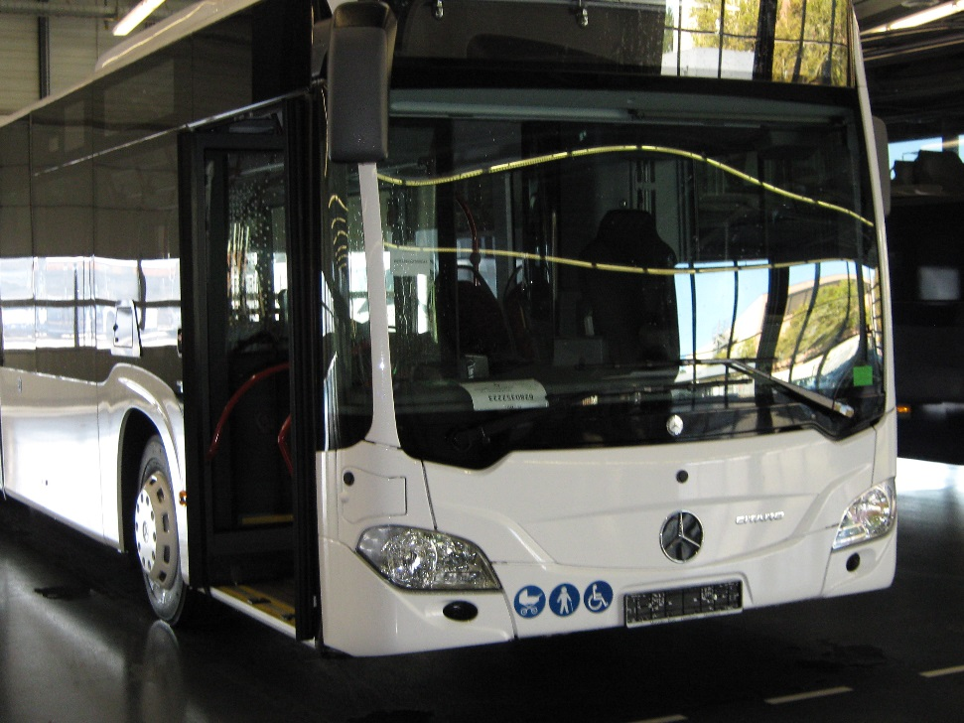

Low floor entrance

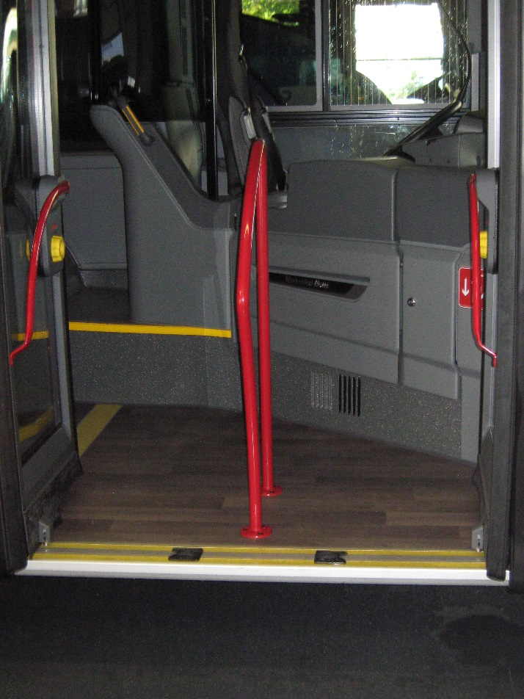

Severaal seat arrangemnts with side-facing seats

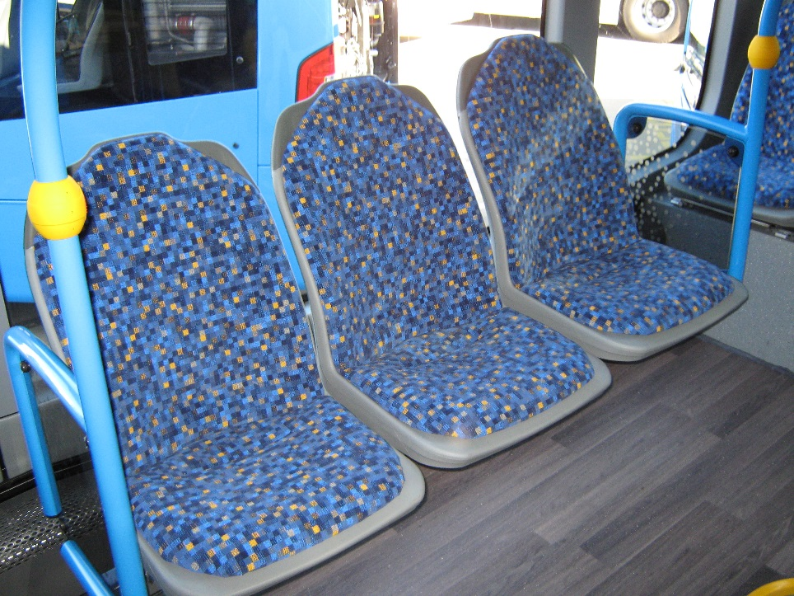

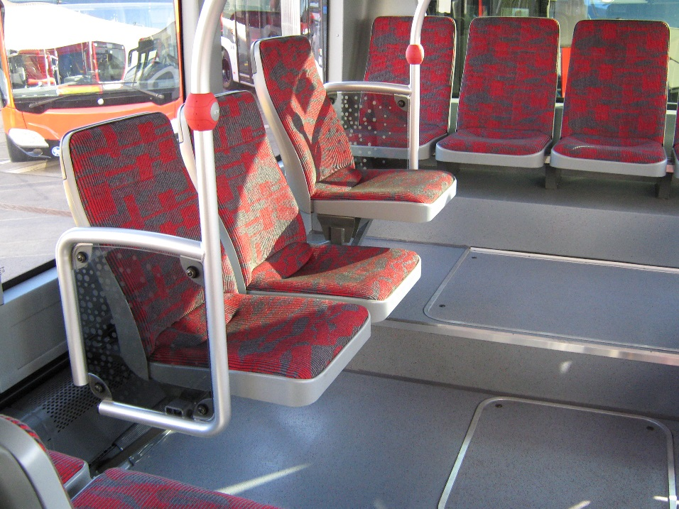

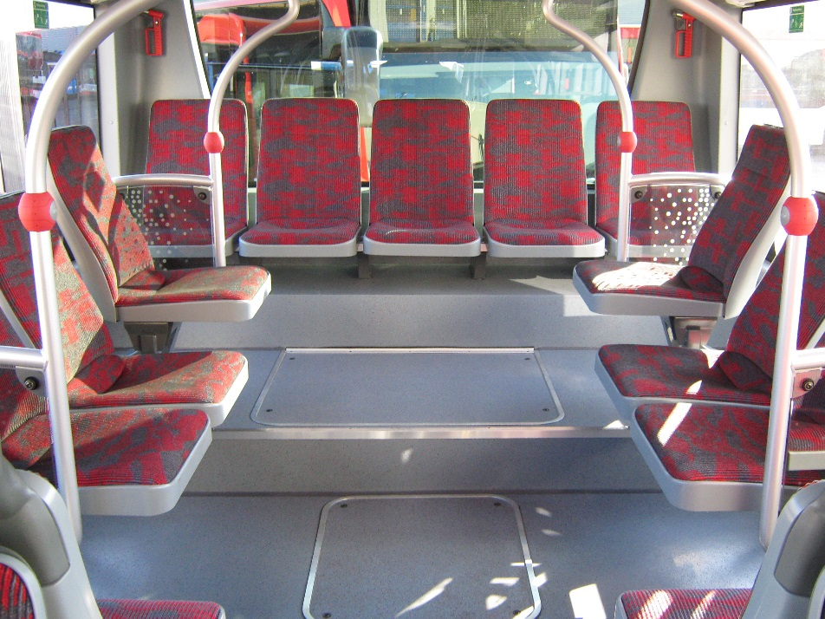

Folding seats

