|  |  |  |  |
| --- | --- | --- | --- |
|  | United Nations | ECE/TRANS/WP.29/GRVA/2020/8 | |
| _unlogo | **Economic and Social Council** | | Distr.: General  29 November 2019  Original: English |

**Economic Commission for Europe**

Inland Transport Committee

**World Forum for Harmonization of Vehicle Regulations**

**Working Party on Automated/Autonomous and Connected Vehicles**[[1]](#footnote-2)\*

**Fifth session**

Geneva, 10-14 February 2020

Item 6 (a) of the provisional agenda

**UN Regulation No. 79:  
Automatically Commanded Steering Function**

Proposal for a Supplement to the 03 series of amendments to UN Regulation No. 79 (Steering equipment)

Submitted by the expert from the European Association for Electromobility [[2]](#footnote-3)\*\*

The text reproduced below was prepared by the expert from the European Association for Electromobility (AVERE) introducing an amendment to UN Regulation No. 79. It is aimed at clarifying the text of the Regulation. It is based on ECE/TRANS/WP29/GRVA/2019/27. The modifications to the existing text of the Regulation are marked in bold for new and strikethrough for deleted characters.

I. Proposal

*Paragraph 5.6.4.6.4,* amend to read:

“5.6.4.6.4. The lateral movement of the vehicle towards the intended lane shall not start earlier than 1 second after the start of the lane change procedure. Additionally, the lateral movement to approach the lane marking and the lateral movement necessary to complete the lane change manoeuvre, shall be completed as one continuous movement.

The lane change manoeuvre shall not be initiated before a period of 3.0 seconds and not later than **15.0** ~~5.0~~ seconds after the deliberate action of the driver described in paragraph 5.6.4.6.2. above.

**[If the ACSF function has not commenced the lane change manoeuvre 10.0 seconds after the deliberate action of the driver, the driver will be notified through an acoustic or visual warning when the manoeuvre is about to commence.]”**

*Annex 8, Paragraph 3.5.1.2.,* amend to read:

“3.5.1.2. The requirements of the test are fulfilled if:

(a) The lateral movement towards the marking does not start earlier than 1 second after the lane change procedure was initiated,

(b) The lateral movement to approach the lane marking and the lateral movement necessary to complete the lane change manoeuvre are completed as one continuous movement,

(c) The recorded lateral acceleration does not exceed 1 m/s²,

(d) The moving average over half a second of the lateral jerk does not exceed 5 m/s³,

(e) The measured time between the start of the lane change procedure and the start of the lane change manoeuvre is not less than 3.0 seconds and not more than **15.0** ~~5.0~~ seconds.

(f) The system provides information to the driver to indicate that the lane change procedure is ongoing,

(g) The lane change manoeuver is completed in less than 5 seconds for M1, N1 vehicle categories and less than 10 s for M2, M3, N2, N3 vehicle categories,

(h) ACSF of Category B1 automatically resumes after the lane change manoeuvre is completed, and

(i) The direction indicator is deactivated not before the end of the lane change manoeuvre and no later than 0.5 seconds after ACSF of Category B1 has resumed.”

*Paragraph 5.6.4.6.8.1,* amend to read:

"5.6.4.6.8.1. The lane change procedure shall be suppressed automatically by the system when at least one of the following situations occurs before the lane change manoeuvre has started:

(a) The system detects a critical situation (as defined in paragraph 5.6.4.7.);

(b) The system is overridden or switched off by the driver;

(c) The system reaches its boundaries (e.g. lane markings are no longer detected);

(d) The system has detected that the driver is not holding the steering control at the start of the lane change manoeuvre;

(e) The direction indicator lamps are manually deactivated by the driver;

(f) The lane change manoeuvre has not commenced within **15.0** ~~5.0~~ seconds following the deliberate action of the driver described in paragraph 5.6.4.6.2.;

(g) The lateral movement described in paragraph 5.6.4.6.4. is not continuous.

II. Justification

**A. Paragraph 5.6.4.6.4.**

1. Real world driving data, presented below, provides evidence that humans regularly require indicator times up to 15 seconds in order to notify surrounding traffic of an intent to lane-change into the neighbouring lane. Some examples of longer indication time include situations where the driver needs to wait for a vehicle to pass (such as a truck) or when the driver needs to request sufficient space to perform the lane-change. We propose that a maximum time of up to 15 seconds for the system to start a lane change is required in order to allow an Automatically Commanded Steering Function (ACSF) of Category C functionality in average driving situations. It should be noted that 15 seconds is a maximum time to initiate the lane change and does not preclude shorter indicator times to be used by the driver. The longer time for indication also accommodates use in certain countries where cultural driving practice is to use the indicator well in advance of the lane change in order to clearly signal intent to other road users.

2. Graph 1 below provides a histogram distribution of 2,275 manually driven European Union (EU) Model 3s for 28 days within a 4-month timeframe. The majority of lane-changes are performed with a blinker time leading up to the lane-change manoeuvre of 1.5 seconds, which reflects use of the soft detent on the indicator. (An ACSF of Category C (1-Step Human Machine Interface (HMI)) is currently not allowed to indicate for less than three seconds, again not reflecting natural behaviour). Filtering out indicator times below two seconds provides a clearer spread of indicator use times leading into a lane-change and is representative of driver behaviour in vehicles without such soft-detent functionality. (Graph 3 and 4) The majority of lane-change cases can be captured within 15 seconds of time; longer timed lane changes occur but are more infrequent than shorter lane-change times. This is normal due to the traffic- or infrastructure-conditional, but relatively regular, nature of longer lane change times.

3. An assessment of indicator times of an ACSF of Category C (1-step HMI) system not limited by the UN Regulation No.79 (03 series) requirements shows 5 to 20 seconds are needed in 82 per cent of the lane change cases. (Graph 2). A representation in five second brackets can be found in Graph 4.

4. We propose Contracting Parties to define ACSF of Category C (1-step HMI) requirements to reflect natural, human behaviour as much as possible in order to ensure safe and predictable operation, to ensure comfortability to the driver and to ensure effective use of assistance systems. Unnatural behaviour could lead to confusing and dangerous situations for the driver and surrounding traffic, as other human drivers may not be able to adequately predict vehicle behaviour.

5. This proposal amends the current published text of UN Regulation No.79 (03 series), while these proposals should be considered in combination with the amendments adopted in the September 2019 GRVA session in ECE/TRANS/WP.29/GRVA/2019/24. We therefore wish to account for the ACSF of Category C (2-steps HMI) principles that have been adopted. An increase of the maximum timer to the C Category (1-step HMI) should also apply to the maximum timer of the C Category (2 steps-HMI). We will have to clarify with the GRVA Secretary on how to best proceed in presenting these amendments. In all likelihood, an informal document will be submitted for consideration by the Contracting Parties which will reflect the changes proposed in this document in view of ECE/TRANS/WP.29/GRVA/2019/24 which was adopted in the September GRVA session.

**Graph 1  
Indicator time distribution of manually driven 2.275 EU Model 3s, including <2s time**

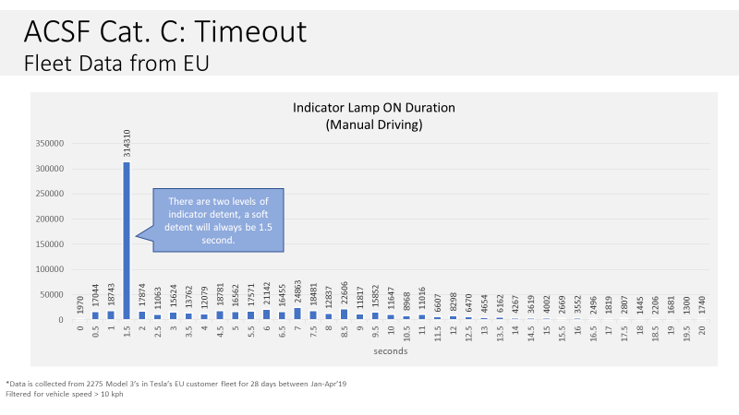

**Graph 2  
Pie chart distribution of indicator times for a ACSF of Category C1 system not limited by the maximum time requirements (left) and manual driving including soft detent (right), 2275 EU Model 3s**

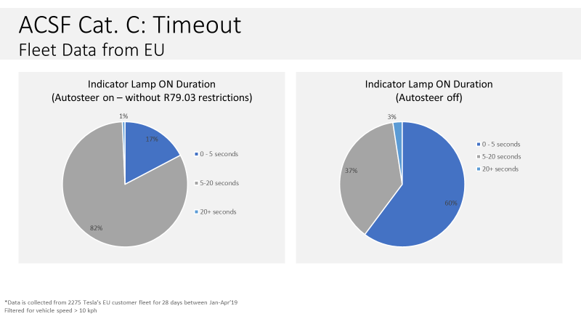

**Graph 3  
Indicator time distribution of manually driven 2.275 EU Model 3s, <2s time filtered**

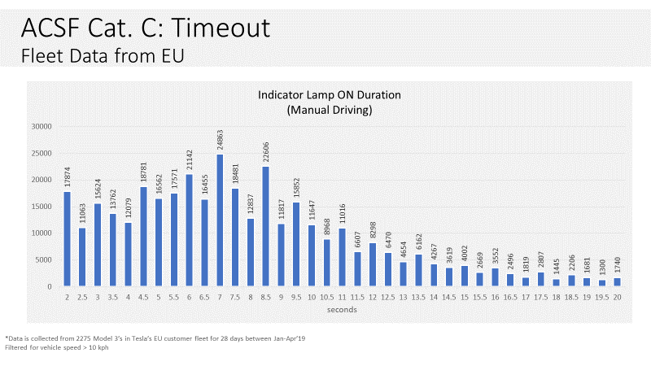

**Graph 4   
Pie chart distribution of indicator times in 5 second brackets for a C1 system not limited by R79.03 maximum time requirements (left) and manual driving excluding soft detent (right), 2275 EU Model 3s**

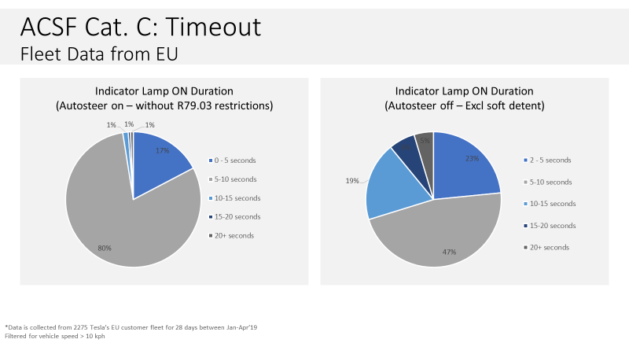

**B. Annex 8, Paragraphs 3.5.1.2. and 5.6.4.6.8.1.**

6. Adjustments to reflect changes proposed for the other provisions described in this document.

1. \* Formerly: **Working Party on Brakes and Running Gear (GRRF)**. [↑](#footnote-ref-2)
2. \*\* In accordance with the programme of work of the Inland Transport Committee for 2020 as outlined in proposed programme budget for 2020 (A/74/6 (part V sect. 20) para 20.37), the World Forum will develop, harmonize and update UN Regulations in order to enhance the performance of vehicles. The present document is submitted in conformity with that mandate. [↑](#footnote-ref-3)